Literature Review

Search Strategy
The search strategy has a core systematic approach augmented with additional items from a range of sources. The search identified a wide variety of articles, which outlined and augmented the review.
The search identified many related articles. Starting with a broad search strategy, the results were narrowed. Those of particular relevance were identified by reading abstracts and cross referencing with other papers. Colleagues identified further relevant literature.
Additional papers were identified from the bibliographies of relevant papers. Reviews and meta-analyses presented search strategies and identified highly relevant studies.
The search was limited to to high blood pressure, however, many papers consider broader clinical endpoints. These included metabolic syndrome, diabetes and cerebrovascular and cardiovascular disease.
My search terms are included in Table 1below. They were searched through a university meta database which includes Medline, and Ovid and Scopus. This meta database includes an ongoing search sends notification of articles as they are published.

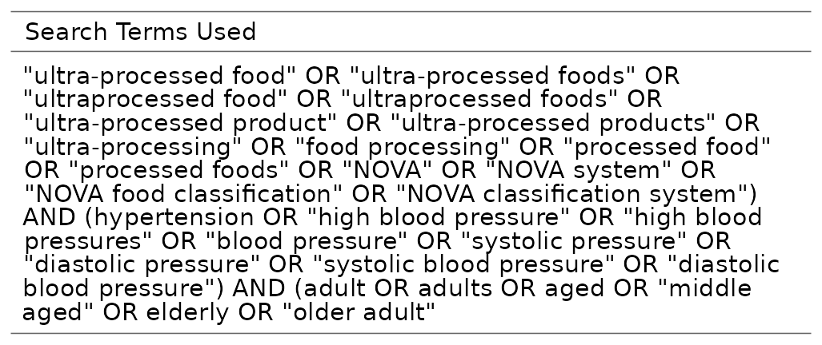Table 1: Search Terms Used

Search results
The search produced 1328 results. The search allowed medical, public health, nursing articles to be prioritised. Engineering, chemical, and technology articles were deprioritised.
No time limits, language limits or availability limits were included in the initial search. Reading titles and abstracts identified relevant articles.
Papers were excluded which related to technology including food technology. They were also excluded if the primary purpose of the paper was unrelated to dietary or nutritional causes of clinical outcomes.

Overview of literature
The literature has developed over some time. The results arrange themselves into several groups. The oldest are those which describe the development of the argument that Na relates to BP and to NCD. UPF is a recent concept developed within the Nova framework which was described in 2009. Hence articles around UPF and its relation to BP and NCD are more recent. This later group do build on earlier work. Importantly they analyse the way that UPF is correlated with BP. They don’t go into how Na might be involved in this relationship.
Papers are also categorised as primary research, systematic reviews with meta analysis, model analysis, and papers which use the other categories to consider public health policy approaches.

Aims of literature review
- 1 describe literature
- 2 synthesise literature
- 3 critique literature
- 4 explain role of study within context

Na, BP, NCD and Public Health
Non-communicable disease is an increasing burden on public health. (3) layout the charges against salt most clearly. They identify comprehensively the connection between changes in salt intake and changes in blood pressure and changes in cardiovascular (CVD) and cerebrovascular diseases. They link the nutritional effect of salt but they also identify the way this is affected by social and commercial determinants of health. These are branches from different epistemological backgrounds, nutrition from positivism, and the social determinants from a more constructivist approach.
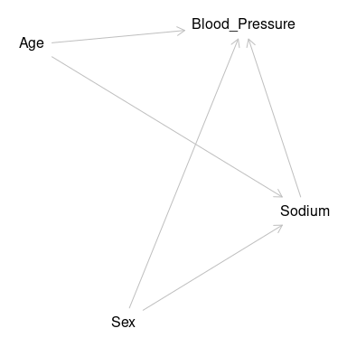
Diagram of relationships between BP and Salt
Explaining the role of the Framingham studies Kannel ((7) , (8)) and Mahmood (9) describe how risk factor medicine came about. They describe raised blood pressure as a ‘prominent member’ of a group of risks in cardiovascular disease. A disease which is the outcome of ‘multiple forces’. Their description sees Framingham as part of the march of progress in understanding cardiovascular disease in particular, but also non-communicable disease. Kannel identifies that cardiologists alone cannot conquer cardiovascular disease. Pringle (10) shows how stroke risk relates to BP.
Since then BP has come to feature more and more in NCD, following studies showing that reducing BP reduced the risk of CVD. This placed detection, management, and control of BP at the centre of reducing CVD. Ettehad (11) reported a comprehensive systematic review with 123 studies over 49 years and 613815 participants. More contemporary studies look at app use to improve BP monitoring (12). Bress (13) clearly identifies that patient trust and engagement are essential in reducing ‘race’ based inequalities. Boutain (14) identifies stress and worry as important factors for African American men and women. In North west England Roche (15) developed quality assurance approaches to BP management which highlight that there are many different approaches to assessment monitoring and control.
Causes come from different epistological paradigms. Medically, the causes of BP, as Kannel explains, are divided into secondary BP where there is an identified pathological cause and ‘essential’ or idiopathic BP where no cause is identifiable. Contributors to and partial causes of this essential BP have been sought, at individual and societal levels, using medical and epidemiological approaches ( (16) , (17) , (18) ).
At the level of physiology, salt (Na) is a contributor to BP. The role of salt in normal and abnormal BP control has been established through WHO and Intersalt (19) with Elliot (20) updating the findings and repeating the message. However news reports such as that of Newman (21) identify contentious aspects. Elijovich (22) carefully explains how the American Heart Association deals with the idea that there may be individuals with higher sensitivity to salt .
‘Lifestyle’ causes, such as Boutain’s ( (14) ) stresses, are reported as a mix of personal ‘choice’, ‘behaviours’ and responses to other social factors. That is, they are not choices at all. Whilst Jones et al. (23) demonstrated that there is a cost to adopting dietary recommendations in the UK. Salisbury’s editorial (24) discusses how commerce also has a role to play in a causation model which embraces an understanding of causation on a population scale.
Personal choice may be affected by taste sensation and satiety. Tan (25) discovered that this is difficult to study with a wide range of approaches across their systematic review. Nakamura et al. (26) used NDNS to explore how alternative flavourings might reduce the use of salt.
Reducing salt intake works. Vollmer (27) reports findings that reduced salt intake can reduce BP in diverse groups in the USA. Hendriksen (28) also explored this using Dutch and other European data to support this. Laverty et al. (29) demonstrates how policy reduces salt intake, and how reversal of policy allows intake to increase again.

Food classification
has traditionally concentrated on nutritional analysis eg Nutriscore ( (30) , (31), (32) , (33) ).
The social aspect of food has been studied famously by Bourdieu ( (34), (35) ).
The effect of the social and commercial nature of food is partly accounted for in Monteiro’s Nova classification. Dickie et al( (36) , (31) ) tried to develop a system which took this idea further, but struggled to build a model which was any more effective.
Monteiro’s initial explanation uses the concept of ‘processing’ ( (37) , (38) , (39) , (40) ). In a recent debate (41) and (42) discuss the concept of UPF and if it is valid or useful.
Explanations for the differential effect of these foods have developed as quickly as new ultra-processed foods have been developed . Is it due to nutritional content( (43) )? They are high in salt and sugar on average. Is it due to effects on satiety, or changes to appetite( (44) )? Do they taste better (45) ? Is it due to being easy to buy, and easy to eat( (46) )? Is it because they don’t require time and effort in the home to process? Is it because these processes are industrial? Is it because these foods contain ‘chemicals’ or new ingredients? These explanations move from nutritional through into social and commercial.
Colombet (47) showed that household income is correlated with UPF intake in the UK as well as exploring the relationship in the French West Indies (48).
All these critiques are possible because of the social element to the classification. Colombet (47) identify that the intake of UPF has an inequality dimension and then (49) use modeling to describe a ‘nutrition transition’.
Nutrition based classifications appear less socially divisive due to scientific isolation. They still contain elements of social factors. In particular, the way that foods are analysed can change their reported nutritional content. Eg a ‘standard’ food may be compared to a ‘traditionally prepared’ food. The first is prepared in a factory with control of its nutrition, the second by a home cook with limited access to nutrition modification technology.
Statements about the scheme often discuss the high salt and sugar content. Papers discussing the effect on physiology, and pathology in particular highlight these, but they do not back their statements with analysis. They do not show that the sodium, and UPF together increase the risk of CVD, or BP rise. This dissertation intends to address this gap
(50) show an approach between individual action and changing laws. This approach would target those most at risk due to negative social determinants. It does move into the realm of coercion of those ‘making the wrong choices’ into making better choices.

UPF
NOVA classification (37) looks at food beyond the nutrient level. It primarily incorporates ideas relating to ‘processing of food’. As the Nova concept has developed it can also be seen that ‘processsing’ incorporates how food is made available within social systems. Nova also involves ‘processing’ affects consumption behaviours through changes in cooking and eating behaviour within social systems.
Group one are foods which are in a natural state, as plucked from the tree. Group two is foods which are used in processes to modify group one foods. Group three initially was all other foods, but was soon separated into minimally processed foods, and group four the ultra-processed foods.Increasing Nova category four food, or UPF, is associated with increasing BP. There are other approaches to food classification which try to address more than the nutritional content.
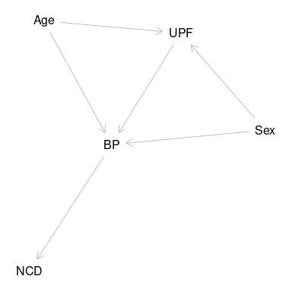
DAG of relationships of UPF

Can UPF be described in nutritional terms?
Webster (51) and niMurchu (52) identify the amount of salt in ultraprocessed foods. Vargas (53) concentrates on sodium and potassium using the Mexican national health and nutrition survey.
Sugars are the focus for Rauber (44), particularly free sugar intake.
Armendariz (54) look at how the retail food evironment in Mexican cities has changed and how it affects BP.

UPF and Ill Health
Mertens (mertens?), Barbosa (55), Santos (56) ,Aceves-martins (43), and Rauber (57) explore how UPF are associated with poor health. Whilst this is primarily metabolic pathology they do often mention BP. Schulze (58) comprehensively reviews UPF and metabolic health. Dicken and Betterham (59) provide a comprehensive review of papers considering a range of metabolic and other health endpoints.
(60) try to identify ill health in young people associated with the increasing use of UPF.
Hodge (61) dedicated an edition of ‘Public Health Nutrition’ to this question
(20)

obesity
The link to obesity is perhaps more direct. Munoz (62) looked at Mexican school age children. Li (63) looked at adults in China. Rauber (57) used the NDNS study to look at obesity in the UK.

diabetes and cardiometabolic syndromes
Given the effects on obesity and the increase of energy intake the connection to diabetes and cardiometabolic syndromes has been the subject of more papers.
Aguiar (64) concentrates on diabetes only. Li (65) uses a national study to link UPF with diabetes in China.
de Miranda Renata Costa (66) identifies the effect on metabolic health. Martinez (67) connects the dietary share of UPF in the US population. Tavares (68) doing the same in Brazilian adolescents.
dos Santos (69) identifies this as cardiometabolic health and provides a systematic review (56) . Goodman et al (70) explore this in Venezualan adults. Vilela (71) give a ‘…prospective approach to childhood’.
Some authors look how these metabolic effects lead to other conditions. For example Weinstein (72) with dementia. Gomez-Smith (73) identify a possible pathological explanation. Ivancovsky (74) connects NAFLD. Lee (75) connects these to CVD.
Colombet (48) connects these changes in metabolic syndrome with changes in socioeconomic inequalities again linking the nutritional identity of diet with its social aspects.

cancer
(76) and seperately (77) have identified a risk of colorectal cancer.

ckd
Kityo (78) identifies the effect on the kidneys. Identifying the diverse effects of UPF and possibly also another contributory cause of BP changes.

Increasing UPF intake
Many studies show the increasing role of UPF within the diet. Mertens (79) and ni Mhurchu (52) show how UPF are being eaten in ever greater quantities across Europe but especially across the UK.
Wang (46) identifies increasing consumption in US youths, D’Avila (80) also identify that increasingly upf are the key source of energy in adolescents. Gupta (81) explores the role of youth, identifying the peculiar age distribution of UPF intake.
Rauber (44) look instead at free sugar intake.

UPF BP and Salt
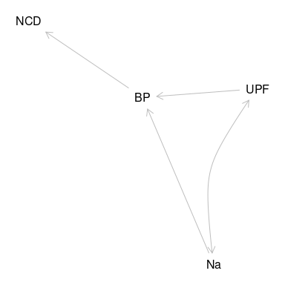
DAG of relationships explored by analysis
What is not known is how UPF cause BP. Suter (82) asked Is it nutrient based? In which case is this mediated by Salt? Is it other factors such as the food sales environment as explored by Goncalves (83) ? This study looks only at if Na is part of the causal pathway The thesis is that UPF is more of a risk than the salt it contains
Many studies use quite carefully constructed categories to achieve significant results.
The role of UPF in BP is described in a number of papers. Wang (84) delivers a meta analysis and systematic review. This identifies the best primary research and gives an odds ratio. Scaranni (85) and de Deus Mendonca (86) deliver key primary studies in specific populations with Shim (87) providing a Korean perspective.Du (2) gives the data for China. Oliveira (60) looks at the effect in children, Rezende (88) with adolescents.
Lima (89) reviewed already hypertensive individuals.
These papers answer to a connection between UPF and Hypertension. They leave the next obvious question to brief speculation and future research. Their offer is that UPF are high in Salt and sugars. The question is dropped, the focus elsewhere.
smiljenac (90) and tzelfa (91) both look at how UPF affect the vasculature which may be part of the pathway to BP.

Approach to change
Understanding the best approaches to reducing salt requires approaches that also cross epsitological paradigms.
The relationship between Na and socioeconomic position was demonstrated by Ji et al. (92).
Is it best to get individuals to reduce intake( (93), (94) , (27) , (95) , (96) ), or for all of the food industry to reduce salt levels( (97) , (98) ).
Lifestyle factors are contented. Whilst individual choice is involved. The range of choices available to individuals is limited by the nature of their society. A misapplication of lifestyle results in blaming individuals for the poor choices determined by their social and commercial environment. Iso (99) looks at how education may be effective in delivering change.
This can be tackled using a comprehensive integrated policy approach such as ‘healthy cities’ (100). Macregor (101) explores how political change affects both the process and outcome of population level approaches to improving health.
Instead of trying to change activity of millions of people can be more effective to change laws and policies once ( (102) , (29) , (103) , (104) , (105) ). These ‘upstream’ changes are relatively simple, and are much more effective though they can also be reversed ( (3) ). Cost is one of the causes of change as shown by Jones (23) using NDNS to identify the cost premium of a good diet as defined by UK dietary recommendation . Opposition sometimes comes from industry.
(29) and (101) showed that an analytical model can effectively demonstrate the effects of different policies on population health. They identify that reducing the effectiveness of a policy on salt in food leads to changes in BP and so on to NCD.
(106) identify the benefits of their strategy. They discuss the range of nation level approaches to reducing salt intake.
- National Food Strategy, editor. National Food Strategy: part one.

- . London: National Food Strategy,; 2020. Available from: https://www.nationalfoodstrategy.org/partone/

Literature review Conclusion
The literature review identified and analysed a range of literature across the field. Key points being that CVD is a significant NCD, and has links with Na and UPF. These links are often described in different paradigms. This study aims to cross link these paradigms looking at how Na and UPF interact and looking to understand from a positivist approach what effects UPF have within the positivist paradigm. At the same time knowing and accepting that effects of UPF in this paradigm are a subset of the total effect. Whilst also understanding that Na in its nutritional paradigm similarly projects into the other paradigm.

