Results

Participants and Descriptive Data
The whole NDNS population was 15,655. The mean age was 40. Categorising age shows that 22% of the population was between 19 and 35. There were 49% male participants. Mean BP was 123 mmHg. On outcome, 7256 participants had a BP below 140 mmHg, but there were 7196 participants unknown. There was no BP recorded for year 11. The mean exposure to Na was 2037 mg daily. The mean UPF exposure was 48%.

The population with those on medication included 14217 participants. The mean age was 38. The biggest age group again was 19-35. There were again 49% male participants. Mean outcome, BP was 121 mmHg. The exposure, Na was 2043 mg and UPF was still 48%.
There appeared little difference in bmi, educational level, IMD, or region of origin.
This first table Table 1 shows all variables.
Continuous variables are represented by the mean and standard deviation in brackets. Categorical variables give the number of participants and the percentage of the sample in brackets.

Figure 1:

Table 1: Table of weighted amalgamated population data from NDNS 2008-2019
Table 2: Table of weighted population NDNS 2008-2019
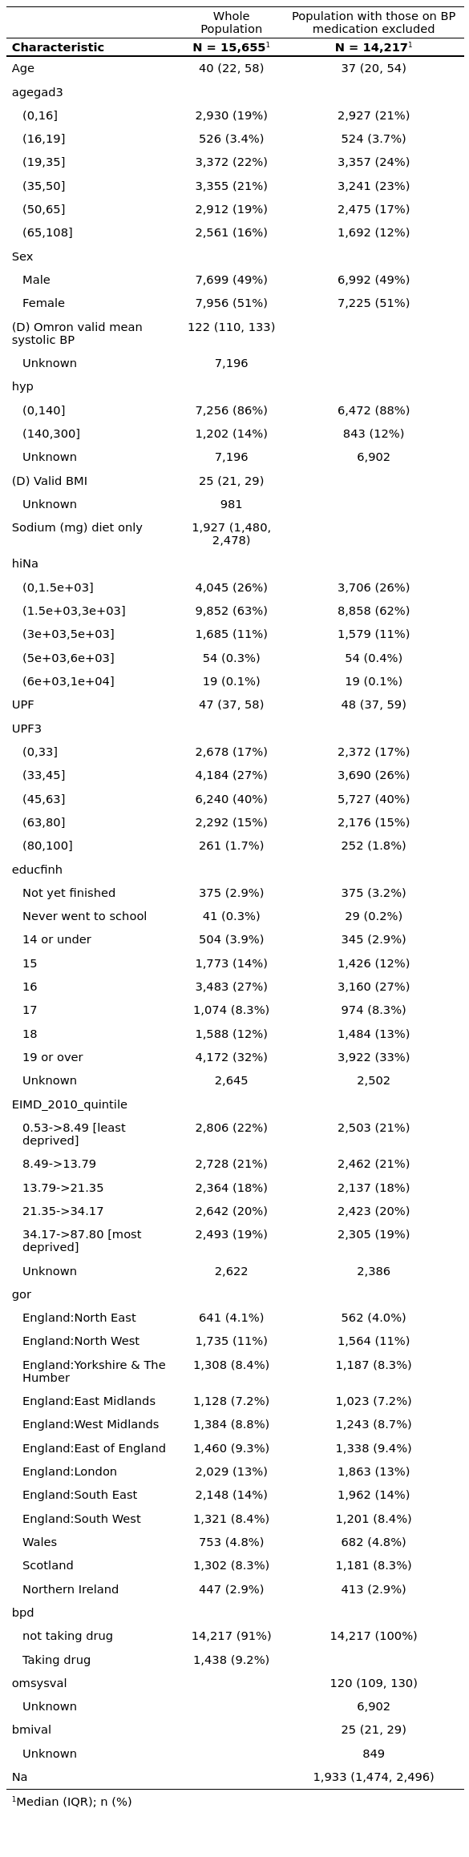Table : Population counts NDNS 2008-2019

Population by Survey Wave
The variables were compared across annual waves. The numbers seemed smaller towards the end of the series, for Na, UPF and for BP. Each cohort was adjusted to be comparable using weighting values given by the study coordinators. The highest mean value for Na was 2257 (standard deviation is 878) in year one. The lowest mean value for Na was 1892 (724) in year ten.
Mean UPF was highest in year 2 and year 6 at 50%. The lowest mean UPF intake was 45% in years 8,9 and 10. The mean outcome variable BP was highest in year one with 125 mmHg, and the lowest 120 mmHg in year 6.
The separate waves had separate participants.
The data is presented in Table 2.
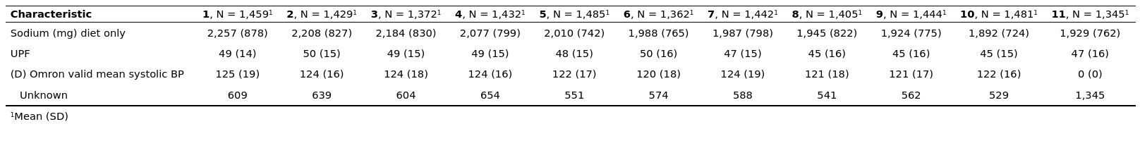
Table 2: Key variables counts across survey years NDNS 2008-2019

Results were illustrated by plots against survey year. Figure 1 showed overlap between the waves for UPF intake. Figure 2 showed Na exposure overlap between waves. Figure 3 identified the lack of data for year 11.

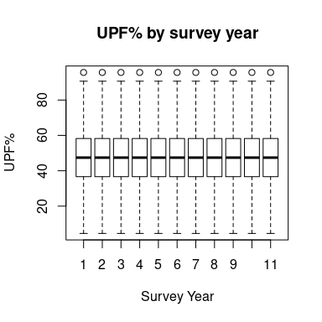Figure 1: Energy from UPF% in each annual cohorts NDNS (2008-2019)

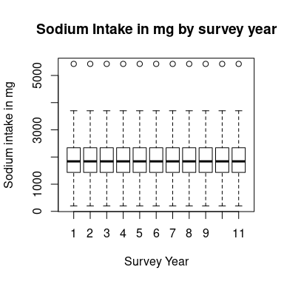Figure 2: Na in mg in each annual cohort NDNS(2008-2019)

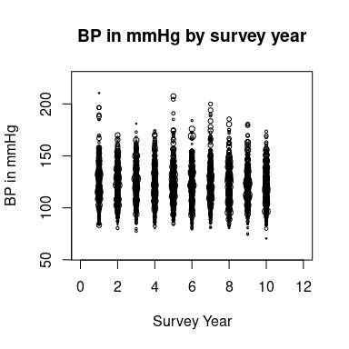Figure 3: Plot of the BP in mmHg by year from NDNS (2008-2018)

General linear regression modelling was used, with wave 1 as a comparator for analysis of the other waves.
This showed that for Na there was a negative beta value with p.value <0.001 in wave 4-11. For UPF the beta value was negative in wave 7,8,9 and 10 with p.value <0.05. The BP had a negative beta value in all waves, with p.value <0.05 in waves 5,6,8,9 and 10.
Age was a variable which the whole sample was weighted to be maintained across the waves. There were no p.values below 0.12.
BMI had a negative p.value in most years but the p.value was <0.05 only in wave 7 and 8.
Table 2shows results for continuous variables.

Table 3: Data across Survey Wave NDNS 2008-2019

The categorical data also had p.values >0.05 for the controlled variables (age, sex, IMD) against annual wave. UK region is part of the weighting, but this sample showed variation with p.value <0.05.

Vegetarian, categorised UPF intake, and hypertension had a p.value of <0.05.
BMI had a p.value of 0.77.
Data for year 5 was absent for education. Data for year 11 was absent for hypertension.
Table 4 follows.

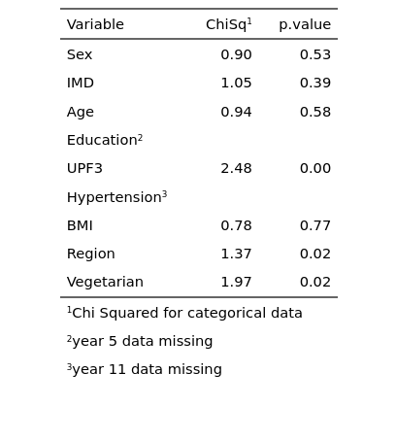Table 4: Categorical data from NDNS 2008-2019

Exposure and outcome variables by Sex, Age and Place
Table 6: Data counts by governmental region of NDNS 2008-2019
In each case the lower gradient of the relationship between the variable and Sex was statistically significant.Table 5 shows the difference between male and female in the key variables.
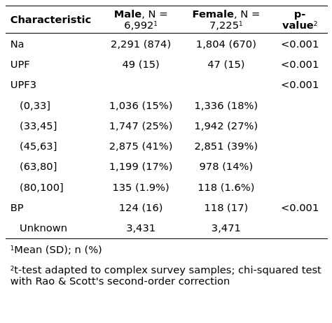Table 5: Data by Sex NDNS 2008-2019

Peak mean Na was 2302mg in the 19-35 age group. The mean peak UPF exposure was 58% in the 16-18 age group, but was almost matched by 56% the 0-16 group. BP rose through life to a mean of 134 mm Hg in the over 65 age category.
Table 7shows the age distribution of exposure to sodium and UPF and the resulting BP.

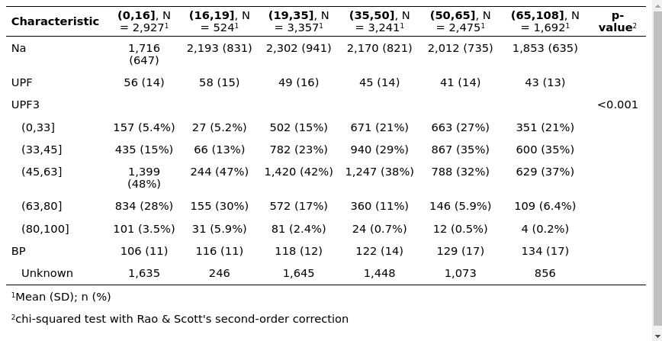Table 7: Data by age group NDNS 2008-2019

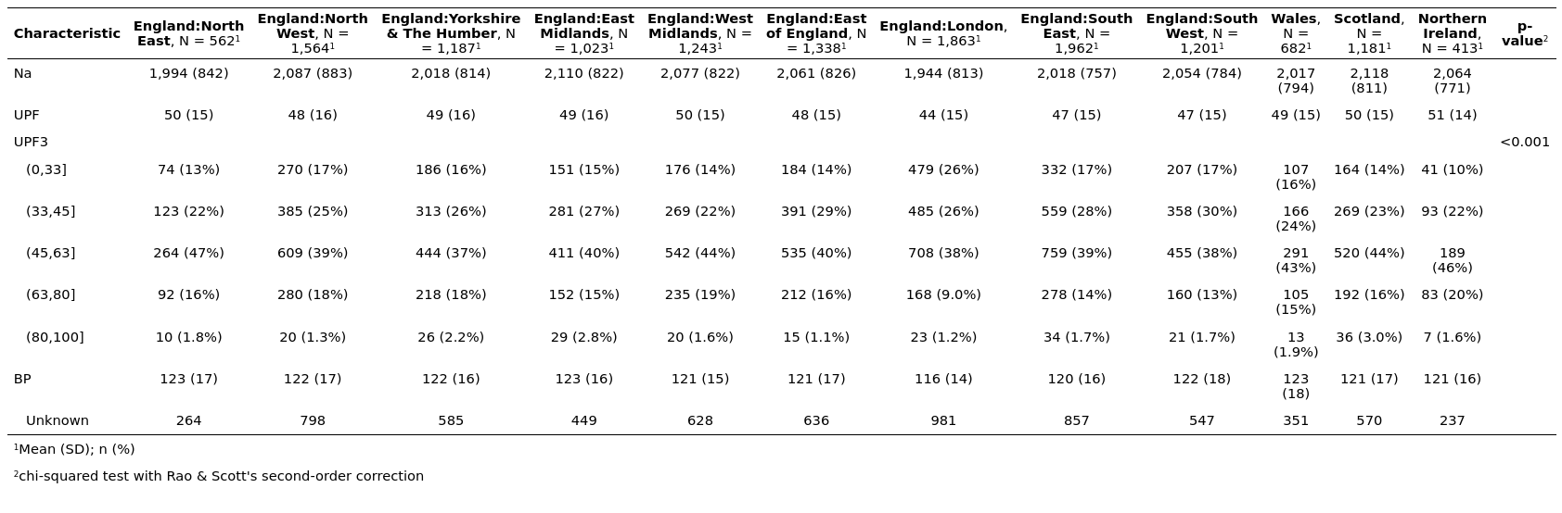
UPF exposure was highest in Northern Ireland and lowest in London. The sodium exposure was highest in Scotland and lowest in London. Outcome BP was also lowest in London, with the highest in the North East.Table 6shows the data.

Paired Regression of variables on each other

Simple linear regression equations look for the relationship between the outcome BP, and the independent exposure variable.
The regression model for Sodium against BP shows that there is no linear relationship between Sodium and BP in this table Table 8 UPF compared to Na also shows a zero beta value indicating no linear relationship.
UPF does show a negative relationship with age, which is statistically significant. There is also a negative relationship with Age, again statistically significant.
Age has a relationship with BP with a statistically significant positive gradient. There is also a positive relationship with Na, which is also statistically significant to the 95% level.
In conclusion the linear regression models show that there are correlations between the systolic BP and energy intake only. The next section will examine how this situation changes as variables interact in more complex models.
Figure 4:
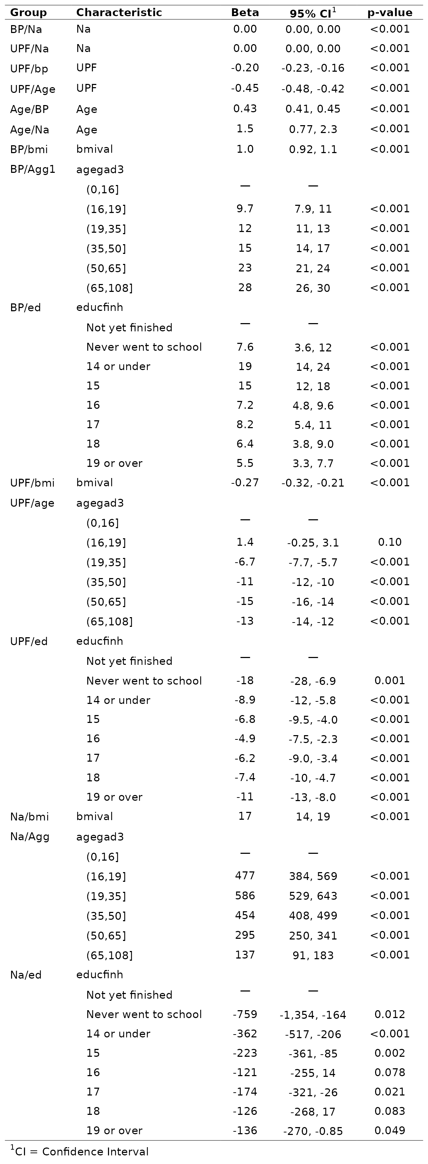Table 8: Univariable regrssion models NDNS 2008-2019

Multi variable logistic regression
This set of models looked at when the data was regressed against hyp a variable identifying hypertension as 140mmHg in patients who are not on BP reducing medication.
The first model, labelled “No sodium or UPF” of this set looks at the relationships between BP and some of the background variables (Age and Sex, education and IMD) all of which may have an effect on BP. The result shows that the odds ratio for females is 0.6 and this is statistically significant. That is the odds of a female participant having a BP above 140 are almost half those for a male participant. BMI odds ratios are not statistically significant across the categories. That is a BMI over 30 is not associated with a BP above 140mmHg in this data set. All age groups have statistically significant differences in odds of hypertension compared to the under 16 age group. That of the oldest age group being a 372 times greater risk. The IMD groups are not statistically different from the least deprived.
The second model, “Sodium Only”, adds sodium as the exposure variable. The odds ratio for the group taking between 5000mg and 6000mg per day is statistically significantly different from those taking less than 3000mg per day. There is an odds ratio of 7.5 for this group. It also shows minimal effects on other variables in the model.
“UPF only” is the third model. Here there is no significant difference in odds ratio for any group. Again there are minimal effects on the other variables.
The last model, “Sodium and UPF”, shows that when combined there is still little effect identified statistically, on each other or on the other variables. The difference in odds ratio for 5000-6000mg of Na remains, and remains statistically significant. Table 8 follows below.

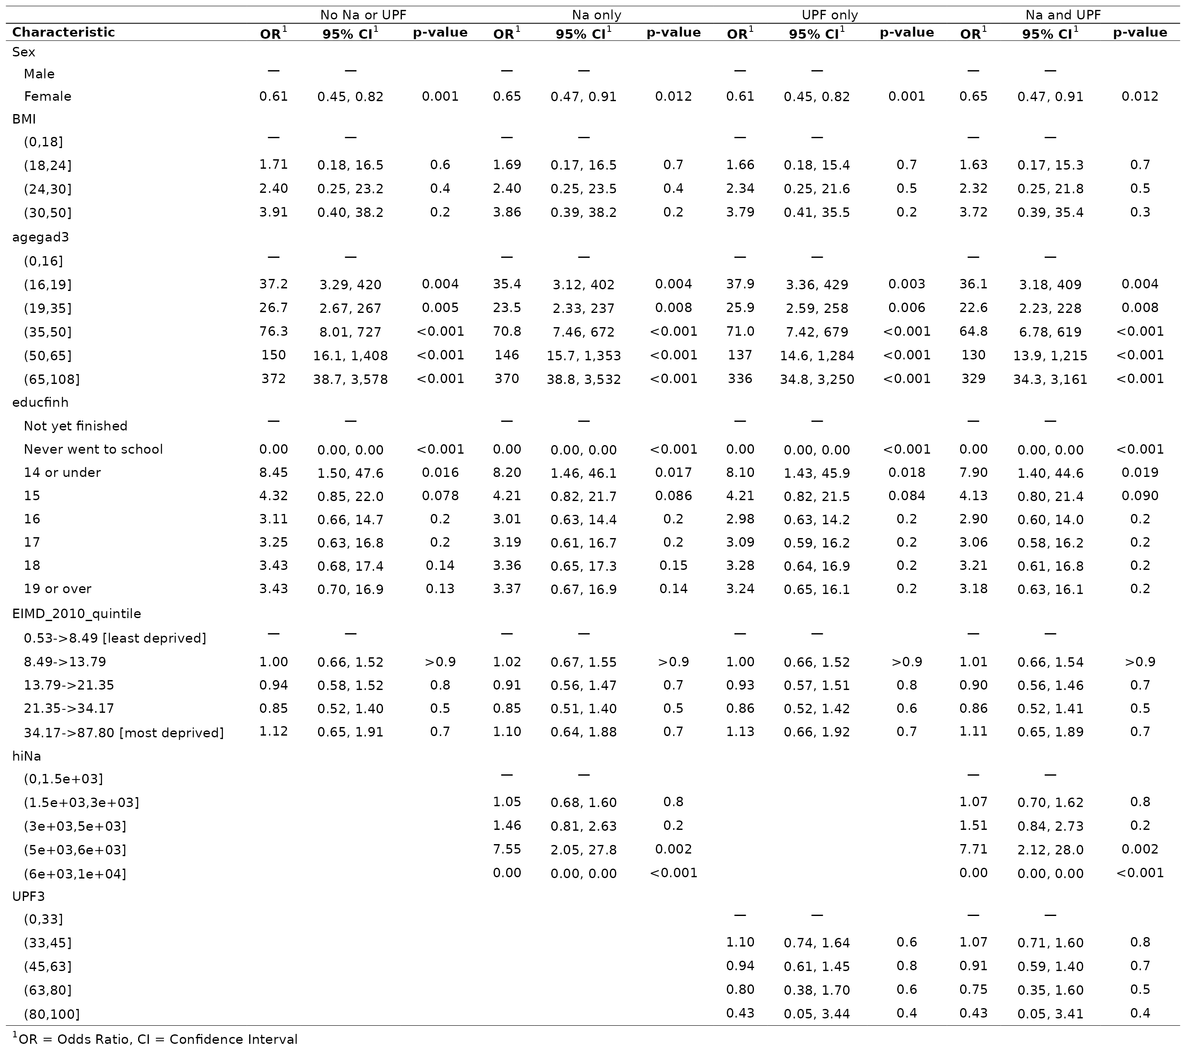
Table 8: Multivariable Logistic regression on BP NDNS2008-2019
Using the AIC statistic for each model gives another way of understanding the comparative effects. The subsequent Table 9 shows the size of the effect relating to sodium. The lowest scored model is the optimal model. The ‘best’ of these models is that with only sodium included “Na only”. The UPF models both being further away from the lowest value.

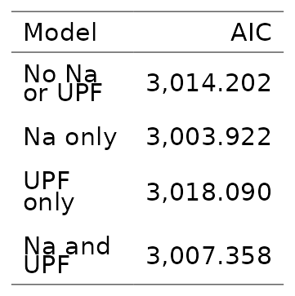Table 9: Comparison of AIC multivariable regression modelsNDNS 2008-2019
Of the difference between the lowest scoring model and the highest 80/20 is due to UPF
There is a significant sensitivity of the data set to improved modelling. Though the set of models around the same values includes the four regressed against BP, and two of those against UPF which include BP.

