Table of Contents
Results 1
Participants and Descriptive Data 1
Exposure variables 4
Outcome Variable 4
Analysis of Change across cohorts 4
Other variables compared across cohorts 7
Analysis of Key variables by Sex 8
Analysis of Key Variables by Age 10
Analysis of Key Variables by Place 13
Paired Regression of variables on each other 15
Complex Modelling using Multi variable regression 20
Regression on BP 20
simple set Regression on BP 22
Regression on Na 23
Regression on UPF 25
Summary of Results 28
Table of Figures
Figure 1: Plot of Energy from UPF by survey year 5
Figure 2: Figure of Sodium intake by survey year 6
Figure 3: Figure of Systolic BP by survey year 6
Figure 4: Box Plot of the difference between the sexes in UPF 9
Figure 5: Box Plot of difference between the sexes in BP showing slight lower level in females 9
Figure 6: Box Plot of the difference in Systolic BP in mmHg between Age groups showing a strong overlap 11
Figure 7: Box Plot of the difference in UPF intake in % between Age groups showing a sttrong overlap 11
Figure 8: Box Plot of the difference in Sodium intake in mg between Age groups showing a sttrong overlap 12
Figure 9: diagram of the relationships explored by the analysis 15
Figure 10: Plot of BP by Na showing no visible directional relationship 16
Figure 11: Plot of BP by UPF showing limited directional relationship 16
Figure 12: Plot of UPF against Na to look for a relationship, but none is apparent from this plot 17
Index of Tables
Table 1: Table of key data in whole population and in those on medication 2
Table 2: Table of Key variable linear regression against survey year showing reducing values 7
Table 3: Table of Age and Bmi (continuous variables) regression against survey year showing no statistically significant change for Age, but BMI has reduced 8
Table 4: Table of categorical variables compared to survey year using Chi Squared test showing that no change in Sex and IMD, but changes in Education, Vegetarians and UPF3 8
Table 5: Table of key variables by sex also showing p values showing statistically significant differences between the sexes 9
Table 6: Table of key variables by Age group Each showing statistically significant change 11
Table 7: Table of key variables across Age groups showing that UPF intake reduces, BP increases and Na has a peak in young adulthood 13
Table 8: Table showing Key Variables by Place. showing that the UPF exposure is highest in Northern Ireland and lowest in London. The sodium exposure is highest in Scotland and lowest in London. Outcome BP is also lowest in London, with the highest in the North East 14
Table 9: Table of results of univariate GLM general linear regression models showing relationships between exposure and outcome variables. It identifies the absence of a relationship between BP and Na, as well as UPF and Na, the negative relationship between UPF and BP as well as UPF and Age, and finally the positive relationship between Age and BP, and Age and Na 18
Table 10: Table of univariate GLM models of linear regression of pairs of other variables used in the analysis. Showing a range of significant responses. 19
Table 11: Table of a set (BP1) of beta values, confidence intervals, and p.values from Multivariate regression of variables against BP 21
Table 12: Table of a set (BP) of beta values, confidence intervals, and p.values from Multivariate regression of variables against BP 23
Table 13: Table of a set (Na) of beta values, confidence intervals, and p.values from Multivariate regression of variables against BNa 24
Table 14: Table of a set (UPF) of beta values, confidence intervals, and p.values from Multivariate regression of variables against UPF 26
Table 15: Table of AIC values for each model in each of the four sets 29

Results

Participants and Descriptive Data
This first Table 1 includes all variables. These are weighted values analysed using a software package called ‘survey’ (102) .
The tables presented by NDNS have been amalgamated and new weighting values calculated which enable compilation of data from separate tables into one.
Table 1: Table of key data in whole population and in those on medication
 | Whole Population | Not on BP medication
Characteristic | N = 15,655¹ | N = 5,105¹
Age | 40 (22, 58)
agegad3
(0,16] | 2,930 (19%) | 879 (17%)
(16,19] | 526 (3.4%) | 202 (4.0%)
(19,35] | 3,372 (22%) | 1,272 (25%)
(35,50] | 3,355 (21%) | 1,248 (24%)
(50,65] | 2,912 (19%) | 943 (18%)
(65,108] | 2,561 (16%) | 562 (11%)
Sex
Male | 7,699 (49%) | 2,358 (46%)
Female | 7,956 (51%) | 2,747 (54%)
(D) Omron valid mean systolic BP | 122 (110, 133)
Unknown | 7,196
(D) Valid BMI | 25 (21, 29)
Unknown | 981
Sodium (mg) diet only | 1,927 (1,480, 2,478)
Epcnt_4 | 47 (37, 58) | 47 (37, 58)
UPF3
(0,33] | 2,678 (17%) | 890 (17%)
(33,63] | 10,423 (67%) | 3,405 (67%)
(63,100] | 2,554 (16%) | 809 (16%)
educfinh
1 | 375 (2.9%) | 101 (2.4%)
2 | 41 (0.3%) | 13 (0.3%)
3 | 504 (3.9%) | 77 (1.8%)
4 | 1,773 (14%) | 458 (11%)
5 | 3,483 (27%) | 1,189 (28%)
6 | 1,074 (8.3%) | 306 (7.3%)
7 | 1,588 (12%) | 580 (14%)
8 | 4,172 (32%) | 1,478 (35%)
Unknown | 2,645 | 903
EIMD_2010_quintile
1 | 2,806 (22%) | 998 (23%)
2 | 2,728 (21%) | 934 (22%)
3 | 2,364 (18%) | 763 (18%)
4 | 2,642 (20%) | 853 (20%)
5 | 2,493 (19%) | 759 (18%)
Unknown | 2,622 | 798
gor
North East | 641 (4.1%) | 210 (4.1%)
North West | 1,735 (11%) | 517 (10%)
Yorkshire & The Humber | 1,308 (8.4%) | 407 (8.0%)
East Midlands | 1,128 (7.2%) | 405 (7.9%)
West Midlands | 1,384 (8.8%) | 430 (8.4%)
East of England | 1,460 (9.3%) | 498 (9.7%)
London | 2,029 (13%) | 647 (13%)
South East | 2,148 (14%) | 764 (15%)
South West | 1,321 (8.4%) | 454 (8.9%)
Wales | 753 (4.8%) | 225 (4.4%)
Scotland | 1,302 (8.3%) | 428 (8.4%)
Northern Ireland | 447 (2.9%) | 117 (2.3%)
age |  | 38 (22, 53)
omsysval |  | 118 (108, 128)
bmival |  | 25 (21, 28)
Unknown |  | 128
Sodiummg |  | 1,955 (1,515, 2,470)
¹Median (IQR); n (%)
Continuous variables are represented by the mean and standard deviation in brackets. Categorical variables give the number of participants and the percentage of the sample in brackets.

Exposure variables
The exposure variables Sodiummg, and Epcnt_4 are continuous. The mean value for Sodiummg is 2,037. That for Epcnt_4 is 48. The categorical variable UPF3 shows that 67% of the population fall within the central category calculated from the standard deviation of the mean.

Outcome Variable
The BP is also continuous with a mean of 123 and standard deviation of 17. There are a significant number of unknowns, 7196 out of a sample of 15,655.

Analysis of Change across cohorts
These key variables are now compared between the cohorts fist in tbl-keydata.
#keydatw <-tbl_svysummary(ndns_1_11d,SurveyYear , include = c(Sodiummg,Epcnt_4,omsysval))
The numbers seem to be smaller towards the end of the series, for Sodium intake, UPF intake (Epcnt_4) and for systolic BP. Each cohort has been adjusted to be comparable using weighting values given by the study coordinators. However they are separate cohorts of separate participants with no linear association between them. It can be seen that there are lower values for all of the variables in the later groups.
Figure 1 shows the energy from UPF in percent (Epcnt_4) against cohort number. This plot shows that the ranges largely overlap. No visible difference is clear on this plot.
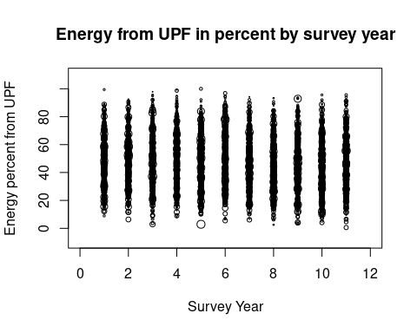Figure 1: Plot of Energy from UPF by survey year
Plot of the percentage of energy from UPF in each annual cohort showing an apparent overlap
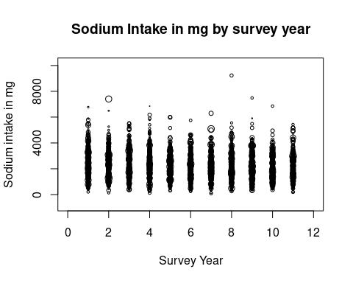Figure 2: Figure of Sodium intake by survey year
Plot of the intake of Na in mg in each annual cohort showing an apparent overlap
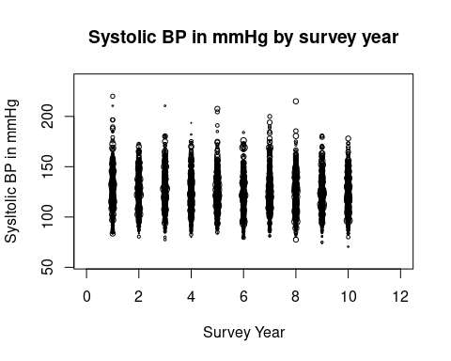Figure 3: Figure of Systolic BP by survey year
Plot of the BP in mmHg in each annual cohort showing an apparent overlap
The sodium intake Figure 2, and the Systolic BP Figure 3 do not show an obvious change across the cohorts.
Table 2: Table of Key variable linear regression against survey year showing reducing values
Group | Characteristic | Beta | 95% CI¹ | p-value
Sodium in mg | NDNS Survey year | -36 | -43, -30 | <0.001
Percent Energy UPF | NDNS Survey year | -0.41 | -0.53, -0.29 | <0.001
Systolic BP | NDNS Survey year | -0.37 | -0.56, -0.19 | <0.001
¹CI = Confidence Interval
Table 2compares mean sodium, UPF and systolic BP values across the individual cohorts. This uses general linear regression modelling, with cohort 1 as a comparator for the other cohorts. The differences and the beta variable do not depend on there being a linear or ordinal arrangement between the cohorts.
This shows that for sodium there is a beta of -36.2767894 with confidence limits of -43, -30; For UPF beta is -0.4068208 and confidence limits -0.53, -0.29; and for BP -0.3743859 and -0.56, -0.19. Each beta value is negative which means that these values in each cohort is largely below that of the first reference year. The confidence intervals do not pass unity and so these results are statistically significant.
These corresponding negative beta values do not mean that there is a correlation between these variables. This will be examined later.

Other variables compared across cohorts
This section shows how variables are distributed between the survey annual cohorts. The NDNS dataset was weighted to keep many of these, but not all, the same between datasets. Continuous variables are assessed using linear regression and categorical variables using chi squared tests to give p.values.
This table Table 3 suggests that there is a significant difference in the bmi of the cohorts.
Table 3: Table of Age and Bmi (continuous variables) regression against survey year showing no statistically significant change for Age, but BMI has reduced
Group | Characteristic | Beta | 95% CI¹ | p-value
Age | NDNS Survey year | 0.10 | -0.06, 0.25 | 0.2
BMI | NDNS Survey year | -0.09 | -0.13, -0.04 | <0.001
¹CI = Confidence Interval
There is a difference in the age of finishing education.
The differences in IMD, are not statistically significant.
Table 4 identifies a significant difference in the number of vegetarians.
Table 4: Table of categorical variables compared to survey year using Chi Squared test showing that no change in Sex and IMD, but changes in Education, Vegetarians and UPF3
Variable | ChiSq¹ | p.value
Sex | 0.8357 | 0.5921
Education | 3.5072 | 0.0000
IMD | 1.1718 | 0.2208
Vegetarian | 1.9096 | 0.0245
UPF3 | 4.1740 | 0.0000
¹Chi Squared for categorical data

Analysis of Key variables by Sex
Table 5: Table of key variables by sex also showing p values showing statistically significant differences between the sexes
Characteristic | Male, N = 7,699¹ | Female, N = 7,956¹ | p-value²
Sodium (mg) diet only | 2,193 (1,677, 2,778) | 1,722 (1,354, 2,164) | <0.001
Epcnt_4 | 48 (38, 59) | 46 (36, 57) | <0.001
UPF3 |  |  | <0.001
(0,33] | 1,164 (15%) | 1,514 (19%)
(33,63] | 5,124 (67%) | 5,299 (67%)
(63,100] | 1,411 (18%) | 1,143 (14%)
(D) Omron valid mean systolic BP | 124 (115, 134) | 116 (107, 130) | <0.001
Unknown | 3,560 | 3,636
¹Median (IQR); n (%)
²Wilcoxon rank-sum test for complex survey samples; chi-squared test with Rao & Scott's second-order correction
Table 5 shows the difference between male and female in the key variables.

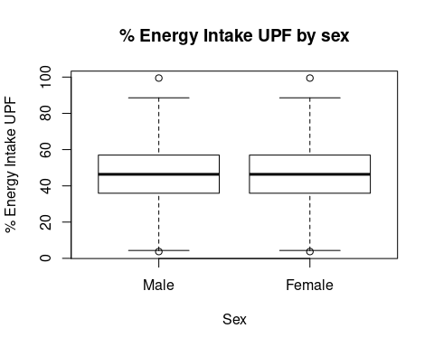Figure 4: Box Plot of the difference between the sexes in UPF
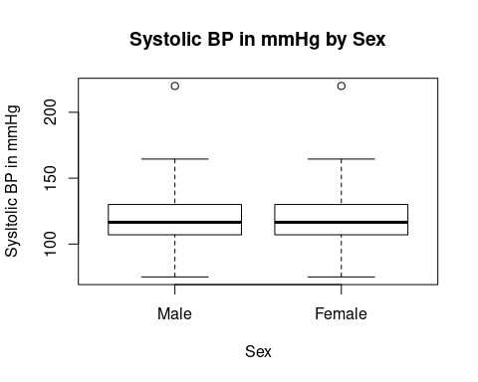Figure 5: Box Plot of difference between the sexes in BP showing slight lower level in females
The difference in Systolic BP in mmHg between male and female showing a slightly lower value in the female cohort
In each graph there is little difference apparent, though perhaps the female plot is slightly lower.

Analysis of Key Variables by Age
Table 6: Table of key variables by Age group Each showing statistically significant change
Characteristic | (0,16], N = 2,930¹ | (16,19], N = 526¹ | (19,35], N = 3,372¹ | (35,50], N = 3,355¹ | (50,65], N = 2,912¹ | (65,108], N = 2,561¹ | p-value²
Sodium (mg) diet only | 1,634 (1,254, 2,072) | 2,068 (1,616, 2,681) | 2,207 (1,624, 2,779) | 2,062 (1,595, 2,641) | 1,955 (1,533, 2,450) | 1,805 (1,434, 2,221) | <0.001
Epcnt_4 | 57 (47, 66) | 57 (48, 69) | 50 (39, 60) | 45 (35, 56) | 41 (33, 51) | 43 (34, 52) | <0.001
UPF3 |  |  |  |  |  |  | <0.001
(0,33] | 158 (5.4%) | 27 (5.2%) | 503 (15%) | 704 (21%) | 745 (26%) | 542 (21%)
(33,63] | 1,835 (63%) | 311 (59%) | 2,210 (66%) | 2,253 (67%) | 1,965 (67%) | 1,850 (72%)
(63,100] | 937 (32%) | 188 (36%) | 660 (20%) | 398 (12%) | 202 (6.9%) | 170 (6.6%)
(D) Omron valid mean systolic BP | 106 (99, 113) | 114 (108, 123) | 118 (110, 126) | 121 (112, 130) | 129 (118, 140) | 134 (122, 146) | <0.001
Unknown | 1,636 | 246 | 1,646 | 1,475 | 1,159 | 1,035
¹Median (IQR); n (%)
²Wilcoxon rank-sum test for complex survey samples; chi-squared test with Rao & Scott's second-order correction
Table 6shows the age distribution of exposure to sodium and UPF. Peak sodium exposure in the 19-35 age group. The peak UPF exposure is in the 16-18 age group, but is almost matched by the 0-16 group. The outcome BP rises through life.
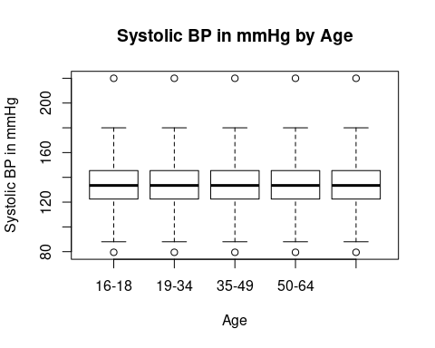Figure 6: Box Plot of the difference in Systolic BP in mmHg between Age groups showing a strong overlap
The difference in Systolic BP in mmHg between Age groups showing a strong overlap
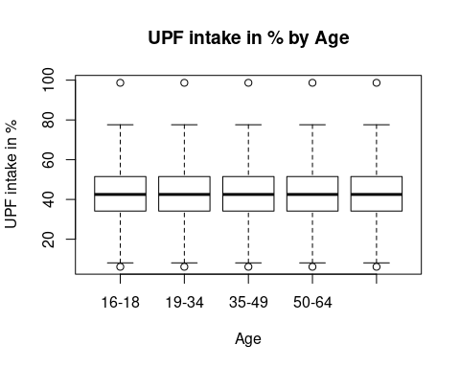Figure 7: Box Plot of the difference in UPF intake in % between Age groups showing a sttrong overlap
The difference in UPF intake in % between Age groups showing a sttrong overlap
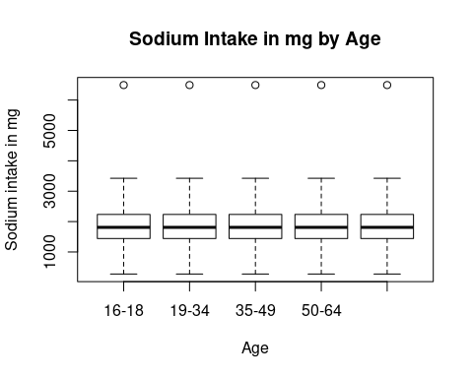Figure 8: Box Plot of the difference in Sodium intake in mg between Age groups showing a sttrong overlap
The difference in Sodium intake in mg between Age groups showing a strong overlap
Table 7: Table of key variables across Age groups showing that UPF intake reduces, BP increases and Na has a peak in young adulthood
Group | Characteristic | Beta | 95% CI¹ | p-value
Sodium in mg | agegad2
 | 16-18 | — | —
 | 19-34 | 151 | 70, 232 | <0.001
 | 35-49 | 21 | -53, 96 | 0.6
 | 50-64 | -110 | -181, -39 | 0.002
 | 65+ years | -263 | -331, -195 | <0.001
Percent Energy UPF | agegad2
 | 16-18 | — | —
 | 19-34 | -8.1 | -9.6, -6.6 | <0.001
 | 35-49 | -13 | -14, -12 | <0.001
 | 50-64 | -16 | -18, -15 | <0.001
 | 65+ years | -15 | -17, -14 | <0.001
Systolic BP | agegad2
 | 16-18 | — | —
 | 19-34 | 2.9 | 1.4, 4.4 | <0.001
 | 35-49 | 6.7 | 5.2, 8.2 | <0.001
 | 50-64 | 14 | 12, 16 | <0.001
 | 65+ years | 20 | 18, 22 | <0.001
¹CI = Confidence Interval
Table 7 is interesting in that it shows that whilst the BP goes up across the age categories, the UPF intake decreases. The changes in sodium content are particularly interesting as they show that the older age groups have much lower sodium intake, but the highest sodium intake in in the second group, with the first and third being statistically no different.

Analysis of Key Variables by Place
Table 8: Table showing Key Variables by Place. showing that the UPF exposure is highest in Northern Ireland and lowest in London. The sodium exposure is highest in Scotland and lowest in London. Outcome BP is also lowest in London, with the highest in the North East
Characteristic | North East, N = 641¹ | North West, N = 1,735¹ | Yorkshire & The Humber, N = 1,308¹ | East Midlands, N = 1,128¹ | West Midlands, N = 1,384¹ | East of England, N = 1,460¹ | London, N = 2,029¹ | South East, N = 2,148¹ | South West, N = 1,321¹ | Wales, N = 753¹ | Scotland, N = 1,302¹ | Northern Ireland, N = 447¹ | p-value²
Sodium (mg) diet only | 1,898 (1,362, 2,493) | 1,946 (1,511, 2,505) | 1,912 (1,441, 2,470) | 1,991 (1,517, 2,552) | 1,955 (1,507, 2,504) | 1,962 (1,518, 2,554) | 1,789 (1,347, 2,398) | 1,891 (1,478, 2,437) | 1,956 (1,503, 2,448) | 1,896 (1,466, 2,425) | 2,003 (1,555, 2,540) | 1,956 (1,520, 2,495) | <0.001
Epcnt_4 | 50 (39, 59) | 48 (37, 59) | 48 (38, 60) | 47 (38, 57) | 50 (39, 60) | 48 (38, 58) | 43 (31, 54) | 46 (36, 57) | 46 (37, 56) | 48 (38, 58) | 49 (39, 60) | 51 (41, 61) | <0.001
UPF3 |  |  |  |  |  |  |  |  |  |  |  |  | <0.001
(0,33] | 89 (14%) | 302 (17%) | 205 (16%) | 171 (15%) | 193 (14%) | 212 (15%) | 548 (27%) | 374 (17%) | 235 (18%) | 115 (15%) | 187 (14%) | 46 (10%)
(33,63] | 438 (68%) | 1,112 (64%) | 838 (64%) | 771 (68%) | 921 (67%) | 1,013 (69%) | 1,276 (63%) | 1,452 (68%) | 900 (68%) | 511 (68%) | 881 (68%) | 309 (69%)
(63,100] | 113 (18%) | 321 (19%) | 265 (20%) | 186 (16%) | 270 (19%) | 234 (16%) | 204 (10%) | 322 (15%) | 186 (14%) | 126 (17%) | 234 (18%) | 92 (21%)
(D) Omron valid mean systolic BP | 123 (113, 136) | 122 (112, 132) | 122 (111, 135) | 123 (112, 134) | 122 (111, 132) | 122 (110, 132) | 116 (107, 128) | 120 (110, 132) | 122 (110, 133) | 123 (112, 137) | 120 (109, 134) | 122 (110, 134) | <0.001
Unknown | 282 | 828 | 606 | 475 | 659 | 669 | 1,011 | 902 | 568 | 365 | 590 | 242
¹Median (IQR); n (%)
²Wilcoxon rank-sum test for complex survey samples; chi-squared test with Rao & Scott's second-order correction
Table 8shows the UPF exposure is highest in Northern Ireland and lowest in London. The sodium exposure is highest in Scotland and lowest in London. Outcome BP is also lowest in London, with the highest in the North East.

Paired Regression of variables on each other
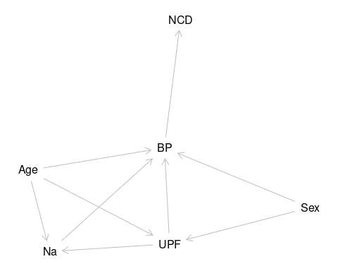Figure 9: diagram of the relationships explored by the analysis
diagram of the relationships explored by the analysis
Figure 9 shows the range of relationships explored by the paired regressions.
Simple linear regression equations look for the relationship between the outcome BP, and the independent exposure variable.
First Figure 10
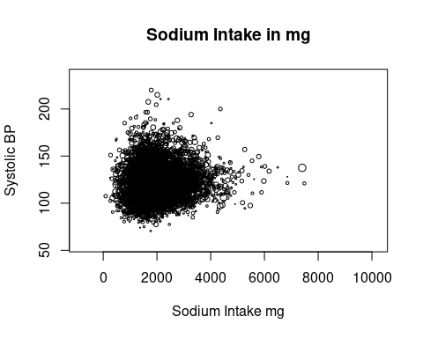Figure 10: Plot of BP by Na showing no visible directional relationship
Then Figure 11
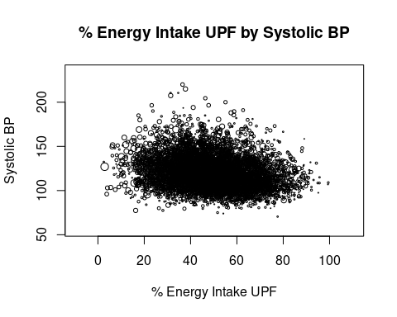Figure 11: Plot of BP by UPF showing limited directional relationship
and lastly (fig-UPF-and-Na-plot?)
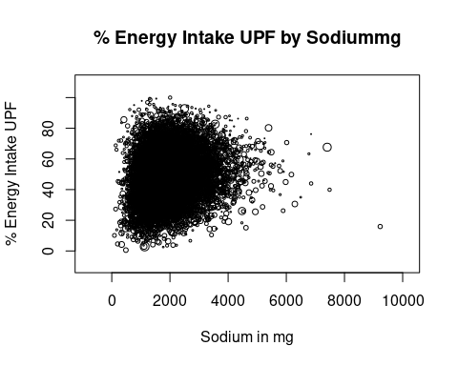Figure 12: Plot of UPF against Na to look for a relationship, but none is apparent from this plot
Simple plots of exposure against outcome appear to show limited correlation.
Table 9: Table of results of univariate GLM general linear regression models showing relationships between exposure and outcome variables. It identifies the absence of a relationship between BP and Na, as well as UPF and Na, the negative relationship between UPF and BP as well as UPF and Age, and finally the positive relationship between Age and BP, and Age and Na
Group | Characteristic | Beta | 95% CI¹ | p-value
BP/Na | Sodium (mg) diet only | 0.00 | 0.00, 0.00 | <0.001
UPF/Na | Sodium (mg) diet only | 0.00 | 0.00, 0.00 | <0.001
UPF/BP | UPF | -0.21 | -0.24, -0.17 | <0.001
UPF/Age | UPF | -0.46 | -0.49, -0.44 | <0.001
Age/BP | Age | 0.43 | 0.40, 0.45 | <0.001
Age/Na | Age | 0.75 | 0.08, 1.4 | 0.028
¹CI = Confidence Interval
The regression model for Sodium against BP shows that there is no linear relationship between Sodium and BP in this table Table 9. UPF compared to Na also shows a zero beta value indicating no linear relationship.
UPF does show a negative relationship with age, which is statistically significant. There is also a negative relationship with Age, again statistically significant.
Age has a relationship with BP with a statistically significant positive gradient. There is also a positive relationship with Na, which is also statistically significant to the 95% level.
Table 10: Table of univariate GLM models of linear regression of pairs of other variables used in the analysis. Showing a range of significant responses.
Group | Characteristic | Beta | 95% CI¹ | p-value
BP/bmi | (D) Valid BMI | 0.95 | 0.83, 1.1 | <0.001
BP/Agg1 | agegad1
 | 16-24 | — | —
 | 25-49 | 3.5 | 2.0, 4.9 | <0.001
 | 50-64 | 12 | 10, 14 | <0.001
 | 65+ years | 18 | 16, 20 | <0.001
BP/ed | educfinh
 | 1 | — | —
 | 2 | 15 | 6.8, 23 | <0.001
 | 3 | 21 | 17, 25 | <0.001
 | 4 | 16 | 14, 19 | <0.001
 | 5 | 8.8 | 6.4, 11 | <0.001
 | 6 | 9.7 | 6.8, 13 | <0.001
 | 7 | 7.4 | 4.9, 10 | <0.001
 | 8 | 6.7 | 4.5, 8.9 | <0.001
UPF/bmi | (D) Valid BMI | -0.26 | -0.31, -0.21 | <0.001
UPF/age | agegad1
 | 16-24 | — | —
 | 25-49 | -7.4 | -8.9, -6.0 | <0.001
 | 50-64 | -12 | -14, -11 | <0.001
 | 65+ years | -11 | -13, -9.7 | <0.001
UPF/ed | educfinh
 | 1 | — | —
 | 2 | -19 | -29, -8.4 | <0.001
 | 3 | -8.1 | -11, -5.2 | <0.001
 | 4 | -7.3 | -10, -4.6 | <0.001
 | 5 | -5.3 | -7.9, -2.8 | <0.001
 | 6 | -6.7 | -9.4, -3.9 | <0.001
 | 7 | -7.7 | -10, -5.0 | <0.001
 | 8 | -11 | -13, -8.3 | <0.001
Na/bmi | (D) Valid BMI | 15 | 13, 18 | <0.001
Na/Agg | agegad1
 | 16-24 | — | —
 | 25-49 | 27 | -60, 113 | 0.5
 | 50-64 | -169 | -254, -83 | <0.001
 | 65+ years | -322 | -406, -237 | <0.001
Na/ed | educfinh
 | 1 | — | —
 | 2 | -697 | -1,168, -226 | 0.004
 | 3 | -333 | -479, -187 | <0.001
 | 4 | -222 | -357, -87 | 0.001
 | 5 | -129 | -262, 4.5 | 0.058
 | 6 | -181 | -327, -36 | 0.014
 | 7 | -138 | -280, 5.0 | 0.059
 | 8 | -143 | -277, -8.5 | 0.037
¹CI = Confidence Interval
In conclusion the linear regression models in Table 9, and Table 10 show that there are correlations between the systolic BP and energy intake only. The next section will examine how this situation changes as variables interact in more complex models.

Complex Modelling using Multi variable regression
This section uses models of several variables to try to highlight the contributions of each variable. The complexity in these models is much less than that of reality. There are four sets of four models. The first a baseline model, the second and third introduce each variable separately, the final model includes all three.
The intention is to work towards an optimal model. This ideally mathematically describes the situation. In reality there may be a set of models with no single one predominating.
In particular the research question asks about the relationship between Sodium and UPF intake with BP. The models will reflect this question by looking to include or exclude particular variables. Comparisons between these models are then made using sensitivity analysis, identifying how sensitive the model is to sodium, or other factors

Regression on BP
Table 11: Table of a set (BP1) of beta values, confidence intervals, and p.values from Multivariate regression of variables against BP
 | No sodium or UPF |  |  | Sodium only |  |  | Epcnt only |  |  | Sodium and UPF
Characteristic | Beta | 95% CI¹ | p-value | Beta | 95% CI¹ | p-value | Beta | 95% CI¹ | p-value | Beta | 95% CI¹ | p-value
Sex
Male | — | — |  | — | — |  | — | — |  | — | —
Female | -6.6 | -8.0, -5.3 | <0.001 | -6.3 | -7.8, -4.9 | <0.001 | -6.7 | -8.0, -5.3 | <0.001 | -6.3 | -7.7, -4.9 | <0.001
(D) Valid BMI | 0.36 | 0.19, 0.54 | <0.001 | 0.36 | 0.19, 0.54 | <0.001 | 0.36 | 0.19, 0.54 | <0.001 | 0.36 | 0.19, 0.54 | <0.001
agegad2
16-18 | — | — |  | — | — |  | — | — |  | — | —
19-34 | 1.8 | -0.09, 3.6 | 0.062 | 1.7 | -0.20, 3.5 | 0.081 | 1.6 | -0.28, 3.5 | 0.095 | 1.4 | -0.47, 3.3 | 0.14
35-49 | 5.2 | 3.1, 7.2 | <0.001 | 5.2 | 3.1, 7.2 | <0.001 | 4.9 | 2.7, 7.0 | <0.001 | 4.8 | 2.6, 6.9 | <0.001
50-64 | 11 | 8.4, 13 | <0.001 | 11 | 8.4, 13 | <0.001 | 10 | 7.8, 13 | <0.001 | 10 | 7.8, 13 | <0.001
65+ years | 18 | 15, 20 | <0.001 | 18 | 15, 21 | <0.001 | 17 | 14, 20 | <0.001 | 17 | 14, 20 | <0.001
educfinh
1 | — | — |  | — | — |  | — | — |  | — | —
2 | 4.8 | -1.9, 12 | 0.2 | 5.1 | -1.4, 12 | 0.13 | 4.5 | -2.3, 11 | 0.2 | 4.7 | -1.9, 11 | 0.2
3 | 6.2 | 1.1, 11 | 0.017 | 6.3 | 1.3, 11 | 0.014 | 6.2 | 1.1, 11 | 0.017 | 6.3 | 1.3, 11 | 0.014
4 | 2.3 | -1.2, 5.9 | 0.2 | 2.4 | -1.2, 5.9 | 0.2 | 2.3 | -1.2, 5.9 | 0.2 | 2.4 | -1.2, 5.9 | 0.2
5 | 0.81 | -2.0, 3.6 | 0.6 | 0.84 | -2.0, 3.6 | 0.6 | 0.76 | -2.1, 3.6 | 0.6 | 0.77 | -2.0, 3.6 | 0.6
6 | 0.99 | -2.5, 4.5 | 0.6 | 1.1 | -2.4, 4.6 | 0.6 | 0.90 | -2.6, 4.4 | 0.6 | 0.95 | -2.6, 4.5 | 0.6
7 | 2.2 | -0.77, 5.2 | 0.15 | 2.2 | -0.78, 5.2 | 0.15 | 2.1 | -0.91, 5.1 | 0.2 | 2.0 | -0.96, 5.0 | 0.2
8 | 0.34 | -2.4, 3.1 | 0.8 | 0.37 | -2.3, 3.1 | 0.8 | 0.14 | -2.6, 2.9 | >0.9 | 0.12 | -2.6, 2.9 | >0.9
EIMD_2010_quintile
1 | — | — |  | — | — |  | — | — |  | — | —
2 | 0.30 | -1.7, 2.3 | 0.8 | 0.29 | -1.7, 2.3 | 0.8 | 0.29 | -1.7, 2.3 | 0.8 | 0.27 | -1.7, 2.3 | 0.8
3 | 0.49 | -1.6, 2.6 | 0.6 | 0.42 | -1.7, 2.5 | 0.7 | 0.49 | -1.6, 2.6 | 0.6 | 0.41 | -1.7, 2.5 | 0.7
4 | 0.24 | -2.1, 2.6 | 0.8 | 0.24 | -2.1, 2.6 | 0.8 | 0.26 | -2.1, 2.6 | 0.8 | 0.25 | -2.1, 2.6 | 0.8
5 | -0.34 | -2.5, 1.8 | 0.8 | -0.33 | -2.5, 1.8 | 0.8 | -0.30 | -2.5, 1.9 | 0.8 | -0.27 | -2.4, 1.9 | 0.8
Sodium (mg) diet only |  |  |  | 0.00 | 0.00, 0.00 | 0.3 |  |  |  | 0.00 | 0.00, 0.00 | 0.2
Epcnt_4 |  |  |  |  |  |  | -0.02 | -0.07, 0.02 | 0.3 | -0.03 | -0.08, 0.01 | 0.2
¹CI = Confidence Interval
This first set of models are in Table 11 and look at what happens when regression against BP is used.
The first model, labelled “No sodium or UPF” of this set looks at the relationships between BP and some of the background variables (Age and Sex, education and IMD) all of which may have an effect on BP. This model excludes UPF and Na.
The second model, “Sodium Only”, shows that sodium has a zero beta coefficient, but that this is not statistically significant. It also shows minimal effects on the other variables in the model.
The model, “UPF only”, is in the third set of columns. Here there is a negative beta coefficient, but the confidence intervals cross one. This indicates that the effect is statistically uncertain. Again there are minimal effects on the other variables.
The last set of columns, “Sodium and UPF”, shows that when combined there is still little effect identified statistically, on each other or on the other variables.

simple set Regression on BP
Table 12: Table of a set (BP) of beta values, confidence intervals, and p.values from Multivariate regression of variables against BP
 | Sodium only |  |  | UPF only |  |  | Sodium and UPF
Characteristic | Beta | 95% CI¹ | p-value | Beta | 95% CI¹ | p-value | Beta | 95% CI¹ | p-value
Sodium (mg) diet only | 0.00 | 0.00, 0.00 | <0.001 |  |  |  | 0.00 | 0.00, 0.00 | <0.001
agegad2
16-18 | — | — |  | — | — |  | — | —
19-34 | 2.6 | 1.1, 4.1 | <0.001 | 3.0 | 1.4, 4.5 | <0.001 | 2.4 | 0.91, 3.9 | 0.002
35-49 | 6.7 | 5.2, 8.2 | <0.001 | 6.8 | 5.2, 8.4 | <0.001 | 6.5 | 4.9, 8.0 | <0.001
50-64 | 14 | 12, 16 | <0.001 | 14 | 12, 16 | <0.001 | 14 | 12, 16 | <0.001
65+ years | 20 | 18, 22 | <0.001 | 20 | 18, 22 | <0.001 | 20 | 18, 22 | <0.001
Epcnt_4 |  |  |  | 0.01 | -0.03, 0.05 | 0.7 | -0.02 | -0.06, 0.02 | 0.4
¹CI = Confidence Interval
This set of regression Table 12 follows the pattern but omits the baseline as those variables are all excluded.

Regression on Na
Table 13: Table of a set (Na) of beta values, confidence intervals, and p.values from Multivariate regression of variables against BNa
 | No bp or UPF |  |  | BP only |  |  | Epcnt only |  |  | BP and UPF
Characteristic | Beta | 95% CI¹ | p-value | Beta | 95% CI¹ | p-value | Beta | 95% CI¹ | p-value | Beta | 95% CI¹ | p-value
Sex
Male | — | — |  | — | — |  | — | — |  | — | —
Female | -558 | -613, -502 | <0.001 | -570 | -637, -503 | <0.001 | -537 | -591, -483 | <0.001 | -550 | -615, -486 | <0.001
(D) Valid BMI | 3.1 | -1.1, 7.3 | 0.15 | 1.1 | -5.1, 7.2 | 0.7 | 2.4 | -1.7, 6.5 | 0.3 | -0.15 | -6.2, 5.9 | >0.9
agegad2
16-18 | — | — |  | — | — |  | — | — |  | — | —
19-34 | 190 | 85, 294 | <0.001 | 196 | 52, 340 | 0.008 | 270 | 165, 376 | <0.001 | 275 | 128, 422 | <0.001
35-49 | 25 | -77, 128 | 0.6 | 7.8 | -131, 147 | >0.9 | 162 | 59, 265 | 0.002 | 141 | 2.2, 279 | 0.047
50-64 | -110 | -211, -8.5 | 0.034 | -104 | -240, 31 | 0.13 | 72 | -32, 176 | 0.2 | 75 | -66, 216 | 0.3
65+ years | -224 | -326, -122 | <0.001 | -214 | -364, -63 | 0.005 | -38 | -145, 69 | 0.5 | -28 | -182, 127 | 0.7
educfinh
1 | — | — |  | — | — |  | — | — |  | — | —
2 | -574 | -1,089, -60 | 0.029 | -571 | -1,130, -12 | 0.045 | -459 | -921, 3.6 | 0.052 | -416 | -878, 46 | 0.078
3 | -84 | -274, 106 | 0.4 | -220 | -477, 38 | 0.094 | -121 | -305, 63 | 0.2 | -208 | -462, 47 | 0.11
4 | -0.29 | -165, 165 | >0.9 | -33 | -249, 182 | 0.8 | -34 | -191, 124 | 0.7 | -31 | -236, 173 | 0.8
5 | 13 | -146, 172 | 0.9 | -43 | -245, 159 | 0.7 | -1.0 | -153, 151 | >0.9 | -20 | -213, 173 | 0.8
6 | -14 | -187, 159 | 0.9 | -127 | -361, 108 | 0.3 | -26 | -192, 140 | 0.8 | -87 | -308, 135 | 0.4
7 | 28 | -139, 194 | 0.7 | 12 | -198, 222 | >0.9 | 38 | -120, 196 | 0.6 | 65 | -135, 265 | 0.5
8 | -21 | -182, 140 | 0.8 | -58 | -272, 156 | 0.6 | 22 | -131, 175 | 0.8 | 29 | -176, 234 | 0.8
EIMD_2010_quintile
1 | — | — |  | — | — |  | — | — |  | — | —
2 | 0.72 | -68, 70 | >0.9 | 17 | -69, 103 | 0.7 | 3.9 | -65, 73 | >0.9 | 21 | -64, 105 | 0.6
3 | 71 | -13, 156 | 0.10 | 119 | 21, 217 | 0.017 | 71 | -13, 154 | 0.10 | 119 | 22, 216 | 0.017
4 | 22 | -56, 100 | 0.6 | 6.0 | -96, 107 | >0.9 | 6.6 | -69, 82 | 0.9 | -0.29 | -100, 100 | >0.9
5 | -39 | -131, 53 | 0.4 | -19 | -152, 113 | 0.8 | -57 | -148, 35 | 0.2 | -38 | -171, 96 | 0.6
(D) Omron valid mean systolic BP |  |  |  | 1.3 | -1.1, 3.7 | 0.3 |  |  |  | 1.6 | -0.73, 3.8 | 0.2
Epcnt_4 |  |  |  |  |  |  | 10 | 8.4, 13 | <0.001 | 11 | 8.3, 14 | <0.001
¹CI = Confidence Interval
This set of models Table 13 follows the established pattern. Baseline, add variable one to baseline, add add variable two to baseline, and both variables.
This time variable one is BP, and variable two is UPF.
The baseline regression shows some changes from the previous baseline. The sex coefficent is still statistically significant. The bmi coefficient is not. The age pattern shows an increase in the second age group, but then clear reduction in subsequent ones . That with education and IMD is similar.
Introducing BP doesn’t change the structure of the beta values, or the statistical significance, There is clearly a strong effect of BP on the nature of the regressions. This is shown again when BP and UPF are included.
UPF now has a clear positive effect on the Na intake. When BP is included, despite its effect not being statistically significant, the model drops its AIC value again.

Regression on UPF
Table 14: Table of a set (UPF) of beta values, confidence intervals, and p.values from Multivariate regression of variables against UPF
 | No BP or Na |  |  | BP only |  |  | Na only |  |  | Na and BP
Characteristic | Beta | 95% CI¹ | p-value | Beta | 95% CI¹ | p-value | Beta | 95% CI¹ | p-value | Beta | 95% CI¹ | p-value
Sex
Male | — | — |  | — | — |  | — | — |  | — | —
Female | -2.0 | -3.0, -1.0 | <0.001 | -1.8 | -3.0, -0.55 | 0.005 | -0.02 | -1.1, 1.0 | >0.9 | 0.39 | -0.98, 1.8 | 0.6
(D) Valid BMI | 0.07 | 0.00, 0.14 | 0.056 | 0.11 | 0.01, 0.21 | 0.029 | 0.06 | -0.01, 0.13 | 0.10 | 0.11 | 0.01, 0.20 | 0.030
agegad2
16-18 | — | — |  | — | — |  | — | — |  | — | —
19-34 | -7.7 | -9.7, -5.6 | <0.001 | -7.2 | -9.8, -4.5 | <0.001 | -8.3 | -10, -6.3 | <0.001 | -7.9 | -11, -5.3 | <0.001
35-49 | -13 | -15, -11 | <0.001 | -12 | -15, -9.5 | <0.001 | -13 | -15, -11 | <0.001 | -12 | -15, -9.6 | <0.001
50-64 | -17 | -19, -15 | <0.001 | -16 | -19, -14 | <0.001 | -17 | -19, -15 | <0.001 | -16 | -18, -13 | <0.001
65+ years | -18 | -20, -16 | <0.001 | -17 | -20, -14 | <0.001 | -17 | -19, -15 | <0.001 | -16 | -19, -13 | <0.001
educfinh
1 | — | — |  | — | — |  | — | — |  | — | —
2 | -11 | -21, -0.91 | 0.033 | -14 | -27, -0.84 | 0.037 | -9.0 | -18, 0.20 | 0.055 | -12 | -24, -0.13 | 0.047
3 | 3.6 | -0.38, 7.5 | 0.076 | -1.1 | -6.3, 4.1 | 0.7 | 3.8 | 0.03, 7.7 | 0.048 | -0.26 | -5.4, 4.8 | >0.9
4 | 3.2 | -0.22, 6.6 | 0.067 | -0.18 | -4.3, 4.0 | >0.9 | 3.2 | -0.08, 6.4 | 0.056 | -0.06 | -4.0, 3.9 | >0.9
5 | 1.3 | -1.9, 4.5 | 0.4 | -2.1 | -5.9, 1.8 | 0.3 | 1.3 | -1.8, 4.4 | 0.4 | -1.9 | -5.6, 1.8 | 0.3
6 | 1.1 | -2.4, 4.6 | 0.5 | -3.6 | -7.9, 0.59 | 0.091 | 1.2 | -2.2, 4.5 | 0.5 | -3.2 | -7.1, 0.82 | 0.12
7 | -0.96 | -4.3, 2.4 | 0.6 | -4.8 | -8.8, -0.82 | 0.018 | -1.1 | -4.3, 2.1 | 0.5 | -4.8 | -8.6, -1.1 | 0.012
8 | -4.1 | -7.4, -0.84 | 0.014 | -7.9 | -12, -3.9 | <0.001 | -4.0 | -7.2, -0.92 | 0.011 | -7.6 | -11, -3.9 | <0.001
EIMD_2010_quintile
1 | — | — |  | — | — |  | — | — |  | — | —
2 | -0.30 | -1.6, 0.97 | 0.6 | -0.33 | -1.9, 1.3 | 0.7 | -0.31 | -1.6, 0.98 | 0.6 | -0.40 | -2.0, 1.2 | 0.6
3 | 0.07 | -1.3, 1.5 | >0.9 | 0.00 | -1.9, 1.9 | >0.9 | -0.18 | -1.6, 1.2 | 0.8 | -0.46 | -2.3, 1.4 | 0.6
4 | 1.5 | -0.04, 3.0 | 0.057 | 0.57 | -1.4, 2.5 | 0.6 | 1.4 | -0.07, 2.8 | 0.063 | 0.55 | -1.3, 2.4 | 0.6
5 | 1.7 | 0.15, 3.2 | 0.032 | 1.7 | -0.38, 3.7 | 0.11 | 1.8 | 0.28, 3.4 | 0.020 | 1.7 | -0.36, 3.8 | 0.10
(D) Omron valid mean systolic BP |  |  |  | -0.02 | -0.06, 0.02 | 0.3 |  |  |  | -0.03 | -0.06, 0.01 | 0.2
Sodium (mg) diet only |  |  |  |  |  |  | 0.00 | 0.00, 0.00 | <0.001 | 0.00 | 0.00, 0.00 | <0.001
¹CI = Confidence Interval
This fourth set of models Table 14 regresses on UPF intake. Variable one is BP, and variable two is sodium (Na).
Again the baseline differs from that regressed on BP with the bmi in particular affected. There is also a stronger effect relating to age. All age categories are statistically different to the reference, previously only the older ones have been.
BP and Na are not statistically significant independently or together in themselves. However together they affect reduce the sex difference to loose statistical significance.
On its own introducing BP affects the effect of bmi.

Table 15: Table of AIC values for each model in each of the four sets
Model | AIC
BP1:No sodium or UPF | 21,982.14
BP1:Sodium only | 21,982.31
BP1:Epcnt only | 21,982.75
BP1:Sodium and UPF | 21,982.10
BP:Sodium only | 44,383.55
BP:UPF only | 44,442.17
BP:Sodium and UPF | 44,384.23
Na:No bp or UPF | 75,042.64
Na:bp only | 42,457.62
Na:UPF only | 74,872.48
Na:bp and UPF | 42,347.00
UPF:No BP or Na | 38,183.62
UPF:BP only | 21,623.66
UPF:Na only | 38,013.45
UPF:BP and Na | 21,513.04

The AIC values Table 15 in models with BP are the lowest of all the models presented. This identifies the regression against UPF including Na and BP as the best model. This also identifies the model regressed against Na without BP or UPF as the least good model for the dataset.

The difference between the two values as a proportion of the larger is 71.3322424 %. There is a significant sensitivity of the data set to improved modelling. Though the set of models around the same values includes the four regressed against BP, and two of those against UPF which include BP.

Summary of Results
Table 1 Shows the population counts for key variables.
Table 2 with means for the key variables across the dataset showing a reduction across the cohorts. This is less evident in the plots, but the statistical analysis of the key variables shows the reduction.
Table 3 and Table 4 show the other variables analysed and show that there has been change in the balance of the populations.
Analysis by Sex shows that female sex always reduces BP. When analysed by age, UPF reduces, BP increases, as does Na though with a more complex relationship. Analysis by place shows that most areas are similar, but with London as an outlier.
Paired regression,Table 9, shows that sodium intake has no relationship with BP or UPF with Na. It shows that UPF intake decreases with age, and UPF decreases with BP. It also shows that the change of BP with age and with Na are positive
The sets of models of multivariable regressions show that the model regressed on UPF including Na and BP has the lowest AIC. The highest AIC statistic is for the model regressed against Na without BP or UPF.

