**Step 1: Configure your Pi**

Link : <http://docs.aws.amazon.com/iot/latest/developerguide/iot-device-sdk-node.html>

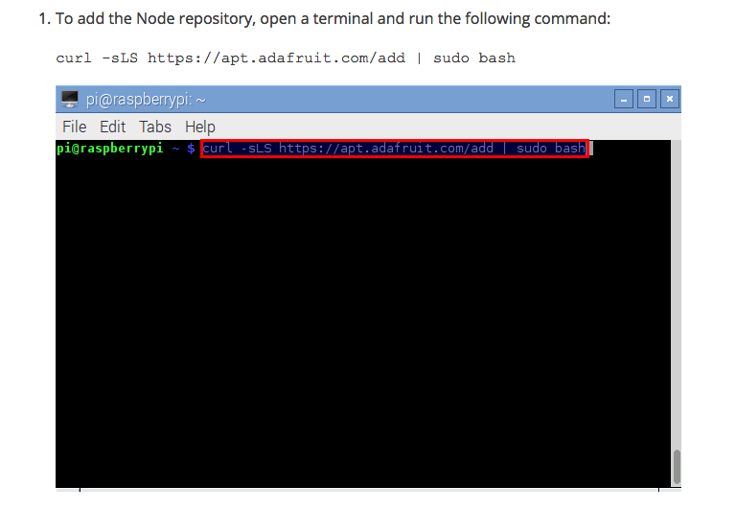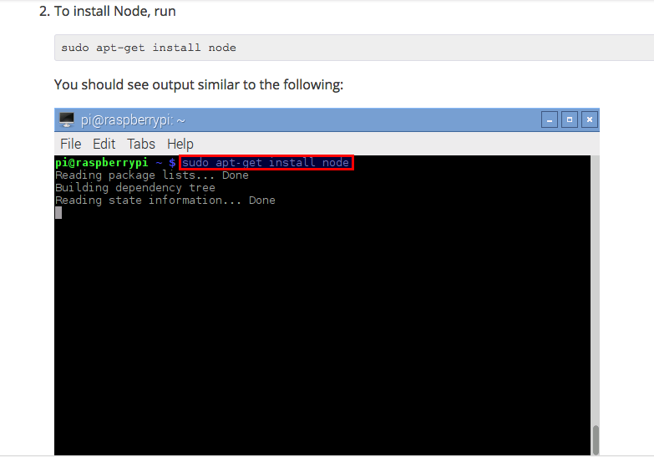

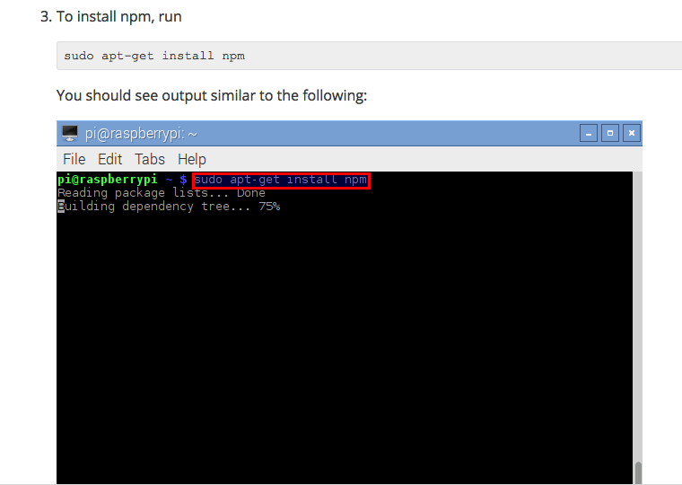

**Step 2: Create an AWS-IoT’s Account**

🡪 https://console.aws.amazon.com/console/home

**Step 3: Create a thing and test connection**

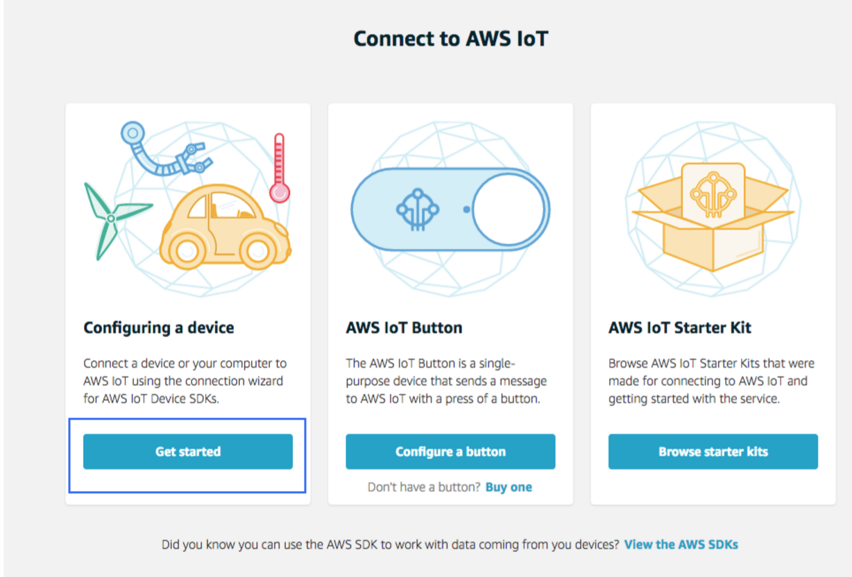

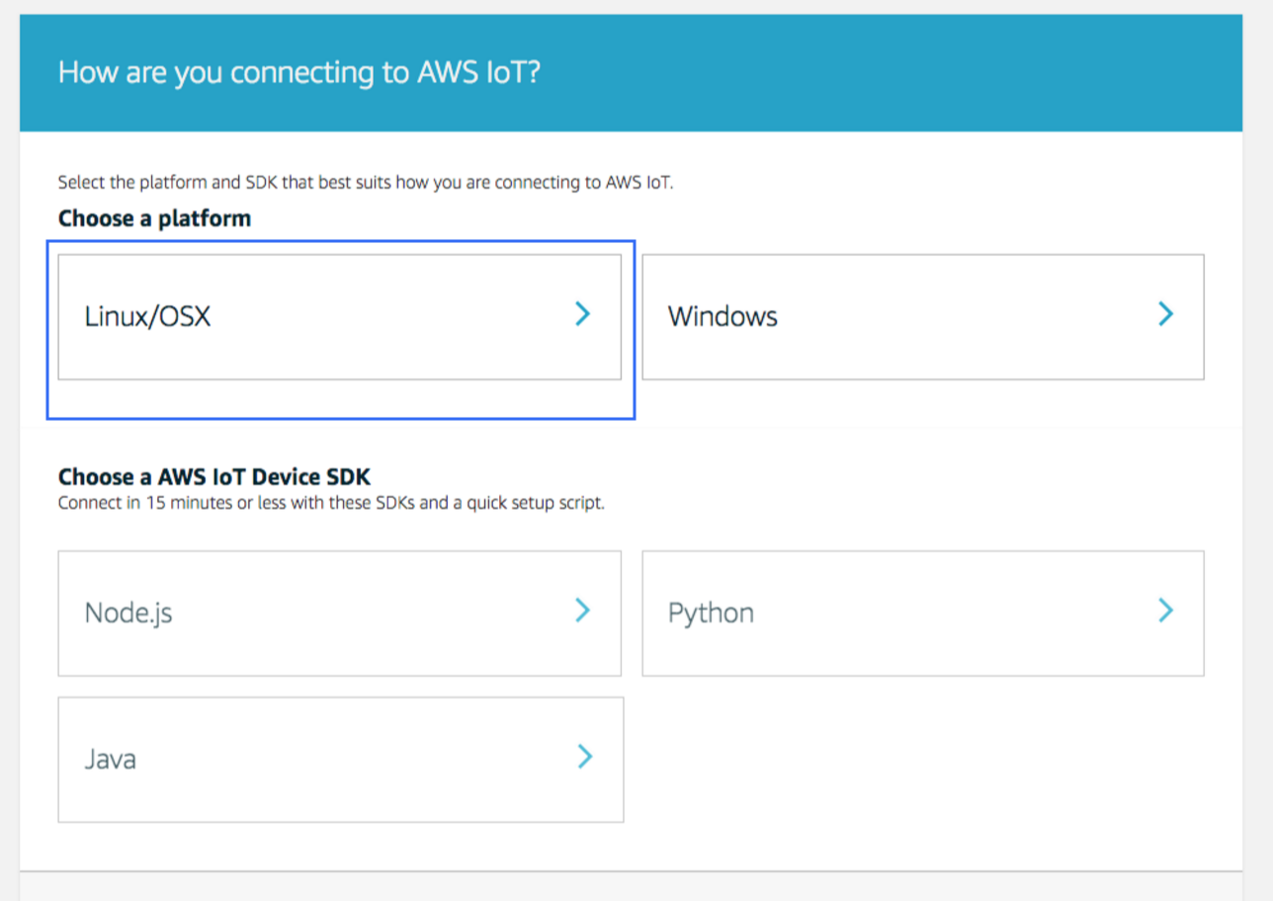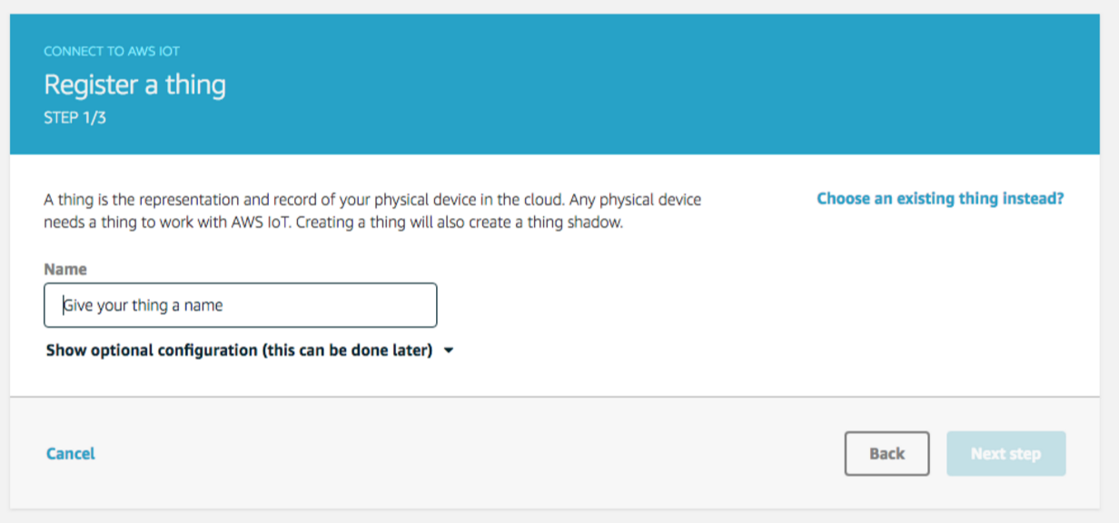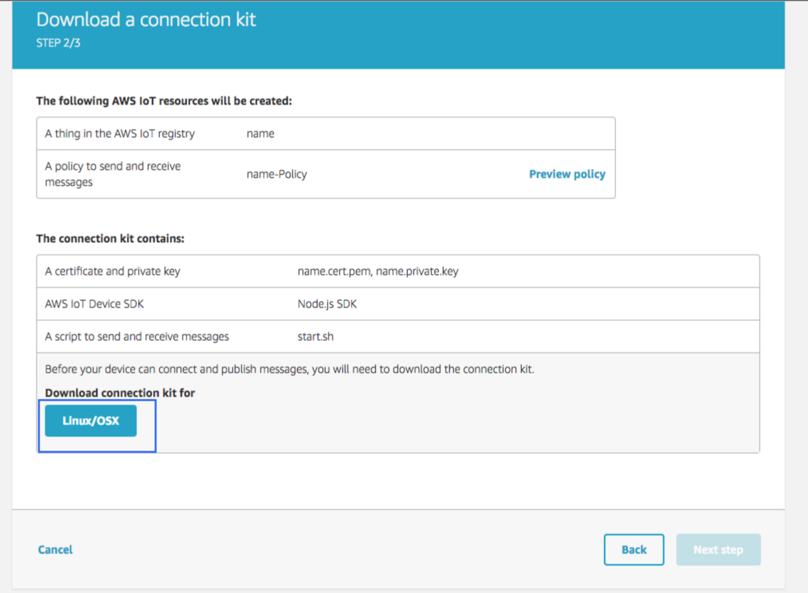

**Step 3: Working with wiring-pi**

Link: <https://www.npmjs.com/package/wiring-pi>

OR: <https://github.com/WiringPi/WiringPi-Node>

1. Install
   1. ***$-sudo npm install wiring-pi***
2. Test blink an LED
   1. Wiring-Pi pinout diragram on raspberry-pi

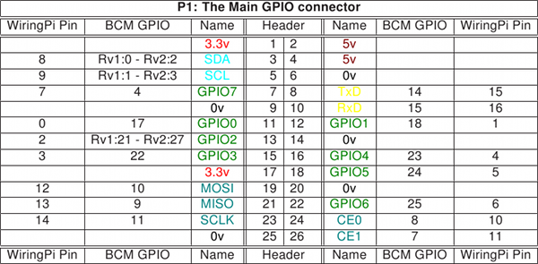

* 1. Create a blinkled node js
     1. **$-nano blinkled.js**

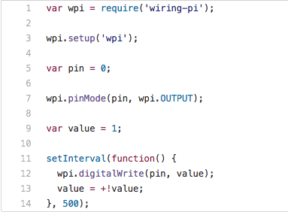

* + 1. ***$-sudo node blinkled.js***

You will see the light blinking !!

**Step 4: Put it all together**

