1. СУТЬ ИГРЫ

**«Pusher»** - логическая игра-головоломка, в которой игрок передвигает ящики по лабиринту, показанному в виде плана, с целью поставить все ящики на заданные конечные позиции. Только один ящик может быть передвинут за раз, причём герой игры - «кладовщик» - может только толкать ящики.

1. ОПИСАНИЕ ГРАФИЧЕСКОЙ ЧАСТИ

Каждый уровень игры представлен в отдельной форме. Каждый уровень содержит следующие объекты: персонаж, двигающий коробки, одна или более коробок, стены, метки, на которые необходимо переместить коробки. Все данные объекты представлены с помощью элементов PictureBox.

Первый уровень создан с помощью создания формы Lvl1. На рис.1 представлен пример первого уровня.

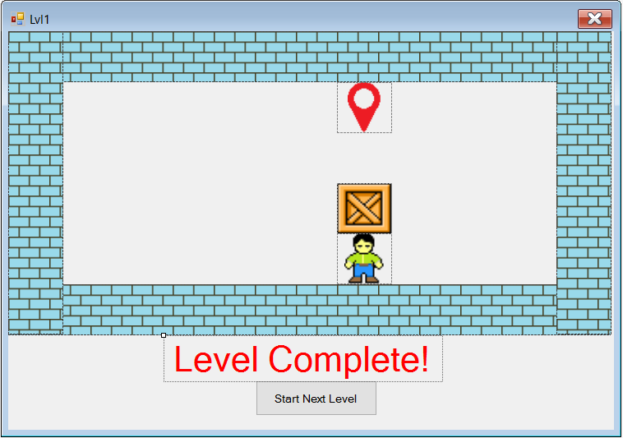

Рис.1

В данном примере на первом уровне: 1 коробка, 1 метка, 4 стенки и персонаж. Для определения их внешнего вида использованы следующие атрибуты: BackColor, Image, SizeMode, BackgroundImageLayout, BackgroundImage.

Например, для объекта метки, использовалась картинка с прозрачным фоном,

из-за чего пришлось установить BackColor. Для сохранения отношения сторон картинки был выбран SizeMode = Zoom. Чтобы замостить выбранной картинкой всю область объекта, необходимо для атрибута BackgroundImage выбрать соответствующую картинку, a для BackgroundImageLayout установить параметр Tile, что, например, было сделано с объектом стенки.

Атрибуты объектов метки, коробки и персонажа одинаковы, кроме картинки в атрибуте Image (рис.2). Для объекта стенки установление картинки происходит через атрибут BackgroundImage, и присвоение атрибуту BackgroundImageLayout значение Tile (рис.3).

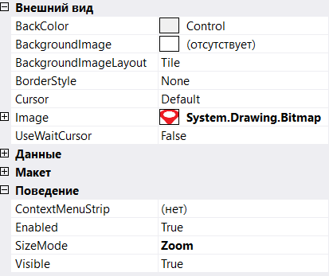

Рис.2

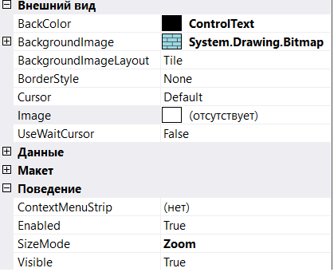

Рис.3

Помимо перечисленных объектов в самом начале, в форме также присутствуют объекты label1 типа label и button1 типа button.

Label1 нужна для того, чтобы оповестить пользователя, что пройден уровень или игра. Для определения графических свойств объекта label1 использованы атрибуты Font, ForeColor, Text. Для установления шрифта, размера и наклона надписи, выбирается интересующий параметр в атрибуте Font, цвет надписи зависит от ForeColor, текст надписи записан в атрибуте Text. На рис.4 представлены параметры атрибутов объекта label1.

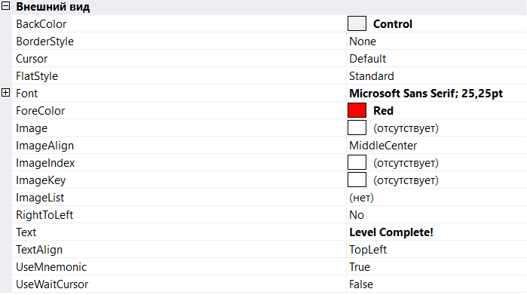

Рис.4

Button1 служит для того, чтобы перейти на следующий уровень. Для объекта button1 использован атрибут Text (рис.5).

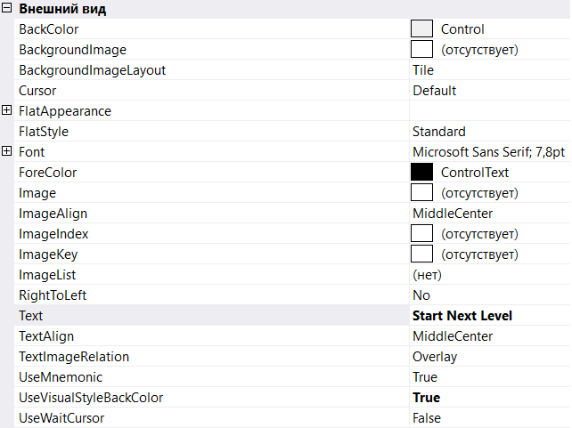

Рис.5

1. ОПИСАНИЕ ИНТЕРАКТИВНОЙ ЧАСТИ

Управление в игре осуществлено с помощью нажатий клавиш-стрелок. Чтобы форма реагировала на нажатие клавиши, во вкладке Events формы был создан обработчик события KeyDown. Для его создания нужно нажать 2 раза по пустому окошку рядом с событием KeyDown, автоматически создастся обработчик этого события, в который нужно будет вставить нужные нам команды:

private: System::Void Lvl3_KeyDown(System::Object^ sender, System::Windows::Forms::KeyEventArgs^ e) {}

При движении персонажа необходимо проверять стоит ли на его пути стена. Для этого создана функция CheckBorderRight, в которой проверяется, не стоит ли стена справа. В эту функция передается объект, который движется, и стенку, с которой сравнивается его местоположение.

System::Boolean CheckBorderRight(System::Windows::Forms::PictureBox^ moving, System::Windows::Forms::PictureBox^ border)

{

if (moving->Location.X + moving->Size.Width == border->Location.X)

{

if ((border->Location.Y <= moving->Location.Y)&(border->Location.Y + border->Size.Height >= moving->Location.Y + moving->Size.Height))

return false;

else return true;

}

else return true;

}

Т.к. на каждом уровне находится более 1 стены, то при проверке возможности движения персонажа вправо нужно вызывать эту функцию для каждой конкретной стены. Для этого создана функция CheckMoveRight, в которую передается движущейся объект, и в ней делается проверка для каждой стены.

System::Boolean CheckMoveRight(System::Windows::Forms::PictureBox^ moving)

{

if (CheckBorderRight(moving, pictureBox1))

{

if (CheckBorderRight(moving, pictureBox2))

{

if (CheckBorderRight(moving, pictureBox3))

{

if (CheckBorderRight(moving, pictureBox4)) return true;

else return false;

}

else return false;

}

else return false;

}

else return false;

}

Аналогично созданы функции CheckBorderUp, CheckBorderDown, CheckBorderLeft, в которых проверяется, не стоит ли стена сверху, внизу, слева персонажа соответственно и CheckMoveUp, CheckMoveDown, CheckMoveLeft в которых проверяется, возможно ли движение персонажа вверх, вниз и влево соответственно.

Чтобы определить, стоит ли коробка на пути персонажа, при его движении вправо, создана функция IsOnRigth, в которую передается движущейся объект и коробка:

System::Boolean IsOnRight(System::Windows::Forms::PictureBox^ first, System::Windows::Forms::PictureBox^ second)

{

if (first->Location.X + first->Size.Width == second->Location.X)

{

if (first->Location.Y == second->Location.Y)

{

return true;

}

else return false;

}

else return false;

}

Тем же способом созданы функции IsOnUp, IsOnDown, IsOnLeft, в которых проверяется стоит ли коробка сверху, снизу, слева движущегося объекта соответственно.

Функция Move1 создает и возвращает новые координаты движущегося объекта:

System::Drawing::Point Move1(System::Windows::Forms::PictureBox^ moving, char c)

{

System::Drawing::Point Point;

switch (c)

{

case 'r':

{

Point = System::Drawing::Point(moving->Location.X + moving->Size.Width, moving->Location.Y);

return Point;

}

case 'l':

{

Point = System::Drawing::Point(moving->Location.X - moving->Size.Width, moving->Location.Y);

return Point;

}

case 'u':

{

Point = System::Drawing::Point(moving->Location.X, moving->Location.Y - moving->Size.Height);

return Point;

}

case 'd':

{

Point = System::Drawing::Point(moving->Location.X, moving->Location.Y + moving->Size.Height);

return Point;

}

}

}

Уровень завершается, когда все коробки располагаются на метках. Для того, чтобы определить стоит ли коробка на метке, создана функция CheckOnMark, в которую передается коробка и метка:

System::Boolean CheckOnMark(System::Windows::Forms::PictureBox^ first, System::Windows::Forms::PictureBox^ second)

{

if ((first->Location.X == second->Location.X)& (first->Location.Y == second->Location.Y)) return true;

else return false;

}

Когда все коробки будут находится на метках, button1 и label1 станут видимыми (в начале работы они невидимы):

if (CheckOnMark(Box1, Mark1))

{

button1->Visible = true;

label1->Visible = true;

}

Чтобы запустить уровень заново, нужно установить клавишу, при нажатии которой персонаж и коробки переходили бы в свое начальное положение (в примере данной клавишей является R):

if (e->KeyCode == Keys::R)

{

Box1->Location = System::Drawing::Point(300, 150);

Man1->Location = System::Drawing::Point(300, 200);

}

Для данного примера обработчик события KeyDown имеет следующий вид:

System::Void Lvl1_KeyDown(System::Object^ sender, System::Windows::Forms::KeyEventArgs^ e)

{

if (e->KeyCode == Keys::Right)

{

if (CheckMoveRight(Man1))

{

if (IsOnRight(Man1, Box1))

{

if (CheckMoveRight(Box1))

{

Box1->Location = System::Drawing::Point(Move1(Box1, 'r'));

Man1->Location = System::Drawing::Point(Move1(Man1, 'r'));

}

}

else Man1->Location = System::Drawing::Point(Move1(Man1, 'r'));

}

}

else if (e->KeyCode == Keys::Left)

{

if (CheckMoveLeft(Man1))

{

if (IsOnLeft(Man1, Box1))

{

if (CheckMoveLeft(Box1))

{

Box1->Location = System::Drawing::Point(Move1(Box1, 'l'));

Man1->Location = System::Drawing::Point(Move1(Man1, 'l'));

}

}

else Man1->Location = System::Drawing::Point(Move1(Man1, 'l'));

}

}

else if (e->KeyCode == Keys::Up)

{

if (CheckMoveUp(Man1))

{

if (IsOnUp(Man1, Box1))

{

if (CheckMoveUp(Box1))

{

Box1->Location = System::Drawing::Point(Move1(Box1, 'u'));

Man1->Location = System::Drawing::Point(Move1(Man1, 'u'));

}

}

else Man1->Location = System::Drawing::Point(Move1(Man1, 'u'));

}

}

else if (e->KeyCode == Keys::Down)

{

if (CheckMoveDown(Man1))

{

if (IsOnDown(Man1, Box1))

{

if (CheckMoveDown(Box1))

{

Box1->Location = System::Drawing::Point(Move1(Box1, 'd'));

Man1->Location = System::Drawing::Point(Move1(Man1, 'd'));

}

}

else Man1->Location = System::Drawing::Point(Move1(Man1, 'd'));

}

}

else if (e->KeyCode == Keys::R)

{

Box1->Location = System::Drawing::Point(300, 150);

Man1->Location = System::Drawing::Point(300, 200);

}

if (CheckOnMark(Box1, Mark1))

{

button1->Visible = true;

label1->Visible = true;

}

}

Чтобы перейти на следующий уровень, создана форма Lvl2. При ее объявлении указывается «родитель» этой формы, т.е. форма будет создана при определенных действиях в форме Lvl1.

public:

Lvl2(Lvl1^ parent)

{

InitializeComponent();

parentForm = parent;

}

private: Lvl1^ parentForm;

Чтобы форма с новым уровнем создавалась при клике мышки на кнопку button1, в форме Lvl1, в файле Lvl1.h только объявлен обработчик события, а определение его помещено в файл Lvl1.cpp. Таким же образом создан Lvl3, вызывающийся из Lvl2 и Lvl4, вызывающийся из Lvl3.

Файл Lvl1.cpp выглядит следующим образом.

#include "Lvl1.h"

#include "Lvl2.h"

#include "Lvl3.h"

#include "Lvl4.h"

#include "Header.h"

using namespace System;

using namespace System::Windows::Forms;

namespace Pusher

{

System::Void Lvl1::button1_Click(System::Object^ sender, System::EventArgs^ e)

{

Lvl2^ f2 = gcnew Lvl2(this);

f2->Show();

this->Hide();

}

System::Void Lvl2::button1_Click(System::Object^ sender, System::EventArgs^ e)

{

Lvl3^ f3 = gcnew Lvl3(this);

f3->Show();

this->Hide();

}

System::Void Lvl3::button1_Click(System::Object^ sender, System::EventArgs^ e)

{

Lvl4^ f4 = gcnew Lvl4(this);

f4->Show();

this->Hide();

}

}

[STAThread]

void main()

{

Application::EnableVisualStyles();

Application::SetCompatibleTextRenderingDefault(false);

Pusher::Lvl1 form;

Application::Run(%form);

}

1. КОНТРОЛЬНЫЕ ПРИМЕРЫ

На рис. 6-13 представлены результаты работы программы.

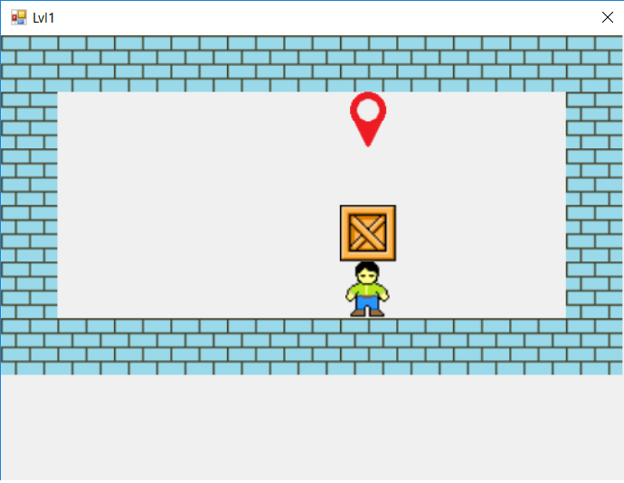

Рис.6

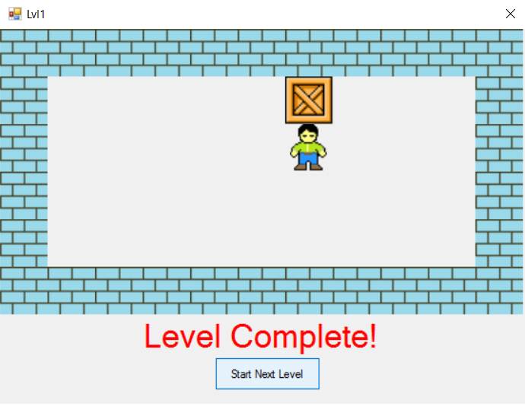

Рис.7

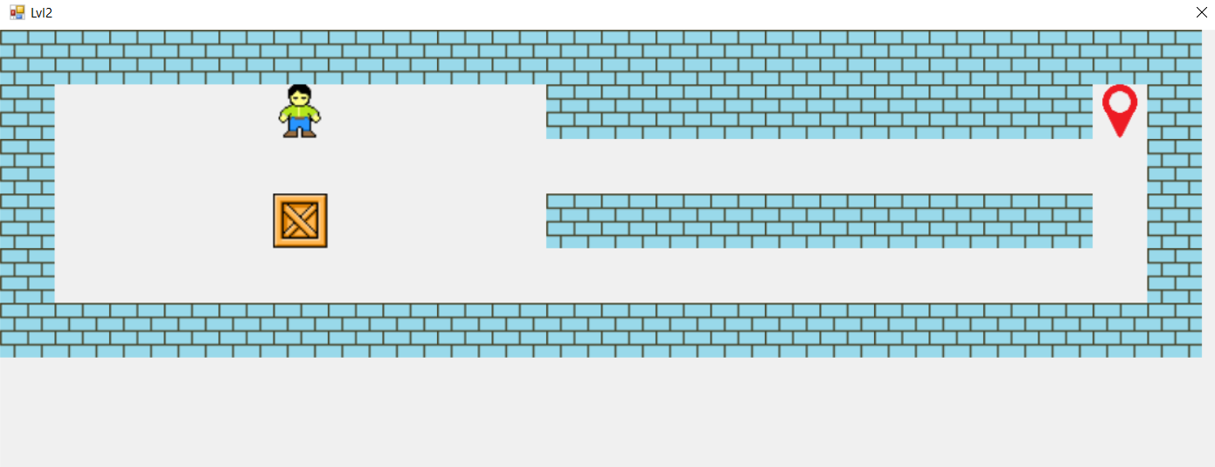

Рис.8

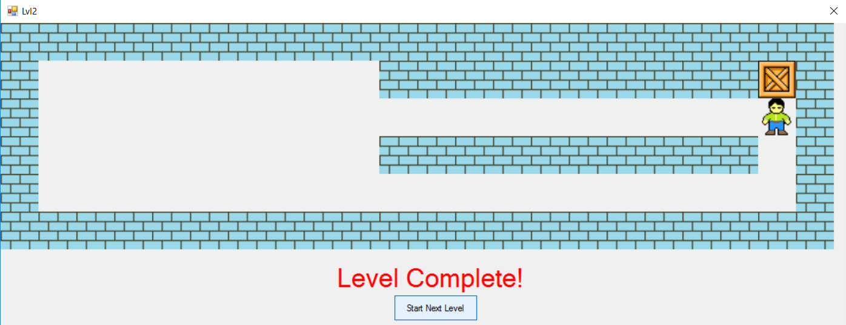

Рис.9

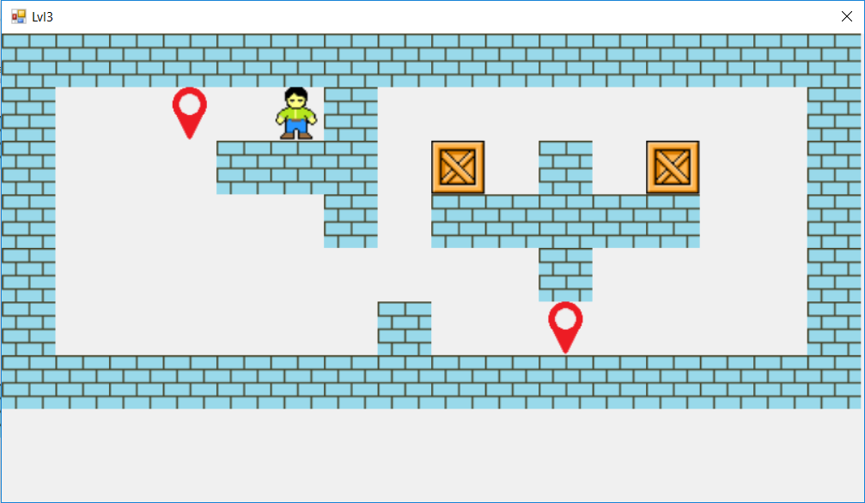

Рис.10

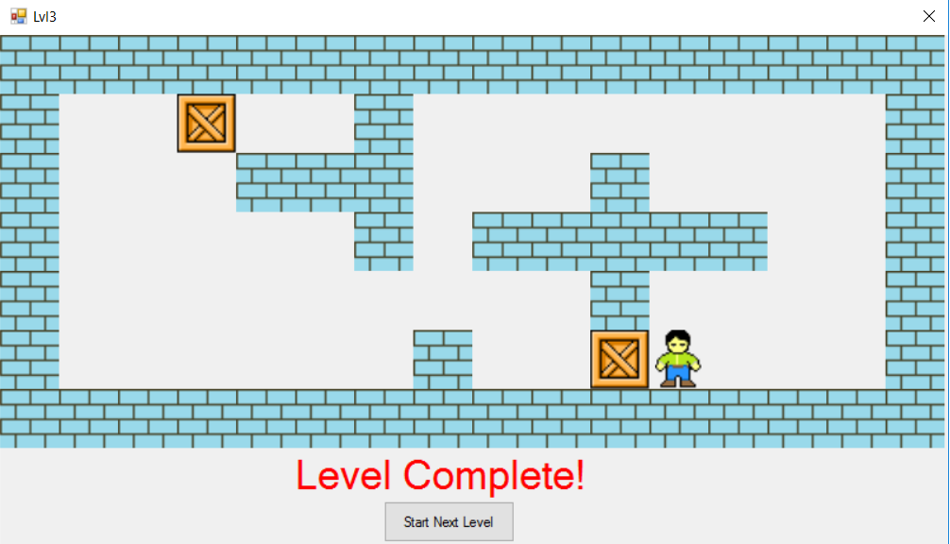

Рис.11

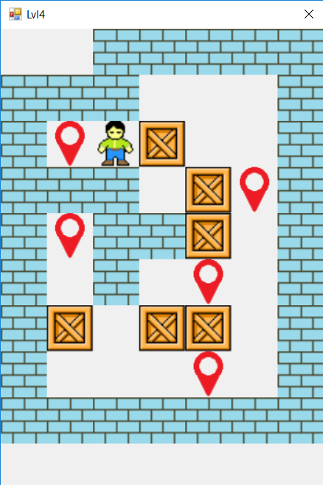

Рис.12

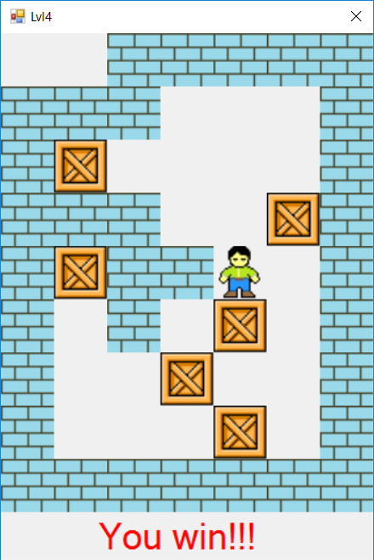

Рис.13

1. КОД ПРОГРАММЫ

Файл Lvl1.cpp

#include "Lvl1.h"

#include "Lvl2.h"

#include "Lvl3.h"

#include "Lvl4.h"

#include "Header.h"

using namespace System;

using namespace System::Windows::Forms;

namespace Pusher

{

System::Void Lvl1::button1_Click(System::Object^ sender, System::EventArgs^ e)

{

Lvl2^ f2 = gcnew Lvl2(this);

f2->Show();

this->Hide();

}

System::Void Lvl2::button1_Click(System::Object^ sender, System::EventArgs^ e)

{

Lvl3^ f3 = gcnew Lvl3(this);

f3->Show();

this->Hide();

}

System::Void Lvl3::button1_Click(System::Object^ sender, System::EventArgs^ e)

{

Lvl4^ f4 = gcnew Lvl4(this);

f4->Show();

this->Hide();

}

}

[STAThread]

void main()

{

Application::EnableVisualStyles();

Application::SetCompatibleTextRenderingDefault(false);

Pusher::Lvl1 form;

Application::Run(%form);

}

Файл Header.h

#include "Lvl1.h"

System::Boolean CheckBorderRight(System::Windows::Forms::PictureBox^ moving, System::Windows::Forms::PictureBox^ border)

{

if (moving->Location.X + moving->Size.Width == border->Location.X)

{

if ((border->Location.Y <= moving->Location.Y)&(border->Location.Y + border->Size.Height >= moving->Location.Y + moving->Size.Height))

return false;

else return true;

}

else return true;

}

System::Boolean CheckBorderLeft(System::Windows::Forms::PictureBox^ moving, System::Windows::Forms::PictureBox^ border)

{

if (moving->Location.X == border->Location.X + border->Size.Width)

{

if ((border->Location.Y <= moving->Location.Y)&(border->Location.Y + border->Size.Height >= moving->Location.Y + moving->Size.Height))

return false;

else return true;

}

else return true;

}

System::Boolean CheckBorderDown(System::Windows::Forms::PictureBox^ moving, System::Windows::Forms::PictureBox^ border)

{

if (moving->Location.Y + moving->Size.Height == border->Location.Y)

{

if ((border->Location.X <= moving->Location.X)&(border->Location.X + border->Size.Width >= moving->Location.X + moving->Size.Width))

return false;

else return true;

}

else return true;

}

System::Boolean CheckBorderUp(System::Windows::Forms::PictureBox^ moving, System::Windows::Forms::PictureBox^ border)

{

if (moving->Location.Y == border->Location.Y + border->Size.Height)

{

if ((border->Location.X <= moving->Location.X)&(border->Location.X + border->Size.Width >= moving->Location.X + moving->Size.Width))

return false;

else return true;

}

else return true;

}

System::Boolean CheckOnMark(System::Windows::Forms::PictureBox^ first, System::Windows::Forms::PictureBox^ second)

{

if ((first->Location.X == second->Location.X)& (first->Location.Y == second->Location.Y))

return true;

else return false;

}

System::Boolean IsOnRight(System::Windows::Forms::PictureBox^ first, System::Windows::Forms::PictureBox^ second)

{

if (first->Location.X + first->Size.Width == second->Location.X)

{

if (first->Location.Y == second->Location.Y)

{

return true;

}

else return false;

}

else return false;

}

System::Boolean IsOnLeft(System::Windows::Forms::PictureBox^ first, System::Windows::Forms::PictureBox^ second)

{

if (first->Location.X == second->Location.X + second->Size.Width)

{

if (first->Location.Y == second->Location.Y)

{

return true;

}

else return false;

}

else return false;

}

System::Boolean IsOnDown(System::Windows::Forms::PictureBox^ first, System::Windows::Forms::PictureBox^ second)

{

if (first->Location.Y + first->Size.Height == second->Location.Y)

{

if (first->Location.X == second->Location.X)

{

return true;

}

else return false;

}

else return false;

}

System::Boolean IsOnUp(System::Windows::Forms::PictureBox^ first, System::Windows::Forms::PictureBox^ second)

{

if (first->Location.Y == second->Location.Y + second->Size.Height)

{

if (first->Location.X == second->Location.X)

{

return true;

}

else return false;

}

else return false;

}

System::Drawing::Point Move1(System::Windows::Forms::PictureBox^ moving, char c)

{

System::Drawing::Point Point;

switch (c)

{

case 'r':

{

Point = System::Drawing::Point(moving->Location.X + moving->Size.Width, moving->Location.Y);

return Point;

}

case 'l':

{

Point = System::Drawing::Point(moving->Location.X - moving->Size.Width, moving->Location.Y);

return Point;

}

case 'u':

{

Point = System::Drawing::Point(moving->Location.X, moving->Location.Y - moving->Size.Height);

return Point;

}

case 'd':

{

Point = System::Drawing::Point(moving->Location.X, moving->Location.Y + moving->Size.Height);

return Point;

}

}

}

Файл Lvl1.h

#include "Header.h"

namespace Pusher {

using namespace System;

using namespace System::ComponentModel;

using namespace System::Collections;

using namespace System::Windows::Forms;

using namespace System::Data;

using namespace System::Drawing;

/// <summary>

/// Сводка для Lvl1

/// </summary>

public ref class Lvl1 : public System::Windows::Forms::Form

{

public:

Lvl1(void)

{

InitializeComponent();

//

//TODO: добавьте код конструктора

//

}

protected:

/// <summary>

/// Освободить все используемые ресурсы.

/// </summary>

~Lvl1()

{

if (components)

{

delete components;

}

}

private: System::Windows::Forms::Button^ button1;

private: System::Windows::Forms::Label^ label1;

private: System::Windows::Forms::PictureBox^ Box1;

private: System::Windows::Forms::PictureBox^ Man1;

private: System::Windows::Forms::PictureBox^ Mark1;

private: System::Windows::Forms::PictureBox^ pictureBox1;

private: System::Windows::Forms::PictureBox^ pictureBox2;

private: System::Windows::Forms::PictureBox^ pictureBox3;

private: System::Windows::Forms::PictureBox^ pictureBox4;

private:

/// <summary>

/// Обязательная переменная конструктора.

/// </summary>

System::ComponentModel::Container ^components;

#pragma region Windows Form Designer generated code

/// <summary>

/// Требуемый метод для поддержки конструктора — не изменяйте

/// содержимое этого метода с помощью редактора кода.

/// </summary>

void InitializeComponent(void)

{

System::ComponentModel::ComponentResourceManager^ resources = (gcnew System::ComponentModel::ComponentResourceManager(Lvl1::typeid));

this->button1 = (gcnew System::Windows::Forms::Button());

this->label1 = (gcnew System::Windows::Forms::Label());

this->Box1 = (gcnew System::Windows::Forms::PictureBox());

this->Man1 = (gcnew System::Windows::Forms::PictureBox());

this->Mark1 = (gcnew System::Windows::Forms::PictureBox());

this->pictureBox1 = (gcnew System::Windows::Forms::PictureBox());

this->pictureBox2 = (gcnew System::Windows::Forms::PictureBox());

this->pictureBox3 = (gcnew System::Windows::Forms::PictureBox());

this->pictureBox4 = (gcnew System::Windows::Forms::PictureBox());

(cli::safe_cast<System::ComponentModel::ISupportInitialize^>(this->Box1))->BeginInit();

(cli::safe_cast<System::ComponentModel::ISupportInitialize^>(this->Man1))->BeginInit();

(cli::safe_cast<System::ComponentModel::ISupportInitialize^>(this->Mark1))->BeginInit();

(cli::safe_cast<System::ComponentModel::ISupportInitialize^>(this->pictureBox1))->BeginInit();

(cli::safe_cast<System::ComponentModel::ISupportInitialize^>(this->pictureBox2))->BeginInit();

(cli::safe_cast<System::ComponentModel::ISupportInitialize^>(this->pictureBox3))->BeginInit();

(cli::safe_cast<System::ComponentModel::ISupportInitialize^>(this->pictureBox4))->BeginInit();

this->SuspendLayout();

//

// button1

//

this->button1->Location = System::Drawing::Point(301, 425);

this->button1->Margin = System::Windows::Forms::Padding(4, 4, 4, 4);

this->button1->Name = L"button1";

this->button1->Size = System::Drawing::Size(148, 43);

this->button1->TabIndex = 7;

this->button1->Text = L"Start Next Level";

this->button1->UseVisualStyleBackColor = true;

this->button1->Visible = false;

this->button1->Click += gcnew System::EventHandler(this, &Lvl1::button1_Click);

//

// label1

//

this->label1->AutoSize = true;

this->label1->BackColor = System::Drawing::SystemColors::Control;

this->label1->Font = (gcnew System::Drawing::Font(L"Microsoft Sans Serif", 25.25F, System::Drawing::FontStyle::Regular, System::Drawing::GraphicsUnit::Point,

static_cast<System::Byte>(204)));

this->label1->ForeColor = System::Drawing::Color::Red;

this->label1->Location = System::Drawing::Point(192, 373);

this->label1->Margin = System::Windows::Forms::Padding(4, 0, 4, 0);

this->label1->Name = L"label1";

this->label1->Size = System::Drawing::Size(334, 51);

this->label1->TabIndex = 8;

this->label1->Text = L"Level Complete!";

this->label1->Visible = false;

//

// Box1

//

this->Box1->Image = (cli::safe_cast<System::Drawing::Image^>(resources->GetObject(L"Box1.Image")));

this->Box1->Location = System::Drawing::Point(400, 185);

this->Box1->Margin = System::Windows::Forms::Padding(4, 4, 4, 4);

this->Box1->Name = L"Box1";

this->Box1->Size = System::Drawing::Size(67, 62);

this->Box1->SizeMode = System::Windows::Forms::PictureBoxSizeMode::StretchImage;

this->Box1->TabIndex = 4;

this->Box1->TabStop = false;

//

// Man1

//

this->Man1->Image = (cli::safe_cast<System::Drawing::Image^>(resources->GetObject(L"Man1.Image")));

this->Man1->Location = System::Drawing::Point(400, 246);

this->Man1->Margin = System::Windows::Forms::Padding(4, 4, 4, 4);

this->Man1->Name = L"Man1";

this->Man1->Size = System::Drawing::Size(67, 62);

this->Man1->SizeMode = System::Windows::Forms::PictureBoxSizeMode::Zoom;

this->Man1->TabIndex = 3;

this->Man1->TabStop = false;

//

// Mark1

//

this->Mark1->Image = (cli::safe_cast<System::Drawing::Image^>(resources->GetObject(L"Mark1.Image")));

this->Mark1->Location = System::Drawing::Point(400, 62);

this->Mark1->Margin = System::Windows::Forms::Padding(4, 4, 4, 4);

this->Mark1->Name = L"Mark1";

this->Mark1->Size = System::Drawing::Size(67, 62);

this->Mark1->SizeMode = System::Windows::Forms::PictureBoxSizeMode::Zoom;

this->Mark1->TabIndex = 2;

this->Mark1->TabStop = false;

//

// pictureBox1

//

this->pictureBox1->BackColor = System::Drawing::SystemColors::ControlText;

this->pictureBox1->BackgroundImage = (cli::safe_cast<System::Drawing::Image^>(resources->GetObject(L"pictureBox1.BackgroundImage")));

this->pictureBox1->Location = System::Drawing::Point(0, 0);

this->pictureBox1->Margin = System::Windows::Forms::Padding(4, 4, 4, 4);

this->pictureBox1->Name = L"pictureBox1";

this->pictureBox1->Size = System::Drawing::Size(733, 62);

this->pictureBox1->SizeMode = System::Windows::Forms::PictureBoxSizeMode::Zoom;

this->pictureBox1->TabIndex = 9;

this->pictureBox1->TabStop = false;

//

// pictureBox2

//

this->pictureBox2->BackColor = System::Drawing::SystemColors::ControlText;

this->pictureBox2->BackgroundImage = (cli::safe_cast<System::Drawing::Image^>(resources->GetObject(L"pictureBox2.BackgroundImage")));

this->pictureBox2->Location = System::Drawing::Point(0, 308);

this->pictureBox2->Margin = System::Windows::Forms::Padding(4, 4, 4, 4);

this->pictureBox2->Name = L"pictureBox2";

this->pictureBox2->Size = System::Drawing::Size(733, 62);

this->pictureBox2->TabIndex = 10;

this->pictureBox2->TabStop = false;

//

// pictureBox3

//

this->pictureBox3->BackColor = System::Drawing::SystemColors::ControlText;

this->pictureBox3->BackgroundImage = (cli::safe_cast<System::Drawing::Image^>(resources->GetObject(L"pictureBox3.BackgroundImage")));

this->pictureBox3->Location = System::Drawing::Point(0, 0);

this->pictureBox3->Margin = System::Windows::Forms::Padding(4, 4, 4, 4);

this->pictureBox3->Name = L"pictureBox3";

this->pictureBox3->Size = System::Drawing::Size(67, 369);

this->pictureBox3->TabIndex = 11;

this->pictureBox3->TabStop = false;

//

// pictureBox4

//

this->pictureBox4->BackColor = System::Drawing::SystemColors::ControlText;

this->pictureBox4->BackgroundImage = (cli::safe_cast<System::Drawing::Image^>(resources->GetObject(L"pictureBox4.BackgroundImage")));

this->pictureBox4->Location = System::Drawing::Point(667, 0);

this->pictureBox4->Margin = System::Windows::Forms::Padding(4, 4, 4, 4);

this->pictureBox4->Name = L"pictureBox4";

this->pictureBox4->Size = System::Drawing::Size(67, 369);

this->pictureBox4->TabIndex = 12;

this->pictureBox4->TabStop = false;

//

// Lvl1

//

this->AutoScaleDimensions = System::Drawing::SizeF(8, 16);

this->AutoScaleMode = System::Windows::Forms::AutoScaleMode::Font;

this->BackgroundImageLayout = System::Windows::Forms::ImageLayout::None;

this->ClientSize = System::Drawing::Size(737, 485);

this->Controls->Add(this->pictureBox4);

this->Controls->Add(this->pictureBox3);

this->Controls->Add(this->pictureBox2);

this->Controls->Add(this->pictureBox1);

this->Controls->Add(this->Man1);

this->Controls->Add(this->label1);

this->Controls->Add(this->Box1);

this->Controls->Add(this->button1);

this->Controls->Add(this->Mark1);

this->FormBorderStyle = System::Windows::Forms::FormBorderStyle::FixedSingle;

this->Margin = System::Windows::Forms::Padding(4, 4, 4, 4);

this->MaximizeBox = false;

this->MinimizeBox = false;

this->Name = L"Lvl1";

this->Text = L"Lvl1";

this->KeyDown += gcnew System::Windows::Forms::KeyEventHandler(this, &Lvl1::Lvl1_KeyDown);

(cli::safe_cast<System::ComponentModel::ISupportInitialize^>(this->Box1))->EndInit();

(cli::safe_cast<System::ComponentModel::ISupportInitialize^>(this->Man1))->EndInit();

(cli::safe_cast<System::ComponentModel::ISupportInitialize^>(this->Mark1))->EndInit();

(cli::safe_cast<System::ComponentModel::ISupportInitialize^>(this->pictureBox1))->EndInit();

(cli::safe_cast<System::ComponentModel::ISupportInitialize^>(this->pictureBox2))->EndInit();

(cli::safe_cast<System::ComponentModel::ISupportInitialize^>(this->pictureBox3))->EndInit();

(cli::safe_cast<System::ComponentModel::ISupportInitialize^>(this->pictureBox4))->EndInit();

this->ResumeLayout(false);

this->PerformLayout();

}

#pragma endregion

private: System::Boolean CheckMoveRight(System::Windows::Forms::PictureBox^ moving)

{

if (CheckBorderRight(moving, pictureBox1))

{

if (CheckBorderRight(moving, pictureBox2))

{

if (CheckBorderRight(moving, pictureBox3))

{

if (CheckBorderRight(moving, pictureBox4)) return true;

else return false;

}

else return false;

}

else return false;

}

else return false;

}

private: System::Boolean CheckMoveLeft(System::Windows::Forms::PictureBox^ moving)

{

if (CheckBorderLeft(moving, pictureBox1))

{

if (CheckBorderLeft(moving, pictureBox2))

{

if (CheckBorderLeft(moving, pictureBox3))

{

if (CheckBorderLeft(moving, pictureBox4)) return true;

else return false;

}

else return false;

}

else return false;

}

else return false;

}

private: System::Boolean CheckMoveDown(System::Windows::Forms::PictureBox^ moving)

{

if (CheckBorderDown(moving, pictureBox1))

{

if (CheckBorderDown(moving, pictureBox2))

{

if (CheckBorderDown(moving, pictureBox3))

{

if (CheckBorderDown(moving, pictureBox4)) return true;

else return false;

}

else return false;

}

else return false;

}

else return false;

}

private: System::Boolean CheckMoveUp(System::Windows::Forms::PictureBox^ moving)

{

if (CheckBorderUp(moving, pictureBox1))

{

if (CheckBorderUp(moving, pictureBox2))

{

if (CheckBorderUp(moving, pictureBox3))

{

if (CheckBorderUp(moving, pictureBox4)) return true;

else return false;

}

else return false;

}

else return false;

}

else return false;

}

private: System::Void Lvl1_KeyDown(System::Object^ sender, System::Windows::Forms::KeyEventArgs^ e)

{

if (e->KeyCode == Keys::Right)

{

if (CheckMoveRight(Man1))

{

if (IsOnRight(Man1, Box1))

{

if (CheckMoveRight(Box1))

{

Box1->Location = System::Drawing::Point(Move1(Box1, 'r'));

Man1->Location = System::Drawing::Point(Move1(Man1, 'r'));

}

}

else Man1->Location = System::Drawing::Point(Move1(Man1, 'r'));

}

}

else if (e->KeyCode == Keys::Left)

{

if (CheckMoveLeft(Man1))

{

if (IsOnLeft(Man1, Box1))

{

if (CheckMoveLeft(Box1))

{

Box1->Location = System::Drawing::Point(Move1(Box1, 'l'));

Man1->Location = System::Drawing::Point(Move1(Man1, 'l'));

}

}

else Man1->Location = System::Drawing::Point(Move1(Man1, 'l'));

}

}

else if (e->KeyCode == Keys::Up)

{

if (CheckMoveUp(Man1))

{

if (IsOnUp(Man1, Box1))

{

if (CheckMoveUp(Box1))

{

Box1->Location = System::Drawing::Point(Move1(Box1, 'u'));

Man1->Location = System::Drawing::Point(Move1(Man1, 'u'));

}

}

else Man1->Location = System::Drawing::Point(Move1(Man1, 'u'));

}

}

else if (e->KeyCode == Keys::Down)

{

if (CheckMoveDown(Man1))

{

if (IsOnDown(Man1, Box1))

{

if (CheckMoveDown(Box1))

{

Box1->Location = System::Drawing::Point(Move1(Box1, 'd'));

Man1->Location = System::Drawing::Point(Move1(Man1, 'd'));

}

}

else Man1->Location = System::Drawing::Point(Move1(Man1, 'd'));

}

}

else if (e->KeyCode == Keys::R)

{

Box1->Location = System::Drawing::Point(300, 150);

Man1->Location = System::Drawing::Point(300, 200);

}

if (CheckOnMark(Box1, Mark1))

{

button1->Visible = true;

label1->Visible = true;

}

}

private: System::Void button1_Click(System::Object^ sender, System::EventArgs^ e);

};

}

Файл Lvl2.h

#include "Header.h"

#include "Lvl1.h"

namespace Pusher {

using namespace System;

using namespace System::ComponentModel;

using namespace System::Collections;

using namespace System::Windows::Forms;

using namespace System::Data;

using namespace System::Drawing;

/// <summary>

/// Сводка для Lvl2

/// </summary>

public ref class Lvl2 : public System::Windows::Forms::Form

{

public:

Lvl2(Lvl1^ parent)

{

InitializeComponent();

parentForm = parent;

}

private: Lvl1^ parentForm;

private: System::Windows::Forms::PictureBox^ pictureBox4;

public:

private: System::Windows::Forms::PictureBox^ pictureBox3;

private: System::Windows::Forms::PictureBox^ pictureBox2;

private: System::Windows::Forms::PictureBox^ pictureBox1;

private: System::Windows::Forms::PictureBox^ Mark1;

private: System::Windows::Forms::PictureBox^ Man1;

private: System::Windows::Forms::Label^ label1;

private: System::Windows::Forms::PictureBox^ Box1;

private: System::Windows::Forms::Button^ button1;

private: System::Windows::Forms::PictureBox^ pictureBox6;

private: System::Windows::Forms::PictureBox^ pictureBox5;

protected:

/// <summary>

/// Освободить все используемые ресурсы.

/// </summary>

~Lvl2()

{

if (components)

{

delete components;

}

}

private:

/// <summary>

/// Обязательная переменная конструктора.

/// </summary>

System::ComponentModel::Container ^components;

#pragma region Windows Form Designer generated code

/// <summary>

/// Требуемый метод для поддержки конструктора — не изменяйте

/// содержимое этого метода с помощью редактора кода.

/// </summary>

void InitializeComponent(void)

{

System::ComponentModel::ComponentResourceManager^ resources = (gcnew System::ComponentModel::ComponentResourceManager(Lvl2::typeid));

this->pictureBox4 = (gcnew System::Windows::Forms::PictureBox());

this->pictureBox3 = (gcnew System::Windows::Forms::PictureBox());

this->pictureBox2 = (gcnew System::Windows::Forms::PictureBox());

this->pictureBox1 = (gcnew System::Windows::Forms::PictureBox());

this->Mark1 = (gcnew System::Windows::Forms::PictureBox());

this->Man1 = (gcnew System::Windows::Forms::PictureBox());

this->label1 = (gcnew System::Windows::Forms::Label());

this->Box1 = (gcnew System::Windows::Forms::PictureBox());

this->button1 = (gcnew System::Windows::Forms::Button());

this->pictureBox6 = (gcnew System::Windows::Forms::PictureBox());

this->pictureBox5 = (gcnew System::Windows::Forms::PictureBox());

(cli::safe_cast<System::ComponentModel::ISupportInitialize^>(this->pictureBox4))->BeginInit();

(cli::safe_cast<System::ComponentModel::ISupportInitialize^>(this->pictureBox3))->BeginInit();

(cli::safe_cast<System::ComponentModel::ISupportInitialize^>(this->pictureBox2))->BeginInit();

(cli::safe_cast<System::ComponentModel::ISupportInitialize^>(this->pictureBox1))->BeginInit();

(cli::safe_cast<System::ComponentModel::ISupportInitialize^>(this->Mark1))->BeginInit();

(cli::safe_cast<System::ComponentModel::ISupportInitialize^>(this->Man1))->BeginInit();

(cli::safe_cast<System::ComponentModel::ISupportInitialize^>(this->Box1))->BeginInit();

(cli::safe_cast<System::ComponentModel::ISupportInitialize^>(this->pictureBox6))->BeginInit();

(cli::safe_cast<System::ComponentModel::ISupportInitialize^>(this->pictureBox5))->BeginInit();

this->SuspendLayout();

//

// pictureBox4

//

this->pictureBox4->BackColor = System::Drawing::SystemColors::ControlText;

this->pictureBox4->BackgroundImage = (cli::safe_cast<System::Drawing::Image^>(resources->GetObject(L"pictureBox4.BackgroundImage")));

this->pictureBox4->Location = System::Drawing::Point(1400, 0);

this->pictureBox4->Margin = System::Windows::Forms::Padding(4, 4, 4, 4);

this->pictureBox4->Name = L"pictureBox4";

this->pictureBox4->Size = System::Drawing::Size(67, 369);

this->pictureBox4->TabIndex = 21;

this->pictureBox4->TabStop = false;

//

// pictureBox3

//

this->pictureBox3->BackColor = System::Drawing::SystemColors::ControlText;

this->pictureBox3->BackgroundImage = (cli::safe_cast<System::Drawing::Image^>(resources->GetObject(L"pictureBox3.BackgroundImage")));

this->pictureBox3->Location = System::Drawing::Point(0, 0);

this->pictureBox3->Margin = System::Windows::Forms::Padding(4, 4, 4, 4);

this->pictureBox3->Name = L"pictureBox3";

this->pictureBox3->Size = System::Drawing::Size(67, 369);

this->pictureBox3->TabIndex = 20;

this->pictureBox3->TabStop = false;

//

// pictureBox2

//

this->pictureBox2->BackColor = System::Drawing::SystemColors::ControlText;

this->pictureBox2->BackgroundImage = (cli::safe_cast<System::Drawing::Image^>(resources->GetObject(L"pictureBox2.BackgroundImage")));

this->pictureBox2->Location = System::Drawing::Point(0, 308);

this->pictureBox2->Margin = System::Windows::Forms::Padding(4, 4, 4, 4);

this->pictureBox2->Name = L"pictureBox2";

this->pictureBox2->Size = System::Drawing::Size(1467, 62);

this->pictureBox2->SizeMode = System::Windows::Forms::PictureBoxSizeMode::CenterImage;

this->pictureBox2->TabIndex = 19;

this->pictureBox2->TabStop = false;

//

// pictureBox1

//

this->pictureBox1->BackColor = System::Drawing::SystemColors::ControlText;

this->pictureBox1->BackgroundImage = (cli::safe_cast<System::Drawing::Image^>(resources->GetObject(L"pictureBox1.BackgroundImage")));

this->pictureBox1->Location = System::Drawing::Point(0, 0);

this->pictureBox1->Margin = System::Windows::Forms::Padding(4, 4, 4, 4);

this->pictureBox1->Name = L"pictureBox1";

this->pictureBox1->Size = System::Drawing::Size(1467, 62);

this->pictureBox1->TabIndex = 18;

this->pictureBox1->TabStop = false;

//

// Mark1

//

this->Mark1->Image = (cli::safe_cast<System::Drawing::Image^>(resources->GetObject(L"Mark1.Image")));

this->Mark1->Location = System::Drawing::Point(1333, 62);

this->Mark1->Margin = System::Windows::Forms::Padding(4, 4, 4, 4);

this->Mark1->Name = L"Mark1";

this->Mark1->Size = System::Drawing::Size(67, 62);

this->Mark1->SizeMode = System::Windows::Forms::PictureBoxSizeMode::Zoom;

this->Mark1->TabIndex = 13;

this->Mark1->TabStop = false;

//

// Man1

//

this->Man1->Image = (cli::safe_cast<System::Drawing::Image^>(resources->GetObject(L"Man1.Image")));

this->Man1->Location = System::Drawing::Point(333, 62);

this->Man1->Margin = System::Windows::Forms::Padding(4, 4, 4, 4);

this->Man1->Name = L"Man1";

this->Man1->Size = System::Drawing::Size(67, 62);

this->Man1->SizeMode = System::Windows::Forms::PictureBoxSizeMode::Zoom;

this->Man1->TabIndex = 14;

this->Man1->TabStop = false;

//

// label1

//

this->label1->AutoSize = true;

this->label1->BackColor = System::Drawing::SystemColors::Control;

this->label1->Font = (gcnew System::Drawing::Font(L"Microsoft Sans Serif", 25.25F, System::Drawing::FontStyle::Regular, System::Drawing::GraphicsUnit::Point,

static_cast<System::Byte>(204)));

this->label1->ForeColor = System::Drawing::Color::Red;

this->label1->Location = System::Drawing::Point(583, 391);

this->label1->Margin = System::Windows::Forms::Padding(4, 0, 4, 0);

this->label1->Name = L"label1";

this->label1->Size = System::Drawing::Size(334, 51);

this->label1->TabIndex = 17;

this->label1->Text = L"Level Complete!";

this->label1->Visible = false;

//

// Box1

//

this->Box1->Image = (cli::safe_cast<System::Drawing::Image^>(resources->GetObject(L"Box1.Image")));

this->Box1->Location = System::Drawing::Point(333, 185);

this->Box1->Margin = System::Windows::Forms::Padding(4, 4, 4, 4);

this->Box1->Name = L"Box1";

this->Box1->Size = System::Drawing::Size(67, 62);

this->Box1->SizeMode = System::Windows::Forms::PictureBoxSizeMode::StretchImage;

this->Box1->TabIndex = 15;

this->Box1->TabStop = false;

//

// button1

//

this->button1->Location = System::Drawing::Point(692, 443);

this->button1->Margin = System::Windows::Forms::Padding(4, 4, 4, 4);

this->button1->Name = L"button1";

this->button1->Size = System::Drawing::Size(148, 43);

this->button1->TabIndex = 16;

this->button1->Text = L"Start Next Level";

this->button1->UseVisualStyleBackColor = true;

this->button1->Visible = false;

this->button1->Click += gcnew System::EventHandler(this, &Lvl2::button1_Click);

//

// pictureBox6

//

this->pictureBox6->BackColor = System::Drawing::SystemColors::ControlText;

this->pictureBox6->BackgroundImage = (cli::safe_cast<System::Drawing::Image^>(resources->GetObject(L"pictureBox6.BackgroundImage")));

this->pictureBox6->Location = System::Drawing::Point(667, 62);

this->pictureBox6->Margin = System::Windows::Forms::Padding(4, 4, 4, 4);

this->pictureBox6->Name = L"pictureBox6";

this->pictureBox6->Size = System::Drawing::Size(667, 62);

this->pictureBox6->TabIndex = 23;

this->pictureBox6->TabStop = false;

//

// pictureBox5

//

this->pictureBox5->BackColor = System::Drawing::SystemColors::ControlText;

this->pictureBox5->BackgroundImage = (cli::safe_cast<System::Drawing::Image^>(resources->GetObject(L"pictureBox5.BackgroundImage")));

this->pictureBox5->Location = System::Drawing::Point(667, 185);

this->pictureBox5->Margin = System::Windows::Forms::Padding(4, 4, 4, 4);

this->pictureBox5->Name = L"pictureBox5";

this->pictureBox5->Size = System::Drawing::Size(667, 62);

this->pictureBox5->TabIndex = 24;

this->pictureBox5->TabStop = false;

//

// Lvl2

//

this->AutoScaleDimensions = System::Drawing::SizeF(8, 16);

this->AutoScaleMode = System::Windows::Forms::AutoScaleMode::Font;

this->ClientSize = System::Drawing::Size(1488, 494);

this->Controls->Add(this->pictureBox5);

this->Controls->Add(this->pictureBox6);

this->Controls->Add(this->pictureBox4);

this->Controls->Add(this->pictureBox3);

this->Controls->Add(this->pictureBox2);

this->Controls->Add(this->pictureBox1);

this->Controls->Add(this->Man1);

this->Controls->Add(this->label1);

this->Controls->Add(this->Box1);

this->Controls->Add(this->button1);

this->Controls->Add(this->Mark1);

this->Margin = System::Windows::Forms::Padding(4, 4, 4, 4);

this->MaximizeBox = false;

this->MinimizeBox = false;

this->Name = L"Lvl2";

this->Text = L"Lvl2";

this->KeyDown += gcnew System::Windows::Forms::KeyEventHandler(this, &Lvl2::Lvl2_KeyDown);

(cli::safe_cast<System::ComponentModel::ISupportInitialize^>(this->pictureBox4))->EndInit();

(cli::safe_cast<System::ComponentModel::ISupportInitialize^>(this->pictureBox3))->EndInit();

(cli::safe_cast<System::ComponentModel::ISupportInitialize^>(this->pictureBox2))->EndInit();

(cli::safe_cast<System::ComponentModel::ISupportInitialize^>(this->pictureBox1))->EndInit();

(cli::safe_cast<System::ComponentModel::ISupportInitialize^>(this->Mark1))->EndInit();

(cli::safe_cast<System::ComponentModel::ISupportInitialize^>(this->Man1))->EndInit();

(cli::safe_cast<System::ComponentModel::ISupportInitialize^>(this->Box1))->EndInit();

(cli::safe_cast<System::ComponentModel::ISupportInitialize^>(this->pictureBox6))->EndInit();

(cli::safe_cast<System::ComponentModel::ISupportInitialize^>(this->pictureBox5))->EndInit();

this->ResumeLayout(false);

this->PerformLayout();

}

#pragma endregion

private: System::Boolean CheckMoveRight(System::Windows::Forms::PictureBox^ moving)

{

if (CheckBorderRight(moving, pictureBox1))

{

if (CheckBorderRight(moving, pictureBox2))

{

if (CheckBorderRight(moving, pictureBox3))

{

if (CheckBorderRight(moving, pictureBox4))

{

if (CheckBorderRight(moving, pictureBox5))

{

if (CheckBorderRight(moving, pictureBox6))

return true;

else return false;

}

else return false;

}

else return false;

}

else return false;

}

else return false;

}

else return false;

}

private: System::Boolean CheckMoveLeft(System::Windows::Forms::PictureBox^ moving)

{

if (CheckBorderLeft(moving, pictureBox1))

{

if (CheckBorderLeft(moving, pictureBox2))

{

if (CheckBorderLeft(moving, pictureBox3))

{

if (CheckBorderLeft(moving, pictureBox4))

{

if (CheckBorderLeft(moving, pictureBox5))

{

if (CheckBorderLeft(moving, pictureBox6))

return true;

else return false;

}

else return false;

}

else return false;

}

else return false;

}

else return false;

}

else return false;

}

private: System::Boolean CheckMoveDown(System::Windows::Forms::PictureBox^ moving)

{

if (CheckBorderDown(moving, pictureBox1))

{

if (CheckBorderDown(moving, pictureBox2))

{

if (CheckBorderDown(moving, pictureBox3))

{

if (CheckBorderDown(moving, pictureBox4))

{

if (CheckBorderDown(moving, pictureBox5))

{

if (CheckBorderDown(moving, pictureBox6))

return true;

else return false;

}

else return false;

}

else return false;

}

else return false;

}

else return false;

}

else return false;

}

private: System::Boolean CheckMoveUp(System::Windows::Forms::PictureBox^ moving)

{

if (CheckBorderUp(moving, pictureBox1))

{

if (CheckBorderUp(moving, pictureBox2))

{

if (CheckBorderUp(moving, pictureBox3))

{

if (CheckBorderUp(moving, pictureBox4))

{

if (CheckBorderUp(moving, pictureBox5))

{

if (CheckBorderUp(moving, pictureBox6))

return true;

else return false;

}

else return false;

}

else return false;

}

else return false;

}

else return false;

}

else return false;

}

private: System::Void Lvl2_KeyDown(System::Object^ sender, System::Windows::Forms::KeyEventArgs^ e)

{

Mark1->Visible = true;

if (e->KeyCode == Keys::Right)

{

if (CheckMoveRight(Man1))

{

if (IsOnRight(Man1, Box1))

{

if (CheckMoveRight(Box1))

{

Box1->Location = System::Drawing::Point(Move1(Box1, 'r'));

Man1->Location = System::Drawing::Point(Move1(Man1, 'r'));

}

}

else Man1->Location = System::Drawing::Point(Move1(Man1, 'r'));

}

}

else if (e->KeyCode == Keys::Left)

{

if (CheckMoveLeft(Man1))

{

if (IsOnLeft(Man1, Box1))

{

if (CheckMoveLeft(Box1))

{

Box1->Location = System::Drawing::Point(Move1(Box1, 'l'));

Man1->Location = System::Drawing::Point(Move1(Man1, 'l'));

}

}

else Man1->Location = System::Drawing::Point(Move1(Man1, 'l'));

}

}

else if (e->KeyCode == Keys::Up)

{

if (CheckMoveUp(Man1))

{

if (IsOnUp(Man1, Box1))

{

if (CheckMoveUp(Box1))

{

Box1->Location = System::Drawing::Point(Move1(Box1, 'u'));

Man1->Location = System::Drawing::Point(Move1(Man1, 'u'));

}

}

else Man1->Location = System::Drawing::Point(Move1(Man1, 'u'));

}

}

else if (e->KeyCode == Keys::Down)

{

if (CheckMoveDown(Man1))

{

if (IsOnDown(Man1, Box1))

{

if (CheckMoveDown(Box1))

{

Box1->Location = System::Drawing::Point(Move1(Box1, 'd'));

Man1->Location = System::Drawing::Point(Move1(Man1, 'd'));

}

}

else Man1->Location = System::Drawing::Point(Move1(Man1, 'd'));

}

}

else if (e->KeyCode == Keys::R)

{

Box1->Location = System::Drawing::Point(250, 150);

Man1->Location = System::Drawing::Point(250, 50);

}

if (CheckOnMark(Box1, Mark1))

{

button1->Visible = true;

label1->Visible = true;

Mark1->Visible = false;

}

if (CheckOnMark(Man1, Mark1)) Mark1->Visible = false;

}

private: System::Void button1_Click(System::Object^ sender, System::EventArgs^ e);

};

}

Файл Lvl3.h

#include "Header.h"

#include "Lvl1.h"

#include "Lvl2.h"

namespace Pusher {

using namespace System;

using namespace System::ComponentModel;

using namespace System::Collections;

using namespace System::Windows::Forms;

using namespace System::Data;

using namespace System::Drawing;

/// <summary>

/// Сводка для Lvl3

/// </summary>

public ref class Lvl3 : public System::Windows::Forms::Form

{

public:

Lvl3(Lvl2^ parent)

{

InitializeComponent();

parentForm = parent;

}

private: System::Windows::Forms::PictureBox^ pictureBox5;

public:

private: System::Windows::Forms::PictureBox^ pictureBox6;

private: System::Windows::Forms::PictureBox^ pictureBox4;

private: System::Windows::Forms::PictureBox^ pictureBox3;

private: System::Windows::Forms::PictureBox^ pictureBox2;

private: System::Windows::Forms::PictureBox^ pictureBox1;

private: System::Windows::Forms::PictureBox^ Mark1;

private: System::Windows::Forms::PictureBox^ Man1;

private: System::Windows::Forms::Label^ label1;

private: System::Windows::Forms::PictureBox^ Box1;

private: System::Windows::Forms::Button^ button1;

private: System::Windows::Forms::PictureBox^ pictureBox7;

private: System::Windows::Forms::PictureBox^ pictureBox9;

private: System::Windows::Forms::PictureBox^ pictureBox8;

private: System::Windows::Forms::PictureBox^ Box2;

private: System::Windows::Forms::PictureBox^ Mark2;

public:

private: Lvl2^ parentForm;

protected:

/// <summary>

/// Освободить все используемые ресурсы.

/// </summary>

~Lvl3()

{

if (components)

{

delete components;

}

}

private:

/// <summary>

/// Обязательная переменная конструктора.

/// </summary>

System::ComponentModel::Container ^components;

#pragma region Windows Form Designer generated code

/// <summary>

/// Требуемый метод для поддержки конструктора — не изменяйте

/// содержимое этого метода с помощью редактора кода.

/// </summary>

void InitializeComponent(void)

{

System::ComponentModel::ComponentResourceManager^ resources = (gcnew System::ComponentModel::ComponentResourceManager(Lvl3::typeid));

this->pictureBox5 = (gcnew System::Windows::Forms::PictureBox());

this->pictureBox6 = (gcnew System::Windows::Forms::PictureBox());

this->pictureBox4 = (gcnew System::Windows::Forms::PictureBox());

this->pictureBox3 = (gcnew System::Windows::Forms::PictureBox());

this->pictureBox2 = (gcnew System::Windows::Forms::PictureBox());

this->pictureBox1 = (gcnew System::Windows::Forms::PictureBox());

this->Mark1 = (gcnew System::Windows::Forms::PictureBox());

this->Man1 = (gcnew System::Windows::Forms::PictureBox());

this->label1 = (gcnew System::Windows::Forms::Label());

this->Box1 = (gcnew System::Windows::Forms::PictureBox());

this->button1 = (gcnew System::Windows::Forms::Button());

this->pictureBox7 = (gcnew System::Windows::Forms::PictureBox());

this->pictureBox9 = (gcnew System::Windows::Forms::PictureBox());

this->pictureBox8 = (gcnew System::Windows::Forms::PictureBox());

this->Box2 = (gcnew System::Windows::Forms::PictureBox());

this->Mark2 = (gcnew System::Windows::Forms::PictureBox());

(cli::safe_cast<System::ComponentModel::ISupportInitialize^>(this->pictureBox5))->BeginInit();

(cli::safe_cast<System::ComponentModel::ISupportInitialize^>(this->pictureBox6))->BeginInit();

(cli::safe_cast<System::ComponentModel::ISupportInitialize^>(this->pictureBox4))->BeginInit();

(cli::safe_cast<System::ComponentModel::ISupportInitialize^>(this->pictureBox3))->BeginInit();

(cli::safe_cast<System::ComponentModel::ISupportInitialize^>(this->pictureBox2))->BeginInit();

(cli::safe_cast<System::ComponentModel::ISupportInitialize^>(this->pictureBox1))->BeginInit();

(cli::safe_cast<System::ComponentModel::ISupportInitialize^>(this->Mark1))->BeginInit();

(cli::safe_cast<System::ComponentModel::ISupportInitialize^>(this->Man1))->BeginInit();

(cli::safe_cast<System::ComponentModel::ISupportInitialize^>(this->Box1))->BeginInit();

(cli::safe_cast<System::ComponentModel::ISupportInitialize^>(this->pictureBox7))->BeginInit();

(cli::safe_cast<System::ComponentModel::ISupportInitialize^>(this->pictureBox9))->BeginInit();

(cli::safe_cast<System::ComponentModel::ISupportInitialize^>(this->pictureBox8))->BeginInit();

(cli::safe_cast<System::ComponentModel::ISupportInitialize^>(this->Box2))->BeginInit();

(cli::safe_cast<System::ComponentModel::ISupportInitialize^>(this->Mark2))->BeginInit();

this->SuspendLayout();

//

// pictureBox5

//

this->pictureBox5->BackColor = System::Drawing::SystemColors::ControlText;

this->pictureBox5->BackgroundImage = (cli::safe_cast<System::Drawing::Image^>(resources->GetObject(L"pictureBox5.BackgroundImage")));

this->pictureBox5->Location = System::Drawing::Point(400, 62);

this->pictureBox5->Margin = System::Windows::Forms::Padding(4, 4, 4, 4);

this->pictureBox5->Name = L"pictureBox5";

this->pictureBox5->Size = System::Drawing::Size(67, 185);

this->pictureBox5->TabIndex = 35;

this->pictureBox5->TabStop = false;

//

// pictureBox6

//

this->pictureBox6->BackColor = System::Drawing::SystemColors::ControlText;

this->pictureBox6->BackgroundImage = (cli::safe_cast<System::Drawing::Image^>(resources->GetObject(L"pictureBox6.BackgroundImage")));

this->pictureBox6->Location = System::Drawing::Point(533, 185);

this->pictureBox6->Margin = System::Windows::Forms::Padding(4, 4, 4, 4);

this->pictureBox6->Name = L"pictureBox6";

this->pictureBox6->Size = System::Drawing::Size(333, 62);

this->pictureBox6->TabIndex = 34;

this->pictureBox6->TabStop = false;

//

// pictureBox4

//

this->pictureBox4->BackColor = System::Drawing::SystemColors::ControlText;

this->pictureBox4->BackgroundImage = (cli::safe_cast<System::Drawing::Image^>(resources->GetObject(L"pictureBox4.BackgroundImage")));

this->pictureBox4->Location = System::Drawing::Point(1000, 0);

this->pictureBox4->Margin = System::Windows::Forms::Padding(4, 4, 4, 4);

this->pictureBox4->Name = L"pictureBox4";

this->pictureBox4->Size = System::Drawing::Size(67, 431);

this->pictureBox4->TabIndex = 33;

this->pictureBox4->TabStop = false;

//

// pictureBox3

//

this->pictureBox3->BackColor = System::Drawing::SystemColors::ControlText;

this->pictureBox3->BackgroundImage = (cli::safe_cast<System::Drawing::Image^>(resources->GetObject(L"pictureBox3.BackgroundImage")));

this->pictureBox3->Location = System::Drawing::Point(0, 0);

this->pictureBox3->Margin = System::Windows::Forms::Padding(4, 4, 4, 4);

this->pictureBox3->Name = L"pictureBox3";

this->pictureBox3->Size = System::Drawing::Size(67, 431);

this->pictureBox3->TabIndex = 32;

this->pictureBox3->TabStop = false;

//

// pictureBox2

//

this->pictureBox2->BackColor = System::Drawing::SystemColors::ControlText;

this->pictureBox2->BackgroundImage = (cli::safe_cast<System::Drawing::Image^>(resources->GetObject(L"pictureBox2.BackgroundImage")));

this->pictureBox2->Location = System::Drawing::Point(0, 369);

this->pictureBox2->Margin = System::Windows::Forms::Padding(4, 4, 4, 4);

this->pictureBox2->Name = L"pictureBox2";

this->pictureBox2->Size = System::Drawing::Size(1000, 62);

this->pictureBox2->TabIndex = 31;

this->pictureBox2->TabStop = false;

//

// pictureBox1

//

this->pictureBox1->BackColor = System::Drawing::SystemColors::ControlText;

this->pictureBox1->BackgroundImage = (cli::safe_cast<System::Drawing::Image^>(resources->GetObject(L"pictureBox1.BackgroundImage")));

this->pictureBox1->Location = System::Drawing::Point(0, 0);

this->pictureBox1->Margin = System::Windows::Forms::Padding(4, 4, 4, 4);

this->pictureBox1->Name = L"pictureBox1";

this->pictureBox1->Size = System::Drawing::Size(1000, 62);

this->pictureBox1->TabIndex = 30;

this->pictureBox1->TabStop = false;

//

// Mark1

//

this->Mark1->Image = (cli::safe_cast<System::Drawing::Image^>(resources->GetObject(L"Mark1.Image")));

this->Mark1->Location = System::Drawing::Point(200, 62);

this->Mark1->Margin = System::Windows::Forms::Padding(4, 4, 4, 4);

this->Mark1->Name = L"Mark1";

this->Mark1->Size = System::Drawing::Size(67, 62);

this->Mark1->SizeMode = System::Windows::Forms::PictureBoxSizeMode::Zoom;

this->Mark1->TabIndex = 25;

this->Mark1->TabStop = false;

//

// Man1

//

this->Man1->Image = (cli::safe_cast<System::Drawing::Image^>(resources->GetObject(L"Man1.Image")));

this->Man1->Location = System::Drawing::Point(333, 62);

this->Man1->Margin = System::Windows::Forms::Padding(4, 4, 4, 4);

this->Man1->Name = L"Man1";

this->Man1->Size = System::Drawing::Size(67, 62);

this->Man1->SizeMode = System::Windows::Forms::PictureBoxSizeMode::Zoom;

this->Man1->TabIndex = 26;

this->Man1->TabStop = false;

//

// label1

//

this->label1->AutoSize = true;

this->label1->BackColor = System::Drawing::SystemColors::Control;

this->label1->Font = (gcnew System::Drawing::Font(L"Microsoft Sans Serif", 25.25F, System::Drawing::FontStyle::Regular, System::Drawing::GraphicsUnit::Point,

static_cast<System::Byte>(204)));

this->label1->ForeColor = System::Drawing::Color::Red;

this->label1->Location = System::Drawing::Point(324, 434);

this->label1->Margin = System::Windows::Forms::Padding(4, 0, 4, 0);

this->label1->Name = L"label1";

this->label1->Size = System::Drawing::Size(334, 51);

this->label1->TabIndex = 29;

this->label1->Text = L"Level Complete!";

this->label1->Visible = false;

//

// Box1

//

this->Box1->Image = (cli::safe_cast<System::Drawing::Image^>(resources->GetObject(L"Box1.Image")));

this->Box1->Location = System::Drawing::Point(533, 123);

this->Box1->Margin = System::Windows::Forms::Padding(4, 4, 4, 4);

this->Box1->Name = L"Box1";

this->Box1->Size = System::Drawing::Size(67, 62);

this->Box1->SizeMode = System::Windows::Forms::PictureBoxSizeMode::StretchImage;

this->Box1->TabIndex = 27;

this->Box1->TabStop = false;

//

// button1

//

this->button1->Location = System::Drawing::Point(433, 486);

this->button1->Margin = System::Windows::Forms::Padding(4, 4, 4, 4);

this->button1->Name = L"button1";

this->button1->Size = System::Drawing::Size(148, 43);

this->button1->TabIndex = 28;

this->button1->Text = L"Start Next Level";

this->button1->UseVisualStyleBackColor = true;

this->button1->Visible = false;

this->button1->Click += gcnew System::EventHandler(this, &Lvl3::button1_Click);

//

// pictureBox7

//

this->pictureBox7->BackColor = System::Drawing::SystemColors::ControlText;

this->pictureBox7->BackgroundImage = (cli::safe_cast<System::Drawing::Image^>(resources->GetObject(L"pictureBox7.BackgroundImage")));

this->pictureBox7->Location = System::Drawing::Point(267, 123);

this->pictureBox7->Margin = System::Windows::Forms::Padding(4, 4, 4, 4);

this->pictureBox7->Name = L"pictureBox7";

this->pictureBox7->Size = System::Drawing::Size(133, 62);

this->pictureBox7->TabIndex = 36;

this->pictureBox7->TabStop = false;

//

// pictureBox9

//

this->pictureBox9->BackColor = System::Drawing::SystemColors::ControlText;

this->pictureBox9->BackgroundImage = (cli::safe_cast<System::Drawing::Image^>(resources->GetObject(L"pictureBox9.BackgroundImage")));

this->pictureBox9->Location = System::Drawing::Point(667, 123);

this->pictureBox9->Margin = System::Windows::Forms::Padding(4, 4, 4, 4);

this->pictureBox9->Name = L"pictureBox9";

this->pictureBox9->Size = System::Drawing::Size(67, 185);

this->pictureBox9->TabIndex = 38;

this->pictureBox9->TabStop = false;

//

// pictureBox8

//

this->pictureBox8->BackColor = System::Drawing::SystemColors::ControlText;

this->pictureBox8->BackgroundImage = (cli::safe_cast<System::Drawing::Image^>(resources->GetObject(L"pictureBox8.BackgroundImage")));

this->pictureBox8->Location = System::Drawing::Point(467, 308);

this->pictureBox8->Margin = System::Windows::Forms::Padding(4, 4, 4, 4);

this->pictureBox8->Name = L"pictureBox8";

this->pictureBox8->Size = System::Drawing::Size(67, 62);

this->pictureBox8->TabIndex = 39;

this->pictureBox8->TabStop = false;

//

// Box2

//

this->Box2->Image = (cli::safe_cast<System::Drawing::Image^>(resources->GetObject(L"Box2.Image")));

this->Box2->Location = System::Drawing::Point(800, 123);

this->Box2->Margin = System::Windows::Forms::Padding(4, 4, 4, 4);

this->Box2->Name = L"Box2";

this->Box2->Size = System::Drawing::Size(67, 62);

this->Box2->SizeMode = System::Windows::Forms::PictureBoxSizeMode::StretchImage;

this->Box2->TabIndex = 40;

this->Box2->TabStop = false;

//

// Mark2

//

this->Mark2->Image = (cli::safe_cast<System::Drawing::Image^>(resources->GetObject(L"Mark2.Image")));

this->Mark2->Location = System::Drawing::Point(667, 308);

this->Mark2->Margin = System::Windows::Forms::Padding(4, 4, 4, 4);

this->Mark2->Name = L"Mark2";

this->Mark2->Size = System::Drawing::Size(67, 62);

this->Mark2->SizeMode = System::Windows::Forms::PictureBoxSizeMode::Zoom;

this->Mark2->TabIndex = 41;

this->Mark2->TabStop = false;

//

// Lvl3

//

this->AutoScaleDimensions = System::Drawing::SizeF(8, 16);

this->AutoScaleMode = System::Windows::Forms::AutoScaleMode::Font;

this->ClientSize = System::Drawing::Size(1071, 538);

this->Controls->Add(this->Box2);

this->Controls->Add(this->pictureBox8);

this->Controls->Add(this->pictureBox9);

this->Controls->Add(this->pictureBox7);

this->Controls->Add(this->pictureBox5);

this->Controls->Add(this->pictureBox6);

this->Controls->Add(this->pictureBox4);

this->Controls->Add(this->pictureBox3);

this->Controls->Add(this->pictureBox2);

this->Controls->Add(this->pictureBox1);

this->Controls->Add(this->Man1);

this->Controls->Add(this->label1);

this->Controls->Add(this->Box1);

this->Controls->Add(this->button1);

this->Controls->Add(this->Mark1);

this->Controls->Add(this->Mark2);

this->Margin = System::Windows::Forms::Padding(4, 4, 4, 4);

this->MaximizeBox = false;

this->MinimizeBox = false;

this->Name = L"Lvl3";

this->Text = L"Lvl3";

this->KeyDown += gcnew System::Windows::Forms::KeyEventHandler(this, &Lvl3::Lvl3_KeyDown);

(cli::safe_cast<System::ComponentModel::ISupportInitialize^>(this->pictureBox5))->EndInit();

(cli::safe_cast<System::ComponentModel::ISupportInitialize^>(this->pictureBox6))->EndInit();

(cli::safe_cast<System::ComponentModel::ISupportInitialize^>(this->pictureBox4))->EndInit();

(cli::safe_cast<System::ComponentModel::ISupportInitialize^>(this->pictureBox3))->EndInit();

(cli::safe_cast<System::ComponentModel::ISupportInitialize^>(this->pictureBox2))->EndInit();

(cli::safe_cast<System::ComponentModel::ISupportInitialize^>(this->pictureBox1))->EndInit();

(cli::safe_cast<System::ComponentModel::ISupportInitialize^>(this->Mark1))->EndInit();

(cli::safe_cast<System::ComponentModel::ISupportInitialize^>(this->Man1))->EndInit();

(cli::safe_cast<System::ComponentModel::ISupportInitialize^>(this->Box1))->EndInit();

(cli::safe_cast<System::ComponentModel::ISupportInitialize^>(this->pictureBox7))->EndInit();

(cli::safe_cast<System::ComponentModel::ISupportInitialize^>(this->pictureBox9))->EndInit();

(cli::safe_cast<System::ComponentModel::ISupportInitialize^>(this->pictureBox8))->EndInit();

(cli::safe_cast<System::ComponentModel::ISupportInitialize^>(this->Box2))->EndInit();

(cli::safe_cast<System::ComponentModel::ISupportInitialize^>(this->Mark2))->EndInit();

this->ResumeLayout(false);

this->PerformLayout();

}

#pragma endregion

private: System::Boolean CheckMoveRight(System::Windows::Forms::PictureBox^ moving)

{

if (CheckBorderRight(moving, pictureBox1))

{

if (CheckBorderRight(moving, pictureBox2))

{

if (CheckBorderRight(moving, pictureBox3))

{

if (CheckBorderRight(moving, pictureBox4))

{

if (CheckBorderRight(moving, pictureBox5))

{

if (CheckBorderRight(moving, pictureBox6))

{

if (CheckBorderRight(moving, pictureBox7))

{

if (CheckBorderRight(moving, pictureBox8))

{

if (CheckBorderRight(moving, pictureBox9))

return true;

else return false;

}

else return false;

}

else return false;

}

else return false;

}

else return false;

}

else return false;

}

else return false;

}

else return false;

}

else return false;

}

private: System::Boolean CheckMoveLeft(System::Windows::Forms::PictureBox^ moving)

{

if (CheckBorderLeft(moving, pictureBox1))

{

if (CheckBorderLeft(moving, pictureBox2))

{

if (CheckBorderLeft(moving, pictureBox3))

{

if (CheckBorderLeft(moving, pictureBox4))

{

if (CheckBorderLeft(moving, pictureBox5))

{

if (CheckBorderLeft(moving, pictureBox6))

{

if (CheckBorderLeft(moving, pictureBox7))

{

if (CheckBorderLeft(moving, pictureBox8))

{

if (CheckBorderLeft(moving, pictureBox9))

return true;

else return false;

}

else return false;

}

else return false;

}

else return false;

}

else return false;

}

else return false;

}

else return false;

}

else return false;

}

else return false;

}

private: System::Boolean CheckMoveDown(System::Windows::Forms::PictureBox^ moving)

{

if (CheckBorderDown(moving, pictureBox1))

{

if (CheckBorderDown(moving, pictureBox2))

{

if (CheckBorderDown(moving, pictureBox3))

{

if (CheckBorderDown(moving, pictureBox4))

{

if (CheckBorderDown(moving, pictureBox5))

{

if (CheckBorderDown(moving, pictureBox6))

{

if (CheckBorderDown(moving, pictureBox7))

{

if (CheckBorderDown(moving, pictureBox8))

{

if (CheckBorderDown(moving, pictureBox9))

return true;

else return false;

}

else return false;

}

else return false;

}

else return false;

}

else return false;

}

else return false;

}

else return false;

}

else return false;

}

else return false;

}

private: System::Boolean CheckMoveUp(System::Windows::Forms::PictureBox^ moving)

{

if (CheckBorderUp(moving, pictureBox1))

{

if (CheckBorderUp(moving, pictureBox2))

{

if (CheckBorderUp(moving, pictureBox3))

{

if (CheckBorderUp(moving, pictureBox4))

{

if (CheckBorderUp(moving, pictureBox5))

{

if (CheckBorderUp(moving, pictureBox6))

{

if (CheckBorderUp(moving, pictureBox7))

{

if (CheckBorderUp(moving, pictureBox8))

{

if (CheckBorderUp(moving, pictureBox9))

return true;

else return false;

}

else return false;

}

else return false;

}

else return false;

}

else return false;

}

else return false;

}

else return false;

}

else return false;

}

else return false;

}

private: System::Void Lvl3_KeyDown(System::Object^ sender, System::Windows::Forms::KeyEventArgs^ e)

{

if (e->KeyCode == Keys::Right)

{

if (CheckMoveRight(Man1))

{

if (IsOnRight(Man1, Box1))

{

if (CheckMoveRight(Box1))

{

Box1->Location = System::Drawing::Point(Move1(Box1, 'r'));

Man1->Location = System::Drawing::Point(Move1(Man1, 'r'));

}

}

else if (IsOnRight(Man1, Box2))

{

if (CheckMoveRight(Box2))

{

Box2->Location = System::Drawing::Point(Move1(Box2, 'r'));

Man1->Location = System::Drawing::Point(Move1(Man1, 'r'));

}

}

else Man1->Location = System::Drawing::Point(Move1(Man1, 'r'));

}

}

else if (e->KeyCode == Keys::Left)

{

if (CheckMoveLeft(Man1))

{

if (IsOnLeft(Man1, Box1))

{

if (CheckMoveLeft(Box1))

{

Box1->Location = System::Drawing::Point(Move1(Box1, 'l'));

Man1->Location = System::Drawing::Point(Move1(Man1, 'l'));

}

}

else if (IsOnLeft(Man1, Box2))

{

if (CheckMoveLeft(Box2))

{

Box2->Location = System::Drawing::Point(Move1(Box2, 'l'));

Man1->Location = System::Drawing::Point(Move1(Man1, 'l'));

}

}

else Man1->Location = System::Drawing::Point(Move1(Man1, 'l'));

}

}

else if (e->KeyCode == Keys::Up)

{

if (CheckMoveUp(Man1))

{

if (IsOnUp(Man1, Box1))

{

if (CheckMoveUp(Box1))

{

Box1->Location = System::Drawing::Point(Move1(Box1, 'u'));

Man1->Location = System::Drawing::Point(Move1(Man1, 'u'));

}

}

else if (IsOnUp(Man1, Box2))

{

if (CheckMoveUp(Box2))

{

Box2->Location = System::Drawing::Point(Move1(Box2, 'u'));

Man1->Location = System::Drawing::Point(Move1(Man1, 'u'));

}

}

else Man1->Location = System::Drawing::Point(Move1(Man1, 'u'));

}

}

else if (e->KeyCode == Keys::Down)

{

if (CheckMoveDown(Man1))

{

if (IsOnDown(Man1, Box1))

{

if (CheckMoveDown(Box1))

{

Box1->Location = System::Drawing::Point(Move1(Box1, 'd'));

Man1->Location = System::Drawing::Point(Move1(Man1, 'd'));

}

}

else if (IsOnDown(Man1, Box2))

{

if (CheckMoveDown(Box2))

{

Box2->Location = System::Drawing::Point(Move1(Box2, 'd'));

Man1->Location = System::Drawing::Point(Move1(Man1, 'd'));

}

}

else Man1->Location = System::Drawing::Point(Move1(Man1, 'd'));

}

}

else if (e->KeyCode == Keys::R)

{

Box1->Location = System::Drawing::Point(400, 100);

Box2->Location = System::Drawing::Point(600, 100);

Man1->Location = System::Drawing::Point(250, 50);

}

if (CheckOnMark(Box1, Mark1)&CheckOnMark(Box2, Mark2))

{

button1->Visible = true;

label1->Visible = true;

}

}

private: System::Void button1_Click(System::Object^ sender, System::EventArgs^ e);

};

}

Файл Lvl4.h

#include "Header.h"

#include "Lvl1.h"

#include "Lvl2.h"

#include "Lvl3.h"

namespace Pusher {

using namespace System;

using namespace System::ComponentModel;

using namespace System::Collections;

using namespace System::Windows::Forms;

using namespace System::Data;

using namespace System::Drawing;

/// <summary>

/// Сводка для Lvl4

/// </summary>

public ref class Lvl4 : public System::Windows::Forms::Form

{

public:

Lvl4(Lvl3^ parent)

{

InitializeComponent();

parentForm = parent;

}

private: System::Windows::Forms::PictureBox^ Mark6;

public:

private: System::Windows::Forms::PictureBox^ Box2;

private: System::Windows::Forms::PictureBox^ pictureBox8;

private: System::Windows::Forms::PictureBox^ pictureBox6;

private: System::Windows::Forms::PictureBox^ pictureBox7;

private: System::Windows::Forms::PictureBox^ pictureBox5;

private: System::Windows::Forms::PictureBox^ pictureBox4;

private: System::Windows::Forms::PictureBox^ pictureBox3;

private: System::Windows::Forms::PictureBox^ pictureBox2;

private: System::Windows::Forms::PictureBox^ pictureBox1;

private: System::Windows::Forms::PictureBox^ Mark1;

private: System::Windows::Forms::PictureBox^ Man1;

private: System::Windows::Forms::Label^ label1;

private: System::Windows::Forms::PictureBox^ Box1;

private: System::Windows::Forms::PictureBox^ Mark3;

private: System::Windows::Forms::PictureBox^ Mark4;

private: System::Windows::Forms::PictureBox^ Mark2;

private: System::Windows::Forms::PictureBox^ Box3;

private: System::Windows::Forms::PictureBox^ Box4;

private: System::Windows::Forms::PictureBox^ Box5;

private: System::Windows::Forms::PictureBox^ Mark5;

private: System::Windows::Forms::PictureBox^ Box6;

private: Lvl3^ parentForm;

protected:

/// <summary>

/// Освободить все используемые ресурсы.

/// </summary>

~Lvl4()

{

if (components)

{

delete components;

}

}

private:

/// <summary>

/// Обязательная переменная конструктора.

/// </summary>

System::ComponentModel::Container ^components;

#pragma region Windows Form Designer generated code

/// <summary>

/// Требуемый метод для поддержки конструктора — не изменяйте

/// содержимое этого метода с помощью редактора кода.

/// </summary>

void InitializeComponent(void)

{

System::ComponentModel::ComponentResourceManager^ resources = (gcnew System::ComponentModel::ComponentResourceManager(Lvl4::typeid));

this->Mark6 = (gcnew System::Windows::Forms::PictureBox());

this->Box2 = (gcnew System::Windows::Forms::PictureBox());

this->pictureBox8 = (gcnew System::Windows::Forms::PictureBox());

this->pictureBox6 = (gcnew System::Windows::Forms::PictureBox());

this->pictureBox7 = (gcnew System::Windows::Forms::PictureBox());

this->pictureBox5 = (gcnew System::Windows::Forms::PictureBox());

this->pictureBox4 = (gcnew System::Windows::Forms::PictureBox());

this->pictureBox3 = (gcnew System::Windows::Forms::PictureBox());

this->pictureBox2 = (gcnew System::Windows::Forms::PictureBox());

this->pictureBox1 = (gcnew System::Windows::Forms::PictureBox());

this->Mark1 = (gcnew System::Windows::Forms::PictureBox());

this->Man1 = (gcnew System::Windows::Forms::PictureBox());

this->label1 = (gcnew System::Windows::Forms::Label());

this->Box1 = (gcnew System::Windows::Forms::PictureBox());

this->Mark3 = (gcnew System::Windows::Forms::PictureBox());

this->Mark4 = (gcnew System::Windows::Forms::PictureBox());

this->Mark2 = (gcnew System::Windows::Forms::PictureBox());

this->Box3 = (gcnew System::Windows::Forms::PictureBox());

this->Box4 = (gcnew System::Windows::Forms::PictureBox());

this->Box5 = (gcnew System::Windows::Forms::PictureBox());

this->Mark5 = (gcnew System::Windows::Forms::PictureBox());

this->Box6 = (gcnew System::Windows::Forms::PictureBox());

(cli::safe_cast<System::ComponentModel::ISupportInitialize^>(this->Mark6))->BeginInit();

(cli::safe_cast<System::ComponentModel::ISupportInitialize^>(this->Box2))->BeginInit();

(cli::safe_cast<System::ComponentModel::ISupportInitialize^>(this->pictureBox8))->BeginInit();

(cli::safe_cast<System::ComponentModel::ISupportInitialize^>(this->pictureBox6))->BeginInit();

(cli::safe_cast<System::ComponentModel::ISupportInitialize^>(this->pictureBox7))->BeginInit();

(cli::safe_cast<System::ComponentModel::ISupportInitialize^>(this->pictureBox5))->BeginInit();

(cli::safe_cast<System::ComponentModel::ISupportInitialize^>(this->pictureBox4))->BeginInit();

(cli::safe_cast<System::ComponentModel::ISupportInitialize^>(this->pictureBox3))->BeginInit();

(cli::safe_cast<System::ComponentModel::ISupportInitialize^>(this->pictureBox2))->BeginInit();

(cli::safe_cast<System::ComponentModel::ISupportInitialize^>(this->pictureBox1))->BeginInit();

(cli::safe_cast<System::ComponentModel::ISupportInitialize^>(this->Mark1))->BeginInit();

(cli::safe_cast<System::ComponentModel::ISupportInitialize^>(this->Man1))->BeginInit();

(cli::safe_cast<System::ComponentModel::ISupportInitialize^>(this->Box1))->BeginInit();

(cli::safe_cast<System::ComponentModel::ISupportInitialize^>(this->Mark3))->BeginInit();

(cli::safe_cast<System::ComponentModel::ISupportInitialize^>(this->Mark4))->BeginInit();

(cli::safe_cast<System::ComponentModel::ISupportInitialize^>(this->Mark2))->BeginInit();

(cli::safe_cast<System::ComponentModel::ISupportInitialize^>(this->Box3))->BeginInit();

(cli::safe_cast<System::ComponentModel::ISupportInitialize^>(this->Box4))->BeginInit();

(cli::safe_cast<System::ComponentModel::ISupportInitialize^>(this->Box5))->BeginInit();

(cli::safe_cast<System::ComponentModel::ISupportInitialize^>(this->Mark5))->BeginInit();

(cli::safe_cast<System::ComponentModel::ISupportInitialize^>(this->Box6))->BeginInit();

this->SuspendLayout();

//

// Mark6

//

this->Mark6->Image = (cli::safe_cast<System::Drawing::Image^>(resources->GetObject(L"Mark6.Image")));

this->Mark6->Location = System::Drawing::Point(67, 246);

this->Mark6->Margin = System::Windows::Forms::Padding(4);

this->Mark6->Name = L"Mark6";

this->Mark6->Size = System::Drawing::Size(67, 62);

this->Mark6->SizeMode = System::Windows::Forms::PictureBoxSizeMode::Zoom;

this->Mark6->TabIndex = 57;

this->Mark6->TabStop = false;

//

// Box2

//

this->Box2->Image = (cli::safe_cast<System::Drawing::Image^>(resources->GetObject(L"Box2.Image")));

this->Box2->Location = System::Drawing::Point(267, 185);

this->Box2->Margin = System::Windows::Forms::Padding(4);

this->Box2->Name = L"Box2";

this->Box2->Size = System::Drawing::Size(67, 62);

this->Box2->SizeMode = System::Windows::Forms::PictureBoxSizeMode::StretchImage;

this->Box2->TabIndex = 56;

this->Box2->TabStop = false;

//

// pictureBox8

//

this->pictureBox8->BackColor = System::Drawing::SystemColors::ControlText;

this->pictureBox8->BackgroundImage = (cli::safe_cast<System::Drawing::Image^>(resources->GetObject(L"pictureBox8.BackgroundImage")));

this->pictureBox8->Location = System::Drawing::Point(200, 246);

this->pictureBox8->Margin = System::Windows::Forms::Padding(4);

this->pictureBox8->Name = L"pictureBox8";

this->pictureBox8->Size = System::Drawing::Size(67, 62);

this->pictureBox8->TabIndex = 55;

this->pictureBox8->TabStop = false;

//

// pictureBox6

//

this->pictureBox6->BackColor = System::Drawing::SystemColors::ControlText;

this->pictureBox6->BackgroundImage = (cli::safe_cast<System::Drawing::Image^>(resources->GetObject(L"pictureBox6.BackgroundImage")));

this->pictureBox6->Location = System::Drawing::Point(133, 185);

this->pictureBox6->Margin = System::Windows::Forms::Padding(4);

this->pictureBox6->Name = L"pictureBox6";

this->pictureBox6->Size = System::Drawing::Size(67, 185);

this->pictureBox6->TabIndex = 54;

this->pictureBox6->TabStop = false;

//

// pictureBox7

//

this->pictureBox7->BackColor = System::Drawing::SystemColors::ControlText;

this->pictureBox7->BackgroundImage = (cli::safe_cast<System::Drawing::Image^>(resources->GetObject(L"pictureBox7.BackgroundImage")));

this->pictureBox7->Location = System::Drawing::Point(67, 185);

this->pictureBox7->Margin = System::Windows::Forms::Padding(4);

this->pictureBox7->Name = L"pictureBox7";

this->pictureBox7->Size = System::Drawing::Size(133, 62);

this->pictureBox7->TabIndex = 53;

this->pictureBox7->TabStop = false;

//

// pictureBox5

//

this->pictureBox5->BackColor = System::Drawing::SystemColors::ControlText;

this->pictureBox5->BackgroundImage = (cli::safe_cast<System::Drawing::Image^>(resources->GetObject(L"pictureBox5.BackgroundImage")));

this->pictureBox5->Location = System::Drawing::Point(400, 0);

this->pictureBox5->Margin = System::Windows::Forms::Padding(4);

this->pictureBox5->Name = L"pictureBox5";

this->pictureBox5->Size = System::Drawing::Size(67, 554);

this->pictureBox5->TabIndex = 52;

this->pictureBox5->TabStop = false;

//

// pictureBox4

//

this->pictureBox4->BackColor = System::Drawing::SystemColors::ControlText;

this->pictureBox4->BackgroundImage = (cli::safe_cast<System::Drawing::Image^>(resources->GetObject(L"pictureBox4.BackgroundImage")));

this->pictureBox4->Location = System::Drawing::Point(133, 0);

this->pictureBox4->Margin = System::Windows::Forms::Padding(4);

this->pictureBox4->Name = L"pictureBox4";

this->pictureBox4->Size = System::Drawing::Size(333, 62);

this->pictureBox4->TabIndex = 50;

this->pictureBox4->TabStop = false;

//

// pictureBox3

//

this->pictureBox3->BackColor = System::Drawing::SystemColors::ControlText;

this->pictureBox3->BackgroundImage = (cli::safe_cast<System::Drawing::Image^>(resources->GetObject(L"pictureBox3.BackgroundImage")));

this->pictureBox3->Location = System::Drawing::Point(0, 62);

this->pictureBox3->Margin = System::Windows::Forms::Padding(4);

this->pictureBox3->Name = L"pictureBox3";

this->pictureBox3->Size = System::Drawing::Size(67, 492);

this->pictureBox3->TabIndex = 49;

this->pictureBox3->TabStop = false;

//

// pictureBox2

//

this->pictureBox2->BackColor = System::Drawing::SystemColors::ControlText;

this->pictureBox2->BackgroundImage = (cli::safe_cast<System::Drawing::Image^>(resources->GetObject(L"pictureBox2.BackgroundImage")));

this->pictureBox2->Location = System::Drawing::Point(0, 492);

this->pictureBox2->Margin = System::Windows::Forms::Padding(4);

this->pictureBox2->Name = L"pictureBox2";

this->pictureBox2->Size = System::Drawing::Size(467, 62);

this->pictureBox2->TabIndex = 48;

this->pictureBox2->TabStop = false;

//

// pictureBox1

//

this->pictureBox1->BackColor = System::Drawing::SystemColors::ControlText;

this->pictureBox1->BackgroundImage = (cli::safe_cast<System::Drawing::Image^>(resources->GetObject(L"pictureBox1.BackgroundImage")));

this->pictureBox1->Location = System::Drawing::Point(0, 62);

this->pictureBox1->Margin = System::Windows::Forms::Padding(4);

this->pictureBox1->Name = L"pictureBox1";

this->pictureBox1->Size = System::Drawing::Size(200, 62);

this->pictureBox1->TabIndex = 47;

this->pictureBox1->TabStop = false;

//

// Mark1

//

this->Mark1->Image = (cli::safe_cast<System::Drawing::Image^>(resources->GetObject(L"Mark1.Image")));

this->Mark1->Location = System::Drawing::Point(67, 123);

this->Mark1->Margin = System::Windows::Forms::Padding(4);

this->Mark1->Name = L"Mark1";

this->Mark1->Size = System::Drawing::Size(67, 62);

this->Mark1->SizeMode = System::Windows::Forms::PictureBoxSizeMode::Zoom;

this->Mark1->TabIndex = 42;

this->Mark1->TabStop = false;

//

// Man1

//

this->Man1->Image = (cli::safe_cast<System::Drawing::Image^>(resources->GetObject(L"Man1.Image")));

this->Man1->Location = System::Drawing::Point(133, 123);

this->Man1->Margin = System::Windows::Forms::Padding(4);

this->Man1->Name = L"Man1";

this->Man1->Size = System::Drawing::Size(67, 62);

this->Man1->SizeMode = System::Windows::Forms::PictureBoxSizeMode::Zoom;

this->Man1->TabIndex = 43;

this->Man1->TabStop = false;

//

// label1

//

this->label1->AutoSize = true;

this->label1->BackColor = System::Drawing::SystemColors::Control;

this->label1->Font = (gcnew System::Drawing::Font(L"Microsoft Sans Serif", 25.25F, System::Drawing::FontStyle::Regular, System::Drawing::GraphicsUnit::Point,

static_cast<System::Byte>(204)));

this->label1->ForeColor = System::Drawing::Color::Red;

this->label1->Location = System::Drawing::Point(113, 558);

this->label1->Margin = System::Windows::Forms::Padding(4, 0, 4, 0);

this->label1->Name = L"label1";

this->label1->Size = System::Drawing::Size(211, 51);

this->label1->TabIndex = 46;

this->label1->Text = L"You win!!!";

this->label1->Visible = false;

//

// Box1

//

this->Box1->Image = (cli::safe_cast<System::Drawing::Image^>(resources->GetObject(L"Box1.Image")));

this->Box1->Location = System::Drawing::Point(200, 123);

this->Box1->Margin = System::Windows::Forms::Padding(4);

this->Box1->Name = L"Box1";

this->Box1->Size = System::Drawing::Size(67, 62);

this->Box1->SizeMode = System::Windows::Forms::PictureBoxSizeMode::StretchImage;

this->Box1->TabIndex = 44;

this->Box1->TabStop = false;

//

// Mark3

//

this->Mark3->Image = (cli::safe_cast<System::Drawing::Image^>(resources->GetObject(L"Mark3.Image")));

this->Mark3->Location = System::Drawing::Point(267, 308);

this->Mark3->Margin = System::Windows::Forms::Padding(4);

this->Mark3->Name = L"Mark3";

this->Mark3->Size = System::Drawing::Size(67, 62);

this->Mark3->SizeMode = System::Windows::Forms::PictureBoxSizeMode::Zoom;

this->Mark3->TabIndex = 58;

this->Mark3->TabStop = false;

//

// Mark4

//

this->Mark4->Image = (cli::safe_cast<System::Drawing::Image^>(resources->GetObject(L"Mark4.Image")));

this->Mark4->Location = System::Drawing::Point(267, 431);

this->Mark4->Margin = System::Windows::Forms::Padding(4);

this->Mark4->Name = L"Mark4";

this->Mark4->Size = System::Drawing::Size(67, 62);

this->Mark4->SizeMode = System::Windows::Forms::PictureBoxSizeMode::Zoom;

this->Mark4->TabIndex = 59;

this->Mark4->TabStop = false;

//

// Mark2

//

this->Mark2->Image = (cli::safe_cast<System::Drawing::Image^>(resources->GetObject(L"Mark2.Image")));

this->Mark2->Location = System::Drawing::Point(333, 185);

this->Mark2->Margin = System::Windows::Forms::Padding(4);

this->Mark2->Name = L"Mark2";

this->Mark2->Size = System::Drawing::Size(67, 62);

this->Mark2->SizeMode = System::Windows::Forms::PictureBoxSizeMode::Zoom;

this->Mark2->TabIndex = 60;

this->Mark2->TabStop = false;

//

// Box3

//

this->Box3->Image = (cli::safe_cast<System::Drawing::Image^>(resources->GetObject(L"Box3.Image")));

this->Box3->Location = System::Drawing::Point(267, 246);

this->Box3->Margin = System::Windows::Forms::Padding(4);

this->Box3->Name = L"Box3";

this->Box3->Size = System::Drawing::Size(67, 62);

this->Box3->SizeMode = System::Windows::Forms::PictureBoxSizeMode::StretchImage;

this->Box3->TabIndex = 62;

this->Box3->TabStop = false;

//

// Box4

//

this->Box4->Image = (cli::safe_cast<System::Drawing::Image^>(resources->GetObject(L"Box4.Image")));

this->Box4->Location = System::Drawing::Point(267, 369);

this->Box4->Margin = System::Windows::Forms::Padding(4);

this->Box4->Name = L"Box4";

this->Box4->Size = System::Drawing::Size(67, 62);

this->Box4->SizeMode = System::Windows::Forms::PictureBoxSizeMode::StretchImage;

this->Box4->TabIndex = 63;

this->Box4->TabStop = false;

//

// Box5

//

this->Box5->Image = (cli::safe_cast<System::Drawing::Image^>(resources->GetObject(L"Box5.Image")));

this->Box5->Location = System::Drawing::Point(200, 369);

this->Box5->Margin = System::Windows::Forms::Padding(4);

this->Box5->Name = L"Box5";

this->Box5->Size = System::Drawing::Size(67, 62);

this->Box5->SizeMode = System::Windows::Forms::PictureBoxSizeMode::StretchImage;

this->Box5->TabIndex = 64;

this->Box5->TabStop = false;

//

// Mark5

//

this->Mark5->Image = (cli::safe_cast<System::Drawing::Image^>(resources->GetObject(L"Mark5.Image")));

this->Mark5->Location = System::Drawing::Point(200, 369);

this->Mark5->Margin = System::Windows::Forms::Padding(4);

this->Mark5->Name = L"Mark5";

this->Mark5->Size = System::Drawing::Size(67, 62);

this->Mark5->SizeMode = System::Windows::Forms::PictureBoxSizeMode::Zoom;

this->Mark5->TabIndex = 65;

this->Mark5->TabStop = false;

//

// Box6

//

this->Box6->Image = (cli::safe_cast<System::Drawing::Image^>(resources->GetObject(L"Box6.Image")));

this->Box6->Location = System::Drawing::Point(67, 369);

this->Box6->Margin = System::Windows::Forms::Padding(4);

this->Box6->Name = L"Box6";

this->Box6->Size = System::Drawing::Size(67, 62);

this->Box6->SizeMode = System::Windows::Forms::PictureBoxSizeMode::StretchImage;

this->Box6->TabIndex = 66;

this->Box6->TabStop = false;

//

// Lvl4

//

this->AutoScaleDimensions = System::Drawing::SizeF(8, 16);

this->AutoScaleMode = System::Windows::Forms::AutoScaleMode::Font;

this->ClientSize = System::Drawing::Size(467, 609);

this->Controls->Add(this->Box6);

this->Controls->Add(this->Box4);

this->Controls->Add(this->Box3);

this->Controls->Add(this->Box2);

this->Controls->Add(this->pictureBox8);

this->Controls->Add(this->pictureBox6);

this->Controls->Add(this->pictureBox7);

this->Controls->Add(this->pictureBox5);

this->Controls->Add(this->pictureBox4);

this->Controls->Add(this->pictureBox3);

this->Controls->Add(this->pictureBox2);

this->Controls->Add(this->pictureBox1);

this->Controls->Add(this->Man1);

this->Controls->Add(this->label1);

this->Controls->Add(this->Box1);

this->Controls->Add(this->Mark3);

this->Controls->Add(this->Mark2);

this->Controls->Add(this->Mark6);

this->Controls->Add(this->Mark1);

this->Controls->Add(this->Box5);

this->Controls->Add(this->Mark5);

this->Controls->Add(this->Mark4);

this->Margin = System::Windows::Forms::Padding(4);

this->MaximizeBox = false;

this->MinimizeBox = false;

this->Name = L"Lvl4";

this->Text = L"Lvl4";

this->KeyDown += gcnew System::Windows::Forms::KeyEventHandler(this, &Lvl4::Lvl4_KeyDown);

(cli::safe_cast<System::ComponentModel::ISupportInitialize^>(this->Mark6))->EndInit();

(cli::safe_cast<System::ComponentModel::ISupportInitialize^>(this->Box2))->EndInit();

(cli::safe_cast<System::ComponentModel::ISupportInitialize^>(this->pictureBox8))->EndInit();

(cli::safe_cast<System::ComponentModel::ISupportInitialize^>(this->pictureBox6))->EndInit();

(cli::safe_cast<System::ComponentModel::ISupportInitialize^>(this->pictureBox7))->EndInit();

(cli::safe_cast<System::ComponentModel::ISupportInitialize^>(this->pictureBox5))->EndInit();

(cli::safe_cast<System::ComponentModel::ISupportInitialize^>(this->pictureBox4))->EndInit();

(cli::safe_cast<System::ComponentModel::ISupportInitialize^>(this->pictureBox3))->EndInit();

(cli::safe_cast<System::ComponentModel::ISupportInitialize^>(this->pictureBox2))->EndInit();

(cli::safe_cast<System::ComponentModel::ISupportInitialize^>(this->pictureBox1))->EndInit();

(cli::safe_cast<System::ComponentModel::ISupportInitialize^>(this->Mark1))->EndInit();

(cli::safe_cast<System::ComponentModel::ISupportInitialize^>(this->Man1))->EndInit();

(cli::safe_cast<System::ComponentModel::ISupportInitialize^>(this->Box1))->EndInit();

(cli::safe_cast<System::ComponentModel::ISupportInitialize^>(this->Mark3))->EndInit();

(cli::safe_cast<System::ComponentModel::ISupportInitialize^>(this->Mark4))->EndInit();

(cli::safe_cast<System::ComponentModel::ISupportInitialize^>(this->Mark2))->EndInit();

(cli::safe_cast<System::ComponentModel::ISupportInitialize^>(this->Box3))->EndInit();

(cli::safe_cast<System::ComponentModel::ISupportInitialize^>(this->Box4))->EndInit();

(cli::safe_cast<System::ComponentModel::ISupportInitialize^>(this->Box5))->EndInit();

(cli::safe_cast<System::ComponentModel::ISupportInitialize^>(this->Mark5))->EndInit();

(cli::safe_cast<System::ComponentModel::ISupportInitialize^>(this->Box6))->EndInit();

this->ResumeLayout(false);

this->PerformLayout();

}

#pragma endregion

private: System::Void Restart()

{

Box2->Location = System::Drawing::Point(200, 150);

Man1->Location = System::Drawing::Point(100, 100);

Box1->Location = System::Drawing::Point(150, 100);

Box3->Location = System::Drawing::Point(200, 200);

Box4->Location = System::Drawing::Point(200, 300);

Box5->Location = System::Drawing::Point(150, 300);

Box6->Location = System::Drawing::Point(50, 300);

}

private: System::Boolean CheckMoveRight(System::Windows::Forms::PictureBox^ moving)

{

if (CheckBorderRight(moving, pictureBox1))

{

if (CheckBorderRight(moving, pictureBox2))

{

if (CheckBorderRight(moving, pictureBox3))

{

if (CheckBorderRight(moving, pictureBox4))

{

if (CheckBorderRight(moving, pictureBox5))

{

if (CheckBorderRight(moving, pictureBox6))

{

if (CheckBorderRight(moving, pictureBox7))

{

if (CheckBorderRight(moving, pictureBox8))

return true;

else return false;

}

else return false;

}

else return false;

}

else return false;

}

else return false;

}

else return false;

}

else return false;

}

else return false;

}

private: System::Boolean CheckMoveLeft(System::Windows::Forms::PictureBox^ moving)

{

if (CheckBorderLeft(moving, pictureBox1))

{

if (CheckBorderLeft(moving, pictureBox2))

{

if (CheckBorderLeft(moving, pictureBox3))

{

if (CheckBorderLeft(moving, pictureBox4))

{

if (CheckBorderLeft(moving, pictureBox5))

{

if (CheckBorderLeft(moving, pictureBox6))

{

if (CheckBorderLeft(moving, pictureBox7))

{

if (CheckBorderLeft(moving, pictureBox8))

return true;

else return false;

}

else return false;

}

else return false;

}

else return false;

}

else return false;

}

else return false;

}

else return false;

}

else return false;

}

private: System::Boolean CheckMoveDown(System::Windows::Forms::PictureBox^ moving)

{

if (CheckBorderDown(moving, pictureBox1))

{

if (CheckBorderDown(moving, pictureBox2))

{

if (CheckBorderDown(moving, pictureBox3))

{

if (CheckBorderDown(moving, pictureBox4))

{

if (CheckBorderDown(moving, pictureBox5))

{

if (CheckBorderDown(moving, pictureBox6))

{

if (CheckBorderDown(moving, pictureBox7))

{

if (CheckBorderDown(moving, pictureBox8))

return true;

else return false;

}

else return false;

}

else return false;

}

else return false;

}

else return false;

}

else return false;

}

else return false;

}

else return false;

}

private: System::Boolean CheckMoveUp(System::Windows::Forms::PictureBox^ moving)

{

if (CheckBorderUp(moving, pictureBox1))

{

if (CheckBorderUp(moving, pictureBox2))

{

if (CheckBorderUp(moving, pictureBox3))

{

if (CheckBorderUp(moving, pictureBox4))

{

if (CheckBorderUp(moving, pictureBox5))

{

if (CheckBorderUp(moving, pictureBox6))

{

if (CheckBorderUp(moving, pictureBox7))

{

if (CheckBorderUp(moving, pictureBox8))

return true;

else return false;

}

else return false;

}

else return false;

}

else return false;

}

else return false;

}

else return false;

}

else return false;

}

else return false;

}

private: System::Boolean CheckMoveRightBox(System::Windows::Forms::PictureBox^ moving)

{

bool t = false;

if (CheckMoveRight(moving))

{

if (CheckBorderRight(moving, Box1))

{

if (CheckBorderRight(moving, Box2))

{

if (CheckBorderRight(moving, Box3))

{

if (CheckBorderRight(moving, Box4))

{

if (CheckBorderRight(moving, Box5))

{

if (CheckBorderRight(moving, Box6))

t = true;

}

}

}

}

}

}

return t;

}

private: System::Boolean CheckMoveLeftBox(System::Windows::Forms::PictureBox^ moving)

{

bool t = false;

if (CheckMoveLeft(moving))

{

if (CheckBorderLeft(moving, Box1))

{

if (CheckBorderLeft(moving, Box2))

{

if (CheckBorderLeft(moving, Box3))

{

if (CheckBorderLeft(moving, Box4))

{

if (CheckBorderLeft(moving, Box5))

{

if (CheckBorderLeft(moving, Box6))

t = true;

}

}

}

}

}

}

return t;

}

private: System::Boolean CheckMoveDownBox(System::Windows::Forms::PictureBox^ moving)

{

bool t = false;

if (CheckMoveDown(moving))

{

if (CheckBorderDown(moving, Box1))

{

if (CheckBorderDown(moving, Box2))

{

if (CheckBorderDown(moving, Box3))

{

if (CheckBorderDown(moving, Box4))

{

if (CheckBorderDown(moving, Box5))

{

if (CheckBorderDown(moving, Box6))

t = true;

}

}

}

}

}

}

return t;

}

private: System::Boolean CheckMoveUpBox(System::Windows::Forms::PictureBox^ moving)

{

bool t = false;

if (CheckMoveUp(moving))

{

if (CheckBorderUp(moving, Box1))

{

if (CheckBorderUp(moving, Box2))

{

if (CheckBorderUp(moving, Box3))

{

if (CheckBorderUp(moving, Box4))

{

if (CheckBorderUp(moving, Box5))

{

if (CheckBorderUp(moving, Box6))

t = true;

}

}

}

}

}

}

return t;

}

private: System::Void Lvl4_KeyDown(System::Object^ sender, System::Windows::Forms::KeyEventArgs^ e)

{

if (e->KeyCode == Keys::Right)

{

if (CheckMoveRight(Man1))

{

if (IsOnRight(Man1, Box1))

{

if (CheckMoveRightBox(Box1))

{

Box1->Location = System::Drawing::Point(Move1(Box1, 'r'));

Man1->Location = System::Drawing::Point(Move1(Man1, 'r'));

}

}

else if (IsOnRight(Man1, Box2))

{

if (CheckMoveRightBox(Box2))

{

Box2->Location = System::Drawing::Point(Move1(Box2, 'r'));

Man1->Location = System::Drawing::Point(Move1(Man1, 'r'));

}

}

else if (IsOnRight(Man1, Box3))

{

if (CheckMoveRightBox(Box3))

{

Box3->Location = System::Drawing::Point(Move1(Box3, 'r'));

Man1->Location = System::Drawing::Point(Move1(Man1, 'r'));

}

}

else if (IsOnRight(Man1, Box4))

{

if (CheckMoveRightBox(Box4))

{

Box4->Location = System::Drawing::Point(Move1(Box4, 'r'));

Man1->Location = System::Drawing::Point(Move1(Man1, 'r'));

}

}

else if (IsOnRight(Man1, Box5))

{

if (CheckMoveRightBox(Box5))

{

Box5->Location = System::Drawing::Point(Move1(Box5, 'r'));

Man1->Location = System::Drawing::Point(Move1(Man1, 'r'));

}

}

else if (IsOnRight(Man1, Box6))

{

if (CheckMoveRightBox(Box6))

{

Box6->Location = System::Drawing::Point(Move1(Box6, 'r'));

Man1->Location = System::Drawing::Point(Move1(Man1, 'r'));

}

}

else Man1->Location = System::Drawing::Point(Move1(Man1, 'r'));

}

}

else if (e->KeyCode == Keys::Left)

{

if (CheckMoveLeft(Man1))

{

if (IsOnLeft(Man1, Box1))

{

if (CheckMoveLeftBox(Box1))

{

Box1->Location = System::Drawing::Point(Move1(Box1, 'l'));

Man1->Location = System::Drawing::Point(Move1(Man1, 'l'));

}

}

else if (IsOnLeft(Man1, Box2))

{

if (CheckMoveLeftBox(Box2))

{

Box2->Location = System::Drawing::Point(Move1(Box2, 'l'));

Man1->Location = System::Drawing::Point(Move1(Man1, 'l'));

}

}

else if (IsOnLeft(Man1, Box3))

{

if (CheckMoveLeftBox(Box3))

{

Box3->Location = System::Drawing::Point(Move1(Box3, 'l'));

Man1->Location = System::Drawing::Point(Move1(Man1, 'l'));

}

}

else if (IsOnLeft(Man1, Box4))

{

if (CheckMoveLeftBox(Box4))

{

Box4->Location = System::Drawing::Point(Move1(Box4, 'l'));

Man1->Location = System::Drawing::Point(Move1(Man1, 'l'));

}

}

else if (IsOnLeft(Man1, Box5))

{

if (CheckMoveLeftBox(Box5))

{

Box5->Location = System::Drawing::Point(Move1(Box5, 'l'));

Man1->Location = System::Drawing::Point(Move1(Man1, 'l'));

}

}

else if (IsOnLeft(Man1, Box6))

{

if (CheckMoveLeftBox(Box6))

{

Box6->Location = System::Drawing::Point(Move1(Box6, 'l'));

Man1->Location = System::Drawing::Point(Move1(Man1, 'l'));

}

}

else Man1->Location = System::Drawing::Point(Move1(Man1, 'l'));

}

}

else if (e->KeyCode == Keys::Up)

{

if (CheckMoveUp(Man1))

{

if (IsOnUp(Man1, Box1))

{

if (CheckMoveUpBox(Box1))

{

Box1->Location = System::Drawing::Point(Move1(Box1, 'u'));

Man1->Location = System::Drawing::Point(Move1(Man1, 'u'));

}

}

else if (IsOnUp(Man1, Box2))

{

if (CheckMoveUpBox(Box2))

{

Box2->Location = System::Drawing::Point(Move1(Box2, 'u'));

Man1->Location = System::Drawing::Point(Move1(Man1, 'u'));

}

}

else if (IsOnUp(Man1, Box3))

{

if (CheckMoveUpBox(Box3))

{

Box3->Location = System::Drawing::Point(Move1(Box3, 'u'));

Man1->Location = System::Drawing::Point(Move1(Man1, 'u'));

}

}

else if (IsOnUp(Man1, Box4))

{

if (CheckMoveUpBox(Box4))

{

Box4->Location = System::Drawing::Point(Move1(Box4, 'u'));

Man1->Location = System::Drawing::Point(Move1(Man1, 'u'));

}

}

else if (IsOnUp(Man1, Box5))

{

if (CheckMoveUpBox(Box5))

{

Box5->Location = System::Drawing::Point(Move1(Box5, 'u'));

Man1->Location = System::Drawing::Point(Move1(Man1, 'u'));

}

}

else if (IsOnUp(Man1, Box6))

{

if (CheckMoveUpBox(Box6))

{

Box6->Location = System::Drawing::Point(Move1(Box6, 'u'));

Man1->Location = System::Drawing::Point(Move1(Man1, 'u'));

}

}

else Man1->Location = System::Drawing::Point(Move1(Man1, 'u'));

}

}

else if (e->KeyCode == Keys::Down)

{

if (CheckMoveDown(Man1))

{

if (IsOnDown(Man1, Box1))

{

if (CheckMoveDownBox(Box1))

{

Box1->Location = System::Drawing::Point(Move1(Box1, 'd'));

Man1->Location = System::Drawing::Point(Move1(Man1, 'd'));

}

}

else if (IsOnDown(Man1, Box2))

{

if (CheckMoveDownBox(Box2))

{

Box2->Location = System::Drawing::Point(Move1(Box2, 'd'));

Man1->Location = System::Drawing::Point(Move1(Man1, 'd'));

}

}

else if (IsOnDown(Man1, Box3))

{

if (CheckMoveDownBox(Box3))

{

Box3->Location = System::Drawing::Point(Move1(Box3, 'd'));

Man1->Location = System::Drawing::Point(Move1(Man1, 'd'));

}

}

else if (IsOnDown(Man1, Box4))

{

if (CheckMoveDownBox(Box4))

{

Box4->Location = System::Drawing::Point(Move1(Box4, 'd'));

Man1->Location = System::Drawing::Point(Move1(Man1, 'd'));

}

}

else if (IsOnDown(Man1, Box5))

{

if (CheckMoveDownBox(Box5))

{

Box5->Location = System::Drawing::Point(Move1(Box5, 'd'));

Man1->Location = System::Drawing::Point(Move1(Man1, 'd'));

}

}

else if (IsOnDown(Man1, Box6))

{

if (CheckMoveDownBox(Box6))

{

Box6->Location = System::Drawing::Point(Move1(Box6, 'd'));

Man1->Location = System::Drawing::Point(Move1(Man1, 'd'));

}

}

else Man1->Location = System::Drawing::Point(Move1(Man1, 'd'));

}

}

else if (e->KeyCode == Keys::R)

{

Restart();

}

if (CheckOnMark(Box1, Mark1)&CheckOnMark(Box2, Mark2)&CheckOnMark(Box3, Mark3)&CheckOnMark(Box4, Mark4)&CheckOnMark(Box5, Mark5)&CheckOnMark(Box6, Mark6))

{

label1->Visible = true;

}

}

};

}