`



Author: Tommie Jones
Revision: A01
Date: 10/10/2008

Revision History

Example:

REV.  LTR. | REVISIONS | DATE | AUTHOR
A00 | First draft | 9/19/2008 | Tommie Jones
A01 | Fixed Name and date and added 3 new bugs | 10/10/2008 | Tommie Jones
A02 | Moved table of features to PRDTable.xls document and removed mention of Phase I and Phase II | 10/23/2008 | Tommie Jones

Electronic File Summary

Filename Application File Contents
RealWorx2PRD.doc MS Word 2003 Product requirements document
RealWorx MRD.doc MS Word 2003 Marketing requirements document
PRDTable.xls MS Excel 2003 Product requirements in excel format.
TABLE OF CONTENTS

1. Introduction 4
2. System-level Description and Block Diagram 4
3. Related Documents 8
3.1. Design Plan Document 8
3.2. Test Plan Document 8
3.3. Others 8
4. List of Features 8
4.1 UI Changes 8
4.2 Admin 8
4.3 AT2500 Web interface 9
4.4 Clear Path 9
4.5 Datalog Viewer 9
4.6 Downstream Config 9
4.7 Downstream Daemon 9
4.8 Ingress Config 10
4.9 Ingress Daemon 10
4.10 Ingress Report 11
4.11 Licensing 11
4.12 Live Trace 11
4.13 OS Admin 11
4.14 Overall Gui – 11
4.15 RPM 11
4.16 Server Scalability 11
4.17 SNMP 12
4.18 User Control 12
4.19 General Daemon 12
R5410 – Auto reconnect when system is disconnected 12
R5412 – Able to set on/off reconnect with ability to set timer. 12
4.20 User Settings – 12
5. Categories of responses 12
5.1. Why? 12
5.2. Complete in Q1 12
5.3. Future 12
6. Non-compliance 12
7. Limitations 12

- Introduction
The goal of realworx web 2.0 will be include:
- Add missing features from realworx 2.x
- Make scalable to support hundreds of analyzers.
- Use customer feedback to simplify use.

- System-level Description and Block Diagram
The scope of the project consists of the following modules:
- System Diagram. Figure 1
- Process Diagram for basic functions of monitor.rb Figure 2
- Process Diagram of performance monitoring for monitor.rb. Figure 3
- Process Diagram of ingress monitoring for monitor.rb Figure 4

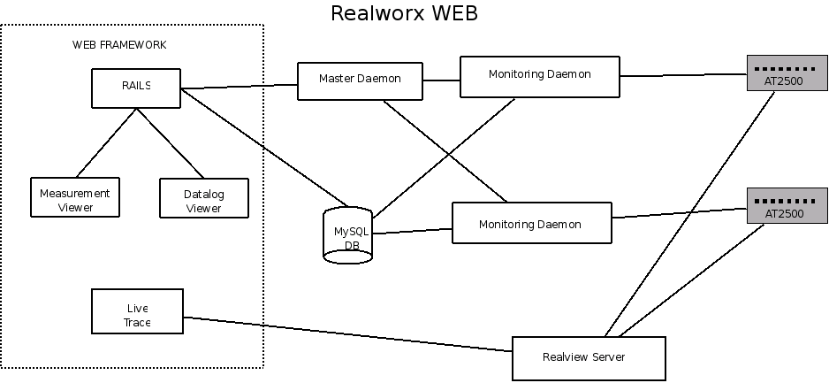
Figure 1.

Figure 1 shows the main components of realworx application. They consist of the Web framework, Master Daemon, Monitoring Daemon, Realview Server, and the AT2500s themselves.

The Web Framework consists of a ruby on rails based application with three flex applications. The Web Framework provides the UI and the DB interface for running realworx reports. It also triggers starting monitoring , stopping monitoring, and upgrading of the AT2500s by communicatin with the monitoring and master daemons. To make the system scalable in the 2.0 system the web framework will have a single server. All access to the application will go through this server .

The realVIEW server is based on the codebase of the windows version of realworx 2.*. Realview is the only threaded application in the realworx system..
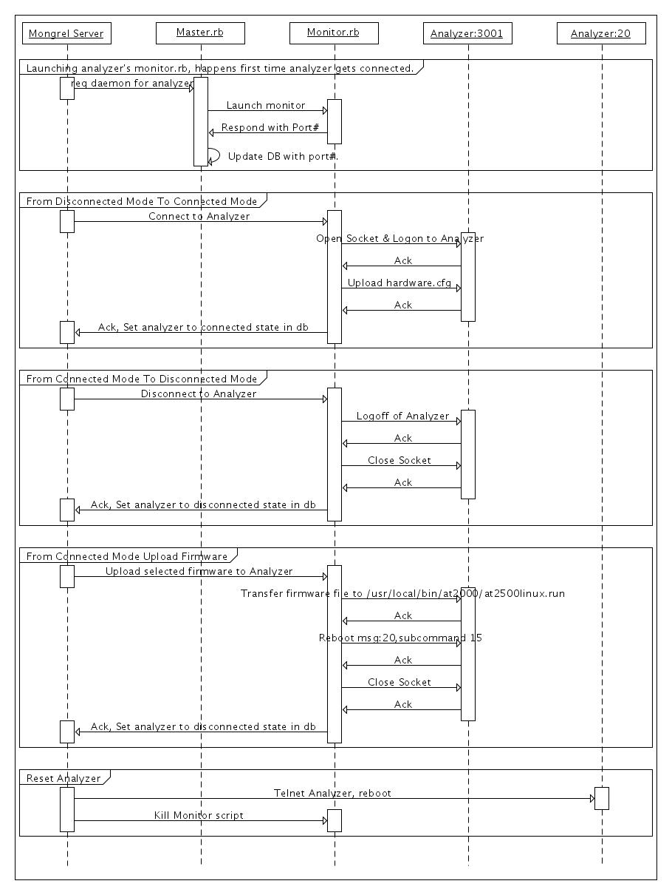
Figure 2.
The Master Daemon’s Job is to start the monitoring daemons and to make sure they stay up and running. It is constantly polling the monitoring Daemons to make sure they are up. If after 5 tries with 10 seconds between each try the monitoring daemon does not respond then the master daemon will relaunch the monitoring daemons. What keeps the master daemon running is a cronjob script run every 5 minutes. The Master Daemon is simple in its algorithm to minimize the introduction of bugs. If a new analyzer is added when the the user attempts to start monitoring the first time it is the master daemons job to start the monitoring daemon the first time. See figure 2 for more details
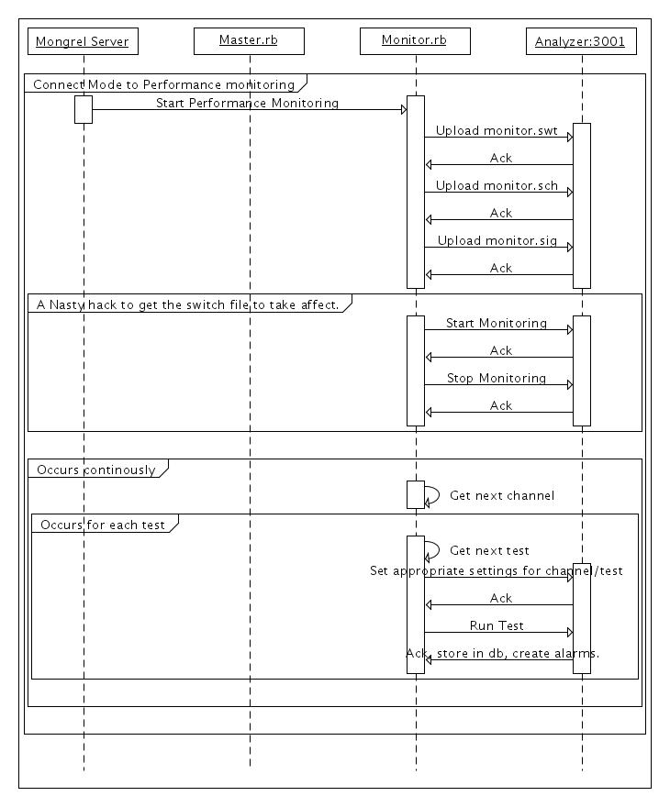
Figure 3
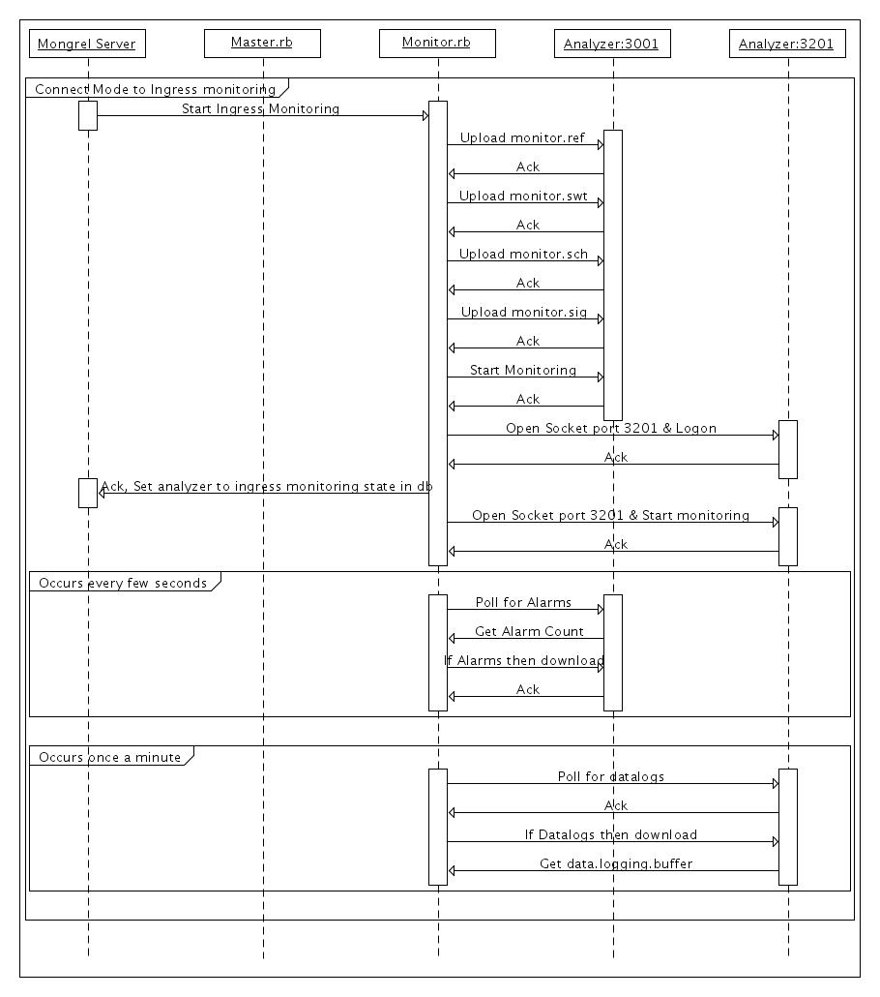
Figure 4

The Monitoring Daemon is responsible for all communication with the analyzer (other than the live trace feeds.) It has minimal communication with the web application. The web application could tell the monitor.rb process to start and stop monitoring or upload a firmware file to th analyzer.
The monitoring daemon responds by either an ‘ACK’ and it current state over the socket and then updates it state, errors and data from the AT2500 to the database. Both Monitor.rb and master.rb contain small web servers so that all commands they receive are through the web application. In theory you could trigger a monitoring application without going through the ruby on rails application by typing in the monitor.rb’s ip, port number and path in a web browser. The security risks of this were minimal on single server version because we could limit access with a firewall but security risks need to be considered for the multi-server version of the application.

- Related Documents
The following are considered to be part of the Product Requirements Document. They may be written as stand-alone documents and included here by reference, or may be embedded as sections within this document.

  - Design Plan Document
Please refer to the RealWorx_DesignPlan.doc. This contains resource allocation and schedule information. This document will reside in subversion.
.

  - Test Plan Document
Product Verification will prepare a Test Plan document, including an overview of the approach to verify that all the specifications in the MRD are met. The Test Plan will also include a Compliance Matrix, indicating how each requirement is tested and the applicable section of the test plan for that requirement. This document will reside in subversion.

We are planning on implementing the following items as part of the test plan:
- Verification test plan will require a Test Requirements Document based on the PRD from engineering.
- Validations test plan will test to the MRD and how the customer will use the product.
- Test Requirements Document should not include vague specs or product proof of design tests i.e. battery life or charge times etc…

  - Others
N/A

- List of Features
The Realworx MRD Rev C from 2008/9/18 will be used as a reference.
The list of realworx features are in the PRTable.xls document.

  - UI Changes

R0950 – Where ever sites are located in a report display nodes. Wherever nodes are visible in a report show sites. If the analyzer or switch is removed at a later date then just leave the node blank.

Whenever you select a site on a flash screen give user the option to do a search by a partial site name or by a node name.

R2390 – Ping Dashboard being added.
  - Admin

Bug 6507. We need to add a screen to the admin screen to allow user to delete datalogs, measurements, alarms and down_alarms. This screen will have 4 buttons each will trigger a truncate on one of the tables mentioned before. The admin role will have permission to this screen.

Bug 6545 – No paging is provided in the current user listing screen. You can only see the first 10 users. This needs a pagin mechanism similar to what we’ve done for alarms.

Bug 6589 – The delete validation needs to be modified for sites and profiles to not allow deletion if they are referenced in other places.

R0900 – Need to add concept of Region and System to the application. All analyzers will be part of a specific system and region. The Region is a superset of systems. Users will be given visibility to Systems. When they have visibility to a region they will be able to execute their assigned roles on the analyzer’s who are part of their system. So an admin will be able to stop and start monitoring on a particular analyzer in his systems or a tech will have access to the data or alarms associated with his system.

R3490 – Need two buttons on the analyzer screen to reset testplans and profiles to use analyzer setting.
R2350 – Switch Verification System. Have system loop through all ports on analyzer in the order of their numbers and allow installer verify switches are in the correct order.
R2360 – Replaced with nominal measurement feature
R2380 – Send SNMP Traps on demand. This allows installer to test snmp configuration.
R3230 -

  - AT2500 Web interface
Will be used to replace winremote and provide to videotron and other customers one interface access to all their system. Will be similar to what we did with livetrace. Will implement Avantron protocol.

  - Clear Path
R3800 & R3820 - Clearpath is an interface to another product. The API has not been defined or reported by the customer yet. This should be treated as a separate project.
  - Datalog Viewer
Bug 6412 – Videotron had a case where avg and min were swapped when the user moves the cursor over a point on the ingress view. I have not been able to recreate this. It may have been fixed.
Bug 6467 – When in profile edit mode if user saves a profile and the profile is not associated with the currently selected site then offer to assign it to the analyzer/port assocated with the current site.
Bug 6506 – Recent Trace bug is not being displayed.
Bug 6553 – Clear Peak hold in live trace when you switch sites. We have a button to do this, we just need to run its code when we switch sites.

  - Downstream Config
Bug 6553 – Fix the ENM and EVM limits. Need to modify the System Editor so that the enm/evm limits are in the correct range (one has only an upper limit the other has only a lower limit.) And we need to change the measurements.yml file to synchronize with the system file.
R1000 – A major code change. Possibly the largest change. Requires different limits for different channels on the same port. Requires a major db change and a major shift in how we do things.
R2740 – Estimate time it takes to do measurements.

  - Downstream Daemon
Bug 6409 – fixed
Bug 6558 – For MER code if there is a tolerance > 0 and there is a alarm that occurs between the Min value and the min + tolerance value then it crashes the analyzer. For every minor alarm we calculate the range the measure must be in. We do this for both max and min. since MER has no max the max value is nil. We do a calculation “max-tolerance” which crashes monitor.rb (nil-value is not allowed)
Bug 6559 – DCP too high initially. I believe this is because we were ignoring the attenuation for downstream. I think we have it fixed in build 1182 but we need to PV this heavily.
R0130-R0298 – some new measurements and some existing measurements. For the new measurements we need to wait for the AT2500 code to be changed so we can trigger the system file autotest remotely and grab the result.
R1910 – Datalogging feature for consteallations. Will store constellations as blobs in the database. Will require significantly more db space. Need to make some calculations for a months worth of data.
R2350 – Switch verification mechanism. Loop through all ports on a switch and pause for a second. The installer will stand infront of the analyzer and verify that each port is hit in the expected order. This is to verify that the switches are not swapped.
R2360 – Verify measurements by looping through channels but need to know how this is different from taking nominals
R2380 – Create an option on the admin screen to trigger an snmp trap to verify snmp is configured correctly.
R2390 Ping Dashboard. Put off until the future. We need to know more detailed design/screen for this.
R2480 – Needs more detail on how to do the sequential testplan. I suggest we put this off into the distant future.
R2600 – Reduce scan time is also dependent on the AT2500 changes. Will require changes to the AT2500 to be able to run the system file testplan remotely
  - Ingress Config
R3460 – Multiple Masks. Assumption is masks will not overlap In frequency. We will merge masks together and upload the combined profile to the analyzer. Where no mask is drawn we will set the frequency range to the attenuation value.
  - Ingress Daemon
R2420 - Incorporate alarm storm prevention. This was done in 2.4, The implementation method was not documented. I have found the undocumented transaction to set this up but have not tested it.
R3230,R3240 – Multiple mask mechanism. Will require masks to not overlap frequencies. Internally we will merge masks into one mask that will be uploaded to the analyzer. When an alarm occurs the system will identify which profile triggered the alarm.
R3280 – A table made up of 4 columns. The first two columns will define the start and stop frequency. The third column will be a dropdown for the profile selection. The fourth column is where the user will enter the value

  - Ingress Report
R3510-R3630,R4200,R4210, R4230 – Profile scoring based on specific ranges. We need to be able to configure the ranges by analyzer or port. Maybe build it into the profile mechanism. Then we need to calculate these by getting the average values in these frequency ranges. We can leverage the latest version avgarray udf function we created in mysql to do a log of this
R3450 – Alarm report which profile it occurs against.
  - Licensing
Bug 6508 –Currently licensing does an ifconfig to get a list of mac addresses that the application could be licensed for. This only shows active interfaces. If the application was licensed for eth0 and the customer only uses eth1 then the application will act as if it was not licensed. We need to use the ‘ifconfig –a’ function to get the list of all interfaces whether they are active or inactive.
  - Live Trace
Bug 6418 – No visual indication that there is not any analyzers available other than an empty dropdown box. Should show an alert box that gives a warning. This happens when no analyzer are in ingress monitoring mode
R3400 - Display mask on the realVIEW live trace
R3570 – Zoom capability on live trace and store setting with name so customer can recall configuration.
R3580 – Modify livetrace to be able to default to a site specified in the URL.
R3585 – Allow zooming by frequency in live trace. May be difficult to implement with the way we display live trace.
R3590 – Show profiles on the realVIEW traces. Protocol already exist in flex. Just not used in application.
  - OS Admin
Need some sort of process management procedure. Suggest we add some features to the setup script to simplify this from the backend terminal. A web interface is discouraged because we put the system at risk when we give web server ability to kill processes.
  - Overall Gui –
Bug 6409 -Longer site names. DB changes made in trunk. Need to restructure Flex layout so we allow longer site names.
Bug 6595 – Replace dropdowns of site name in the flash apps with a hyperlink on the site name. This will give more real estate to display site names. Then when user clicks the site name they will get a dialog box to select a different site site by either a dropdown, search or lookup by analyzer/port.
R0910 – Site name extended, Done in trunk already. Need to verify
R5460 – Multilingual settings . Longer term project but will start with new code and setup the necessary infrastructure.

  - RPM
Bug 6512 – Migrations not run when new release is made. Must be run manually. Only done on install. Need to fix this
  - Server Scalability
R440-R460 – With the introduction of Region we will have an organization technique to spread analyzer monitoring across multiple servers.For each region there will be a single server and there will be a master server for the UI. We also have the potential to split out the database to a separate server. This server will consists of a master.rb and possibly a database that will synchronize with the main rails server. A monitor.rb will be started for each analyzer on this server. Similar to what is being already done. No changes are necessary to the monitor.rb script because it already takes commands through a http protocol. The master.rb needs to be modified so it only pays attention to the analyzer in its assigned region. The rails app needs to be modified to support this and to not assume the same localhost as the location of master.rb. We may also need to put a realVIEW daemon on each Regional server
  - SNMP
R2210,R2230,R5140,R5150 – chaning what info is embedded in the snmp traps. Already sending out SNMP traps.
  - User Control
R0830,R0840 – Ability to kickout and Monitor Users.
  - General Daemon

R5410 – Auto reconnect when system is disconnected

R5412 – Able to set on/off reconnect with ability to set timer.
  - User Settings –
R1990-2150 - Ability to Remember what the last settings were for the flex/flash report view so when they return the flex application returns to those settings. Also have the ability to save those settings under a name that they can return to.

- Categories of responses
  - Why?
We’ve categorized tasks into 3 areas: done, Complete in Q1 and Future. The complete in Q1 is marketings request and not an actual schedule.
  - Complete in Q1
This consists of Requested features from Virgin Media, Videotron and bugfixes. Features marked in Q1 are well understood and have the appropriate assumptions associated with them in the table.

  - Future
Consist of items that I have no idea will work because
They require changes to how web sessions work.
Requires risking security for convience.
Touches every single User interface and risks creating numerous bugs.
Requires changing the functionality of the AT2500 autotest.

- Non-compliance

- Limitations
There are none. RealWorx Rocks!

