Author: | Kendall Robinson | Project Name: | RealWORX WEB v2.0
Revision: | 10 | Project Code: | 080710—ATL—001
Date: | August 10, 2008 | Project Manager: | Kendall Robinson

Revision History:
List each revision and give a brief description of the reason for the revision.
Rev.  Ltr. | Reason | Date | Author
A | Improvements planned for RealWORX Web Ver. 2.0 | Jul 10, 2008 | Kendall Robinson
B | Finalize Improvements planned for RealWORX Web Ver. 2.0 | August 10, 2008 | Kendall Robinson
C | Highlight Videotron Priorities from their RFP list and redefine a few sections for Ver. 2.0 | Sept 15, 2008 | Kendall Robinson
D | Added R3590, R3490, R3585. Changed R1910. | Sept 19, 2008 | Kendall Robinson
E | Added NEW Requirements R0950, R2390.  Moved the following requirements to do in this next phase:  R2330, R2340, R2350, R2360, R2380, R2390, R3230, R3240, R3280, R3400, R3450, R3570, R5410, R5412 | October 21st, 2008 | Kendall Robinson

Electronic File Summary:
List any supporting documents. Include a brief description of the contents, such as: Functional Specifications, supporting annexes, RFCs, specifications, etc.
File Name | Application | File Contents

1. Executive Summary 4
1.1. Customer 4
1.2. Market 4
1.3. Problem & Solution Statement 4
1.4. Expected Revenue 5
2. Opportunity 5
2.1. Problem statement 5
2.2. Solution Statement 6
3. Market Analysis 6
3.1. Market Size 6
3.2. Targeted Customer Profile 8
3.3. Customer or Other Participants 8
3.4. Strategic Fit 8
3.4.1. Division Strategy 8
3.4.2. Sales Channel 9
4. Voice of Customer 10
5. Product Requirements and Specifications 16
5.1. Product Description 16
5.2. High-level UI Definition 17
5.3. Key Features and High-Level Specifications 17
5.4. General overview and requirements 22
5.5 Hardware Architecture 22
Target Platform. 22
Network Environment. 22
5.6 Software architecture and application database 22
5.7 Ingress Monitoring Logging / Data handling 22
5.8 Forward Monitoring Logging / Data handling (Downstream - Analog and Digital) 22
5.9 Graphing Function 39
5.10 Remote Client Access 45
5.11 Compatibility with previous versions 45
Security 45
5.13 Option Sets and Ship Kit 29
5.13.1 Option Sets 29
5.13.2 Ship Kit and Product Packaging 29
5.14 Feature Rollout Priorities 29
5.15 Regulatory Requirements and Certifications 29
6 Competitive Environment 47
6.1 Competition and Alternative Solutions 47
6.2 Points of Differentiation 49
6.3 Technical Alternatives & Risk Assessment 50
6.4 Product Positioning in the Market 50
7 Business Case 50
7.1 Impact On Life Cycle 50
7.2 Value Proposition 50
7.3 Three Year Forecast 51
7.4 Preliminary Timeline 51
7.5 Configurations and Preliminary Pricing 51
7.6 Early Opportunities 52
8 Annexes 52
8.1 Annexes – References and Specifications 52

- Glossary of Terms

Ingress Alarm Profile: This is the limit reference trace that is created when setting up ingress monitoring limits. All alarms are triggered a specified limit distance from the baseline reference trace.

Alarm Thresholds: This is the relative/absolute level at which each of these alarms will trigger. This refers
- Major: The relative alarm level 3 above the baseline reference trace at which this alarm will trigger. (This should be a linear amount above the reference trace)
- Minor: The relative alarm level 2 above the baseline reference trace at which this alarm will trigger. (This should be a linear amount above the reference trace)
- Link-Loss: This is a straight line absolute alarm level (dBmV) at which this alarm will trigger. This will be set in the area of low noise and will trigger when the noise falls below this level.

Appliance Server: This is the term we will use when referring to our Linux based Server.

SNMP definition: Simple Network Management Protocol. The network management protocol used almost exclusively in TCP/IP networks. SNMP provides a means to monitor and control network devices, and to manage configurations, statistics collection, performance, and security.

SNMP trap definition: A notification event issued by a managed device to the network management station when a significant event (not necessarily an outage, a fault, or a security violation) occurs.

SMTP: Simple Mail Transfer Protocol is a core Internet protocol used to transfer e-mail messages between servers and devices.

Task Scheduler: This is the function within the software that allows the user to share monitoring tasks. For example: The user can share time between Forward and Upstream Monitoring tasks.

Test Plans: This will refer to the test plan created by the realGATE application to run remote test sequences on remote devices.

- Executive Summary

  - Scope:

This document addresses the marketing requirements for the Sunrise Telecom realWORX WEB 2.0 monitoring system. This document defines the functional improvements required to realWORX WEB 1.1 by Virgin Media, UK, Videotron, Quebec and other improvements requested by customers. These improvements will offer great value to other customers in the future and will allow us to define a unique set of features that will make realWORX WEB further stand out from our competitors.

  - Customer
The target customers in general are all Cable TV MSO’s, Cable operators and Telco companies. The targeted Telco companies will be narrowed down to those delivering broadband cable television and cable modem services.

  - Market
The realWORX WEB application can be located anywhere in the cable operator’s IT network and will connect to all AT2500HM/HMQ analyzers at both the head-end and hub site locations.

  - Problem & Solution Statement

Problem:

The current version of realWORX WEB 1.1 needs some additional enhanced features to improve and leverage the existing test equipment.

These improvements include:
- Allow existing monitoring analyzers to go out of monitoring mode when a live connection is requested.
- Add additional measurements to the scope of the downstream measurements.
- Fix list of bugs and feature improvement requests.
- Add more monitoring profiles (MASKS) for ingress monitoring and allow these to alarm independently to alert users of more specific ingress events like CPD and laser clipping events.
- Improve server scalability.

Solution:

The project scope is divided into three parts.
- The first is improvements to the Software. This will include GUI, scale type improvements, server scalability and controlling the analyzer direct connection requests.
- The second is the AT2500 firmware. This will include command protocol improvements and interfaces to the new auto-test function. This will enable us to get many more measurements from the analyzer like CSO, CTB, CCN and QIA measurements.
- The third is the web-interface on the AT2500. This will allow direct remote control of the analyzer of all functions. When you need a live connection, the realWORX WEB interface will allow you to choose an analyzer and the software will stop monitoring and force monitoring to resume when the connection is closed again.

  - Expected Revenue
- Preliminary MRD
This is a first-pass, order-of-magnitude, best-guess estimate of the annual revenue potential for this product

Table 1: Sales Forecast by Region
 | 2008 |  | 2009 |  | 2010 |  | Total
 | Qty | $ | Qty | $ | Qty | $ | Qty | $
NA | 10 | $1,000,000 | 15 | $1,500,000 | 20 | $2,000,000 | 45 | $4,500,000
Europe | 1 | $100,000 | 4 | $400,000 | 10 | $1,000,000 | 15 | $1,500,000
Asia | 8 | $800,000 | 8 | $800,000 | 10 | $1,000,000 | 26 | $2,600,000
Australia | 1 | $100,000 | 3 | $300,000 | 3 | $300,000 | 7 | $700,000
Other | 30 | $3,000,000 | 30 | $4,000,000 | 30 | $3,000,000 | 90 | $9,000,000
Totals | 50 | $5,000,000 | 60 | $6,000,000 | 73 | $7,300,000 | 183 | $18,300,000

    - Assumption 1: Base cost $ 100,000. (Includes: AT2500HMQ, switches and server)
    - These sales estimates do NOT include additional sales from other Sunrise products that can also tie into realWORX. (e.g. CM2000, CM2800, CM3000 etc)
    - Assumption 2: Year 2008 will only reflect partial sales starting second quarter.
    - Assumption 3: RoHS and other improvements will be required for the AT2500 in order to take sales beyond Q2, 2009.

- Opportunity
  - Problem statement

Downstream Live Measurements:

When a problem is found in the downstream analyzer, customers want to view live data and make real time measurements. For example they want to look at constellation, spectrum and live scan. The suggestion is to do this in a direct connect mode using a built in web server on the AT2500 to control all functions. When the customer is done with this mode the analyzer should automatically go back to monitoring mode.

Server Scalability:

The current version of realWORX WEB 1.0 can only handle 20 analyzers per server. We need to make this solution scalable to allow several server’s to be viewed from a single URL. RealWORX WEB 2.0 should handle this function.

Multi-Language Support
The current realWORX WEB 1.0 version does not offer multi-language options. As our products are sold to more international locations more customer requests are heard to support multi-language options in our applications.

  - Solution Statement

New Proposed RealWORX features:
We will also take this opportunity to improve features in realWORX WEB 1.1. This will make the product more marketable and will gain additional customers who would not otherwise have purchased realWORX WEB for its current monitoring ability.
These new features are as follows:
- Allow existing monitoring analyzers to go out of monitoring mode when a live connection is requested.
- Fix list of bugs and feature improvement requests.
- Improve server scalability.
- Add new measurements and command protocol to the scope of the current downstream monitoring system. (CSO, CTB, CCN and QIA).
- Add Multiple Profile Masks and specific event alarming to the ingress monitoring system. (Laser clipping and CPD events). We should add more templates (masks). We should also consider adding features like % of threshold breach, length of time threshold was breached, what frequency (‘s) were breached.
- Add reporting tools and provide template for Excel to extract this data to a spreadsheet.
- Allow for multilingual options. These languages may include: English, Chinese simplified, Chinese traditional, Japanese, Korean, German, Italian and Spanish.
- Add Task Scheduler feature.
- Look into feasibility of integrating IneoQuest (Cricket platform) to the performance monitoring.

- Market Analysis

  - Market Size
In order to calculate the realWORX WEB sales potential it is helpful to estimate the number of cable modem, digital service subscribers and VoIP customers. This will give us a good idea as to the urgency the cable companies will place on the monitoring of these types of services.

Also according to Kinetic Strategies as of Q1, 2005, there were 24.4 Million Cable Modem subscribers in North America (including Canada) and they are broken down as follows.

Q1 2005 North American Cable Modem Subscribers by MSO
Source: Kinetic Strategies Estimates, Company Reports

Cable MSO | CM Subs
Comcast | 7,408,000
Time Warner Cable | 4,122,000
Cox | 2,748,659
Charter | 1,978,400
Cablevision | 1,440,579
Adelphia | 1,400,000
Bright House | 750,000
Mediacom | 407,000
Insight | 367,800
RCN | 235,000
CableOne | 197,378
Other | 330,000
Total U.S. | 21,384,816
Shaw | 1,111,000
Rogers | 988,300
Videotron | 530,000
Cogeco | 276,500
Other | 175,000
Total Canada | 3,080,800
Total North America | 24,465,616

The top 100 US cable operators contains a combined total of 50 million subscribers which is 68% of the total US subscriber count.

Today there are 10,273 headends in North America. Each headend may support one or more remote distribution points, called hubsites.

North American market potential for monitoring systems can be based on this head-end count as well as the 24.4 Million cable modem subscriber count.

Head-ends..................................................10,273
Cable Modem subscribers..........................24,465,000
Total North American Subscribers..............50,000,000
Actual Subscribers estimated per node.....300 (Based on 500 homes passed per node and the estimated 60% penetration rate is the US)
Estimated node count..................................167,000
Total Market for monitoring is estimated as follows:
Hardware Equipment…10,273 (One per headend)
Minimum Switches…….11,000
Software and Servers…10,273

Estimated Market size: Total $491Million

  - Targeted Customer Profile

    - Primary Customers
Primary US based CATV customers, in order of market share, are Comcast, Time Warner, Cox, Charter, Cablevision, Adelphia, Bright House, Mediacom, Insight, RCN and Cable One.
Within these Primary Customers, the RealWORX WEB system will be used by Headend Technicians and Field technicians to provide monitoring of upstream and downstream nodes in order to isolate problems. Downstream measurements are used to confirm Headend and hub performance and to create up-to-date POP reports to the FCC and trending analysis to use for preventative maintenance.
    - Secondary Customers
The secondary customers are as follows:
International customers. NTL, SkyPerfect, JCOM, Virgin Media.
An additional secondary market is the converging telecom industry who are also providing RF CATV connections to their customers. (ViOS) Verizon should be our first secondary customer on this list and we will leverage our current business relationships with them to gain RealWORX acceptance in this industry. We should look closely at the requirements of this market and look at providing a specific subset of their required downstream RF measurements as well as reverse ingress monitoring. We must look at the specific test / compliance requirements for this industry.

  - Customer or Other Participants

We should choose four key customers to evaluate the Beta version of realWORX 3.0. in late Q2. They should be taken from this list of current realWORX customers. We should also have at least one international customer.

Verizon Laboratories – Waltham, MA
Cox – Las Vegas, NV
Cox – Omaha, NE
Videotron – Montreal, Canada
Time Warner – Waco, TX
Comcast – Memphis, TN
Cable West – Japan
Skyperfect TV– Japan
NTL– UK

  - Strategic Fit

    - Division Strategy
The Web-based realWORX WEB system from Sunrise Broadband is very strategic because it promotes the possible integration of all AT2500 products. The Web based platform makes it easier to use and control devices over a wider area. Due to this fact customer will see the benefits and considering adding new devices to their system.
We should be able to leverage incremental sales from existing realWORX customers and capture new customers with unique product features that will be added to the new realWORX WEB system.

    - Sales Channel
The current sales representative channels will need to be better educated in order to sell the next generation of realWORX WEB product effectively. The current realWORX product has been very confusing for the sales channel to grasp. The realWORX system being comprised of many devices, servers and a host of applications and specific setup sequences is just one of the many previous challenges when arranging a live customer demo.
The Web-based application will make realWORX WEB technical demonstrations much simpler and reduce the demo cost. It will be possible to offer ‘webinars’ or give multiple customers simultaneous access to a live realWORX WEB system without the concern of locking out connections already in use.

    - Marketing Strategy
This product should be marketed from three angles. (a) As a monitoring system for upstream ingress and downstream signals and (b) As a measurement system for downstream signal verification. (c) As a return path hardening and maintenance tool. Currently we only market realWORX WEB as a monitoring system and some customers cannot get corporate purchasing approval for realWORX because they already own a competitive ingress monitoring system. (For example: JDSU – Pathtrak).
There is a market opportunity for a measurement system that can connect many RF devices and make the required FCC / RF measurements at many locations in the network. The realWORX system should be easy to configure and make POP measurements or any selection of required downstream measurements quickly and easily. This should connect to our RF devices and measure the signal parameters in the head-end and the field. No other vendor does this and we have a unique opportunity to enter the market with this as an advantage.

We should also strongly promote our ingress monitoring system as a tool that can notify users of unique conditions that occur within the cable or telco plant.

For example: We can provide alarming for laser clipping events and do this by identifying peak events at the laser’s harmonic frequencies above 65MHz. Competitive products are limited by their frequency range (below 65MHz) and cannot achieve monitoring of this type of event. This requires that we monitor from 5 to 200MHz and allow field devices to have the option to view 5 to 45MHz or the full span.
We should promote this feature to highlight the unique ability of the realWORX ingress monitoring system. (Advertisements should read: “Does your RF monitoring system notify you when you have a laser clipping event or Common Path distortion event?)

- Voice of Customer

Videotron Requirements

 |  |  |  | RealWorx - HFC forward and return path monitoring
 |  |  |  | Vidéotron requirements - 2008-07-09
Reference | Sunrise Requirement Number | Affects | Status | Description | Priority | Roadblockers | Status VL
RFP 4.1.01 |  |  |  | Carrier level (dBmV) measurements. |  |  | Tested
RFP 4.1.02 |  |  |  | CATV Video and Aural carrier level measurements (dBmV). |  |  | Tested
RFP 4.1.03 | [R0130] | AT2500 |  | Carrier-to-Noise (C/N) measurements. | 4 |  | Not available
RFP 4.1.04 | [R0135] – [R0144] | AT2500 |  | Composite Second Order measurements. | 4 |  | Not available
RFP 4.1.05 | [R0144] – [R0150] | AT2500 |  | Composite Triple Beat measurements. | 4 |  | Not available
RFP 4.1.06 | [R0155] | AT2500 |  | Depth of modulation. | 4 |  | Not available
RFP 4.1.07 | [R0152] | AT2500 |  | HUM measurements | 4 |  | Not available
RFP 4.1.08 | [R0166] | AT2500 |  | FM Deviation. | 4 |  | Not available
RFP 4.1.09 |  |  |  | Frequency Measurements. |  |  | Tested
RFP 4.1.10 |  |  |  | Frequency Shifting Measurements. |  |  | Tested
RFP 4.1.11 |  |  |  | Noise Floor Measurements. |  |  | Tested
RFP 4.1.12 | [R0157] | AT2500 |  | Spurious Signal Measurements. | 4 |  | Not available
RFP 4.1.13 | [R0159] | AT2500 |  | RF level of QPSK carrier. | 4 |  | Not available
RFP 4.1.14 | [R0160] | AT2500 |  | Frequency of QPSK carrier. | 4 |  | Not available
RFP 4.1.15 | [R0165] | AT2500 |  | Carrier-to-Noise (C/N) of QPSK carrier. | 4 |  | Not available
RFP 4.1.16 |  |  |  | RF level of QAM16/QAM64/QAM128/QAM256 carrier. |  |  | Tested
RFP 4.1.17 |  |  |  | Frequency of QAM16/QAM64/QAM128/QAM256 carrier. |  |  | Tested
RFP 4.1.18 |  |  |  | Carrier-to-Noise (C/N) of QAM16/QAM64/QAM128/QAM256 carrier. |  |  | Tested
RFP 4.1.19 |  |  |  | Scan RF channels in the downstream band (50 - 1000 MHz). |  |  | Tested
RFP 4.1.20 |  |  |  | Scan RF channels in the upstream band (5 – 50 MHz). |  |  | Tested
RFP 4.2.1 |  |  |  | QPSK Demodulation. |  |  | Not available
RFP 4.2.2 |  |  |  | QAM16/QAM64/QAM128/QAM256 Demodulation. |  |  | Tested
RFP 4.2.3 |  |  |  | Modulation Error Rate (MER) (dB). |  |  | Tested
RFP 4.2.4 |  |  |  | Bit Error Rate (BER). |  |  | Tested
RFP 4.2.5 | [R1925] | ATWebserver & RWX WEB | Stored & Live | Display the constellation. | 3 |  | Not available
RFP 4.2.6 |  |  |  | Symbol Rate (symbol/sec). |  |  | Tested
RFP 4.3.1 |  |  |  | Equipment must be rack mountable (19” W). |  |  | Tested
RFP 4.3.2 |  |  |  | I/Os must be F-connector type. |  |  | Tested
RFP 4.3.3 |  |  |  | Impedance of I/Os must be 75 Ω. |  |  | Tested
RFP 4.4.1 |  |  |  | Frequency band from 0 to 1000 MHz |  |  | Tested
RFP 4.4.2 |  |  |  | Span 0 to 1000 MHz |  |  | Tested
RFP 4.4.3 |  |  |  | Minimum sweep time: 200 ms (1000 MHz span and less) |  |  | Tested
RFP 4.4.4 |  |  |  | Resolution BandWidth (RBW): min 100 kHz |  |  | Tested
RFP 4.4.5 |  |  |  | RF input range must be between -63 dBmV and +72 dBmV. |  |  | Tested
RFP 4.5.1.0 |  |  |  | GUI based or WEB based. |  |  | Tested
RFP 4.5.1.1 |  |  |  | Must run on Windows 2000/XP stations. |  |  | Tested
RFP 4.5.1.1 |  |  |  | Automatic detection of specific pattern in the return path ( ex.: common path distortion, electrical noise, etc) |  |  | Not available
RFP 4.5.1.1 | [R3800] | RWX WEB |  | Must manually be able to control Electroline ClearPath switches through automatic testing. | 2 |  | Not available
RFP 4.5.1.2 | [R3820] | RWX WEB |  | Must be able to isolate automatically an ingress problem by opening successively the ClearPaths of a node. | 2 |  | Not available
RFP 4.5.1.3 |  | AT2500 |  | Display a live spectral trace of a forward channel (analog, QAM, QPSK). | 3 |  | Not available
RFP 4.5.1.4 |  |  |  | Real time display of alarms. |  |  | Tested
RFP 4.5.1.5 | [R5135] | RWX WEB |  | Real time GUI must be able to initiate / start from another application (through a command line batch file), and must be startable with a context centered on a testpoint. | 5 |  | Not available
RFP 4.5.1.6 | [R1925] | ATWebserver |  | Real time display of constellation | 3 |  | Not available
RFP 4.5.1.7 |  |  |  | Real time display of BER |  |  | Tested
RFP 4.5.1.8 |  |  |  | Real time display of MER |  |  | Tested
RFP 4.5.1.9 |  |  |  | Real time display of return path |  |  | Tested
RFP 4.5.2.01 |  |  |  | Must run under Unix (preferably Solaris or Linux) |  |  | Tested
RFP 4.5.2.02 |  |  |  | GUI based or WEB based. |  |  | Tested
RFP 4.5.2.03 |  | RWX WEB |  | Set threshold for all measurements mentioned in section 4.1 and 4.2. | 1 |  | Tested, but not working yet
RFP 4.5.2.04 |  | RWX WEB |  | Define a channel plan (set a start frequency, stop frequency, channel name, etc.). | 1 |  | Problem to define channel maps
RFP 4.5.2.05 |  | RWX WEB |  | Possibility to import/export a channel plan configuration from a command line application. | 5
RFP 4.5.2.06 |  |  |  | A minimum ON/OFF time must be held (or hysteresis) before sending SNMP TRAP (to avoid sending alarms continuously).
RFP 4.5.2.07 | [R0840] | RWX WEB |  | Interface to display the active clients connected to the system | 1 |  | Not tested supposed to be in 3.1
RFP 4.5.2.08 |  |  |  | Must be able to interact with an external open schema database (preferably Oracle), specifically for ClearPaths configuration, Channel plan configuration, testpoints configurations. |  |  | Not tested yet
RFP 4.5.2.09 | [R0900] | RWX WEB |  | Provide a grouping mechanism for the tespoint configuration (ex.: head-end). | 2
RFP 4.5.2.10 |  |  |  | Generate an alarm on the variation of the noise floor (return path) when noise increase over consecutive measurements. |  |  | Not available
RFP 4.5.2.11 | [R3630] | RWX WEB |  | Calculate a score for each testpoint (A,B,C,D,E) based on business rules. Store those scores in a database. The business rules must be user configurable. | 5
RFP 4.5.3.01 |  |  |  | GUI or Web base interface to retrieve data regarding an alarm. |  |  | Tested
RFP 4.5.3.02 |  | RWX WEB | Done??? | Command line access to historical data. |  |  | Not tested
RFP 4.5.3.03 |  |  |  | Make a historical datalogging for the forward path in a database (or flat files, etc.). |  |  | Tested
RFP 4.5.3.04 |  |  |  | Make a historical datalogging for the return path in a database (or flat files, etc.). |  |  | Tested
RFP 4.5.3.05 |  |  |  | Store historical data for each test point. |  |  | Tested
RFP 4.5.3.06 |  |  |  | Store historical data for all measurements enabled for one year. |  |  | Tested
RFP 4.5.3.07 |  |  |  | Store spectral curve when a threshold is crossed. |  |  | Tested
RFP 4.5.3.08 |  |  |  | Access data through standard ODBC interface.
RFP 4.5.3.09 | [R4200] |  |  | Generate a text based report of the testpoint scores for a specific period of time. | 5 |  | Raw data available. Need formating for report
RFP 4.5.3.10 | [R4210] |  |  | Generate a text based summary report for a group of testpoints for a specific period of time. | 5 |  | No report tool available. SQL query ?
RFP 4.5.3.11 | [R4230] |  |  | Generate a text based summary report of the last score of a group of testpoint. | 5
RFP 4.5.4.1 | [R0820] |  |  | LDAP authentication of users | 3 |  | Not available
RFP 4.5.4.2 | [R2150] |  |  | Create profile with restrictive rights (admin, user, etc.) | 2 |  | Tested
RFP 4.5.5 |  |  |  | Must support TCP/IP protocol |  |  | Tested
RFP 4.5.5.01 | [R2210] | RWX & AT2500 |  | The system must support SNMP protocol. | 1 |  | Not tested with V3.1. Was not working in V3.0
RFP 4.5.5.02 | [R2230] | RWX & AT2500 |  | The server must be able to send SNMP traps to customizable destinations (at least one destination) if parameters have reached thresholds (preferably 2 thresholds, minor & major) set by the user. | 1 |  | Not tested with V3.1. Was not working in V3.0
RFP 4.5.5.10 | [R5140 –R5150] | RWX & AT2500 |  | SNMP TRAP must contain the type of the TRAP (SET vs CLEAR). | 1 |  | Not tested with V3.1. Was not working in V3.0
RFP 4.5.5.03 | [R5150] | RWX & AT2500 |  | SNMP TRAP must be sent if the state of the event returns to the normal (clear TRAP). | 1 |  | Not tested with V3.1. Was not working in V3.0
RFP 4.5.5.04 | [R5150] | RWX & AT2500 |  | SNMP TRAP must contain monitoring point name. | 1 |  | Not tested with V3.1. Was not working in V3.0
RFP 4.5.5.05 | [R5150] | RWX & AT2500 |  | SNMP TRAP must contain date and time of the event. | 1 |  | Not tested with V3.1. Was not working in V3.0
RFP 4.5.5.06 | [R5150] | RWX & AT2500 |  | SNMP TRAP must contain current value of the monitored parameter. | 1 |  | Not tested with V3.1. Was not working in V3.0
RFP 4.5.5.07 | [R5150] | RWX & AT2500 |  | SNMP TRAP must contain threshold and condition of the monitored parameter. | 1 |  | Not tested with V3.1. Was not working in V3.0
RFP 4.5.5.08 | [R5150] | RWX & AT2500 |  | SNMP TRAP must contain the severity of the alarm. | 1 |  | Not tested with V3.1. Was not working in V3.0
RFP 4.5.5.09 | [R5150] | RWX & AT2500 |  | SNMP TRAP must contain the ID of the alarm. | 1 |  | Not tested with V3.1. Was not working in V3.0
RFP 4.5.6.1 |  |  |  | Access to historical data through a field test set. |  |  | Not tested yet
RFP 4.5.6.2 |  |  |  | Access to real time data through a field test set. |  |  | Not tested yet
RFP 4.5.6.3 |  |  |  | Simultaneous connection from field test set*. |  |  | Not tested yet
20080509-01 |  |  |  | Support for Clearpath control
20080509-02 | [R3510] – [R3540] | RWX WEB |  | Calculation of an average value for the noise floor level (in dBmV) for each ingress spectral trace. We want the system to calculate the average of the noise floor on the testpoint operational spectrum (ie.: 18MHz-35MHz) for each trace that the system analyze and store. This is used as a comparison metric between the traces, to do trending for a testpoint, and to compare testpoints between each others. The carriers shall be excluded from this analysis, ie: we want an approximation of the real noise floor, without considering the carriers level in the calculation. We already have a simple algorithm to exclude the carriers. The average value shall be included in the historical, and we should be able to do a report (graph and tabular) that shows the variation of the average value for a testpoint across time. We want to be able to export this information to external systems each hour (ex.: through an SQL query). To calculate the average, we first exclude the carriers points and the points that are outside the operational spectrum, then we sum all the remaining point levels and divide by the number of remaining point. | 1 |  | Not available
20080509-03 | Done | RWX WEB |  | We want to be able to define a default alarm template for the ingress traces. This template shall be assigned automatically when a new testpoint is added to the system | 2 |  | Not available
20080509-04 | [R3585] | ATWebserver |  | In the ingress realView, allow the user to set the spectrum settings manually (RBW. VBW, start/stop frequency) | 3 |  | Not available
20080509-05 | [R1990] | RWX WEB |  | Possibility to create user defined settings for the ingress realView  Ex.: DOCSIS_28 view -> zoom on the DOCSIS carrier located at 28MHz , with RBW=x and VBW=y, startfreq = 26.5 MHZ, stop freq= 29.5 MHz  EX: DOCSIS_35 view -> zoom on the DOCSIS carrier located at 35MHz , with RBW=x and VBW=y, startfreq = 34.5 MHZ, stop freq= 36.5 MHz | 3 |  | Not available
20080509-06 | [R0440] –[R0460] | RWX WEB | Server scalability project. | We need a common portal (front end) that will allow the user to logon, and that will make transparent the usage of multiple backend servers. | 3 |  | Not available
20080509-07 | [R0810] –[R0820] | RWX WEB |  | We need an admin tool to :  - Display the state of the running process (polling, etc)  - Display the name and IP address of users connected  - Allow the admin to kill a malfunctioning user connection  - Allow the admin to stop and restart a malfunctioning process | 2 |  | Not available
20080509-08 |  |  |  | Authentication of web users shall be done through an external LDAP server provided by Videotron. All users shall be authenticated.
20080509-09 |  | RWX WEB |  | In the historical ingress, we need 20 days of historical data (for frequency/level min, max, and average) |  |  | Not tested
20080509-10 |  | RWX WEB |  | Historical ingress data shall be exportable in CSV format |  |  | Not available
20080509-11 | [R3580] | RWX WEB |  | We want to access the realview page through a direct URL (ex: http://216.77.98.235/livetrace/SITE_NAME) | 2 |  | Not available
20080509-12 | [R5135] –[R5137] | RWX WEB |  | The numerical ID of the spectral trace associated to an alarm shall be passed into the varbinds of the SNMP trap that is sent northbound, so that it could be accessed through an external application (ex.: http://216.77.98.235/g_reports/alarm_trace_tag/484876) | 2 |  | Not available
20080509-13 | Done | RWX WEB |  | Improve the way that new testpoint are added. Need to be all on same web page (ex.: site creation vs assignment of the site to the switch). It requires too many manipulations. | 3 |  | Not available
20080507-01 | Done | RWX WEB |  | System Editor issue for updating RW3 (In SE, it's possible to upgrade only CM2000 module... not RW3) | 1 |  | Not available
20080507-02 | [R5150] | RWX WEB |  | SNMP trap content (like Alarms tab) | 1 |  | Not available
20080507-03 | [R1000] | RWX WEB |  | Multi channel plan / test plan / profile like RW2.X | 1 |  | Not available
20080507-04 | [R5460] | RWX WEB |  | Multi language for the regional settings | 1 |  | Not available
20080507-05 | [R0910] | RWX WEB |  | Mux (or other network element) name is too short for our requirement | 1 |  | Not available

Virgin Media Requirements

Reference | Sunrise Requirement Number | Affects | Sunrise Status | Description |  | Priority |  | Date needed |  | Customer Test Result
Enter Profile by means of table | [R3230] | AT2500 and RWX WEB | Planned for enhancement | Ingress Profiles. See definition of multiple profiles. Multiple alarm Masks are required. |  | 1 |  |  |  | Not available
Enter Profile by means of table | [R3280] | AT2500 and RWX WEB | Planned for enhancement | Ingress Profiles. Must be able to enter the profile by means of a table as well as the draw function. |  | 1 |  |  |  | Not available
Draw and Table Profile | [R3290] | AT2500 and RWX WEB | Planned for enhancement | Ingress Profiles. Both the draw method and table method of profiles should be included. |  | 1 |  |  |  | Not available
Display of Profile / MASK | [R3400] | AT2500 and RWX WEB | Planned for enhancement | Ingress Profiles. You should be able to visually see the designed profile / MASK overlaid on the trace. |  | 1 |  |  |  | Not available
Multiple Profiles | [R3460] | AT2500 | Planned for enhancement |  | Ingress Profiles. Multiple Masks, types, each should trigger a special alarm event. | 1 |  |  | Not available

- Product Requirements and Specifications

  - Product Description

MySQL Database

Redhat Linux O/S

2RU Server

Low noise from fans

RAID 1

Min 600GB storage (SAS 15K drives for quickest acquisition time)

Redundant power supplies. (Dual Redundancy)

    - Platform System Architecture

Figure 1 Hub Site / Head End System Diagram


AT2500HM
AT2500HMQ
AT2500HM/HMQ
AT1601
Server Appliance (Linux)
HUB Site
RS-232
RS-232
AT1601
RF
RF
B
A
Ethernet switch

Figure 2 Field Equipment Diagram

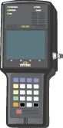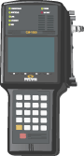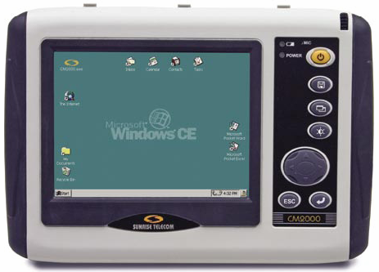
RFF
Field Instruments IINSTRUMENTS
CM1000
CM500
Cable modem
WinRemote
CM2000
Public Network

  - High-level UI Definition
Provide a high-level user interface description. Overall menu structure or hierarchy with major levels and user selections is appropriate. Logical groupings of setup or configuration selections may be included. Any special requirements, such as remote control or touch screens, should be described in this section.
This will be completed after the review process.

  - Key Software Features and Specifications

Table 4: Requirement Level Description
Must, Shall or Mandatory | The item is an absolute requirement.
Should, Strongly Recommended | The item is highly desirable.
May or Optional | The item is desirable, but not compulsory and may be implemented or not as dictated by the schedule or other determinants.

Table 5: Analog Measurement Requirements
Req. | Requirement | Measurement | Range | Precision |  | AT2500  Enhancement
# | Level
R0110 | Must | Visual Carrier Level (dBmV) | -40 to + 50 dBmV | 0.5dB |  | Done
R0115 | Must | Visual Carrier Frequency (MHz) | 5 to 1000 MHz | 1000Hz |  | Done
R0120 | Must | Aural Carrier Level (dBc) | -40 to + 50 dBmV | 0.5dB |  | Done
R0122 | Must | Aural Carrier Frequency (MHz) | 5 to 1000 MHz | 1000Hz |  | Done
R0124 | Must | 2nd Aural Level (dBc) | -40 to + 50 dBmV | 0.5dB |  | To do phase II
R0126 | Must | 2nd Aural Frequency (MHz) | 5 to 1000 MHz | 1000Hz |  | To do phase II
R0128 | Must | Average Power Level (dBmV) | -40 to + 50 dBmV | 0.5dB |  | To do phase II
R0130 | Must | CCN(dB) | 35 to 70dB | 0.1dB |  | To do phase II
R0135 | Must | CSO (dBc)…[worst case] CSO Offset (MHz) | 35 to 80 dB | 0.1dB |  | To do phase II
R0138 | Must | CSO Loc 1 (dBc)…CSO Offset 1 (MHz) | 35 to 80 dB | 0.1dB |  | To do phase II
R0140 | Must | CSO Loc 2 (dBc)…CSO Offset 2 (MHz) | 35 to 80 dB | 0.1dB |  | To do phase II
R0142 | Must | CSO Loc 3 (dBc)…CSO Offset 3 (MHz) | 35 to 80 dB | 0.1dB |  | To do phase II
R0144 | Must | CSO Loc 4 (dBc)…CSO Offset 4 (MHz) | 35 to 80 dB | 0.1dB |  | To do phase II
R0150 | Must | CTB (dBc)…CTB Offset 1(MHz) | 35 to 80 dB | 0.1dB |  | To do phase II
R0152 | Must | Analog Hum/LFD (%) | 0 to 10% | 0.1dB |  | To do phase II
R0155 | Must | Mod Depth (%/dB/IRE) | 60 to 90% | 0.10% |  | To do phase II
R0157 | Must | Spurious Signal Measurement | 35 to 80 dB | 0.1dB |  | To do phase II
R0159 | Must | RF Level of QPSK measurement | -40 to + 50 dBmV | 0.5dB |  | To do phase II
R0160 | Must | Frequency of QPSK measurement | 5 to 1000 MHz | 1000Hz |  | To do phase II
R0165 | Must | Carrier to Noise C/N of QPSK carrier | 35 to 70dB | 0.10% |  | To do phase II
R0166 | Must | FM Deviation | 0 to 6 MHz??? | 1000Hz??? |  | To do phase II

Table 6: HE Digital Measurement Requirements
Req. | Requirement | Measurement | Value | Res | AT2500  Enhancement
# | Level
R0172 | Must | Digital Channel Power | -30 to +65 dBmV | 0.1dB | Done
R0174 | Must | MER | 22 to 40 dB | 0.1dB | Done
R0176 | Must | Pre-BER | 1.0 x 10-4 to 1.0 x 10-12 | 1 dec | Done
R0178 | Must | Post-BER | 1.0 x 10-4 to 1.0 x 10-12 | 1 dec | Done
R0180 | Must | EVM | 0.65% to 4.1% | 0.10% | Done
R0182 | Must | ENM | 1 to 12 dB | 0.1dB | Done
R0184 | Must | SNR | 15 to 45 dB | 0.1dB | To do phase II
R0186 | Must | C / I | 20 to 45dB | 0.1dB | To do phase II
R0188 | Must | In Ch Freq.Resp. | 0 to 10 dB | 0.1dB | To do phase II
R0190 | Must | Echo Margin | 0 to 50dB | 0.1dB | To do phase II
R0192 | Must | Compression | 0 to 10 dB | 0.10% | To do phase II
R0193 | Must | Digital Hum | 0 to 10 dB | 0.10% | To do phase II
R0194 | Must | Phase Noise | 0 to 5 deg | 0.1 deg | To do phase II
R0195 | Must | I/Q Gain Diff. |  | dB | To do phase II
R0196 | Must | I/Q Phase Diff. |  | deg | To do phase II
R0197 | Must | Carr.Freq. Err. | -50 to +50 Hz | 10Hz | To do phase II
R0298 | Must | Symb. Rate Err. | 1000 to 10000Hz | 1Hz | To do phase II

Table 7: Requirements for Tree and Branch Architecture Map
System
Headend
Headend
Headend Spectrum
Hub
Headend Controller
Multiplexer
Combiner
Multiplexer
Multiplexer
Multiplexer (up to 16)
Headend Spectrum
Headend Controller
RF measurement
Probe
Field Location
Remote Probe
Field Location
Remote Probe
Other test device
Remote Probe
Other Test Device
Key
New
component

Table 8 Enhanced Measurements Planned for Phase II 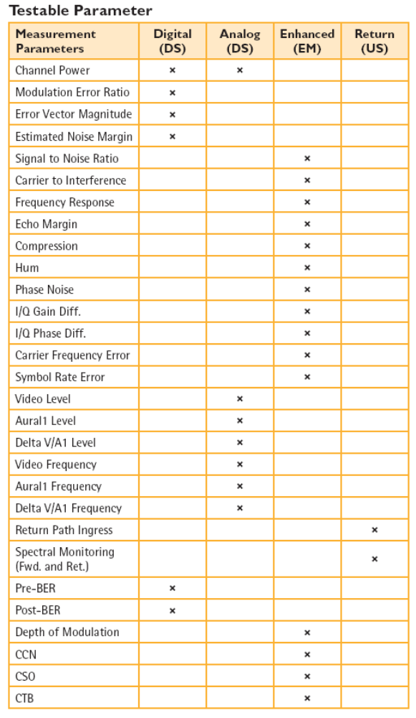

KEY

[Rxxx] Done

[Rxxx] To do in Phase II for Customer

  - General overview and requirements

    - Web based server appliance and Server Scalability Project
[R0400] The ‘Server Appliance’ shall contain the realWORX WEB application and database. The server will be configured as a single logical entity, storing up to one year worth of data.
[R0410] The server will include drive redundancy on the same server using RAID 1 with minimum size, 2 x 300GB SCSI hard drives per server as a standard configuration.
[R0420] The server will have a redundant power supply.
[R0430] The server will support up to 20 analyzers per server.
[R0440] The server will be scalable and will allow multiple servers to be configured as a scalable solution.
[R0450] A front-end portal is required both in the setup menu and dashboard type viewer to monitor the status of each back-end connected server appliance.
[R0460] Multiple realWORX WEB based servers should be able to ‘tie’ together as one seamless application. In other words the user should not have to enter multiple URL’s to access analyzers from another server.
[R0470] The alarms menu, historical ingress and Measurement Viewer should seamlessly tie these additional severs together into one application.

  - Software Architecture
    - Database
[R0600] We must provide customizable reports that extract information from the realWORX WEB MySQL database using a third party program like crystal reports or excel.

    - Data Collection
It must be understood that in order to always offer uninterrupted monitoring and data interval storage the analyzer will always have to remain in monitoring mode.
[R0610] For ingress data collection, each realWORX database shall support up to 20 / AT2500Hxx units per server. (in mixed configurations) This configuration will allow for 5,100 monitored nodes per server.
[R0620] The database shall be specified to support a defined network’s throughput and storage trace requirements for at least one year’s worth of data.

    - Enhanced Web based Admin Tool and Client Viewers

Administration ONLY control page

[R0810] An administration page should be added to show the state of each functioning process within the application. For example: Poling.

[R0820] On the admin page the name and IP address of all connected users should be shown. LDAP authentication of users is required. The administrator should be able to reset or ‘kill’ a malfunctioning user connection. The administrator should also be able to stop and restart any malfunctioning process.
[R0830] Web Client connections should be checked periodically to make sure the user is still using the function. The system should drop the connection if it has been idle for a designated time period. This idle time should be settable by the customer in setup menu.
[R0840] A plug-in interface should be built for RealWORX WEB to display the active clients connected to the system. Not all users should be able to see the user list. This privilege should be controlled by the administrator and user privilege menu.

[R0860] (Reserved for future software enhancements)

5.5.4 Search tool for choosing Nodes/Sites

Active search tool for Sites

[R0900] Must have filter and active search tool to quickly find a single site out of thousands. This should apply to both the Historical Ingress and the Performance Measurement windows.

The suggestion is to add a search criteria filter window above the sites button. If a phrase or number is entered, for example the number [ 21 ] then all site names with the number ‘21’ appearing anywhere in the string will only appear in the search list.

Allow a search by Groups of the following with a Radio selection button:

HUB Name

AT2500HM

AT2500HMQ

Note: Only Ingress Nodes should appear in the historical ingress screen and only performance nodes should be available in the performance measurement screen.

REF: RFP 4.5.2.09

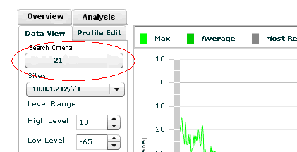

Figure 3a Search criteria (historical ingress)

5.5.5 Longer Site / Mux names
[R0910] Site Name is too short. Need site name with at least 20 characters. (Preferably 30)

[R0950] Site Name and Node Names should always be seen on the same screen.
- In Dashboard, when mouse hovers over a node, display the Port Name and Site Name.
- In Alarm Screen, add a column to the right of Site that includes Port Name.
- In Historical Ingress Screen, Add Port Name next to the Site Name Window.
- In Measurement Screen, Add Port Name next to the Site Name Window.
- In RealVIEW Screen, Add Site Name to Port Name
- In Setup screen, allow customer to easily print a Port Name and Site Name table. This could have the same look and feel as when you click on the switch name and see the following table. (See below)
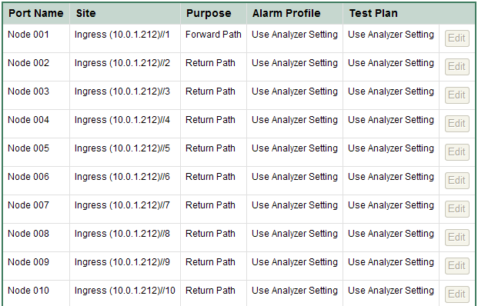

5.5.6 Multi Channel Plan / Test Plan
[R1000] The Nominal Learn concept should be used as this makes setup quicker and simplifies the multiple channel plan approach.

[R1020] Create a Table Matrix for each channel in Setup menu. The channel should be measured then the limits should all be shown in the setup block. (Fig 3b)
[R1030] Use this Table Matrix Concept to also display the performance results in the Performance Menu. It should be possible to click on the cell and have the measurement device stop monitoring and make an active measurement on the current cell. The user should be select ‘resume’ to get the regular performance monitoring sequence to start from where it left off. Note: It should NOT start from the beginning.

Figure 3b Proposed Setup / performance display function KEY

Major
Minor
Tolerance
KEY
Actual
Nominal
dBmV

VLevel
ALevel
V/A Level
V/A FREQ
CCN
DCP
MER
PRE-BER
POST-BER
D-HUM
1
Ch
2
3
4
5
6
Port
1
2
3
4
5
6
7
Major
Minor
Tolerance
KEY
Actual
Nominal
dBmV
4
2
dBmV
20
4
2
dBmV
20
4
2
dBmV
20
4
2
dBmV
20
4
2
dBmV
20
4
2
dBmV
20
4
2
dBmV
20
4
2
dBmV
20
4
2
dBmV
20
4
2
dBmV
20
4
2
dBmV
20
4
2
dBmV
20
4
2
dBmV
20
4
2
dBmV
20
4
2
dBmV
20
4
2
dBmV
20
4
2
dBmV
20
4
2
dBmV
20
4
2
dBmV
20
4
2
dBmV
20
4
2
dBmV
20
4
2
dBmV
20
4
2
dBmV
20
4
2
dBmV
20
4
2
dBmV
20
4
2
dBmV
20
4
2
dBmV
20
4
2
dBmV
20
4
2
dBmV
20
4
2
dBmV
20
4
2
dBmV
20
4
2
dBmV
20
4
2
dBmV
20
4
2
dBmV
20
4
2
dBmV
20
4
2
dBmV
20
4
2
dBmV
20
4
2
dBmV
20
4
2
dBmV
20
4
2
dBmV
20
4
2
dBmV
20
4
2
dBmV
20
Nominal value must be automatically Measured and it should be possible to manually overwrite
As nominal is being measured the cell should display as a highlighted color to show progress.
LEARN NOMINAL
SORT: CH /PORT
Operate
Setup
VLevel
ALevel
V/A Level
V/A FREQ
CCN
DCP
MER
PRE-BER
POST-BER
D-HUM
1
Ch
2
3
4
5
6
Port
1
2
3
4
5
6
7
Major
Minor
Tolerance
KEY
Actual
Nominal
dBmV
4
2
dBmV
21
20
4
2
dBmV
22
20
4
2
dBmV
21
20
4
2
dBmV
21
20
4
2
dBmV
21
20
4
2
dBmV
21
20
4
2
dBmV
21
20
4
2
dBmV
21
20
4
2
dBmV
21
20
4
2
dBmV
21
20
4
2
dBmV
21
20
4
2
dBmV
21
20
4
2
dBmV
21
20
4
2
dBmV
21
20
4
2
dBmV
21
20
4
2
dBmV
21
20
4
2
dBmV
24
20
4
2
dBmV
21
20
4
2
dBmV
21
20
4
2
dBmV
21
20
4
2
dBmV
21
20
4
2
dBmV
21
20
4
2
dBmV
21
20
4
2
dBmV
21
20
4
2
dBmV
21
20
4
2
dBmV
21
20
4
2
dBmV
21
20
4
2
dBmV
21
20
4
2
dBmV
21
20
4
2
dBmV
21
20
4
2
dBmV
21
20
4
2
dBmV
26
20
4
2
dBmV
21
20
4
2
dBmV
21
20
4
2
dBmV
21
20
4
2
dBmV
21
20
4
2
dBmV
21
20
4
2
dBmV
21
20
4
2
dBmV
21
20
4
2
dBmV
21
20
4
2
dBmV
21
20
4
2
dBmV
21
20
Nominal value can be automatically
Measured and manually overwritten
Actual value applies the Upper, Lower & Tolerance Limits against the Nominal Value.
SORT: CH /PORT

Port 1
1
Ch
2
3
4
5
6
Measure
DCPPP
MER
PRE-BER
POST-BER
Major
Minor
Tolerance
KEY
Actual
Nominal
dBmV
4
2
dBmV
21
20
4
2
dBmV
22
20
4
2
dBmV
21
20
4
2
dBmV
21
20
4
2
dBmV
21
20
4
2
dBmV
21
20
4
2
dBmV
21
20
4
2
dBmV
21
20
4
2
dBmV
21
20
4
2
dBmV
21
20
4
2
dBmV
21
20
4
2
dBmV
21
20
4
2
dBmV
21
20
4
2
dBmV
21
20
4
2
dBmV
21
20
4
2
dBmV
21
20
4
2
dBmV
24
20
4
2
dBmV
21
20
4
2
dBmV
21
20
4
2
dBmV
21
20
4
2
dBmV
21
20
4
2
dBmV
21
20
4
2
dBmV
21
20
4
2
dBmV
21
20
4
2
dBmV
21
20
4
2
dBmV
21
20
4
2
dBmV
21
20
4
2
dBmV
21
20
4
2
dBmV
21
20
4
2
dBmV
21
20
4
2
dBmV
21
20
4
2
dBmV
26
20
4
2
dBmV
21
20
4
2
dBmV
21
20
4
2
dBmV
21
20
4
2
dBmV
21
20
4
2
dBmV
21
20
4
2
dBmV
21
20
4
2
dBmV
21
20
4
2
dBmV
21
20
4
2
dBmV
21
20
4
2
dBmV
21
20
Nominal value can be automatically
Measured and manually overwritten
Actual value applies the Upper, Lower & Tolerance Limits against the Nominal Value.
Port 2
Port 3
Port 4
Port 5
Port 6
Port 7
Port 8
<<BACK
>>NEXT
SORT: CH /MEASURE

5.5.7 xxxxxx(Reserved for future enhancements)
[R01200] - [R1300]

  - Hardware Architecture

5.6.1 Server Appliance
[R1400] - [R1500] See general requirements [R0400]

5.6.2 External Test Equipment connections

[R1710] The test equipment providing the ingress traces for ingress monitoring shall be either the AT2500HM or AT2500HMQ.

[R1720] The test equipment providing the test results for analog downstream monitoring or measurements shall be either the AT2500HM or AT2500HMQ.

[R1730] The test equipment providing the test results for digital downstream monitoring or measurements must be the AT2500HMQ.

    - Firmware enhancements on AT2500

[R1810] It should be possible to setup and change the switch number on the analyzer when using remote-web server.

[R1820] A shortcut key should be added to each analyzer GUI screen to change the switch number without going out to a switch setup menu.

See also Section 5.9.2. [R2580] for more information about performance measurement requirements.

    - AT2500 Web Server NEW requirements
[R1900] A Web server must be added to the AT2500.
[R1920] This GUI must be designed to run on a Web server. This should be a phased approach. Phase I would include WinRemoteII functions in the Webserver. Phase 2 should target to control all functionality currently available on the AT2500.

Bare minimum initial requirement should be to replace WinRemote II.
[R1925] PHASE I: Remote control functions should include: Spectrum Analyzer, Constellation, Switch control with node names.
[R1930] This Web server GUI will run independent of RealWORX WEB. In other words this GUI application must be able to operate as part of the AT2500 enhanced control without the need for RealWORX WEB to act as part of the application.
[R1940] The WEB Server GUI should also include a new function that shows the configured AT1600 series switches connected to that analyzer. The GUI should also allow the control and connection of additional RF switches.
[R1950] PHASE 2: The following AT2500 WEB Phase II functions must be controlled inside this GUI. Spectrum Analyzer, Digital Channel Power, Constellation Screen, SLM1, SLM2, 5 channel Scan, Auto Test, Video Demodulator, Setup. This function will be defined completely in a separate AT2500 Web Server MRD.
[R1960] See also [Rxxxx] for AT2500 control while monitoring is running.
[R1980] Add a TAB to RealWORX WEB to track all analyzers and show their status. Current connection status (Monitoring / Off-line / Online / Live Remote-WEB Control) If someone else is using the analyzer for Remote-WEB control, the user should be shown next to the analyzer icon.
[R1985] Analyzer control out of monitoring. (Pg 26)
[R1990] Add shortcuts that can be created and saved that allow the user to quickly jump into the analyzer web-control functions.
For example:
Ex1.: DOCSIS_28 view -> zoom on the DOCSIS carrier located at 28MHz , with RBW=x and VBW=y, startfreq = 26.5 MHZ, stop freq= 29.5 MHz
Ex2: DOCSIS_35 view -> zoom on the DOCSIS carrier located at 35MHz , with RBW=x and VBW=y, startfreq = 34.5 MHZ, stop freq= 36.5 MHz

5.6.5 Future Test Equipment Probe

Note: All future MPEG and other monitoring peripheral devices will use the SCTE 142 standard. (Recommended Practice for Transport Stream Verification)

[R2010] RealWORX WEB should allow integration using SNMP / MIB’s to read SCTE 142.
[R2020] A starting point should be to try integration with IneoQuest (Cricket) or other IneoQuest devices. These should bring MPEG information into the application and provide this in conjunction with digital channel RF information.

  - realWORX Legacy Windows functionality

Ver 2.x functionality that should be included in RealWORX WEB 2.0:

5.7.1 Task Scheduler (See glossary for definition)
[R2110] There should be a configuration option that allows the analyzer to automatically change between ingress and downstream modes with a user defined time schedule.
[R2120] This period of operation of each mode should be selectable by time or by number of cycles.
[R2130] If the period selected is by time then the program should ensure that the full measurement cycle is completed before switching to another task.

[R2140] The task manager should contain the following setup parameters
- Task Name
- Start Date
- Start Time
- Repeat Flag (never, daily weekly, continuous)
- Equipment

5.7.2 User Administration
[R2150] This is a configuration utility for individual users. You should be able to add / delete information about a specific user, add specific regional responsibilities and also allow or locks-out program functions based on privilege level to gain access to certain program privileges.

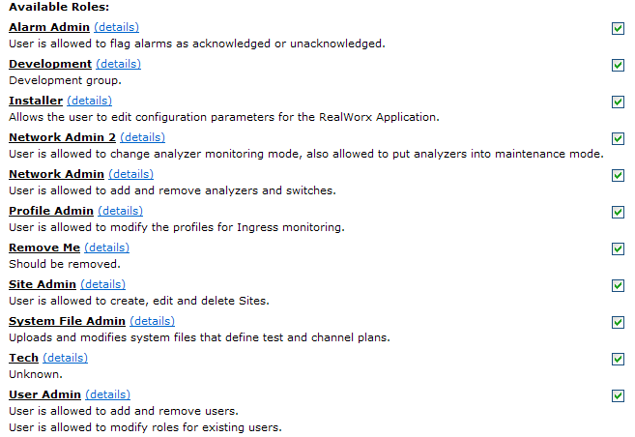

Figure 4 User configuration menu for RealWORX WEB v1.1

General
      - Add new user
      - Delete User
      - User Name (From drop down menu)
      - Password
      - Privilege Level (Administrator, Supervisor, Operator, Technician)
      - Title
      - Notifications
        - Email address

        - SNMP traps

Regions
      - Available Regions (list)
      - Assigned Regions
      - Use Region Restrictions

Privileges

      - General
        - Administer Users
        - Administer Activity Log
        - Administer Alarm Handling
        - Schedule Staff
        - Define Region
        - Administer Trends
        - Schedule Automated Tasks
      - Services
        - Administer Email Services
        - Administer Paging Services
        - Administer SNMP Services
        - Administer Notification
      - realWORX WEB
        - Manage Program Options
        - Manage Filters
      - Device Management
        - Add, Edit and Delete Services
        - Configure Devices
        - Configure Monitoring
        - Start/Stop Monitoring
        - Configure RF Measurements
        - Control Devices States
        - Configure Data Logging
      - Alarm Management
        - Acknowledge Alarms
        - Hide Alarms
        - Delete Alarms
        - Configure Alarm Grid

5.7.4 Staff Scheduler (Use SNMP Manager) [See also R5150 SNMP trap structure]
[R2210] Although this function is not used often it should be considered in a later release phase to allow notification alerts to be directed to the appropriate personnel at the correct times when they are on-call.
[R2220] This should be a configuration utility to assign personnel work dates and times. You should be able to select an employee from an active user drop down list currently in the setup menu.
[R2230] This function could be accomplished using a third party application tool outside of realWORX WEB. (For example: SNMP agent)

5.7.5 Alarm Grid List
[R2300] Alarm grid minimum requirements.
- Sequence
- Alarm date and time
- Alarm Level (Major, Minor etc…)
- Alarm type (Description of problem)
- Element (Cause of Alarm)
[R2310] Sort tab required for each column in the Alarm grid.

5.7.6 Tree and Branch Map
[R2320] Have the ability to add all of the elements to the tree and branch map from table 7.

  - Enhanced SETUP / Test function Tests

More functionally is required in order to help RSSE’s and a customer setup RealWORX WEB quicker and to check main components.

Diagnostic control panel
[R2330] The SETUP Menu should contain a diagnostics dashboard that shows the following TEST components are operating correctly. [R1135 through R1165]. Show the user which components are setup and ready for Ingress or performance operation. [For example: For Ingress: Switches added (YES – Green Light), Switch schedule activated (YES – Green Light), Profile activated (YES – Green Light).] [For example: For Performance Switches added (YES – Green Light), Switch schedule activated (YES – Green Light), System File Loaded (YES – Green Light), Round Trip Test Validated with No alarms (YES – Green Light)]

AT2500 test
[R2340] The test system should verify if all analyzers connected are initialized and communicating correctly.
AT1600 test
[R2350] The test system should verify if all AT1600 series switches connected are initialized and communicating correctly. Also should be able to test with a switch used as a combiner. There should be a test sequence that switches through each port to ensure all ports have been tested. This will serve two purposes. To visually check performance and also to physically test all ports are switching on all nodes. There should be a quick test and a slow visual test. (Users choice) Quick test should run through the ports at max speed. (80 ports /sec). Slow visual test should take 1 second per port. Allow this to be activated in the setup menu.
Downstream measurements test
[R2360] Setup function should make an immediate test on all downstream measurements. This test will check the levels on each channel and check where they fall in relation to their limits. Nominal Tests will also solve this problem.
Ingress test
[R2370] Setup should run ingress quickly on all ports and verify if ingress will breach the current profiles.
SNMP test
[R2380] Allow an SNMP trap to be sent out on demand as a way to test the system.

Analyzer PING / Network Test Application
[R2390] Create a third party or imbedded application tool that shows a dashboard with all analyzers and a relative ping reply to the Server (Show average Network Reply - Keep history/graph for 24 hours) to find network issues.

  - General Monitoring and Alarm Management
[R2400] Ingress Alarm: The monitoring system should alarm when ingress breaches the ‘mask’ limits.
[R2410] Downstream Alarm: The monitoring system should alarm when downstream measurements breach the limits set in the test plan.
[R2420] Alarm Storm Prevention: There should be intelligence built into the ingress alarming to minimize and prevent alarm storms. An algorithm to analyze and trend these incoming alarms is required in order to decide if alarming should occur again on the same node.
[R2430] Special Node Monitoring selection: The user should be able to select a specific node for more frequent monitoring results. i.e. The user should have the ability to “pre-program” the monitoring profile to “adjust” the sequence of nodes to be monitored. Hence, a problematic node could be re-inserted every 2 – 3 – 4 or 5 nodes in the monitoring sequence if that node shows signs of weakness. This should be done either in the initial setup or could be done ‘on the fly’. (Right click to select detailed special monitoring option and node should change color – from grey to orange)
[R2440] Maintenance Mode: The user should be able to select a node not required in the monitoring sequence. Right click to make this occur. (Color of node icon should change from Grey to Blue)
[R2450] Tab to hide dated alarms: It should be possible to minimize previous generated alarms from 1 day to n days prior to the event. Create a minimize tab as used in MS Outlook to close emails from earlier dates. [Dates: Today, Yesterday, Thursday, Wednesday, Tuesday, Monday, Last week, etc.]
[R2460] Trending graphs: The database application should allow graphing analysis of individual measurements over a time period to help spot trends that may ultimately lead to system problems.

  - Downstream (RF Performance) Measurements
[R2470] The realWORX WEB application shall make downstream measurements at intervals as requested by the user based on the measurement test plan.
Muliple test plans in a monitoring sequence
*[R2480] Multiple ‘test plans’ must be usable during a monitoring sequence.
For example: One test sequence may just make signal level measurements and the second test sequence may make all measurements. It must be possible to select a series of ‘test plans’ that will make these measurements in a chosen sequence.
For example: Test Sequence chosen → Test sequence 1
      - Test Plan A
      - Test Plan B
Note: This will alternate between Test Plan A and Test Plan B.
[R2490] The results collected in the measurement database should be exportable in a CSV file or allow copy and paste to clip board.
*[R2510] It must be possible to make a “LIVE” manual measurement on a specific channel. In this case monitoring should be stopped automatically. The application should allow the user to take complete control of the AT2500 and make measurements directly. The AT2500-Webserver application will also allow the user to view the live spectrum or view the live constellation as well. When the user is complete with ‘Live testing mode’ he should be able to click ‘done’ on the AT2500 WEB server side and monitoring should automatically resume.

AT2500 Firmware Enhancements to Command Protocol for Forward Monitoring / Measurements
[R2580] The AT2500 analyzer requires additional command protocol commands in order to bring in the additional required measurements back into realWORX WEB.
[R2590] The additional Analog measurements required are listed in Table 5, marked To do Phase II.
[R2595] The additional Digital measurements required are listed in Table 6, marked To do Phase II.
[R2600] The Scan function must be added to the downstream command protocol. A round trip time to make all analog and digital channel level measurements must be reduced down to less than a minute from about 9 minutes. The digital measurement should use the absolute power measurement from the digital power measurement mode. The time to acquire this measurement should be as quick as possible. Less than 2 seconds. The DCP measurement should not be used for this measurement when running it using SCAN mode.

Forward Monitoring / Data handling (Downstream - Analog and Digital)
[R2700] The realWORX WEB application shall be able to run the required measurements and test sequences simultaneously on many analyzers.
[R2710] ANALOG: The required measurements are listed in Table 5.
[R2720] DIGITAL: The required measurements are listed as follows: All QIA parameters and MER, Pre-BER and Post-BER for16 QAM, 64QAM and 256QAM channels.
[R2730] The application should continuously cycle through all the forward measurements.
[R2740] A round trip time for each ‘test plan’ should be estimated within the RealWORX WEB application.
[R2750] The database shall hold the last 365 days of downstream data in an uncompressed format for every Forward monitored location.
[R2760] The user shall have the option of automatically deleting daily files older than N days, where N is between 2 and 365 days.
[R2800] If the connection between the AT2500HM/HMQ and the data logging server is lost, the AT2500HM/HMQ should conserve the data sets in flash memory. The AT2500HM/HMQ will verify the amount of free space on the flash memory and keep the appropriate number of data sets. When the connection is re-established, the data sets will be transferred to the data logging server. The AT2500HM/HMQ shall support up to 6 hours of data storage.
[R2850] Engineering shall determine what size of compact flash is required to support 6 hour of data storage.
[R2860] An export function shall allow users to select the data to be exported based on filter criteria, including but not limited to: time/date, region, location, trace type, (i.e. Return, Analog, Digital), Instrument/Element, Node/Port, channel, Monitoring Type, and test plan.
[R2900] A database schema design manual should be provided for the realWORX WEB application to allow third party users to develop required import utilities.
[R2910] The realWORX application shall provide the user with the option to export the entire database of monitoring information in a format compatible with popular relational databases (e.g. Oracle, Microsoft SQL Server, mySQL).

  - Upstream (historical ingress) Measurements
    - Ingress Trace Storage
Done [R3010] The database shall be able to store upstream Ingress traces for a one year period of time using the suggested interval collection.
[R3020] Each stored ingress trace should contain the min/max/average traces which are composed of 500 data points each.
[R3030] The average result from the list of (min/max/average) Ingress Traces should be stored every minute to the database.
[R3040] Ingress Trace files should be discarded depending on the age of the data. The end result after discarded traces should result in 1-Minute, 5-minute and 15-minute increments traces depending on age of the data. (As shown in Table 8)
[R3050] Time periods for database compression are shown in Table 8 however these suggested time periods shall be user-settable (daily, weekly, monthly).
[R3060] Ingress Captured traces: The min/max/average traces shall be composed of 500 data points each, covering the selected band.
[R3070] In order to permit consistent graphing of stored ingress data, all graphed data must be based on the same test plan.
[R3080] Once the test plan has been configured, the ingress test plan parameters should all be the same in order to allow this graphing capability.
[R3090] Each analyzer shall make data file measurements in 1 minute increments which should include up to 256 monitored nodes. Each stored file shall consist of three traces per node: min hold, max hold, and average. These three traces are retrievable from the analyzer simultaneously.
[R3110] The realWORX application shall always calculate a daily average of the min, max, and average data from the stored 1-minute data files from the preceding day.
[R3120] The database shall hold the last 7 days of 1-minute data files for (Max, Min and Average traces) in an uncompressed format for each monitored node.
[R3130] After a file is older than 8 days it will be compressed to create 5 minute interval traces for (Max, Min and Average traces).
[R3140] After a file is older than 15 days it will be compressed to create 15 minute interval traces for (Max, Min and Average traces).
[R3150] These 15 minute interval files will be stored for a period of 90 days after which they will be compressed to create 1 daily average trace for (Max, Min and Average traces).
[R3160] The database shall store daily average files for the last 365 days.
[R3170] The user shall have the option of automatically deleting daily average traces older than “N” days, where NN is between 90 and 365 days.
[R3180] Once a data monitoring/logging session is active, if the operator wishes to interrupt monitoring/logging a warning message should appear to indicate that monitoring will be interrupted and logging data will be lost.

    - Alarm Masks / Profiles
[R3200] Ingress alarming should contain a ‘baseline reference trace’ also known as a ‘mask’. (See Glossary for definition)
[R3210] The alarming function should allow the baseline reference trace to be manually drawn.
[R3220] The alarming function should allow the baseline reference trace to have an automatic setup function that will self draw around the ‘Live trace’.
[R3230] There should be seven ‘masks’ that are checked against the incoming trace. These masks will trigger specific named alarms. For example (ingress alarm1, laser clipping alarms)
[R3240] Each of these seven alarms should be configurable to have a different color when displayed on the alarms grid.
[R3250] You should be able to associate a different sound to each of these ‘masks’ when they are generated.
[R3260] There should be four user defined alarm threshold levels for each ‘mask’. (major, sub-major, minor, sub-minor, link-loss). (See Glossary for definition).
[R3265] Each Mask should be checked separately against the spectral ingress information.
[R3270] There should be a way to choose if you want multiple alarming levels on each of the ‘masks’. For example; (major, sub-major, minor, sub-minor, link-loss) You should be able to choose if you want or do not want these to apply to a ‘mask’. In some cases you will only want a single alarm level to apply to a mask.
[R3280] Mask Table: The ‘masks’ should be user configurable by means of a matrix table that will allow entry of Reference Levels relating to a specific frequency. For example: (Frequency resolution should be 0.2dB)
- 1.0MHz....…23dB
- 1.2MHz….23dB
- 1.4MHz.…20dB
- 1.6MHz….19dB
[R3290] Mask / Profile Draw: The current mask draw trace method should also be included as an option to create a ‘mask’.
[R3400] There should be a visual display of the ‘mask’ on the RealVIEW display.
[R3410] The ‘mask’ should be retrievable from a stored data location.
[R3420] It should be possible to associate any of the ‘masks’ to a specific node for alarming purposes.
[R3430] The ‘mask’ should be checked against the ‘live trace’ for events that cross over the alarm threshold detection levels.
[R3440] The names of the ‘Masks shall be as follows:
- Ingress Mask 1
- Ingress Mask 2
- Common Path Distortion (CPD) Mask
- Laser Clipping Mask (user defined)
- Amplitude Response Mask
- User configurable Mask (1)
- User configurable Mask (2)
[R3450] Each of these masks should trigger a specific alarming event. For example (Laser Clipping Alarm)
[R3460] These alarms triggered from the ‘masks’ will appear in the monitoring alarm list.
[R3470] Amplitude Response will be added to the ingress monitoring alarm list.
[R3480] Each mask should be stored in a easy to find (point to directly when needed) if a customer wants to reuse the template anywhere else in his monitoring profiles, a simple copy/paste or insert template should be available. We should have a folder with a list of default templates available to customers.

RESET PROFILES
[R3490] Create a quick way to reset ALL Ports to a Specific Profile or make all Ports use analyzer setting for profiles.

    - Average Noise Floor calculation FP 20080509-02

[R3510] An average noise floor level (dB) power calculation shall be made for each 15 minutes ingress spectral trace. The system must calculate the average noise floor on each test-point’s operational spectrum (ie: 18MHz-35MHz). This will be used as a comparison metric between the traces, to do trending for a testpoint, and to compare testpoints between each others.
[R3520] The average noise floor calculation will be considered a new upstream (Ingress) measurement parameter. The latest result shall be shown next to the ingress test point in the dashboard as well as in the historical ingress trace. (As shown below)

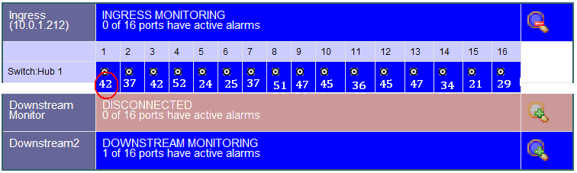
Figure 5 Dashboard showing NEW ave noise floor information.
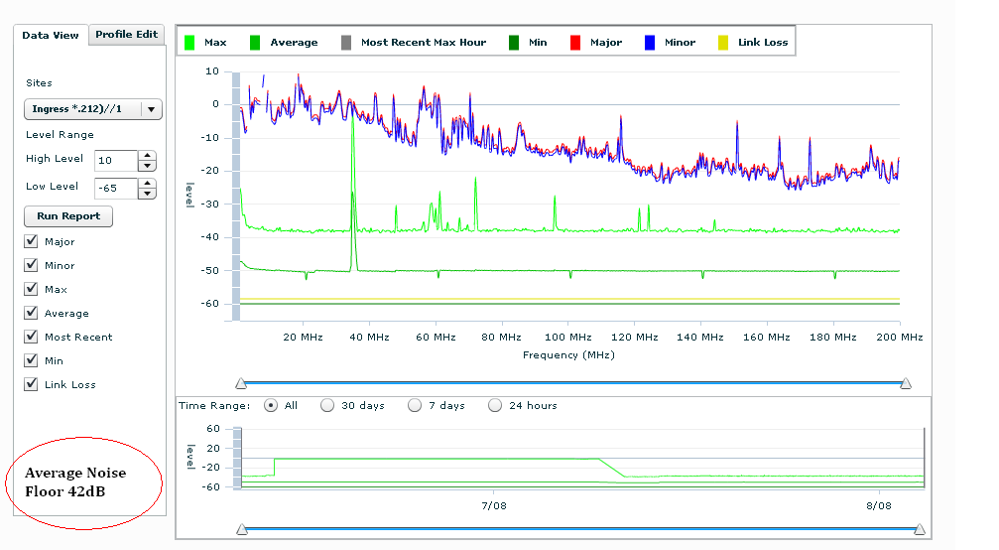
Figure 6 Historical Ingress menu showing NEW Ave Noise Floor measurement

[R3530] The carrier/s in the operational spectrum shall be excluded from this analysis. For example an approximation of the real noise floor is required without being affected by the carriers level in the calculation. A simple algorithm is available to exclude the carriers.*** (Formula from Videtron below)

Calculating noise floor

Analyzer configuration:
Bandwidth: 5 à 45 MHz
Resolution bandwidth: 300 KHz
Video bandwidth: 100 KHz
Sweep: 30 ms

For each analysis, the spectrum takes 20 traces in peak hold mode. All results are sent to the application.

Our analysis is made only between 15 MHz and 38.

The application must remove all carriers to be able to calculate the noise floor. To do that operation, all points between 3 dBmV and 15 dBmV will be excluded, as well as the two next points.

When all carriers are excluded, it’s the time to characterize the noise floor:

Score - Alarm Level | Average noise floor level
Critic (1) | Average > -10
Major (2) | Average > -15
Minor (3) | Average > -20
Warning (4) | Average > -25

Example:
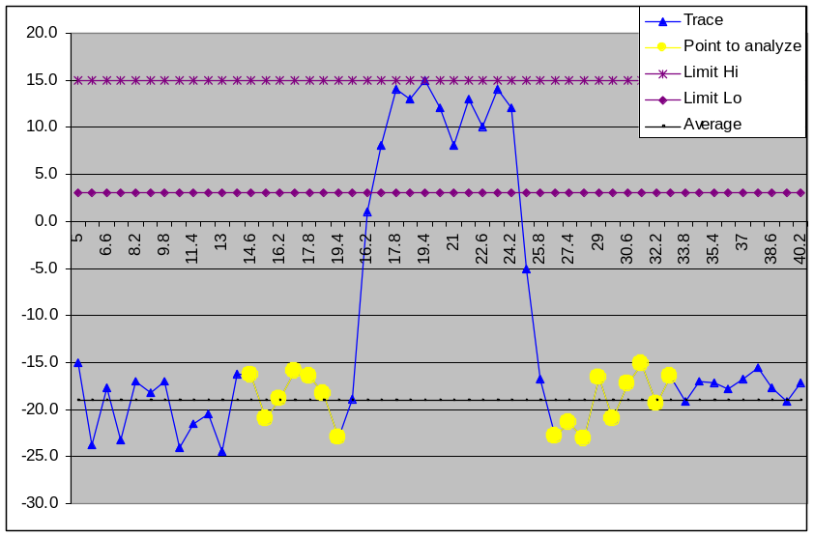

Blue points represent complete trace [5:45]. Yellow one is the ones in the specified bandwidth [18:38] AND not a carrier. So the average of the yellow points is -18.9 dBmV i.e. minor alarm.

Remember:
- Exclude two points before and after a point which is between the carrier's thresholds.
- All values must be user configurable.

[R3540] It should be possible to create a report (graph and tabular) that shows the variation of this average noise value over time.
[R3550] It should be possible to export this information to an external system each hour (eg: through an SQL query).
*** Calculate the average noise as follows: First exclude the points that are outside the operational spectrum. (Exclude carrier points) Next sum all the remaining point levels and divide by the number of the remaining points.

    - RealVIEW measurement TAB

Open multiple RealVIEW measurement TABS
[R3560] Add a button under the realVIEW TAB that will open up a new RealVIEW TAB automatically in IE-7 or Firefox.

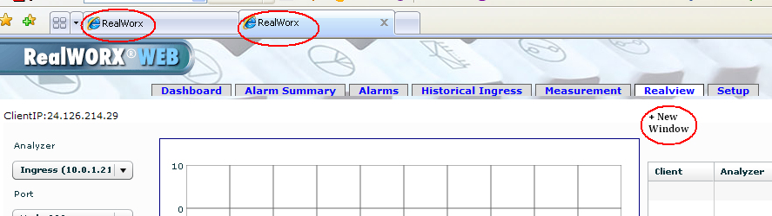
Figure 7 Showing Add New RealVIEW Window button

[R3570] Create user defined settings for realVIEW: (Done in software, not analyzer)
      - Allow naming of special Views (DOCSIS_28)
      - Zoom around a freq location (Set start, stop, top and bottom graticules)

[R3580] The RealVIEW WEB Live trace should be accessible using a specific URL. Currently the URL does not change beyond http://216.77.98.235/livetrace. The user must be able to select the analyzer and port information from a defined URL format.
For example: http://216.77.98.235/livetrace/analyzer_A/Port_21

[R3585] Allow Start and Stop frequencies to be changed in realVIEW. (Zoom function for both vertical/amplitude and horizontal/frequency)
[R3590] Show profiles on the RealVIEW traces. Allow them to be turned on and off.

    - Add Score Card to each ingress node
Add new TABS in Historical Ingress
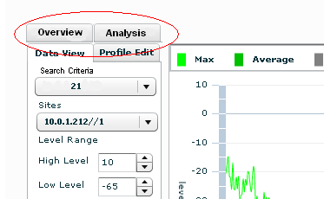
Figure 8 New historical ingress TABS

[R03610] Overview TAB will show table of ALL analyzers and nodes that are running ingress. (Ingress only). However also include the Ave Noise number for each node below the port location.

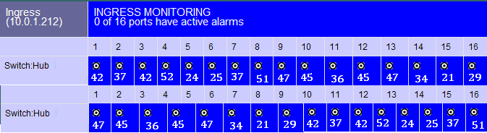
Figure 9 NEW overview TAB

[R3620] Analysis TAB (Score Analysis) will show only Search Criteria, Sites filter and Score Card.

[R3630] Add Score Card criteria into Setup function.
Score card should allocate a letter A through E to Ave noise floor levels.
A – (0% to 20%) No Noise (-45dBmV to -60dBmV)
B – (20% to 40%) Min Noise (-30dBmV to -45dBmV)
C – (40% to 60%) Ave Noise (-15dBmV to -30dBmV)
D – (60% to 80%) Above Ave Noise (0dBmV to -15dBmV)
E – (80% to 100%) Very High Noise (15dBmV to 0dBmV)

Customer should be allowed to create their own levels breaks.

Or create algorithm to calculate recommended levels.
Ask for Max and Min levels then calculate the 20% break points for each letter.
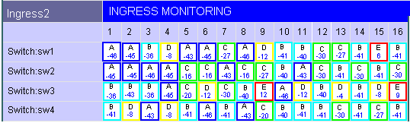
Figure 10 NEW analysis TAB

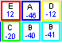
Figure 10 Showing a zoomed view of the analysis TAB

5.10.6. Clearpath Switch Control

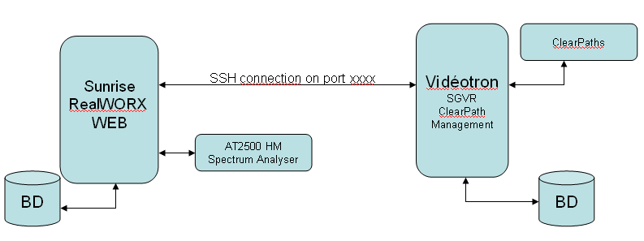
Figure 11 Block diagram of Clear Path system connection to RealWORX WEB.

[R3800] The RealWORX WEB shall be able to interface with the Videotron Clearpath management system via an SSH connection. The application should be able to both manually and automatically take control of Electroline Clear Path Switches and isolate the noise.
[R3810] Manual: Switch manually each clear path unit on the system and isolate the offending noisy node.
[R3820] Automatic: Must be able to automatically isolate an offending node by systematically activating the Clearpath attenuation switch and find the offending noisy node.

Graphing and Reports

Graphing Function
[R4000] For ingress data the graphing function shall allow users to select the data to be displayed based on filter criteria.
These criteria are:
- Time/date
- Region
- Location
- Trace type
- Instrument/Element
- Node/Port
- Channel
- Monitoring Type
- Test plan
[R4010] For downstream data the graphing function shall allow users to select the measured data across a defined period of time.
[R4020] The graphing function shall provide user selectable 2D graphics.
[R4030] The graphing function shall provide user selectable 3D graphics.
[R4040] The graphing function shall provide user selectable 3D Waterfall graphics for ingress traces only.
[R4050] 3D graphs shall be for ingress traces only.
[R4060] 3D graphs shall display an ingress trace over a defined time period. (1 hour, 12 hours, 24 hours)
[R4070] Waterfall graphs should display ingress traces over a selectable time period and show a moving window in time.
[R4080] For waterfall graphs when you hit a new data time period where your data storage window changes (ex: 1 minute to 5 minutes after a week) you must summarize the data from the old window to the new window for each data series (avg, max, min). For each series you should use the appropriate function.
[R4090] For Forward measurements, pre-defined graphs shall include a 2-D graph of any single measurement data set of results shown over a defined period of time. (Complete Measurement list can be found in Tables 5 and 6)
[R4100] For Forward logging, pre-defined graphs shall include a channel analysis graphing tool that that consists of 2-D plots of more that one statistical result for a channel over time. Graphing any of the measurements listed in Table 5 and Table 6. (For example: Channel power, Video Carrier Level, Audio carrier Level, V/A Delta, MER, BER, EVN, etc).
[R4110] The user shall be able to select the measurements required for display on each graph.
[R4120] The user shall have the option of printing, saving or exporting (BMP, JPEG minimum) the graphs created during a session.
[R4130] The time scale tick marks on these graphs (i.e. hours, days, months.) shall adjust to reflect the time period chosen by the user.

    - Alarm Reports

Reports

TEXT BASED REPORTS
[R4200] ALL TEST POINT: A text based report should be available showing all test point scores. Ingress) based on filtered criteria. (Scores range from A – E) and / or (Ave noise floor readings).
[R4210] SPECIFIC GROUP OF TEST POINT: A text based report should alternatively provide a specific group of test points and show each nodes (Scores range from A – E) and/or (Ave noise floor readings).
[R4230] WORST CASE TEST POINT: A text based report should alternatively provide a specific group of test points and show each nodes (Scores range from A – E) and/or (Ave noise floor readings).

ALARM REPORTS
[R4400] The Alarm Report Generator shall be capable of generating two types of reports:
- Summary Report
- Detailed Report

Summary Report

[R4410] The summary report shall be able to provide a filter on each of the following criteria and list the alarms by this selection of choice. (For example: Summary report showing the # of alarms by node, listing the worst case first to the best over a defined time period)
- # of alarms breached per hub
- # of alarms breached per analyzer
- # of alarms breached per port/node
- Alarm Date & Time
- Alarm Type
- Alarm Severity
- Site Location
- Analyzer Device
- Multiplexer Device
- Port/node Name
- Channel #
- Alarm Owner

Detailed Report

[R4420] The detailed report shall be able to provide the following information:
- # of alarms breaches per hub
- # of alarms breaches per analyzer
- # of hits per port/node
- Alarm Date & Time
- Alarm Type
- Alarm Severity
- Site Location
- Analyzer Device
- Multiplexer Device
- Port/node Name
- Channel #
- Alarm Owner

[R4430] Users shall be able to create custom report templates by means of “filtering”.

[R4440] The report generator shall support the following filterable parameters:
- # of alarms breaches per hub
- # of alarms breaches per analyzer
- # of hits per port/node
- Alarm Type
- Alarm Severity
- Site Location
- Analyzer Device
- Multiplexer Device
- Port/node Name
- Channel #
- Alarm Owner

[R4450] Users shall be able to create/save no less than 50 customized report templates for future use

[R4500] Users shall be able to export reports in these formats:
    - CSV
    - ASCII
    - XML
    - PDF

[R4550] The user shall have the option of using any of the following date range period for a report:
    - Last 24 hours
    - Last 7 days
    - Last month
    - Specific Date Range; "From" date --> "To" date.

[R4600] The alarm report shall be able to display both current/active and history alarm information.

[R4620] Top N Nodes with most alarms in the “Date/Time period range” - displays the top N nodes with highest total number of alarms. For each of those nodes, it displays; total numbers of alarms raised, Node name, Instrument Device, Hub site location, most recent alarm date and time, the first alarm data and time.

Top N Nodes with most alarms in the last 24hours
Top N | Alarms | Node | Instrument | Site | Most Recent Alarm | First Alarm Raised (within last 24hours)
1 | 204 | SD234 | Analyzer 1 | Montreal East A | 05/07/2006 6:53:39 AM | 05/06/2006 7:09:13 PM
2 | 159 | SD45 | Analyzer 1 | Montreal East A | 05/06/2006 6:53:14 AM | 05/07/2006 7:00:14 PM
3 | 121 | SD321 | Analyzer 3 | Montreal North A | 05/06/2006 1:18:40 AM | 05/07/2006 6:55:18 PM
4 | 89 | SD67 | Analyzer 1 | Montreal East A | 05/06/2006 6:50:17 AM | 05/07/2006 7:12:40 PM
5 | 54 | SD89 | Analyzer 5 | Montreal South A | 05/06/2006 6:53:34 AM | 05/07/2006 7:23:45 PM
etc..
Figure 12 – “Top N Nodes with most alarms in the last 24hours” Example Screen

[R4630] Alarms by Node Detailed Report - displays the alarm details information that has been generated during a specified time period.
[R4640] Alarms by Hub Site Detailed Report - displays the alarm details information that has been generated during a specified time period.
[R4650] Alarms by Node Summary Report - displays the total number of alarms by severity (of each alarm type) for a specific node during a specified time period.
[R4660] Alarm Totals for All Hub Sites Summary Report - displays the total number of alarms by severity (of each alarm type) for all sites during a specified time period.

Mail, SMTP and SNMP notification

    - SNMP
[R5110] RealWORX shall support SNMP trap protocol.
[R5120] A MIB shall be provided to help re-construct the SNMP traps.
[R5130] The server must be able to send SNMP traps to an alternate destination if parameters have reached preset thresholds. This would allow for a prioritization of alarms depending on the nature of the alarm. A second set of threshold, minor and major is required.
[R5135] Explanation of URL sent. For an ingress (upstream) Alarm → Use hyperlink provided in alarm window and send with SNMP trap.
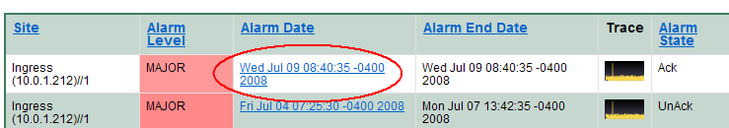
Figure 13 Ingress hyperlink

[R5137] Explanation of URL sent. For a performance (downstream) Alarm → Create a new hyperlink. (Not yet provided) and send with SNMP trap.

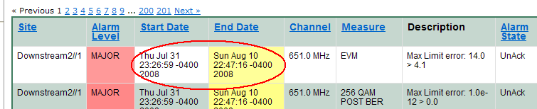
Figure 14 Performance Proposed hyperlink

[R5140] The SNMP trap shall include all of the following alarm components.
- Site Location
- Port Name
- Alarm Level
- Start Date / Time
- End Date / Time
- Channel
- Measure
- Description
- Alarm State
- URL of applicable alarm

[R5150] NEW SNMP format for performance monitoring should be as follows:

TEMPLATE
========= Trap attributes ==============
Timestamp:
Agent:
Enterprise OID:
Generic Type:
Specific Type:
Processing Time:
Varbinds: [oid]->[varbind]
.1.3.6.1.4.1.10300.1.1.1.1 --> SITE
.1.3.6.1.4.1.10300.1.1.1.2 --> PORT NAME
.1.3.6.1.4.1.10300.1.1.1.3 --> ALARM LEVEL
.1.3.6.1.4.1.10300.1.1.1.4 --> START DATE
.1.3.6.1.4.1.10300.1.1.1.5 --> END DATE
.1.3.6.1.4.1.10300.1.1.1.6 --> CHANNEL
.1.3.6.1.4.1.10300.1.1.1.7 --> MEASURE
.1.3.6.1.4.1.10300.1.1.1.8 --> DESCRIPTION
.1.3.6.1.4.1.10300.1.1.1.9 --> ALARM STATE
.1.3.6.1.4.1.10300.1.1.1.10--> URL OF ALARM VIEWER
NOTIFY
========= Trap attributes ==============
Timestamp: 31-Jul-2008 04:25:42 EDT
Agent: 192.168.169.242
Enterprise OID: .1.3.6.1.4.1.10300.1.1.6
Generic Type: 6
Specific Type: 1
Processing Time: 0 Secs
Varbinds: [oid]->[varbind]
.1.3.6.1.4.1.10300.1.1.1.1 --> VL-MO-ASMON-102//1
.1.3.6.1.4.1.10300.1.1.1.2 --> VL-MO-FTXN-4071
.1.3.6.1.4.1.10300.1.1.1.3 --> MAJOR
.1.3.6.1.4.1.10300.1.1.1.4 --> Wed Jul 30 13:11:48 -0400 2008
.1.3.6.1.4.1.10300.1.1.1.5 --> Thu Jul 31 09:57:57 -0400 2008
.1.3.6.1.4.1.10300.1.1.1.6 --> 121.25 MHz
.1.3.6.1.4.1.10300.1.1.1.7 --> Video Level
.1.3.6.1.4.1.10300.1.1.1.8 --> Min Limit error: -8.0 < 0.0
.1.3.6.1.4.1.10300.1.1.1.9 --> UnAck
.1.3.6.1.4.1.10300.1.1.1.10-- http://216.77.98.235/measurement/index/121_25/analog
CLEAR
========= Trap attributes ==============
Timestamp: 31-Jul-2008 10:57:57 EDT
Agent: 192.168.169.242
Enterprise OID: .1.3.6.1.4.1.10300.1.1.6
Generic Type: 6
Specific Type: 2
Processing Time: 0 Secs
Varbinds: [oid]->[varbind]
.1.3.6.1.4.1.10300.1.1.1.1 --> VL-MO-ASMON-102//1
.1.3.6.1.4.1.10300.1.1.1.2 --> VL-MO-FTXN-4071
.1.3.6.1.4.1.10300.1.1.1.3 --> MAJOR
.1.3.6.1.4.1.10300.1.1.1.4 --> Wed Jul 30 13:11:48 -0400 2008
.1.3.6.1.4.1.10300.1.1.1.5 --> Thu Jul 31 09:57:57 -0400 2008
.1.3.6.1.4.1.10300.1.1.1.6 --> 121.25 MHz
.1.3.6.1.4.1.10300.1.1.1.7 --> Video Level
.1.3.6.1.4.1.10300.1.1.1.8 --> Min Limit error: -8.0 < 0.0
.1.3.6.1.4.1.10300.1.1.1.9 --> UnAck
.1.3.6.1.4.1.10300.1.1.1.10-- http://216.77.98.235/measurement/index/121_25/analog

[R5160] The NEW SNMP Clear Trap should include all stated Varbinds as in the example above.

    - Email
[R5210] RealWORX shall support SMTP Server Authentication.
[R5220] The application shall provide alarm email notification to an email address listed as default in the current user profile.
[R5230] There should be various choices of email notification depending on the selection for each user.
      - No notification
      - Communication alarms
      - Major alarm notification
      - Link Loss alarm notification
      - Laser Clipping alarm notification
      - CPD alarm notification

    - Text and SMS
[R5250] RealWORX shall support paging and text message notification.
[R5260] The application shall provide alarm SMS notification to a cell phone listed in the user profile.

Remote Client Access and Security
[R5300] The realWORX application should only allow access to registered users in realVIEW.
[R5330] The system shall support up to 20 simultaneous user viewing live traces (with appropriate license arrangements. Log-in requests received when 20 clients are already logged-in shall receive a “simultaneous user capacity exceeded” message.

[R5340] Security: Access to all parts of realWORX WEB GUIs shall be restricted to those users who are authorized to perform logging configuration. This permission shall be configured through a realWORX User Administration GUI.

  - Other Key feature requirements
Firmware, AT1600, auto-reconnect.
[R5400] RealWORX should be able to push downloads to multiple analyzers in the same way it is planned to manage this with realGATE.
[R5410] During interrupted analyzer communications the user has to individually reconnect each spectrum analyzer. There should be an automatic reconnection test to check if the analyzer is ready to connect to the application.
[R5412] Provide an AUTO CONNECT SWITCH in Network Manager. If Button selected this will auto connect the analyzer to its default monitoring state. Either Ingress or profile monitoring.
- First check for user defined delay before reboot, Immediate, 1 minute etc.
- Check Ping Time before connecting.
- Next check if Connect Button works then activate monitoring
- If Connect button does not work then Auto Reboot Analyzer.
- Keep track of the number of reboot times. If a reboot is required more than x times (User configurable) per hour then stop the auto reconnect process.
- Create a NEW LOG called Reboot LOG. Keep track of this information.

[R5415] A command exists to ensure the analyzer is set to Remote-Mode. A button should be added to activate this command from the analyzer setup menu.
[R5420] The user should have the ability to reboot an analyzer from the realWORX application.
[R5430] When initializing a spectrum analyzer the application should automatically initialize the AT1600 switches at the same time.
[R5440] Third party switches supported should be the following in order of priority: (1) Cheetah RPS, (2) Electroline, (3) Tollgrade.
[R5460] Multi-Language Support: RealWORX WEB 2.0 should provide multi-language options for key functions, TABS, Column Names. These languages should include: English, French, Chinese simplified, Chinese traditional, Japanese, Korean, German, Italian and Spanish. There should be a way to customize this as well. Possibly include multiple columns that show each language Vs Item Name. One column should be custom.

  - Compatibility with previous versions
[R6110] All previously purchased AT2500HM’s and AT1601/2’s will be backwards compatible with realWORX WEB 1.0 and above.
[R6120] AT2000HM/HMQ, AT2000R/RQ’s should be tested for compliancy in realWORX WEB as ingress analyzers. This should work but needs to be tested.
[R6130] Firmware upgrade es will need to be performed on all test equipment in order to ensure compatibility with realWORX WEB 2.0.
[R6140] A legacy realWORX 2.x customer shall be required to purchase a new configured realWORX server appliance.
[R6150] The Server appliance shall be preconfigured with realWORX WEB 2.0. and all other required applications.

  - Option sets and ship kit
For the final MRD provide a table showing the various product option sets or configurations. Also provide a table that lists the contents of the shipping kit and any product packaging requirements.

    - Option sets

    - Ship kit and product packaging

  - Feature rollout priorities
For the final MRD provide a table detailing the roll out priorities for the phased features and options.

  - Regulatory requirements and certifications
For the final MRD use this section to identify any regulatory or certification requirements. Be as specific as reasonably possible.

- Competitive Environment

  - Competition and Alternative Solutions
Key competitors areas follows:

JDSU PathTrak Reverse Monitoring and RSAM5600 Forward monitoring systems.
Pathtrak scans 5 times per second = every 200ms, which is the maximum port scan rate for the (JDSU) Pathtrak can scan ports, the sweep scan speed of a specific node however will be in the 125ms range.

Trilithic’s Guardian System.
The Trilithic unit may be able to scan a port in 60us or so but that only relates to scan speed (trace acquisition), then you need to also consider the port scan rate. (The speed at which the measurement device can switch to a different port)for the Trilithic, their maximum port scan rate is 80 nodes per second.

Sunrise Reverse monitoring system.
The AT2500RQ has a port scan rate of 80 nodes per second but has a scan speed per port of 2ms. This speed is based on monitoring 100MHz of spectrum at a specific port, but based on configuration has the ability to scan a specific port in 0 span in 50us. The port scan rate is still 80 nodes per second since we also have to process, analyze and switch to each port.

The Sunrise equipment is the only equipment that is based on a Spectrum analyzer technology compared to the JDSU and Trilithic which is based on SLM technology. (Spectrum analyzers have a wider dynamic range, can go down to -65dBmV or -5dBuV @ 300KHz and also has a wider spectrum range and can go to 1.0GHz of spectrum range compared to both the Trilithic and JDSU which are both limited to about -40/-45dBmV at best of sensitivity and 65MHz of Spectrum range.
Having the ability to view above 65MHz does allow the end user to view upstream laser clipping since the RF diplex filters of a CATV network is either 42MHz or 65MHz, but the Optical return spectrum does extend up to 200MHz. The ability to view above 42MHz or 65MHz allows you to monitor return laser clipping simply by viewing RF spectrum).

6.1.1. Comparison Table:

Company | Sunrise | JDSU | Trilithic
Monitoring System | realWORX | PathTrak | 9580 SST | 9850 SST+TPX
Freq Range | 1-1000 MHz | 5-65 MHz | 0.3 – 42 MHz | ?
Frequency steps | Variable/cont. | 120 kHz | 0.5 MHz | ?
Chassis per System | No Limit | No Limit | ? | ?
Total test points (Per Chassis) | 256 | 120 | 8 | 64
Test points increments | 16 | 8 | 8 | 8
Raw Scan Rate (Nodes per second) in optimum settings | > 55  (@500 data points) | 40  (@150 data points) | ? | ?
Test points Scan Time (Ingress)(@Min Sweep Time) | 18 msec | 25 msec | ? | ?
Scan Time 10 Channels | 180 msec | 200 msec | ? | ?
Scan Time 128 Channels | 2304 msec | 200 msec | ? | ?
Scan Time 256 Channels | 4608 msec | 200 msec | ? | ?
Monitoring Mode Scan Resolution (data points) | 500 | 250 / 150 | 80
FieldView Frame Rate (max) | 11 FPS | ? | ? | ?
FieldView Refresh Rate (min) | 1 FPS | ? | ? | ?
Channels per Analyzer (Min) | 1 | 8 | ? | ?
Channels per Analyzer (Max) | 256 | 8 | ? | ?
Analyzers per chassis | 1 | 15 | ? | ?
Channel Scanning Order | Sequential, or  Pre-defined List | Sequential Concurrent (Sequential through 8 channels of each analyzer, analyzers operate concurrently) | ? | ?
Switching Component | AT160xM | RPM-1000 | ? | ?
Analyzer Component | AT2500HMx | RPM-1000 | ? | ?
Chassis | AT2500HMx | HCU-400/HCU-1500 | ? | ?
Dwell Time Range | 1 msec to 1000 msec | 1 µsec to 100 msec | ? | ?
Sweep Time | 2 ms to 5 secs in S/A mode | 20 msec | 700 msec
Resolution Bandwidth Filters | 10,30,300,1000MHz | 30, 300, 1000 kHz | 50, 356, 516 kHz
Video Bandwidths | 10,100,1000MHz | 10, 30, 100, 300, 1000 kHz | ? | ?
Tuning Resolution | 10Hz | 5 kHz | 50 kHz
Sensitivity (Min) | -65 dBmV | -40 dBmV | -40 dBmV
Sensitivity (Max) | +65 dBmV | +50 dBmV | +20 dBmV
Dynamic Range (SFDR) | > 70 dB | 40 dB | ? | ?
Recommended input level | 0 to 5 dBmV | 0 to 10 dBmV | ? | ?
Amplitude Accuracy | ± 0.75 dB | ± 2 dB (>10 µsec)  ± 4 dB (>1 µsec) | ± 1.5 dB
RS-232 Ports | 3 | 4 | 8? | ?
RS-485 Ports | 0 | ? | ? | ?
Ethernet | 10/100 Mbps | 10/100 Mbps | 10 Mbps | 10/100 Mbps
Parallel Port | 1 | yes | ? | ?
Ingress Monitoring
Alarm Thresholds (Upper) | 2 (Maj, Min) | At least 2 | At least 2 | At least 2
Alarm Thresholds (Lower) | 1 (Link Loss) | At least 2 | At least 2 | At least 2
Alarm Thresholds (Other) | Instantaneous Level,  Average Level,  Peak Level | Average Level,  Percent of Violations | ? | ?
Alarm Qualifiers | Dwell Time | Dwell Time,  Consecutive scans above threshold,  Number of violations above threshold in a time frame | ? | Number of threshold "hits" before alarm is raised
Alarm Severity | Major, Minor, Link Loss | Critical, Major, Minor, Warning | ? | ?
Alarm Severity Assignments | Fixed to threshold | Assignable | ? | Fixed to threshold
Time Domain Measurements
Time Domain Measurements | Yes | yes | ? | ?
Time Domain Measurements Freq Bandwidth | 1-1000 MHz | 5-65 MHz | 0.3 – 42 MHz
Zero-Span Horizontal Time Range | 50 µsec to 500msec
Minimum Impulse Capturable | 0.5 µsec | < 1 µsec | Yes
AUTOMATED QAM Monitoring | Yes | No | No

  - Points of Differentiation
.
- The RealWORX system based on a 64 node count is 30% to 45% less cost than the Pathtrak system. About the same price as Trilithic.
- RealWORX has the ability to view above 65MHz which allows the end user to view upstream laser clipping since the RF diplex filters of a CATV network is either 42MHz or 65MHz and the Optical return spectrum extends up to 200MHz. The ability to view above 42MHz or 65MHz allows you to monitor return laser clipping simply by viewing the RF spectrum and looking for harmonics at the 2nd and 3rd harmonic of the laser transmit frequency. The JDSU Pathtrak system is limited to 65MHz. The Trilithic system is limited to 42MHz.
- The AT2500RQ has a port scan rate of 80 nodes per second but has a scan speed per port of 2ms. (This calculates to 12ms per port)
- The Sunrise equipment is the only monitoring equipment based on Spectrum analyzer technology. The JDSU Pathtrak and Trilithic systems are based on SLM technology.
- The RealWORX upstream and downstream monitoring system is part of the same monitoring system. JDSU can only offer two separate monitoring systems and alarming occurs on two separate systems. Trilithic only offers ingress monitoring.

  - Technical Alternatives & Risk Assessment
Provide a table that lists the alternatives and the assessed risk. Include pros and cons.

  - Product Positioning in the Market
Position this product in the market place. Address which part of the market this product services (Ex. realWorx services the network monitoring market).

- Business Case

Section | Item
X | - Market size overall, by geography and segment  - Market growth overall, by geography and segment  - Market penetration by quarter for three years, include effects of price erosion  - Effects of cannibalization
X | - Key sales proposition  - Silver Bullets
X | - Size of early opportunities or orders
X | - Cost of delay
x | - COGS

Use this section to build the business case for developing and marketing this product.

  - Impact On Life Cycle
Provide a simple graph showing projected revenue for the “old” product, the new product and the net.
The existing AT2500RQ will remain the same and will work with old and new versions of realWORX. Older AT2000RQ units will not be supported in RealWORX 3.0. Customers should ensure they upgrade to the latest firmware versions to ensure full compliancy with the new platform. The older realWORX software running on Windows servers / pc’s will not be supported beyond version 2.4.
RealWORX 3.0 will tie the other new broadband products together and should help promote software, servers and equipment sales.

  - Value Proposition
The new web based RealWORX 3.0 system will enable scalability above and beyond our customer’s expectations for current Sunrise test equipment and for those being built by us in the future. It will increase productivity, reduce technical response times to problems and increase peace of mind for the system operator. The health of the entire RF distribution system, both in the downstream and the upstream, shall be viewable by means of user friendly GUI’s to show the system health status. RealWORX 3.0 will also become the measurement system of choice. System operators will be able to make all their required proof of performance tests remotely by controlling a wide range of Sunrise broadband test devices. The devices will range from AT2500RQ, AT3000F, AT1800RQs, CM2000, etc…

  - Three Year Forecast
For the preliminary MRD provide a best guess, order-of-magnitude, three year forecast by quarter. This forecast should be refined for the final MRD.

Table 1: Sales Forecast by Region
 | 2007 |  | 2008 |  | 2009 |  | Total
 | Qty | $ | Qty | $ | Qty | $ | Qty | $
NA | 10 | $ 1,000,000 | 40 | $ 4,000,000 | 50 | $ 5,000,000 | 100 | $ 10,000,000
Europe | 1 | $ 100,000 | 4 | $ 400,000 | 6 | $ 600,000 | 11 | $ 1,100,000
Asia | 4 | $ 800,000 | 10 | $ 2,000,000 | 15 | $ 3,000,000 | 29 | $ 5,800,000
Australia | 1 | $ 100,000 | 2 | $ 200,000 | 3 | $ 300,000 | 6 | $ 600,000
Totals | 16 | $ 2,000,000 | 56 | $ 6,800,000 | 74 | $ 8,900,000 | 146 | $ 17,500,000

    - Assumption 1: Base cost $ 100,000. (Includes: AT2500RQ, switches and server)
    - These sales estimates do NOT include additional sales from other Sunrise products that can also tie into realWORX. (ie. AT1800, CM2000, AT3000F)
    - Assumption 2: Year 2007 will only reflect partial sales starting mid-third quarter.
    - Assumption 3: Sales forecast reflects conservative (not aggressive) sales & marketing focus on the RealWORX system.

  - Preliminary Timeline

Q1, 2007 (Mid) – UI prototype
Q2, 2007 (Early) – Early prototype (SSE evaluation)
Q2, 2007 (Late) – Beta version / Product Launch at SCTE (Cabletech show)
Q3, 2007 (Mid) – Final version released (Phase 1)
Q4, 2007 (Late) – Phase 2 (V4 probe compliancy)

  - Configurations and Preliminary Pricing
For the final MRD only. Provide a table or tables listing the various product configurations, include preliminary pricing.

Target Pricing estimates based on system size

RealWORX System |  |  | Small System | Amount | Medium System | Amount | Large System | Amount
US Domestic Pricing |  | Subs | 100K |  | 270K to 500K |  | 1 Mill to 4 Mill
 |  | Nodes | 200 |  | 770 |  | 5000
 |  | Switches | 12.5 |  | 48.125 |  | 312.5
Equipment | Price
AT2500HM | $10,995 |  |  | $0 |  | $0 |  | $0
AT2500HMQ | $16,495 |  | 1 | $16,495 | 4 | $65,980 | 20 | $329,900
AT1601 | $1,495 |  |  | $0 |  | $0 |  | $0
AT1602 | $2,695 |  | 13 | $35,035 | 49 | $132,055 | 313 | $843,535
Server Appliance | $5,000 |  | 1 | $5,000 | 1 | $5,000 | 1 | $5,000
RealWORX XMP | $8,495 |  | 1 | $8,495 | 1 | $8,495 |  | $0
RWX-RMM | $4,995 | Return | 1 | $4,995 | 1 | $4,995 | 1 | $4,995
RWX-AMM | $4,995 | Analog | 1 | $4,995 | 1 | $4,995 | 1 | $4,995
RWX-DMM | $4,995 | Digital | 1 | $4,995 | 1 | $4,995 | 1 | $4,995
RWX-DLM | $2,495 |  |  | $0 |  | $0 |  | $0
Total |  |  |  | $80,010 |  | $226,515 |  | $1,193,420
Total after Volume Discount |  |  | 2% | $78,410 | 5% | $215,189 | 10% | $1,074,078

  - Early Opportunities
For the final MRD only. Provide a list of early sales or marketing opportunities. This list could include customers, trade shows, conferences and etc.

- Annexes
Other annexes should be added as needed to support or clarify other sections of this document.

  - Annexes – References and Specifications
This Annex is a bibliography of governing standards. These documents could be ITU Recommendations, IETF RFCs, Cablelabs documents, ANSI Standards or documents from other standards bodies.

