Tek Acharya

Project A2

GSU, Spring 2020

**Section 3: ARM Assembly Programming**

**Part 1: Second Program**

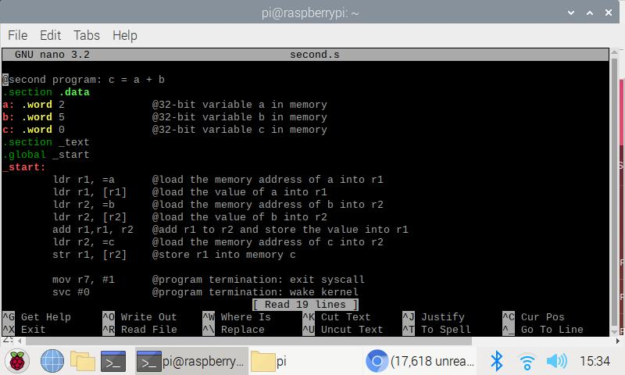

Second.s compiled using nano editor

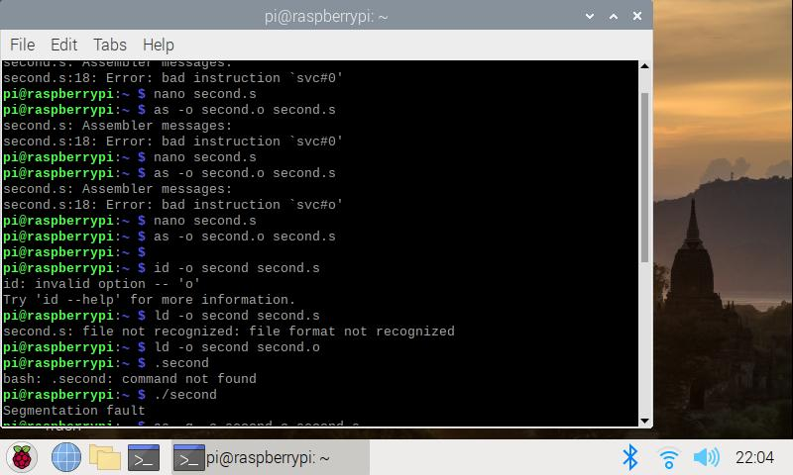

Assembled, linked, and ran the second.s file.

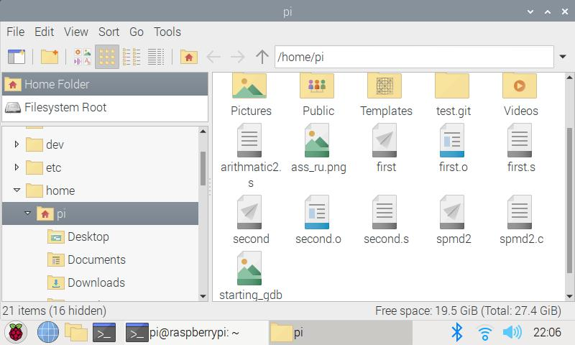

Created executable file

No output is seen as the output are not visible into the console but are inside the register of the microprocessor.

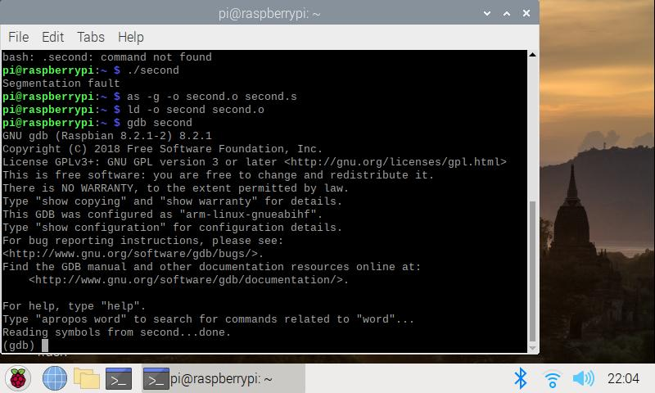

Started debugging using gdb

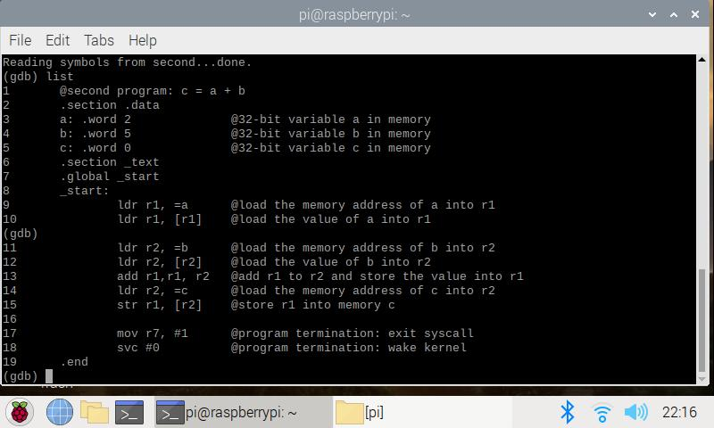Using line number for accurate debugging.

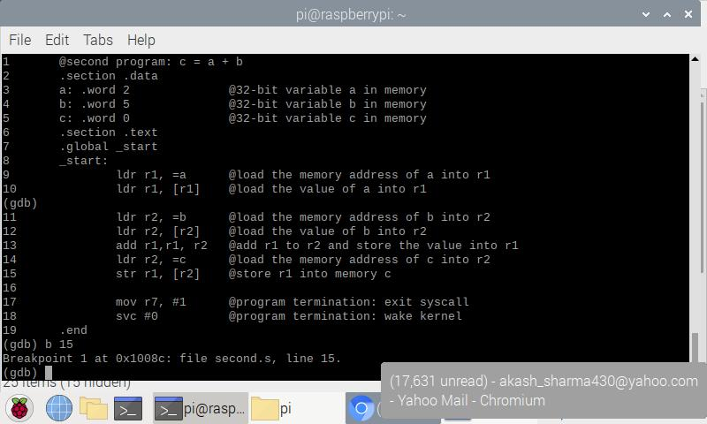

Breakpoint set to line 15 using the command as shown above

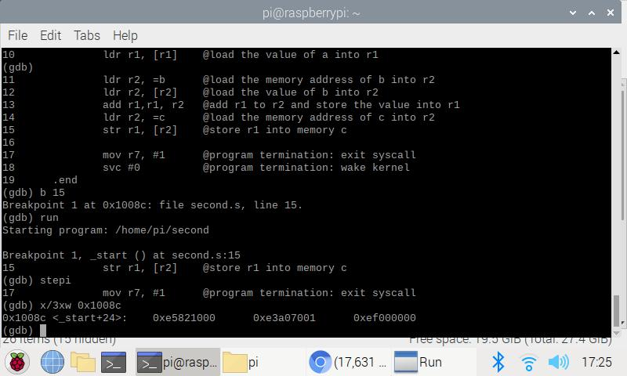

Using command x/3xw 0x1008c supplied, a combination of three words used to generate in hexadecimal. These words are seen in the above slide.