Tek Acharya

Georgia State University

Spring 2020

CSC 3210

ProjectA2

TASK3b

**Parallel Programming**

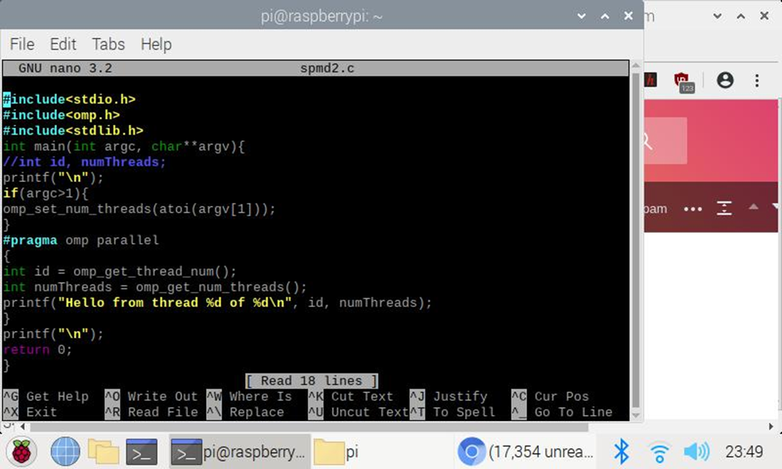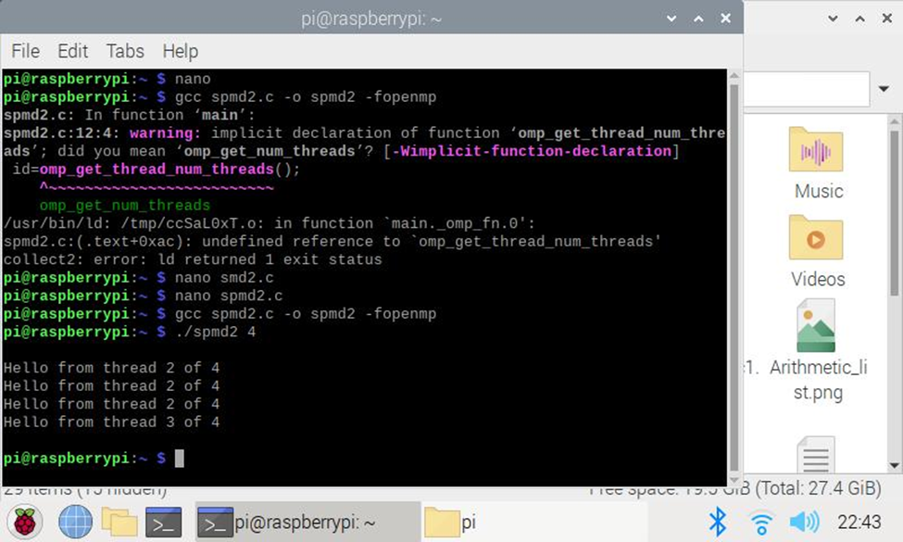

Compiled and ran the spmd2.c file in nano and tried pragma with 4 threads in parallel.

Observed that only three from id 2 and one from id 3 has been involved out of four cores.

This is because, the parallel programming hasn’t been started that started with curly braces from where the pragma has started. Even though the code was there, it was incorrect-the variable declaration wasn’t done.

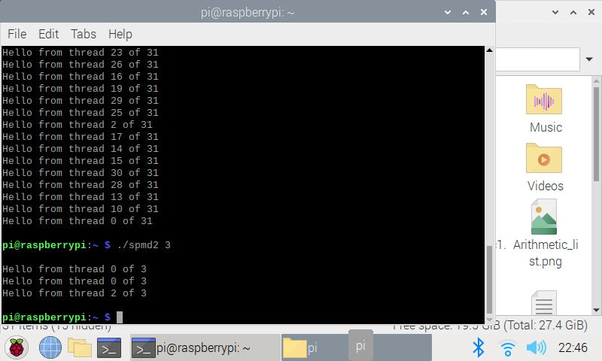

Tried running with different thread counts:

Noticed that not all cores have been used. 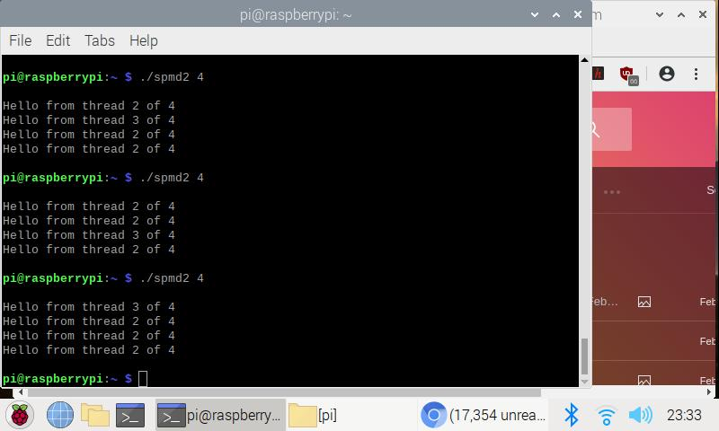Tried with thread 4 multiple times. Noticed that only two cores have been used as before.

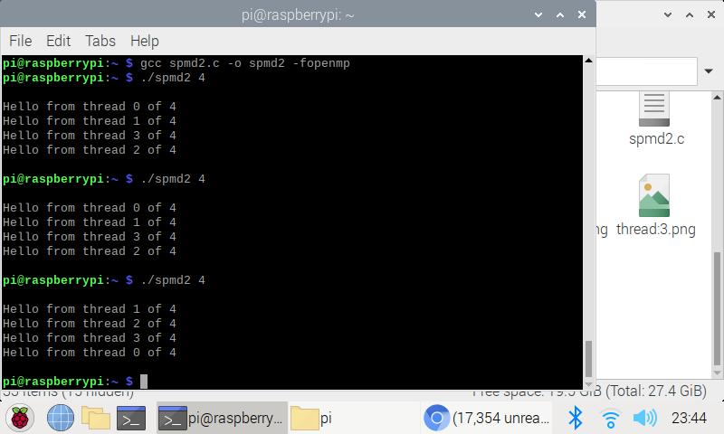

Once we fixed the code errors per instruction, we can see each thread coming from one core parallelly. This is because the pragma started the parallel computation as we declared the variable type within the curly braces of pragma.

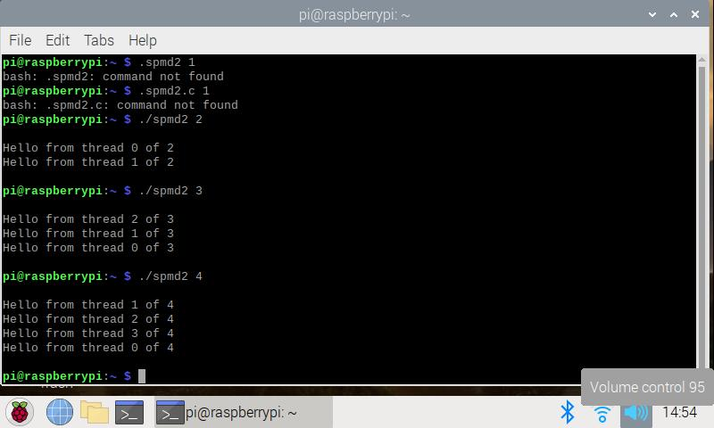

By now we can see the all cores working parallelly.