Tek Acharya

Georgia State University

Spring 2020

CSC 3210

ProjectA2

TASK3b

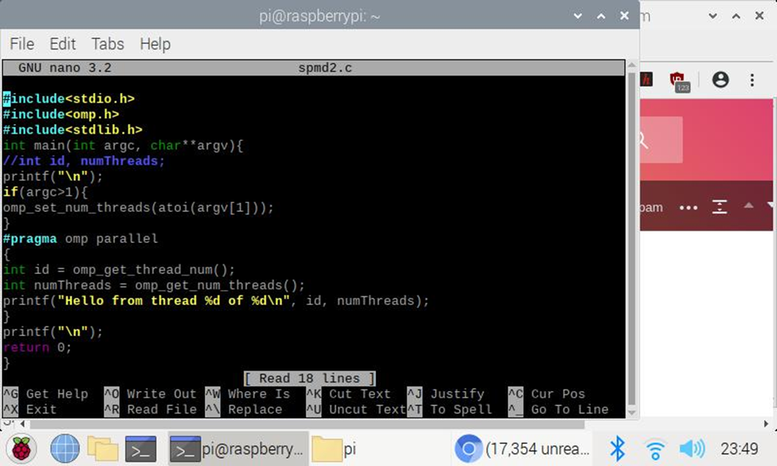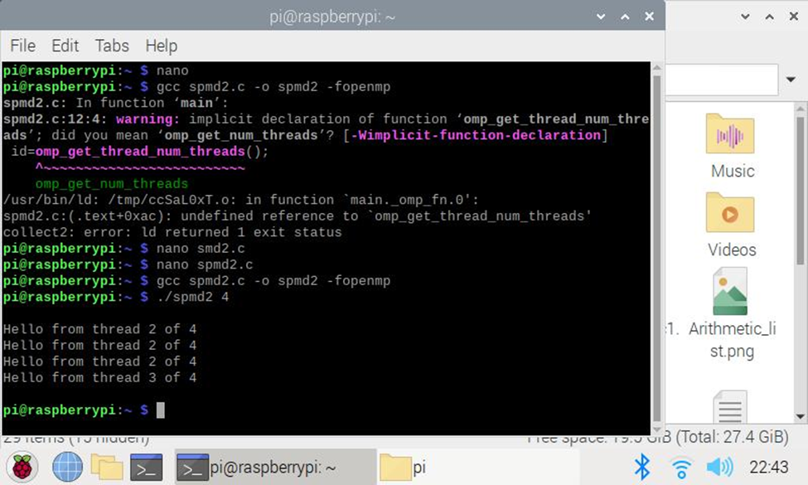

Compiled and ran the spmd2.c file in nano and tried pragma with 4 threads in parallel.

Observed that only three from id 2 and one from id 3 has been involved out of four cores.

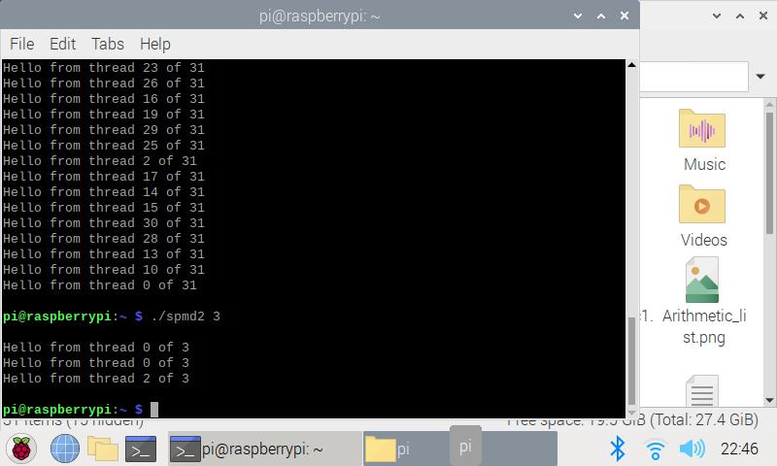

Tried running with different thread counts:

Noticed that not all cores have been used.

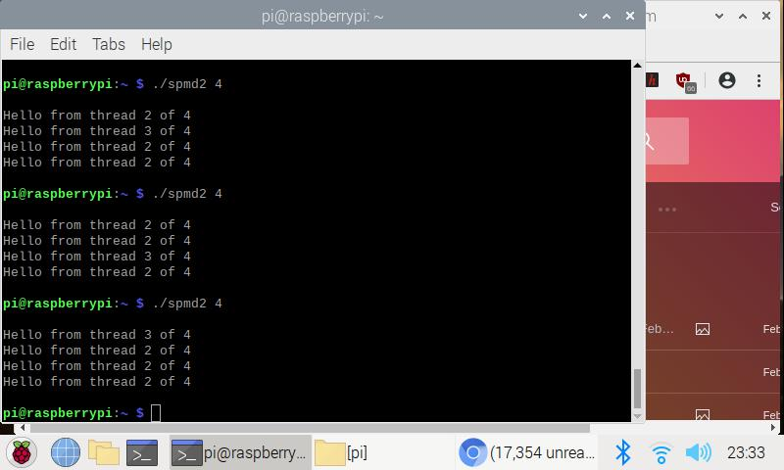

Tried with thread 4 multiple times. Noticed that only two cores have been used as before.

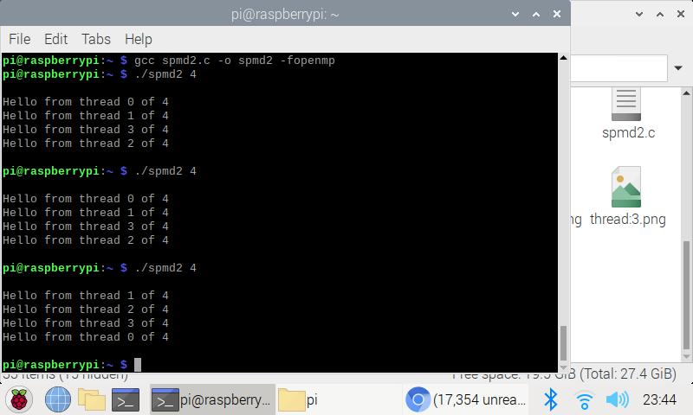

Once we fixed the code errors per instruction, we can see each thread coming from one core parallelly. This is because