**Tek Acharya**

**GSU, Spring 2020**

ProjectA2

TASK4

Part ll

The algorithm used in this project for assembly program is

Register = Val2 + 9 + Val3 – Val1 and the contents of the memory as given bellow in the data segment of the code

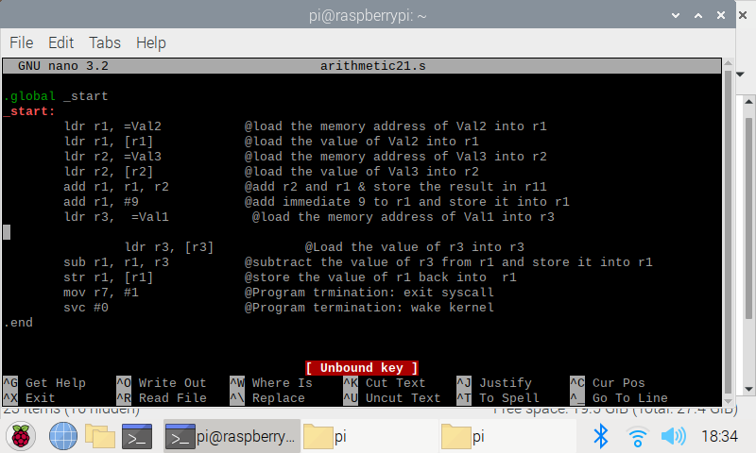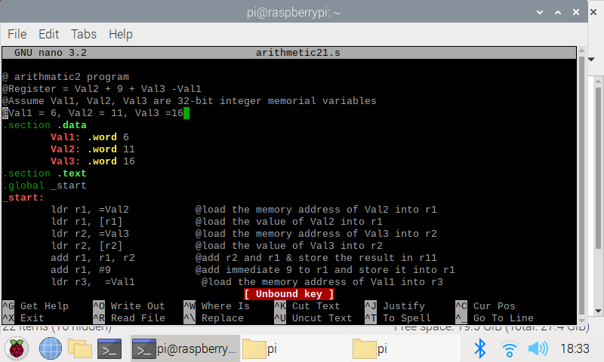I wrote an assembly code and compiled it as shown in the picture bellow.

The executables have been created. Then I assembled, linked and run using the command line.

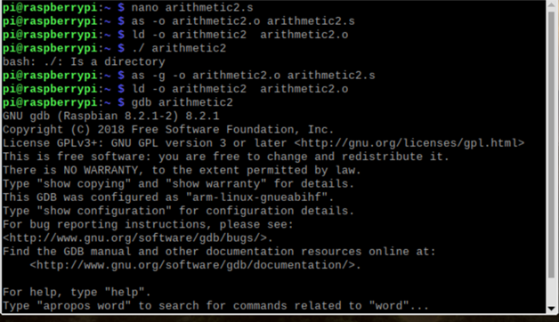

I then used gdb debugger to see the inside of the registers and memory

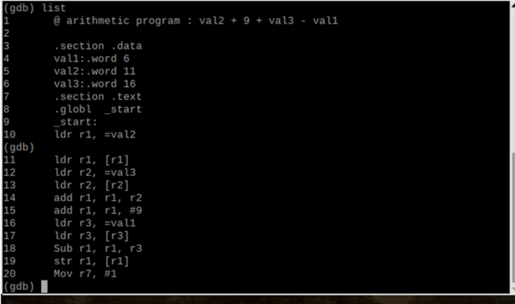

Used list command for better debugging and studied inside the registers

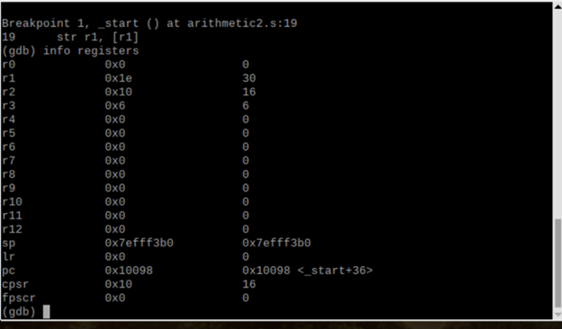

Then I set the breakpoint at line 19 as shown above and used *info regist*er to view into the registers. I also used *stepi* command to get into the next step while studying the memory and registers value changing stepwise.

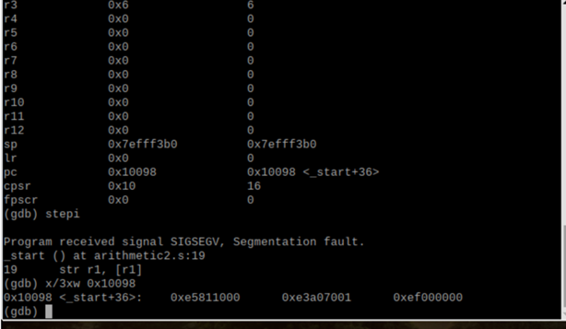

The command x/3xw 0x10098 as shown above has been used to view three words in hexadecimal from the code.

Those three words are shown in the above screenshot at the last line.

I then manually checked the arithmetic into my calculator and found that 30 corresponds to the final value of the register. Also each values of the assigned variable corresponded to the memory of the CPU.