Tek Acharya

ProjectA4

GSU Spring 2020

**Task 4a**

**Part1**

Note: By mistake I typed fourth.s to be fourht.s. Pardon me

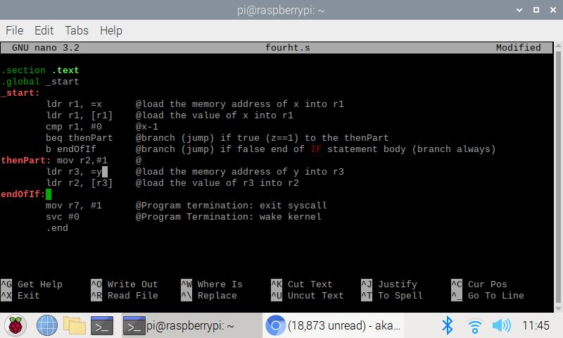fourth.s copied and pasted



Executable created

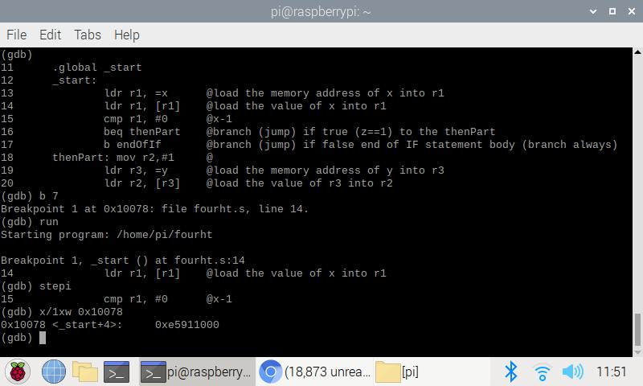

Compiled, linked, used GDB to debug. Breakpoint set at line 7 but it jumped to line 14. I then step in and checked the value of memory and register as shown below. I also examined the code part where the main logic is used (cmp) and monitored how the jump occurred using debugger.

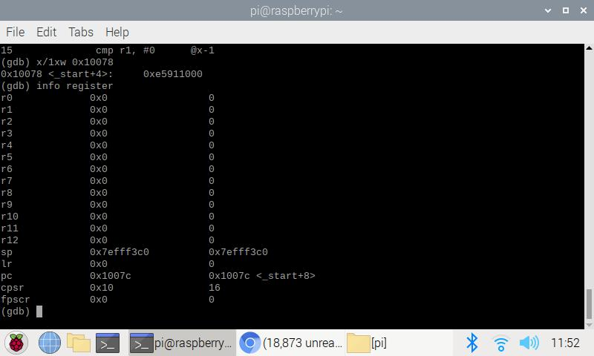

(the end result of the execution)

While using stepi and at point 0x10078, the hex value of 0xe5911000 is the data that is being stored at. At this time the r3 value address is 0x200a8.

While looking into the value of cpsr = 10 means the z (zero flag) value is set which will make jump to thenPart and thus the final value of r2 is 0. Also, while stepping in the then value of the flags I noticed the number 6000010 of cpsr which represents the 0 1 1 0 negative, carry, and 2’s complement, OV respectively.

**Prt2. Improved Code for fourth.s**

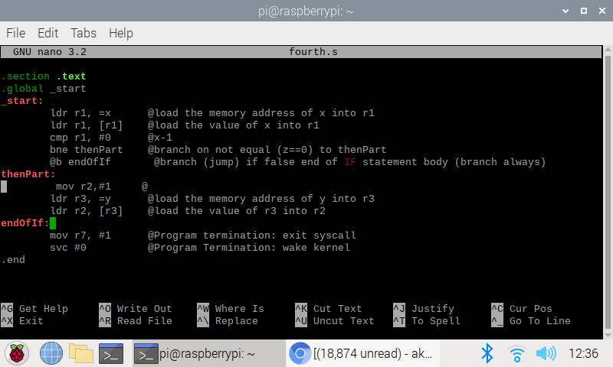

Corrected the code for its better look and efficient avoiding back-to-back branches. In this code, we removed ‘b’ instruction and used ‘bne’ instead that is the refixation of ‘beq’ using De-Morgan’s law.

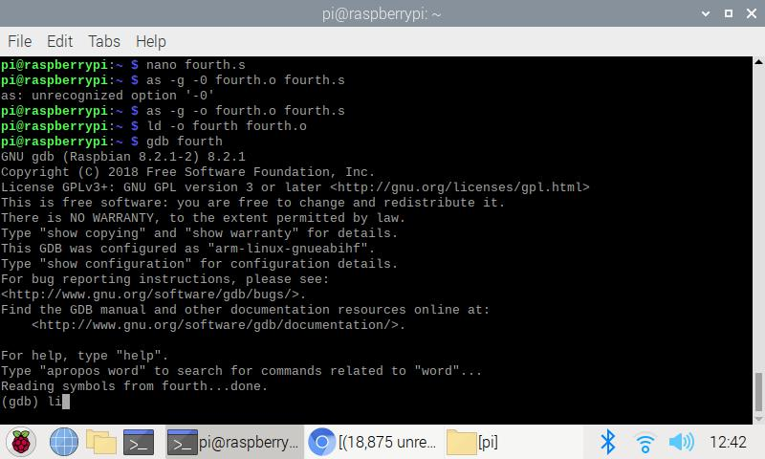

Compiled and linked

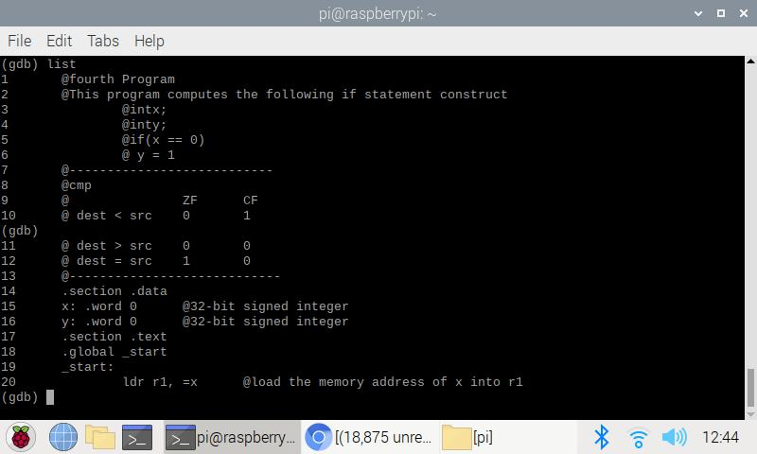

Looked into list view for better debugging.

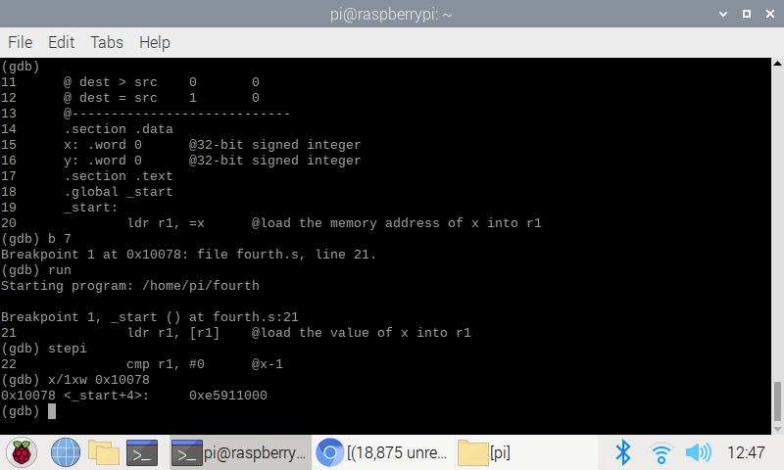

Debugged starting line 21 and stepped in into each line and examined the memory and register content.

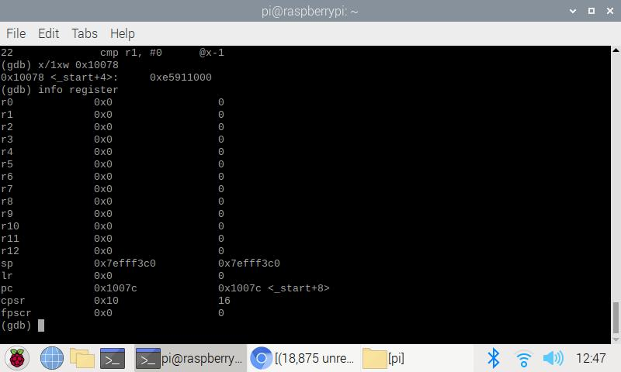

(The end result of execution)

Examined into the registers and flags. My value of r2 is 0 as expected and the z flag value is 10 (the second) which is set as expected.

**Part3: ControlStructure1.s**

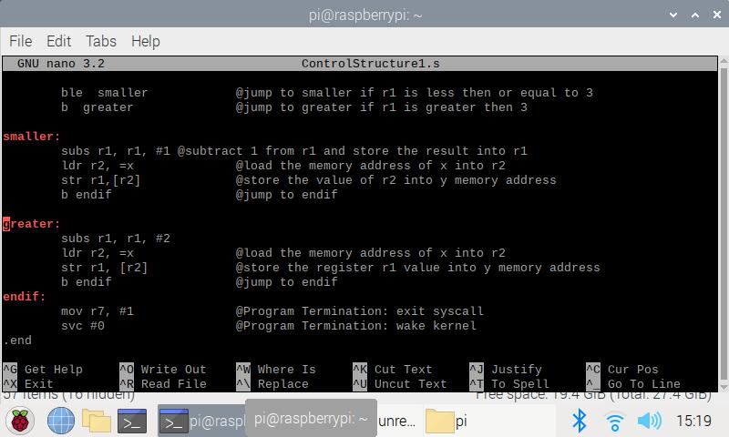

An ARM assembly corresponding to the given if/else condition is programed as above.

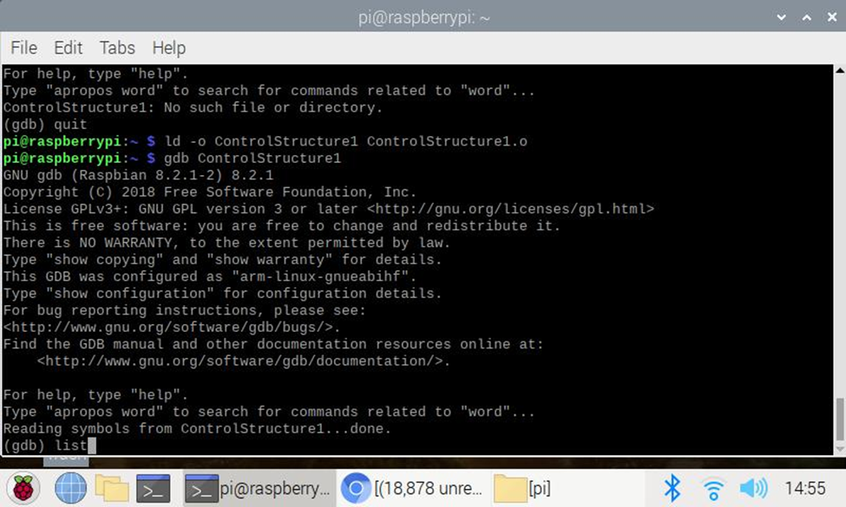

Compiled, linked, ran.

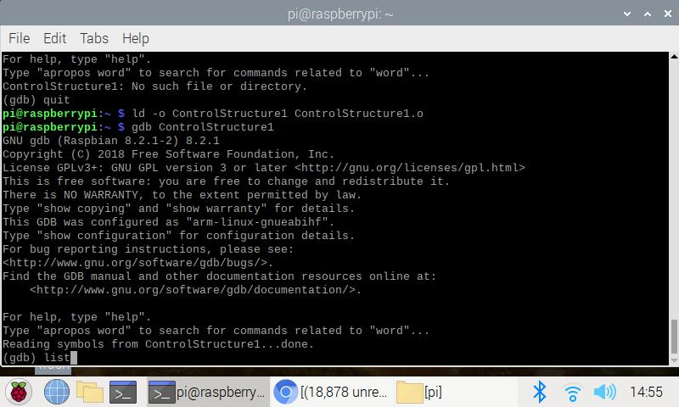

Debugged

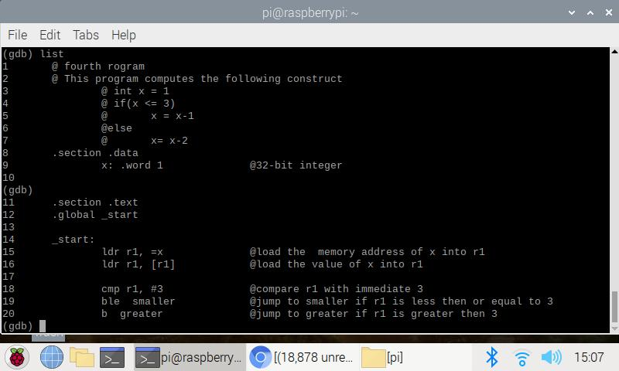

Taken list view to better debugging.

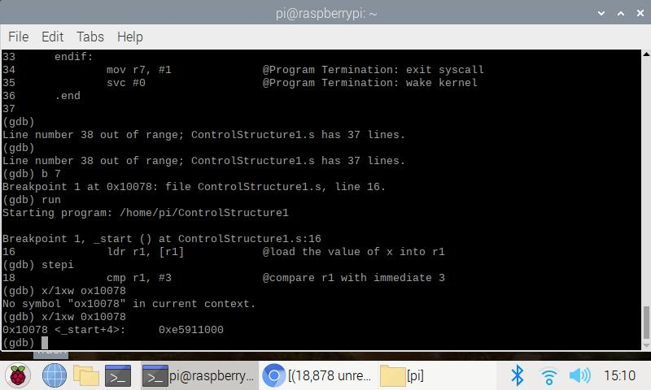

Debugged through breakpoint 7 but taken to line 16

Used step-in to view each lines in the code and examined the value of registers and memory as above.

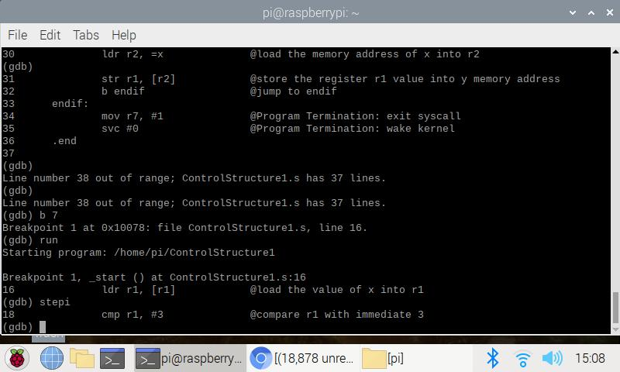

Viewed into different lines

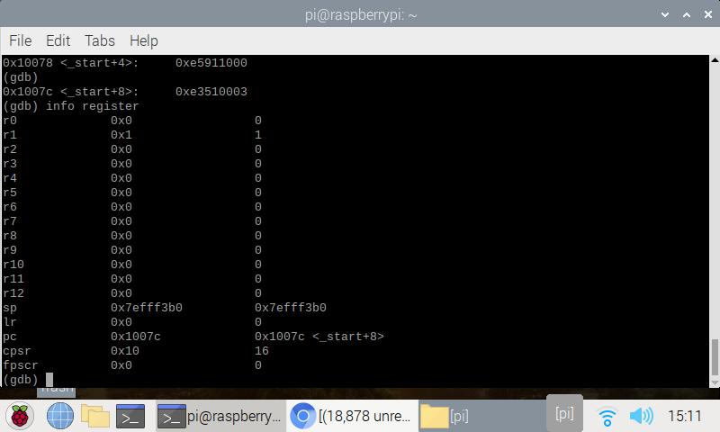

commanded info register to view into the register.

Our value of x is 0h as expected.

The z flag is cleared as expected because 1-1 = 0