Hyoungjun Lee  
individual report Assembly  
2/6/20

TASK 4: Raspberry PI Installation and ARM Assembly Programming

1. We named gitter-geeks as our group name, then we made github to organize our stuffs

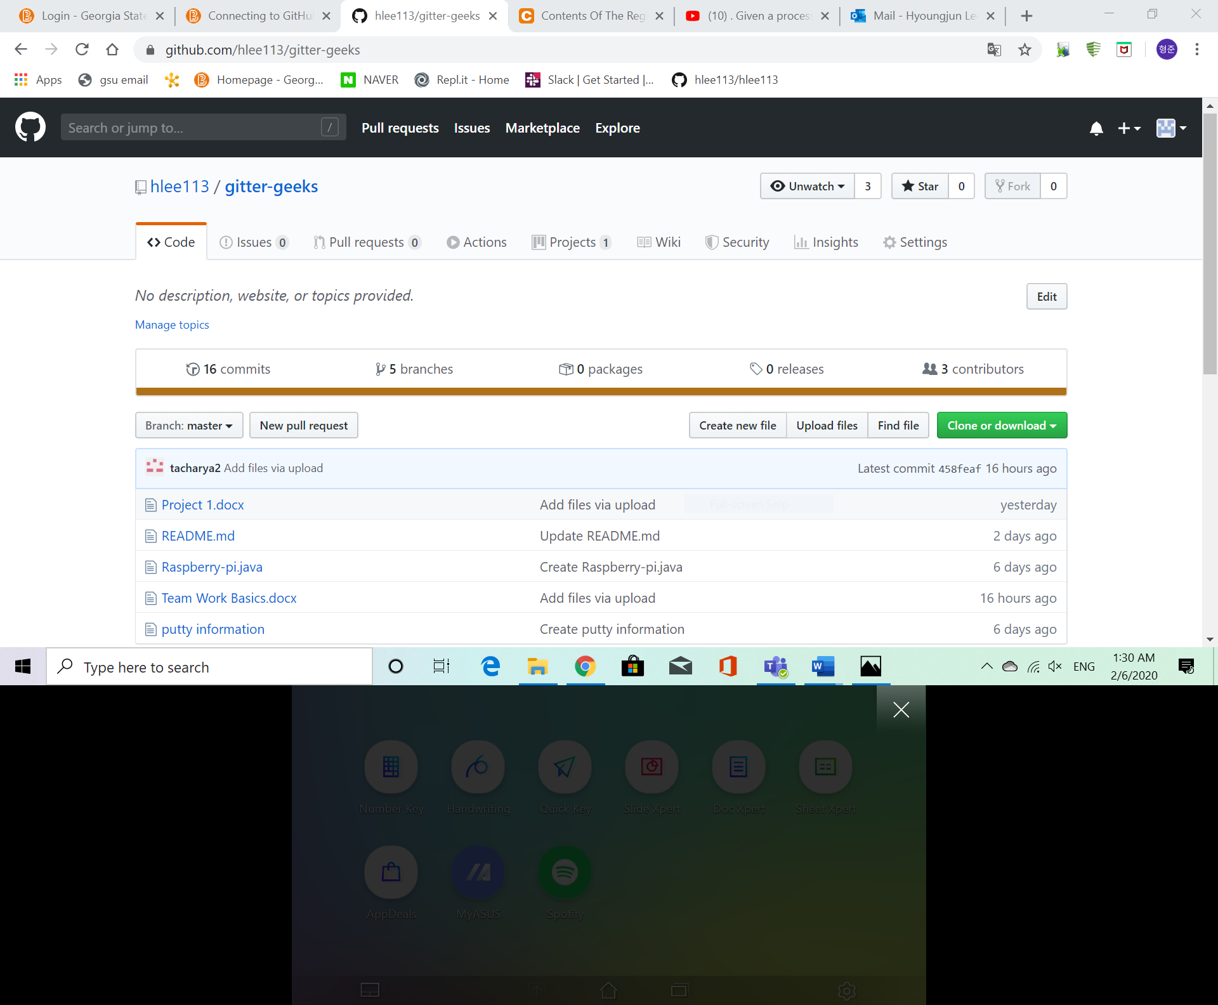

And generate SSH and connect to individual account

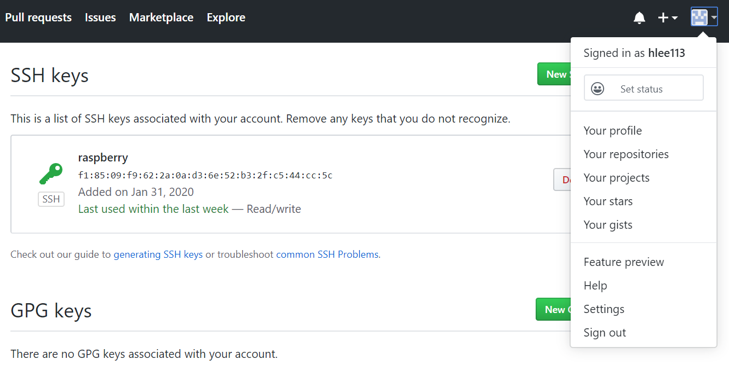

After generate SSH, First I connected to github with SSH, successfully connected as shown below

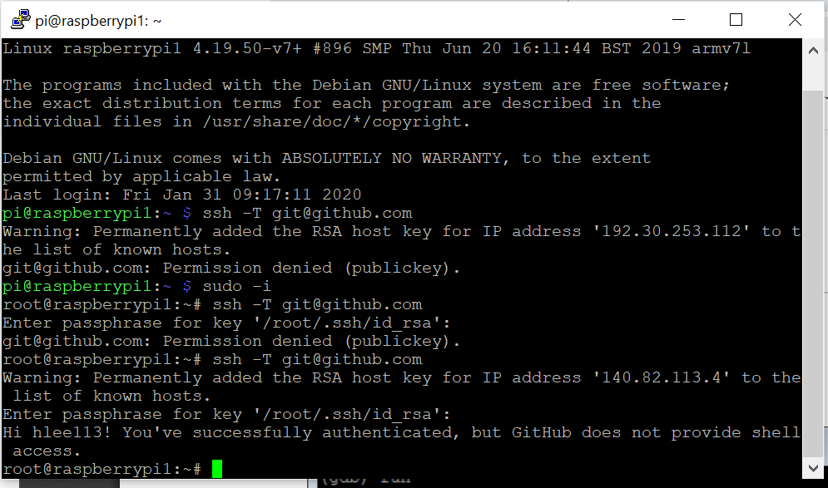

To test, make test.git file into home/pi

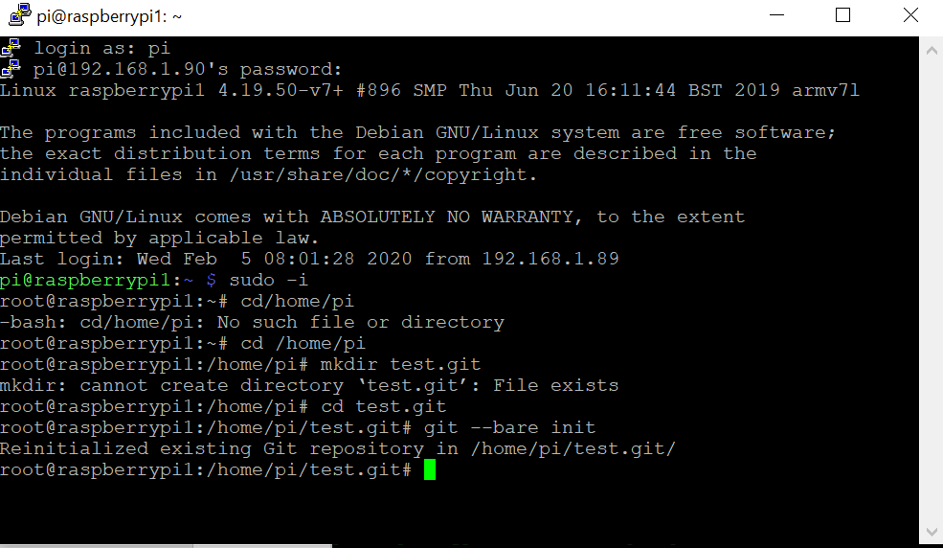

After steps above, this is what my folder looks like

1. **ARM Assembly Programming**

Part 1 – After making the repository in GitHub for our code and connecting our Raspberry Pi to the repository at the GitHub using Git we started the following program.

We use nano text editor to save file inside and edit.

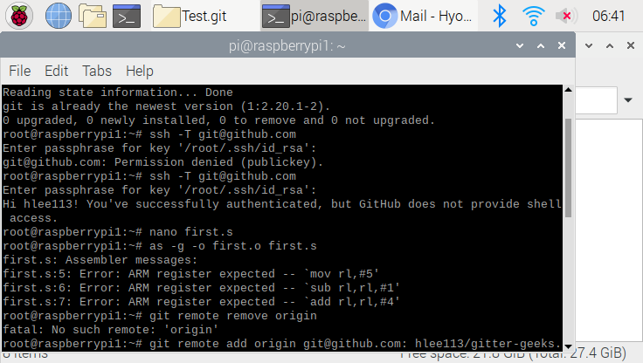

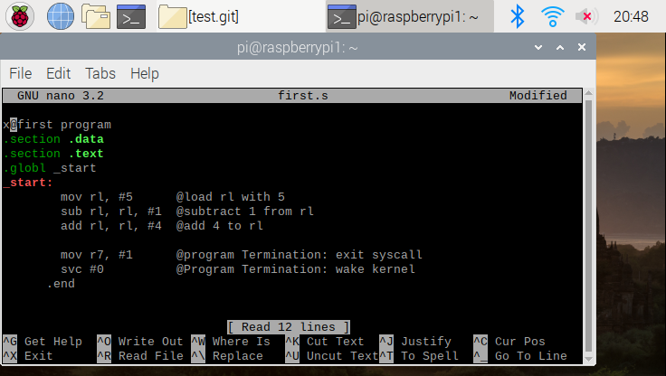

We create file and assembled file , also linked to executable , even after we run the code, we can not see anything because all the programs takes place into registry

We used gdb command ( debugging) that how program is being executed, We used -g flag to reassemble the program to run GDB.

This is just for github pulled

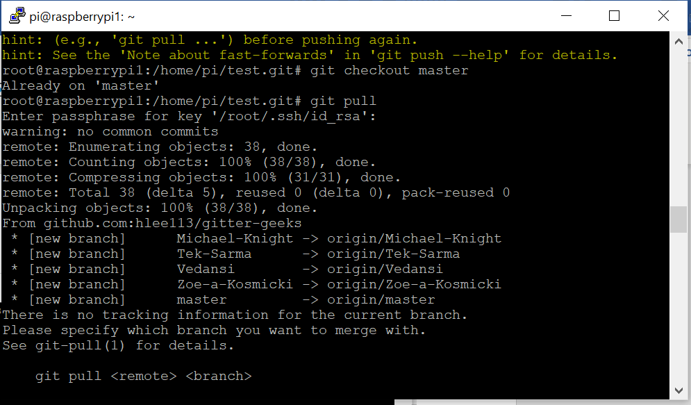

We set the break point at 11, When we run the program, the program execution will stop right before line 11 is executed

We used command info register to varify literal value in register, Register 1 has a value of 8 , because at the first register set to value of 5 , and then it was 4 because 1 was subtracted from it, then 4 was added to that value, which make resulting it to 8.

Part 2 - Write a program that calculates the following expression: A = (A + B) − (C * D), where A=10, B=11, C=7, and D=2

Start with nano editor as we did in part 1

We saved following code in arithmetics1.s and then assembled file then linked to get executable, we ran the proram, as we expected we could not see any result

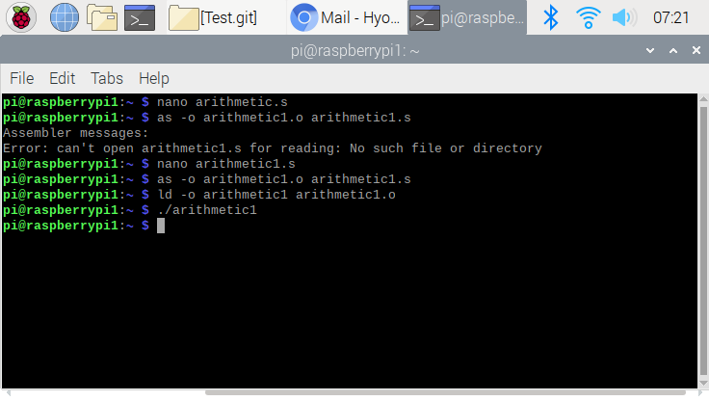

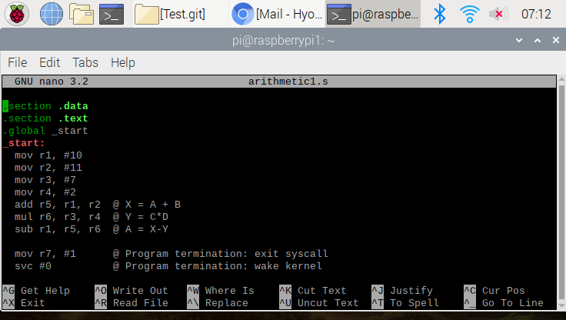

We used gdb(debugging) command again to see how this program being executed we used -g flag to reassemble and run GDB

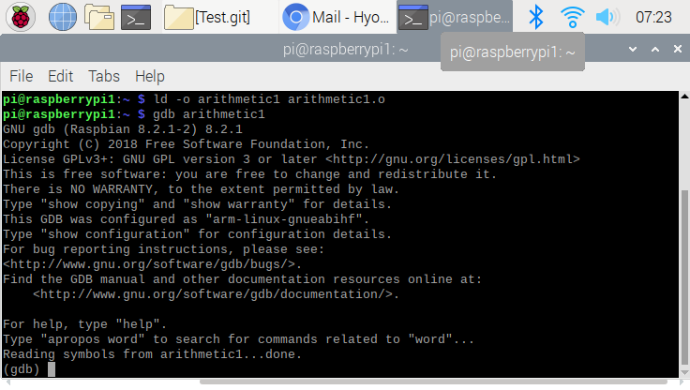

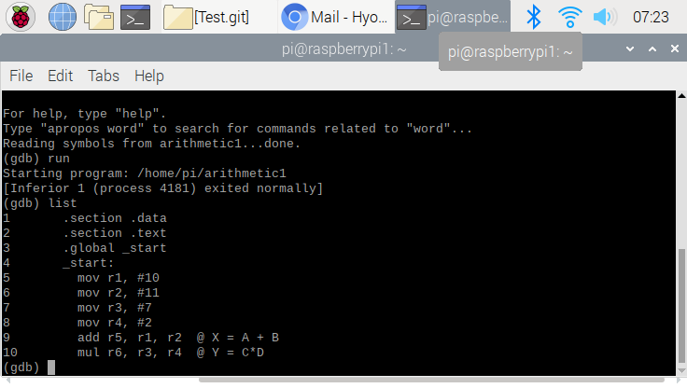

We set the breakpoint at line 14, debug will go through every step that we set the point

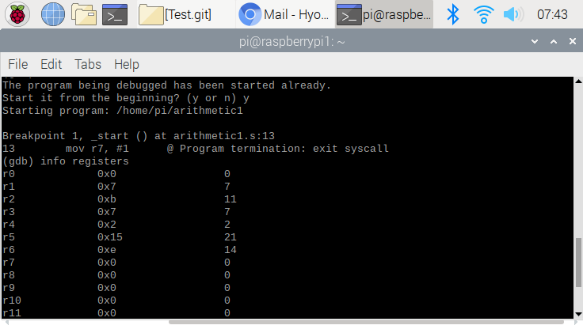

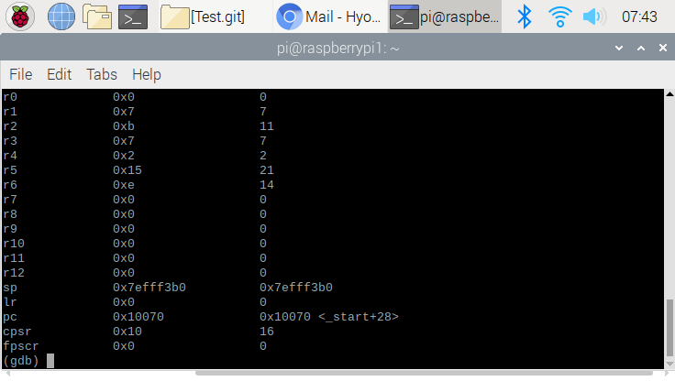

These are the registers that shows r2(register 2) is 11, 3 for 7 , 4 for 2

This is totally what we expected because A = (A + B) − (C *D),

Where A = 10 B =11 C = 7 D =2

Register 6 stores result of value (C * D) = 14 , register 1 stores final value of 7.