

Date: 1 January 2026 Reference: 3/1/6/1/2/2 Enquiries:
Tel: 0130020569
Email: Edith.Mpheteng@ump.ac.za

PERSONAL AND CONFIDENTIAL

Dear:

APPOINTMENT AS A TUTOR IN THE ACADEMIC SUPPORT SERVICES DEPARTMENT (FYE PROGRAMME)

We are pleased to offer you a one-year appointment (1 year) as Mentor in the Academic Support Services department (FYE Programme).

The period of employment will be from 01 February 2026 to 31 December 2026.

Reporting Line : Academic Staff Development Professional
Rate of claim : R --- per hour (Rate based on the level of study)

UMP would like to welcome you as a valued member of staff. Kindly notify us in writing of your acceptance of the appointment by completing the attached ACCEPTANCE OF OFFER and returning it to the Academic Support Services email:Mabizweni.machava@ump.ac.za within 10 working days upon receipt of this offer letter.


Yours faithfully

Dr M Madiope
Director: Academic Support Services Division



ACCEPTANCE OF OFFER

I (Full Name), hereby wish to confirm that I accept the employment offer as a Mentor in the Academic Support Services department (FYE Programme) with effect from
01 February 2026

SIGNED: DATE:

WITNESS 1
WITNESS 2

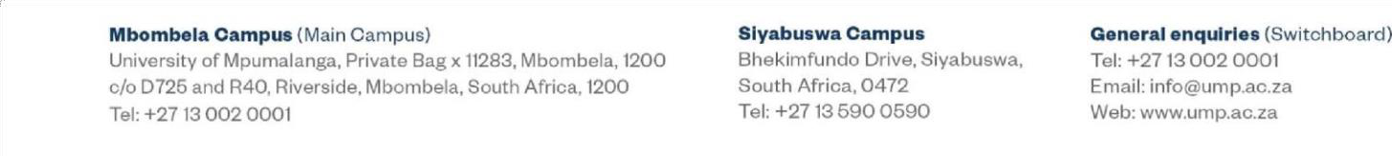

Mbombela Camp119 (Main Campus)
University of Mpumalanga, Private Bag x 11283, Mbombela, 1200 c/o D725 and R40, Riverside,Mbombela, South Africa, 1200
Tel: +2713 002 0001
Slyabuswa Campus Bhekimfundo Drive, Siyabuswa, South Africa, 0472
Tel: +27136900690
Ganaral anqulrlaa (Switchboard) Tel: +27 13 002 0001
Email: info@ump.ac.za Web: www.ump.ac.za

