<http://www.amnh.org/our-research/natural-science-collections-conservation/general-conservation/preventive-conservation/temperature-and-relative-humidity-rh>

# Temperature and Relative Humidity (RH)

**General information on temperature and collections**

The detrimental effects of incorrect temperatures (either too high or too low) are often observed after considerable time has passed, and so the slow deterioration that results is often underestimated. Natural science specimens are often composed of two or more types of materials each with their own rates of thermal expansion and contraction, which can cause physical damage as a result of fluctuations.  High temperatures promote faster chemical reactions, and so the overall degradation of organic materials occurs more quickly.  High temperatures can also accelerate desiccation of organic materials leading to loss of flexibility and cracking. While cold storage is a good preservation technique for some types of unstable collections and most collections would benefit from cooler temperatures than normally used in museums, temperatures that are too cold could cause embrittlement, hazing and cracks in other types of specimens.

Cultural institutions often have to compromise between the temperatures that are best for the preservation of the collection, what is economical in terms of equipment and energy policies, and what is best for the comfort of staff, researchers, and visitors.

**General Information on humidity and collections**

Different types of collections have substantially different relative humidity requirements and so it is hard to give specific set-points.  Specimens with metal components may benefit from RH levels that are as low as possible.  Organic artifacts require more moderate RH levels to prevent desiccation or embrittlement.  Most specimens benefit from RH levels that are moderate and stable to prevent physical damage that can be caused by wide climatic shifts.  Generally, recommendations for museum environments are given as to 50% while attempting to minimize dramatic swings to between 40-60%, even if broad seasonal trends are hard to avoid.

A variety of different environmental control strategies can be used depending on the situation. At the macro environment level this includes control of air temperature within a building (with or without passive relative humidity control), room level temperature control (e.g. radiators with window mounted a/c units), or entirely passive control based on the buffering effects of the building envelope (e.g. door seals).

Controlling RH at the building or room level can be very expensive, and if not done properly may actually end up causing structural damage.  However, RH can sometimes be very effectively and relatively cheaply controlled by creating a micro-environment around the specimen by a combination of well-sealed storage cabinets or exhibit cases and by using buffering materials, such as acid free tissue, wooden drawers, and passive environmental measures such as silica gel.

Even if there is limited ability to control the environment in buildings or rooms, it is a good idea to know what conditions your collection is being subjected to, so problems can be anticipated or micro-climate level solutions can be devised.  Monitoring environmental conditions can be done using equipment such as Heating Ventilation and Air Conditioning (HVAC) and/or Building Management Systems (BMS), reasonably priced electronic data-loggers or recording hygrothermographs.

**Collection Specific**

Temperature/RH and Invertebrate Zoology Collections

Fluid preserved specimens benefit from cool and stable environmental conditions. High temperatures accelerate the rate of deterioration of specimens and the rate of evaporation of ethanol, whereas low temperatures may cause fats and lipids to solidify, leaving deposits on specimens. Temperature fluctuations cause screw-on lids to loosen due to the differential expansion rates of glass and plastic. The ideal temperature for 70% v/v ethanol is 70° F with minimal fluctuations.

**[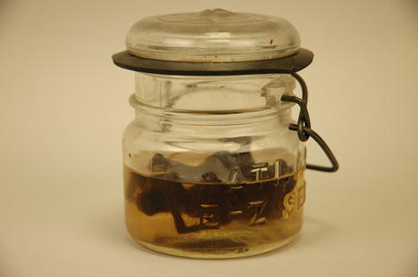](http://www.amnh.org/layout/set/plain/content/view/popup/56763/(baseNodeID)/56659)**

©Justine Cooper, Courtesy Daneyal Mahmood Gallery

For dry entomology collections temperature and RH should be maintained at levels that will not encourage pest infestations (see the section on IPM for more information) or mold growth.

Wasp nest specimen with mold growth as a result of incorrect humidity conditions.

©Justine Cooper, Courtesy Daneyal Mahmood Gallery

Shells (marine and egg) composed of calcium carbonate are susceptible to Byne’s “disease”, a form of acid attack that occurs when acid vapors in the environment form salts.  This problem is accelerated by high relative humidity conditions.  (see the Pollutants section for further information).

For more on preserving invertebrate zoology collections click here.

Temperature/RH and Vertebrate Zoology Collections

Vertebrate collections may benefit from cool temperatures that inhibit pest infestations.  Skins can be safely stored in cold rooms or freezers.  RH levels should be moderate.  It is important to prevent Temperature and RH levels from dropping too low which will lead to desiccation or too high which can result in mold or fungal attack.

For more on preserving vertebrate zoology collections click here.

Temperature/RH and Paleontology Collections

High temperatures are generally bad for paleontology collections because they promote physical aging and deterioration. On the other hand, temperatures that are too cold can promote thermal shock, in which a specimen could become brittle and crack or shatter. Incorrect temperatures also can lead to changes in the crystalline structure of minerals; soften adhesives that are used in fossil preparation, resulting in slumping; and, when combined with high relative humidity can lead to mold growth on specimens, labels, and storage containers.  Large shifts in RH may result in physical damage to specimens; fractures and crumbling can occur as the specimen alternately absorbs or releases moisture, causing swelling or shrinkage.  High RH can also promote oxidation and corrosion of certain minerals, such as iron pyrite.  For paleontological collections the National Park Service Museum Handbook recommends temperatures of 59-77 degrees Fahrenheit with RH in the moderate range of 45-55%.

For more on preserving paleontology collections click here.

Temperature/RH and Physical Sciences Collections

Temperatures that are too cold can promote thermal shock, in which a geological specimen can become brittle and crack or shatter. Incorrect temperatures also can lead to changes in the crystalline structure of minerals.  High RH may promote oxidation and corrosion of certain minerals, such as iron pyrite leading to “pyrite disease”.  Specimens suffering from pyrite disease must be maintained at RH levels under 30%.  **[Click here for more information on pyrite disease.](http://collections.paleo.amnh.org/6/storing/storage-environments" \t "_blank)**  RH that is too low can cause efflorescence in mineral specimens with soluble salts or shrinkage in absorbent specimens such as shale.

Sulfate specimens that have begun to fracture and powder as a result of incorrect RH.

©Justine Cooper, Courtesy Daneyal Mahmood Gallery

Like paleontology collections, stable and moderate temperatures and RH levels are normally specified for physical sciences collections.

**[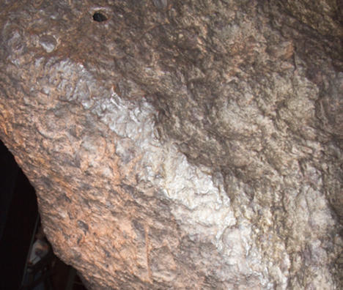](http://www.amnh.org/layout/set/plain/content/view/popup/56764/(baseNodeID)/56659)**

The surface of this meteorite has resulted as a result of incorrect RH.

For more on preserving physical sciences collections click here [link to collection specific challenges section]

**Additional Resources**

The National Park Service Conserve-O-Gram series has several documents that deal with practical topics relating to environmental monitoring of collections including:

* 3/1 Using a Psychrometer to Measure Relative Humidity [**[http://www.nps.gov/history/museum/publications/conserveogram/03-01.pdf](http://www.nps.gov/history/museum/publications/conserveogram/03-01.pdf" \t "_self)**]
* 3/2 Calibration of Hygrometers and Hygrothermographs [**[http://www.nps.gov/history/museum/publications/conserveogram/03-02.pdf](http://www.nps.gov/history/museum/publications/conserveogram/03-02.pdf" \t "_self)**]
* 3/3 Datalogger Applications in Monitoring the Museum Environment, Part I:Comparison of Temperature Relative Humidity Dataloggers [http://www.nps.gov/history/museum/publications/conserveogram/03-03.pdf

**[Canadian Conservation Institute Notes](http://www.cci-icc.gc.ca/resources-ressources/ccinotesicc/index-eng.aspx" \t "_blank)** offer practical advice about issues and questions related to the care, handling, and storage of cultural objects. Relevant Notes include:

* **[CCI Environmental Monitoring Equipment Loans Program](http://www.cci-icc.gc.ca/services/equip/equipbro-instbro-eng.aspx" \t "_blank)**

Appelbaum, Barbara. 1991.Guide to Environmental Protection of Collections. Madison, Connecticut: Sound View Press.

Bachmann, Konstanze . 1992.Conservation Concerns: A Guide for Collectors and Curators, Washington DC: Smithsonian Institution Press.

Thomson, Garry. 1986.The Museum Environment, 2nd ed. London: Butterworth-Heinemann.