DEACONESSES
The Board of Deaconess are sisters in the church who are moral, spiritual, and of good report among the members of the church as suggested in the New Testament: 1 Timothy 3:11 and Titus 2:2-5. The duties shall be to assist the deacons in maintaining moral and spiritual life among the members. The board of deaconesses will assist the pastor in developing the spiritual life of the women and girls of the church for the best possible Christian Service. The board will assist the pastor and the board of deacons in visiting the members, in the identification and care of the sick, needy and distressed members of the church.
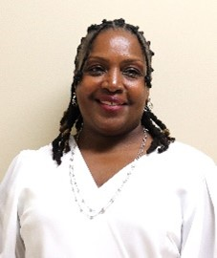

Angela Johnson
President
President of the Deaconess. Member of the Usher Ministry, and Women’s Ministry
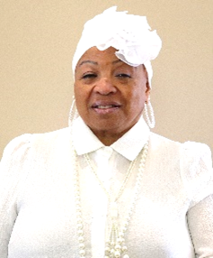

Carrie Jones
Deaconess Vice President
Member of Mt. Moriah since her childhood, member of the Deaconess Board for more than 5 years, member of the Official Team. Former member of the Music Ministry and Missionary Ministry.
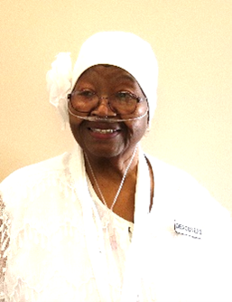

Mattie Bryant
Longtime member of Mt. Moriah. Former member of the Missionary Ministry and the Music Ministry
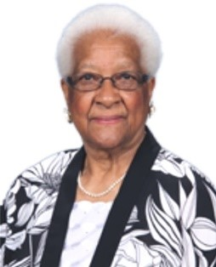

L. Joyce Biles
Former member of the Missionary Ministry, Women’s Ministry, bulletin board ministry, and represented Mt. Moriah at Community Kitchen.
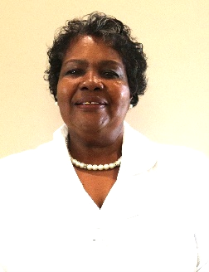

Ruthie Washington
Former Missionary Ministry Treasurer, Women’s Ministry member, and secretary for the Usher Ministry.
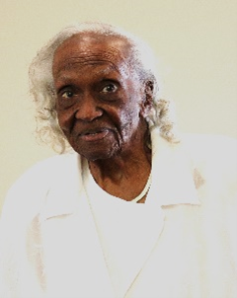

Mildred Arnold
Oldest member of the Usher Ministry, former member of the Missionary Ministry and retired head of the Culinary Ministry.
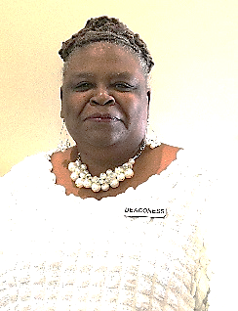

Sherona Waldon
Member of Mt. Moriah for 61 years, President of Women’s Ministry. Former Administrative Assistant to Pastor Calvin Cole, Sr. and Former Choir member.

