DEACONS
The deacons are ordained to do their work according to Acts 6: 1-8, 1 Timothy 3: 8-13 and Titus 2.
The deacons assist the pastor, cooperate with the pastor in providing the pulpit supply and the leaders of the prayer meeting; visit members; care for the sick and needy and distressed members of the church. The board shall promote Christian instruction and ministry to the church membership.
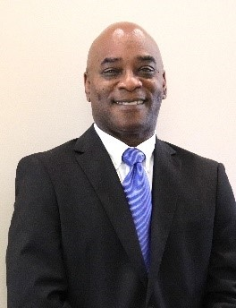

John Burnett
Chairman of Deacons
Deacon Burnett has been a deacon for over 20 years, serves as vice-president of the Ushers Ministry, Finance Vice-Chairman; and is a member of Culinary Ministry and a member of the Official Team.
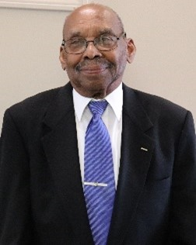

Thomas L. Biles
Deacon for over 40 years, Member of the Male Chorus, Discipleship Training teacher and a member of the Official Team.
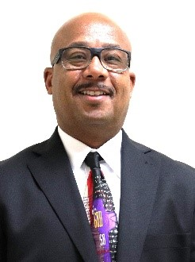

Mario Johnson
Deacon for more than 15 years and member of the Official Team.
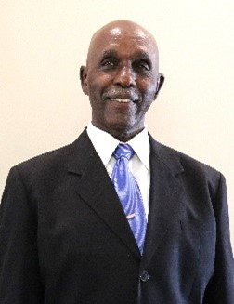

William S. Jones
Deacon for over 30 years, Vice-chairman Trustee Board, member of the Usher Ministry, Male Chorus, Official Team and Discipleship Training teacher.
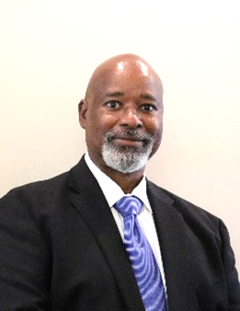

Weldon Stokes
Deacon for over 30 years, Finance Chief, member of the Usher Ministry, Culinary Ministry and Official Team Secretary
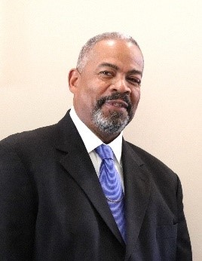

David Jones, Sr.
Ordained as a deacon on June 21, 2013. Member of the Male Chorus, and Official Team.
