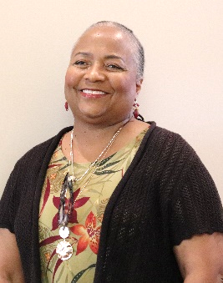

Evangelist Melanie Nunn
Before moving to Paducah, she and her family lived in Detroit, MI for twenty-five years where she taught English and Journalism at Henry Ford High School.
Evangelist Nunn responded to God’s call in 2000 and has never looked back. She is an associate minister at Mount Moriah Missionary Baptist Church in Paducah, KY where she also served as Superintendent of Disciples in Training (formerly known as Sunday school). She considers it an honor to be both licensed and ordained by her father in the ministry and pastor, Reverend Dr. Calvin Cole, Sr.
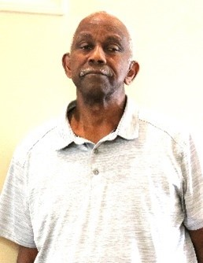

Elder Jimmy Jones
Elder Jones was born in Cairo IL, graduate of Sumner High School, West KY Vocational-Technical School and attended Coyne Electronic Institute for 15 months. He was an employee of USEC for 37 years in instrument maintenance.
He was married to Teressia Jones for 38 years and from this union they have 4 children.
Elder Jones was ordained February 18, 1996, at Higher Dimensions Church, Paducah Ky by Rev. Zachery Strong.
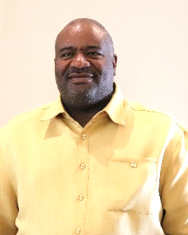

Rev. Fairly Taylor
Reverend Fairley Taylor Jr, is the son of Brenda Taylor and the late Fairley Taylor Sr.
Reverend Taylor grew up in Hopkinsville KY. He received his commission in 1988 as a U S Army Officer.
In 1989 he graduated from Murray State University with a Bachelor of Science degree in Animal Science.
He was ordinated as a deacon in 1991. He served several years on the finance committee, church clerk, youth leader and chairman of the van ministry. He was called into the ministry in 2005, and his initial sermon was “Why Do We Doubt God”, 1 Kings 19:1-5.
He received his licensed to preach January 4, 2007, from Reverend Dr. W.G. Harvey Sr. at New Greater Love Missionary Baptist Church, Paducah KY
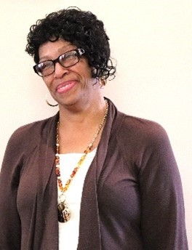

Minister Joyce Shields
Joyce Marie Harden-Shields is second oldest of five children born to the parents Leon (deceased) and Joyce Harden.
A 1978 graduate of Eudora High School, Eudora Arkansas; completed Personal Care Training at Central Arkansas Area Agency on Aging in 1985; graduated in 1993 from Great Rivers Vocational School in McGee Arkansas with a business secretary degree.
At fourteen she accepted Jesus Christ as her Lord and Savior and was baptized under the leadership of the late Rev. Edgar Handie, Zion Chapel Baptist Church.
While in Eudora formed a gospel group The Wings of Joy under the direction of musician Antionetta Harden.
November 1996, she and her two sons Maurice and LaMarcus moved to Paducah KY.
In 1997 joined White Oak Missionary Baptist Church, Rev. Calvin R. Cole, Sr. Pastor.
February 10, 2001, she married Jesse Shields Jr. This union brought a family of three to a family of six Maurice, LaMarcus, Jonathan and Vahon with 6 children.
On April 15, 2001, her membership was moved to Mt. Moriah Missionary Baptist Church under the leadership of Rev. Calvin R. Cole, Sr.
March 31, 2019, received and accepted the call into the ministry.
Past offices: president of the Missionary Circle, Discipleship Training Superintendent and Women’s Ministry secretary.
One of her many favorite scriptures 2nd Chronicles 7:14 “If my people who are called by my name will humble themselves and pray and seek my face and turn from their wicked ways, then I will hear from heaven, and I will forgive their sins and will heal their land”.
I owe it ALL to the Lord….if it had not been for the Lord on my side who kept me safe even when I couldn’t see it…. where would I be. All my help comes from the Lord.
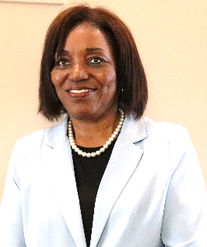

Minister Doralyn Warren
Currently employed at West Kentucky Community and Technical College as an Instructor of teaching in the Nursing Assistant Program.
Her previous employment was working in Longterm Care for over 40 years. Her passion for taking care of the elderly community she says “is a calling”. Now she is teaching nursing assistants to give the best care and service to the elders.
She has a strong passion for teaching which she sees is a gift from God.
The purpose of her call into the ministry is to teach God’s love to all people without a respect of persons.
Education
Bachelor of Science Nursing (BSN) from Wesleyan University in 2010
Now attending Newburgh Seminary to receive a Master of Ministry degree.
Professional Skills
Doralyn Warren, LLC Consultant
Answer questions from family members in regard to longterm care placement or at home assistance.
Allowing family’s to express their concerns of becoming a caregiver.
Personal Hobbies
Riding her bike, walking, cooking and reading
Studying the Old Testament is her favorite lessons in the Bible.
Personal Philosophy
“Life is a gift, you decide how you open it”.
Proverbs 23:7a NKJV
“For as he thinks in his heart, so is he.
Family
She is the parent of Kimberly D. Warren and
H. Jermaine Warren of Louisville, Kentucky.
One favorite granddaughter, Jordayn and two grandsons, Justin and Josh.
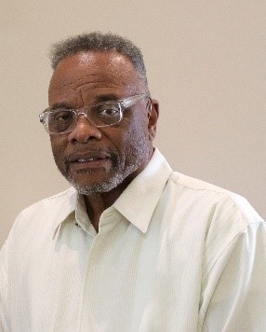

Rev. Dennis Gray
Pastor Dennis Gray, a native of Hickman, Kentucky, is a commissioned minister of the Christian Church (Disciple of Christ). Pastor Gray was called by God to the ministry in January 1997; he answered the call and made the petition to God that if He would fill him with the Holy Spirit, he would go wherever he was sent.
Pastor Gray served as the pastor of Second Christian Church in Mayfield, KY for 23 years, where he shepherded the congregation into transformation. His portfolio includes Overseas Ministry in Haiti, Heaven on Earth conference in Indianapolis, attended Lexington Theological seminary where he did special study classes and program activities such as Disciples History, Survey of Christian Thought, Introduction to Pastoral Care, Preaching, Evangelism, and Church Leadership, Minister and Pastor’s Leadership, Temple Hill MD.
Pastor Gray has retired from Pastoring at Second Christian Church and is now serving at Mt. Moriah Missionary Baptist Church in Paducah, Kentucky as an Associate Minister. Pastor Gray is the husband of Sue Gray, and together they have three children and four grandchildren.
Pastor Gray is very serious about the work of the Lord. He is an inspirational and gifted teacher-preacher with exceptional leadership and team-building skills.

