That’s amazing — Peak GPT Wrapper : r/OpenAI
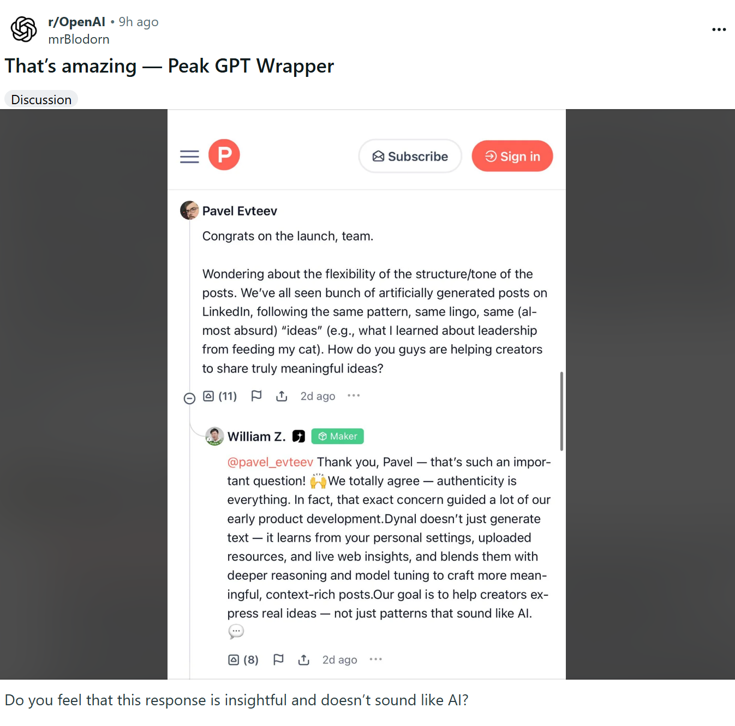

https://www.linkedin.com/posts/aitalk_someone-asks-is-this-mushroom-edible-activity-7388796878399893504-LrEL?utm_source=share&utm_medium=member_desktop&rcm=ACoAAC2urAgBfu2C0z-IMFqvdkkELYpn-XBgOqM
