# Establishing the goals of your project

What is your project fundamentally about?

My project involves implementing a Machine Learning Continuous integration tool for automating tests on the machine learning code. The project will create a common repository to store the uploaded code, while allowing the users to make real-time changes to them. For the users, we will develop a web platform to enable real-life updates to the existing code. Using the repository structure enables us to simplify and shorten the time require for code development.

What are you intending to design/build/investigate?

The project will involve source control to track the changes within the repository to reflect the changes. A tracker to identify the changes within the repository and allowing the user to determine when to commit the changes. Demonstrate the pull function to go back to previous code versions. Within the repository, the key functionalities will be helping the user to track and correct bugs, identifying mistakes within the previous versions in the repository, and determine the compatibility of the code on different platforms.

What do you intend to deliver as the project results?

A Python program to process the repositories. Enabled automation of building and testing within the program. Import external continuous integration services to run the program.

What would constitute, in your own and your supervisor’s eyes, a 100% satisfactory solution?

Resolve commit conflicts made by different users as show in Figure 1.

|  |  |
| --- | --- |
| Objective | Stage |
| Create different branches within a repository. | ⏳ |
| Demonstrate successful testing of machine learning code | ⏳ |
| Develop version control and suitably handle the commit conflicts. | ⏳ |
| Provide a platform to build and run the code. | ⏳ |
| Automatically run tests for each commit | ⏳ |
| For each failed build and test, identify the bugs for the users | ⏳ |
| Include external servers to run and test the program in different environment. [Figure 3] | ⏳ |

In the worst case what is the minimum that needs to be completed to achieve a pass?

|  |  |
| --- | --- |
| Objective | Stage |
| Create a web interface for the continuous integration platform | ⏳ |
| Build a copy for each branch within the repository | ⏳ |
| Provide a basic visual layout for the website | ⏳ |
| Provide unit testing for each functionality | ⏳ |

What are your personal aims that you hope to achieve?

1. Develop better understanding of how to apply the Jenkins library to create a source control repository. 🎯
2. Improve and demonstrate Python skills at creating the coded solutions. 🎯
3. Automated testing aims to improve the understanding of the software development cycle [Figure 2], especially the testing stage. 🎯

# Figures

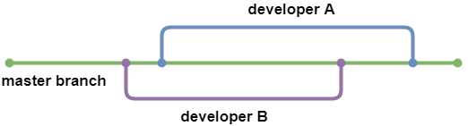

Figure

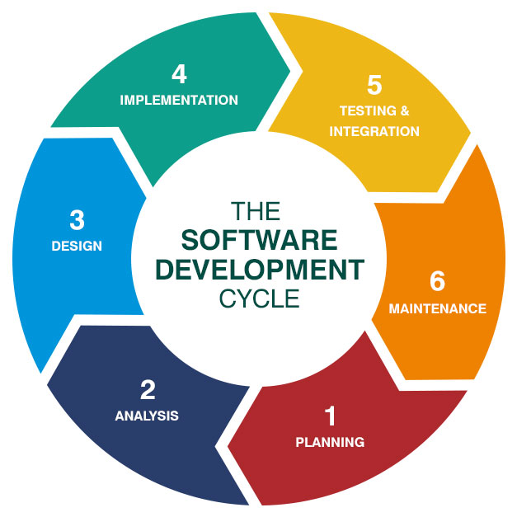

Figure

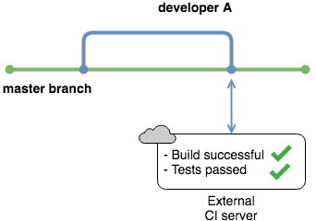

Figure