<https://stackoverflow.com/questions/70200476/github-actions-every-step-must-define-a-uses-or-run-key>

For formatting the yaml file instructions.

I removed the redundant columns from the variable columns

"""

drop_list = drop_columns + useless_column *# initialises the list to drop the items from the dataframe*

*# initialise the practise columns.*

practice_list = ["legum","conc","add","lact","breed","covman","comp","drag","cov","plow","solar","biog","ecodr"]

for feat in first_line: *# iterate through the first line columns*

    if **any**(x in feat for x in practice_list): *# checks if the features are in the practice_list*

        drop_list.**append**(feat) *# adds the features onto the drop-list*

*# print("Feature: {}".format(feat)) # test displays the features that will be added into the useless column*

*# compare drop_list with columns*

**print**("Columns: {}".**format**(**len**(columns)))

**print**("Drop_list: {}".**format**(**len**(drop_list)))

*# removes items that start with "net_name" from the variable columns*

columns = [feat for feat in columns if "net_name" not in feat]

for feat in drop_list: *# iterate through the drop_list*

    if feat in columns:

**print**("Feature: {}".**format**(feat))

*# df = df.drop(feat) # drop the feature from the dataframe*

Created a function to process the data headings

GOAL: encapsulate the heading processes into a function. – COMPLETE

I used the function collect_headings to process the data frame to extract the necessary information for grouping the data into different columns:

def **collect_headings**(df):

    """

    Function uses the dataframe to collect the headings from the csv file

    @param: df - dataframe

    @return: headings - list of headings

    """

*# get the first line from farmers.csv*

    first_line = df.iloc[0]

    columns_test = first_line.to_string().split(',') *# split the first line into a list by comma*

*# print the first element of the list with the first character removed*

    column_headings = columns_test[0].split('\n')

    real_headings = [] *# intialises a list to store the heading variables*

    for heading in column_headings: *# iterates through the unprocessed column headings*

*# split the heading by any whitespace*

        heading = heading.split()

*# append the second element of the list to the real_headings list*

        real_headings.**append**(heading[1])

    return real_headings

Implement a function to process the data in the dataset before using pandas to format the data structures.

I implemented a function to convert the loaded data frame into suitable data formats by iterating through the datasets and eliminating the newline and the spaces functions.

<https://realpython.com/python-csv/>

Researched this site to help with improving how to process the data.

I generated the column names by reading the files with the csv function.

I wrote a test that displayed the data in table format through the code:

def **read_data**():

    """

    Reads the data from the csv file

    @param: None

    @return: dataframe with the data that has been loaded into the csv file "data.csv"

    """

    file_name = 'farmers.csv' *# name of the csv file*

    with **open**(file_name) as csv_file: *# open the csv file*

        csv_reader = **csv**.**reader**(csv_file, delimiter = ',') *# read the csv file*

*# intialise a variable to track the number of lines in the csv file*

        line_count = 0

        for row in csv_reader: *# iterate through the csv file*

            if line_count == 0:

**print**(f'Column names are {", ".**join**(row)}') *# displays the column names*

            line_count += 1 *# increment the line count*

    df = **pd**.**read_csv**(file_name) *# read the csv file into a dataframe*

    return df

df = **read_data**()

**print**(df)

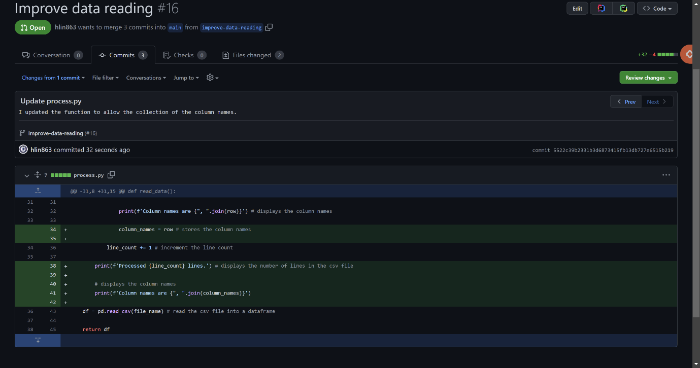

Used data frame to process the individual columns.

I generated the function to clean up the datasets for later operations.

I created a function to apply logistic regression on the cleaned datasets after removing the null values and splitting the data into training and testing sets.

*# import the Linear Regression class*

from **sklearn**.**linear_model** import **LinearRegression**

*# import the sklearn library to preprocess the data*

from **sklearn** import **preprocessing**

*# import the pandas library*

import **pandas** as **pd**

*# import the train_test_split function*

from **sklearn**.**model_selection** import **train_test_split**

*# import the matplotlib library*

import **matplotlib**.**pyplot** as **plt**

*# load the farmers_cleaned.csv dataset*

df = **pd**.**read_csv**('farmers_cleaned.csv')

*# create a Linear Regression model*

model = **LinearRegression**()

df.**dropna**(inplace=True)

*# intialise the input and output variables: X and y*

X = df.**to_numpy**() *# converts the dataframe to a numpy array*

X = **preprocessing**.**scale**(X) *# preprocess the data*

y = df.**pop**('cons_general').**to_numpy**() *# removes the net_name column from the dataframe and converts it to a numpy array*

X_train, X_test, y_train, y_test = **train_test_split**(X, y, test_size=0.2, random_state=0)

*# fit the model to the data*

model.**fit**(X_train, y_train)

*# print the model's score*

**print**("The score for the Linear Regression model is: ", model.**score**(X_test, y_test))

*# visualise the model's predictions*

**plt**.**scatter**(y_test, model.**predict**(X_test), color='black')

**plt**.**xlabel**('Actual Consumption') *# set the x-axis label*

**plt**.**ylabel**('Predicted Consumption') *# set the y-axis label*

**plt**.**title**('Actual Consumption vs Predicted Consumption') *# set the title*

**plt**.**show**()