Table of Contents

Background 1

Establishing the goals of your project 1

What is your project fundamentally about? 1

What are you intending to design/build/investigate? 2

What do you intend to deliver as the project results? 2

What would constitute, in your own and your supervisor’s eyes, a 100% satisfactory solution? 2

Design 2

Front-end 2

Back-end 2

In the worst case what is the minimum that needs to be completed to achieve a pass? 3

Planning 3

Front-end 3

Back-end 3

Testing 4

External Libraries 4

What are your personal aims that you hope to achieve? 4

Figures 5

Sources 7

# Background

There has been existing work on automating tests e.g., Git [Figure 6] and Jenkins. While the existing tools are great at tracking and managing source code change and enabling teamwork on a project, they aren’t effective at setting benchmarks and conduct tests for the Machine Learning code. Machine Learning has additional data requirements because it consists of training and testing code.

When applying the project, the system should be able to train the datasets based on the training and the benchmarks before moving onto the testing data to determine the model’s performance.

# Establishing the goals of your project

## What is your project fundamentally about?

When building machine learning projects, the common challenge is overfitting or underfitting the model. In our project, the goal is to automate the building, testing, and the deploying of the new ML code [1]. My project is divided into two sections: the input containing the ML training and benchmark code, and the data. Through the automation, the project aims to create an iterative process to improve the existing machine learning model. Consequently, through the programs, a working machine learning code will be built.

## What are you intending to design/build/investigate?

The target is to build a machine learning continuous integration system. While there are existing systems to automate tests on repository code, there remains plenty of areas of development for the machine learning coding aspects.

The project will be divided into the training and the data sections. Based on the training and the testing data, the program automates error analysis, which allows the program to continue the iterations. Using the tests, the project aims to simplify the process to validate the tests and ensure that the product transitions to the deployment stage within a shorter timeframe.

Figure 5 provides a visual representation for the inputs. The inputs will be divided into two sub sections: the code (ML training and benchmark) and the datasets to train the ML algorithms.

## What do you intend to deliver as the project results?

Figure 4 provides an overview of the project diagram, in which we allow connections with the existing source control systems. Using the figure, I aim to deliver an interactive training program on ML code. Using each test result and the performance statistics, we aim to retrain the model through automation.

Whenever there is a change made to the repository, new tests are run on the data to compare with the previous tests. The comparison will help to determine which version of code to become the updated version.

Use the difference between the test set results and the expected results to calculate the test score. Test score will help to compare the machine learning model with the expected result. After a series of continuous iteration testing the code and assess the model with the desired model, the test score will be expected to converge. Produce a visualised representation for the test score in table format.

## What would constitute, in your own and your supervisor’s eyes, a 100% satisfactory solution?

Resolve commit conflicts made by different users as show in Figure 1.

### Design

|  |  |
| --- | --- |
| Objective | Stage |
| Outline the software development cycle. | ⏳ |

### Front-end

|  |  |
| --- | --- |
| Objective | Stage |
| Provide different interfaces with working functionalities. | ⏳ |

#### Model

|  |  |
| --- | --- |
| Objective | Stage |
| Automate pushing code | ⏳ |
| Automate the ML models and the data | ⏳ |

### Back-end

|  |  |
| --- | --- |
| Objective | Stage |
| Develop version control and suitably handle the commit conflicts. | ⏳ |
| Merge function runs tests on the training and the datasets. | ⏳ |
| Include external servers to run and test the program in different environment. [Figure 3] | ⏳ |
| Create an iterative process to train and benchmark the ML code. | ⏳ |
| Calculate a prediction accuracy score on the training and testing datasets. | ⏳ |

#### Data Control

|  |  |
| --- | --- |
| Objective | Stage |
| For large datasets, conduct research into different data version controls and select a suitable method to process the datasets. | ⏳ |
| Allowing the user to determining the training and validation sample size. | ⏳ |

#### Testing

|  |  |
| --- | --- |
| Objective | Stage |
| Set up a test system to compare the new model with the existing model using a common test score. | ⏳ |

#### Display

|  |  |
| --- | --- |
| Objective | Stage |
| Using the merge results, generate and display performance statistics. | ⏳ |

#### Benchmarking

|  |  |
| --- | --- |
| Objective | Stage |
| Use the benchmark to perform other operations e.g., push code, model, and data onto the repository. | ⏳ |

## In the worst case what is the minimum that needs to be completed to achieve a pass?

### Planning

|  |  |
| --- | --- |
| Objective | Stage |
| Build the diagram outlining the program structure. | ⏳ |

### Front-end

|  |  |
| --- | --- |
| Objective | Stage |
| Create a web interface for the continuous integration platform | ⏳ |

### Back-end

#### Data

|  |  |
| --- | --- |
| Objective | Stage |
| Load the datasets into the repository. | ⏳ |
| Apply existing data version control system to keep the data up to date. | ⏳ |

#### Data Processing

|  |  |
| --- | --- |
| Objective | Stage |
| Split the data into training and testing groups. | ⏳ |

#### Code function

|  |  |
| --- | --- |
| Objective | Stage |
| Detect changes within the repository. | ⏳ |
| Link existing source control systems with the developed code. | ⏳ |
| Enables the ML code to run different versions of local code. | ⏳ |

### Testing

|  |  |
| --- | --- |
| Objective | Stage |
| For each failed build and test, identify the bugs for the users. | ⏳ |
| Provide an outcome for each training process. | ⏳ |
| Identify and select a version control system to ensure that the program is up to date. | ⏳ |
| I can successfully run the back-end code using the command prompt platform. | ⏳ |
| Integrate the system with an existing ML service. | ⏳ |

#### Display

|  |  |
| --- | --- |
| Objective | Stage |
| Present the benchmark statistics in a visually aesthetic format. | ⏳ |
| Generate a probabilistic result (probability in which a result is valid). [3] | ⏳ |

### External Libraries

|  |  |
| --- | --- |
| Connect the ML-CI tool with an existing source control (e.g., GitHub or Jenkins) | ⏳ |

## What are your personal aims that you hope to achieve?

1. Improve and demonstrate Python skills at creating the coded solutions. 🎯
2. Automated testing aims to improve the understanding of the software development cycle [Figure 2]. Within the cycle, improve the training for the testing stage and identify the differences between the traditional software testing with testing ML software. 🎯
3. Learn and apply the ML development cycle into the current CI system. 🎯
4. Demonstrate building machine learning to minimize the errors from overfitting. 🎯
5. Improve upon the existing automated testing strategies and improving automated training and benchmarking mechanisms for the ML system. 🎯
6. Apply my research skill into planning and coding the project. 🎯
7. Make some progress within the CI development for the machine learning type of code. 🎯
8. Determine a score (probability) for the validity of the test and a confidence interval. 🎯

# Figures

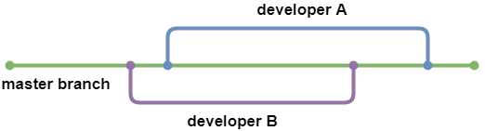

*Figure 1*

*Figure 2*

*Figure 3*

*Figure 4*

*Figure 5*

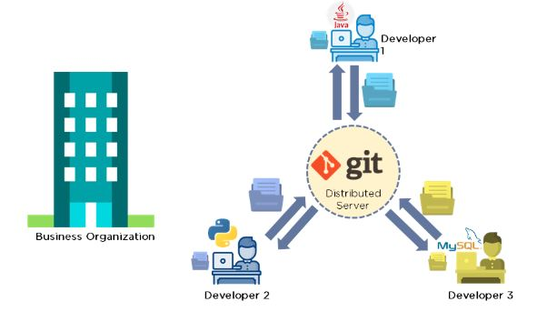

*Figure 6*

# Sources

1. Karlaš, Bojan, et al. "Building continuous integration services for machine learning." Proceedings of the 26th ACM SIGKDD International Conference on Knowledge Discovery & Data Mining. 2020.
2. Danglot, Benjamin, et al. "An approach and benchmark to detect behavioral changes of commits in continuous integration." Empirical Software Engineering 25.4 (2020): 2379-2415.
3. Renggli, Cedric, et al. "Continuous integration of machine learning models with ease. ml/ci: Towards a rigorous yet practical treatment." *Proceedings of Machine Learning and Systems* 1 (2019): 322-333.