**Term 1:**

1. COMP0133 Distributed Systems and Security

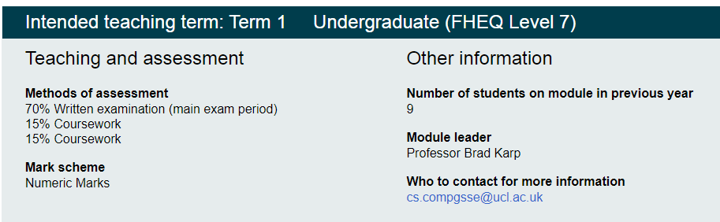

2. COMP0078 Supervised Learning

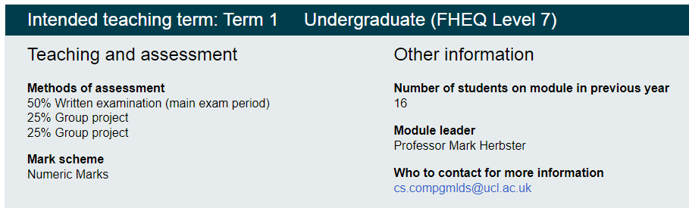

3. COMP0104 Software Development Practice

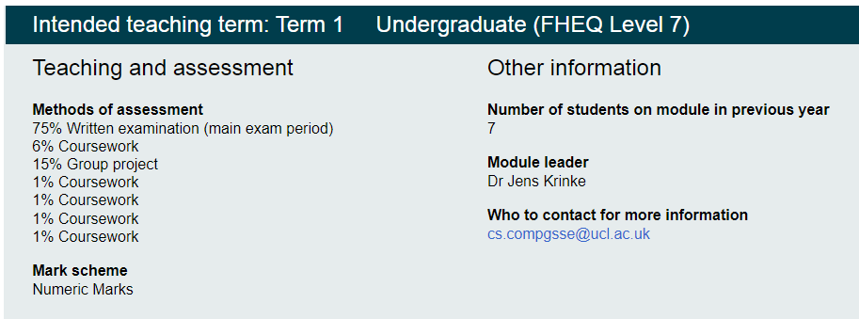

4. COMP0080 Graphical Models

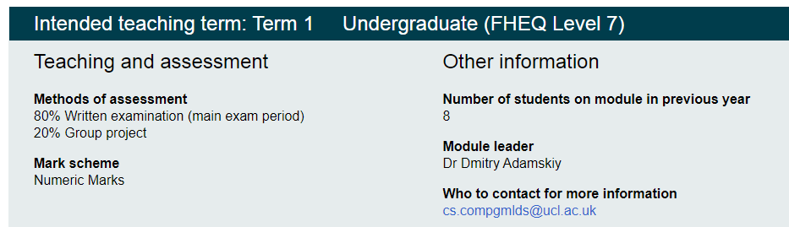

COMP0137 Machine Vision

**Term 2:**

1. COMP0053 Affective Computing and Human-Robot Interaction

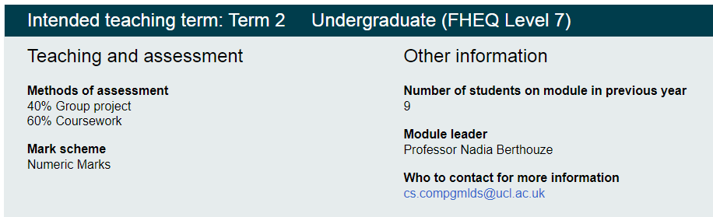

2. COMP0113 Virtual Environments

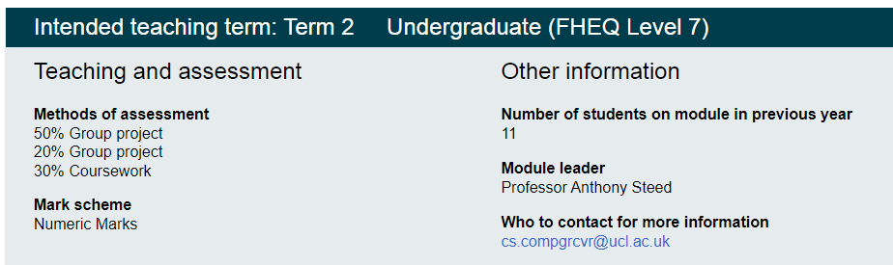

3. COMP0084 Information Retrieval and Data Mining

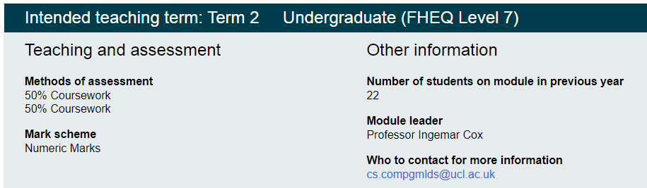

4. COMP0174 Practical Program Analysis

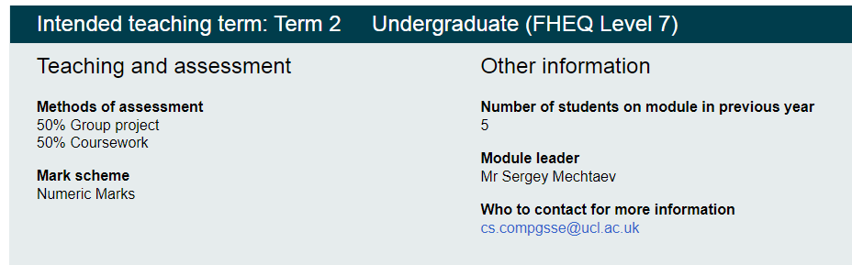

5. COMP0081 Applied Machine Learning

