Tools:

1. Use *netstat -nr* to discover the route table.

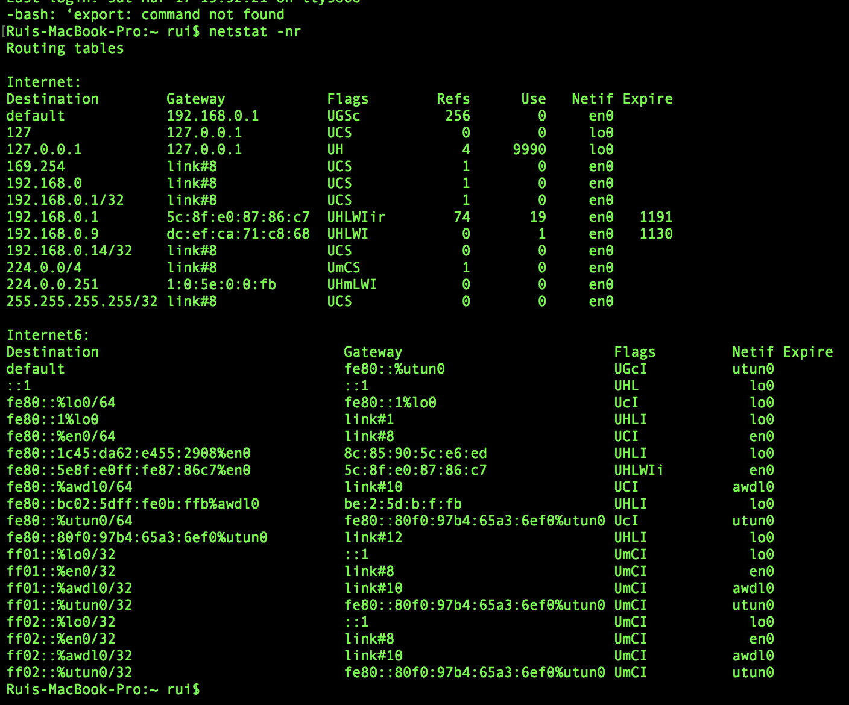

Use *sudo route -n add 10.2.0.254 10.0.0.* to add a new router*

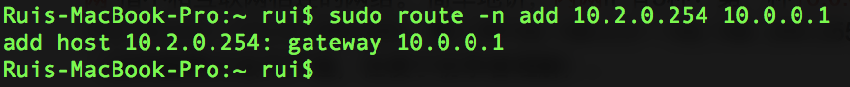

1. Use *netstat -i* or *ifconfig -a* to find the network interfaces.

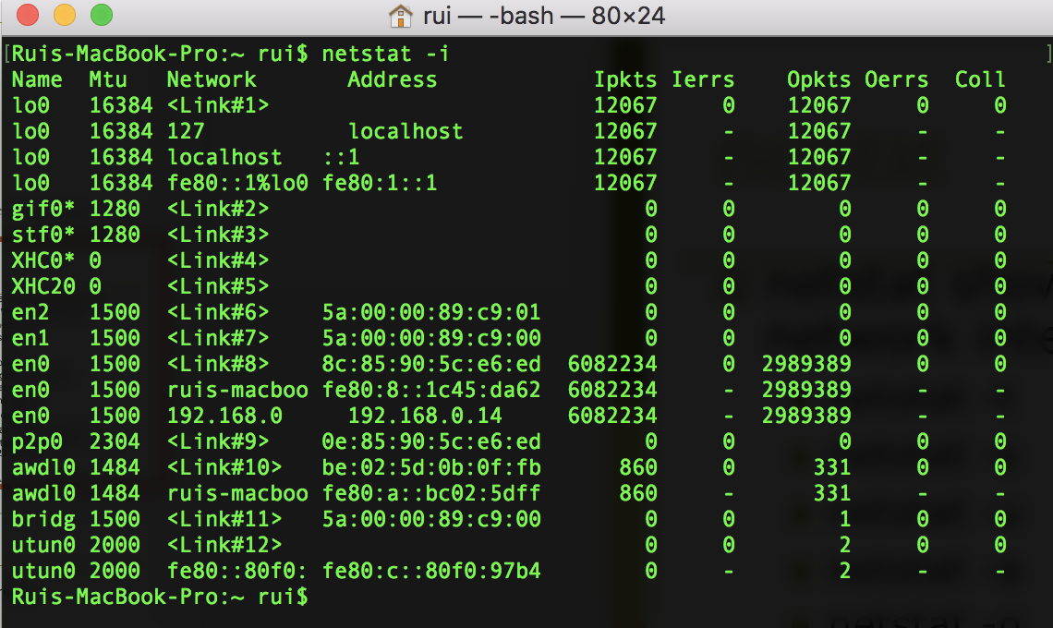

I use *ifconfig en0 192.168.0.14* to set the address of en0 to 192.168.0.14(before it is 192.168.0.16).

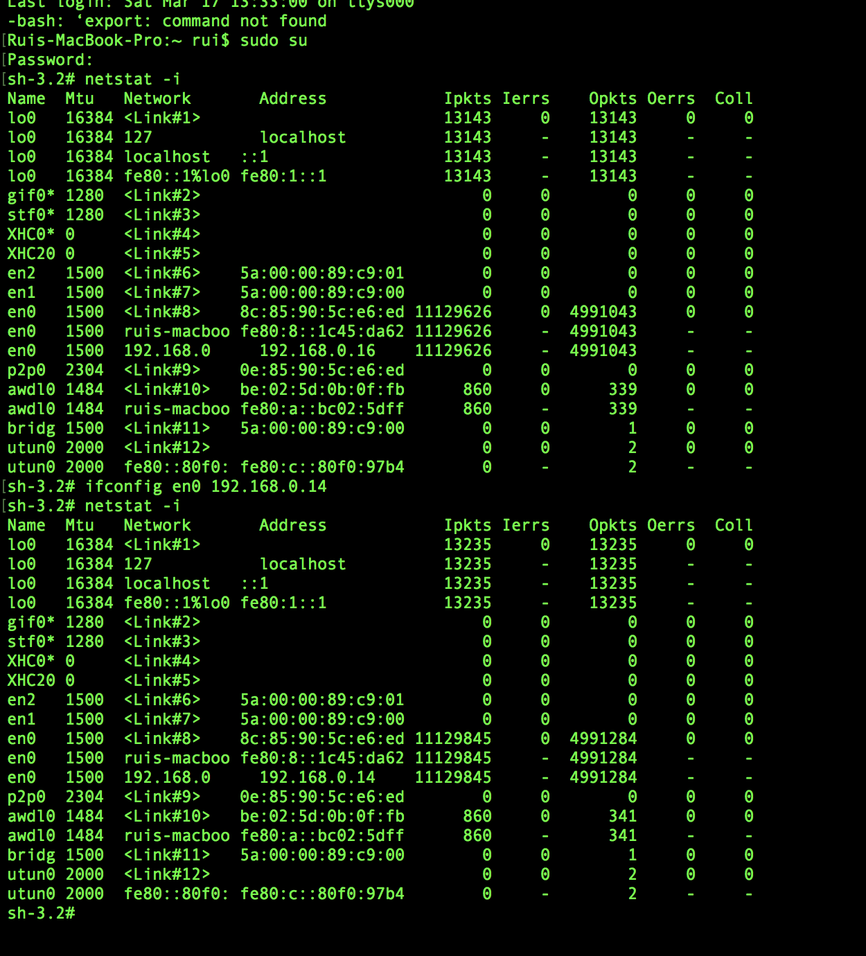

1. Use *nslookup google.com* to find the IP address of google.com

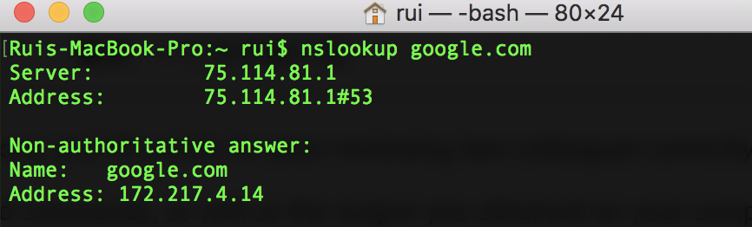

1. Use *traceroute google.com* to find the find the routers on the connection between me and google.com

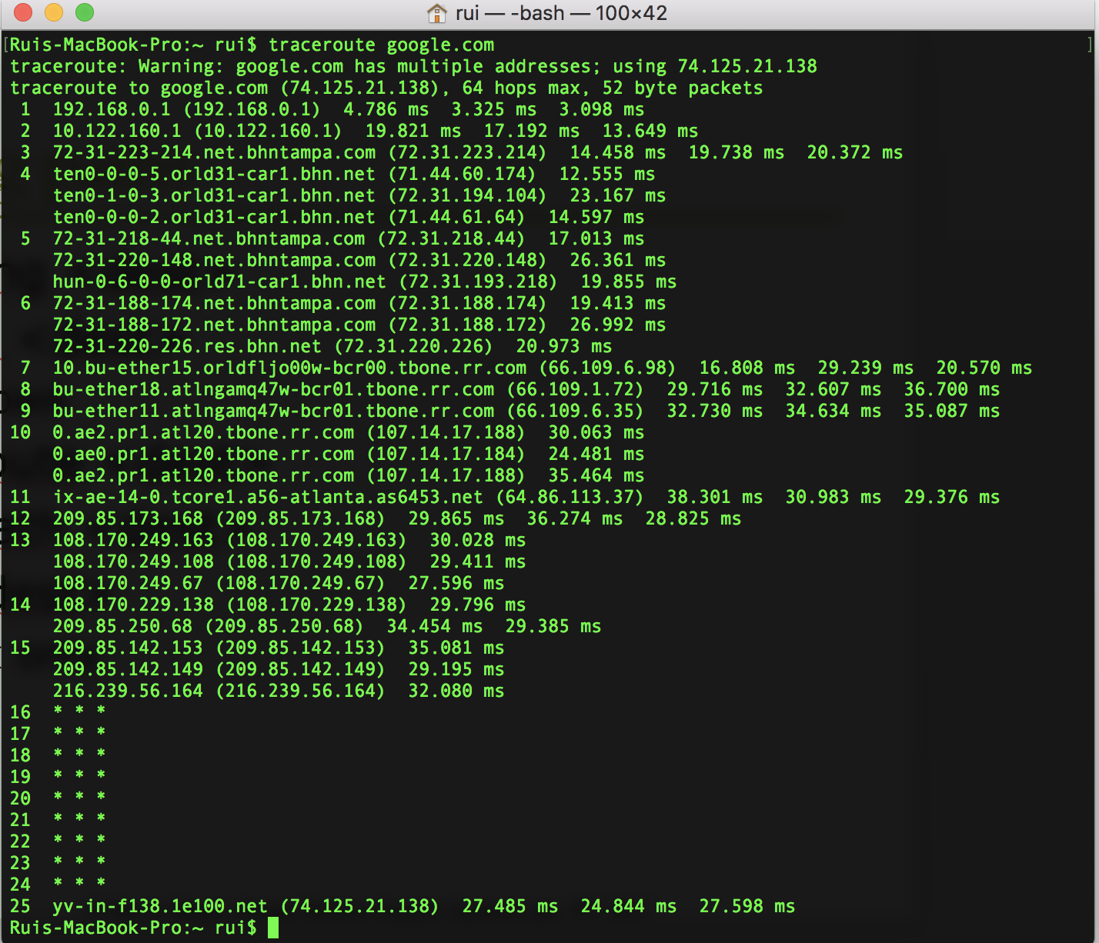

1. **Use *arp****[****-a****[*InetAddr*] [****-N***IfaceAddr*]] [****-g****[*InetAddr*] [****-N***IfaceAddr*]] [****-d***InetAddr*[*IfaceAddr*]] [****-s***InetAddr EtherAddr*[*IfaceAddr*]]* to inspect and manipulate the arp table.

Here are the switch definitions:

**-a** **[**InetAddr**] [-N**IfaceAddr**]** **:** Displays current ARP cache tables for all interfaces. To display the ARP cache entry for a specific IP address, use **arp -a** with the InetAddr parameter, where InetAddr is an IP address. To display the ARP cache table for a specific interface, use the **-N** IfaceAddr parameter where IfaceAddr is the IP address assigned to the interface. The **-N**parameter is case-sensitive.

**-g** **[**InetAddr**] [-N**IfaceAddr**]** **:** Identical to **-a**.

**-d**InetAddr **[**IfaceAddr**]** **:** Deletes an entry with a specific IP address, where InetAddr is the IP address. To delete an entry in a table for a specific interface, use the IfaceAddr parameter where IfaceAddr is the IP address assigned to the interface. To delete all entries, use the asterisk (*) wildcard character in place of InetAddr.  So "arp -d *" will flush your ARP cache.

**-s**InetAddr EtherAddr**[**IfaceAddr**]** **:** Adds a static entry to the ARP cache that resolves the IP address InetAddr to the physical address EtherAddr. To add a static ARP cache entry to the table for a specific interface, use the IfaceAddr parameter where IfaceAddr is an IP address assigned to the interface.

**/?:** Displays help at the command prompt.

For example, use *arp -a* to list the arp table:

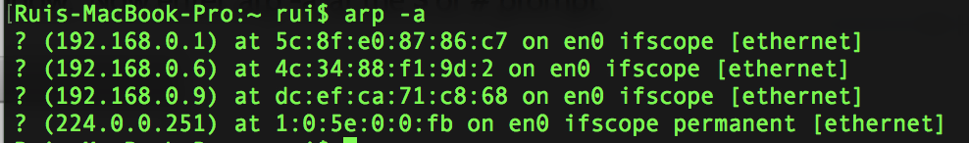

1. Using *netstat -e* to show the Ethernet statistics.

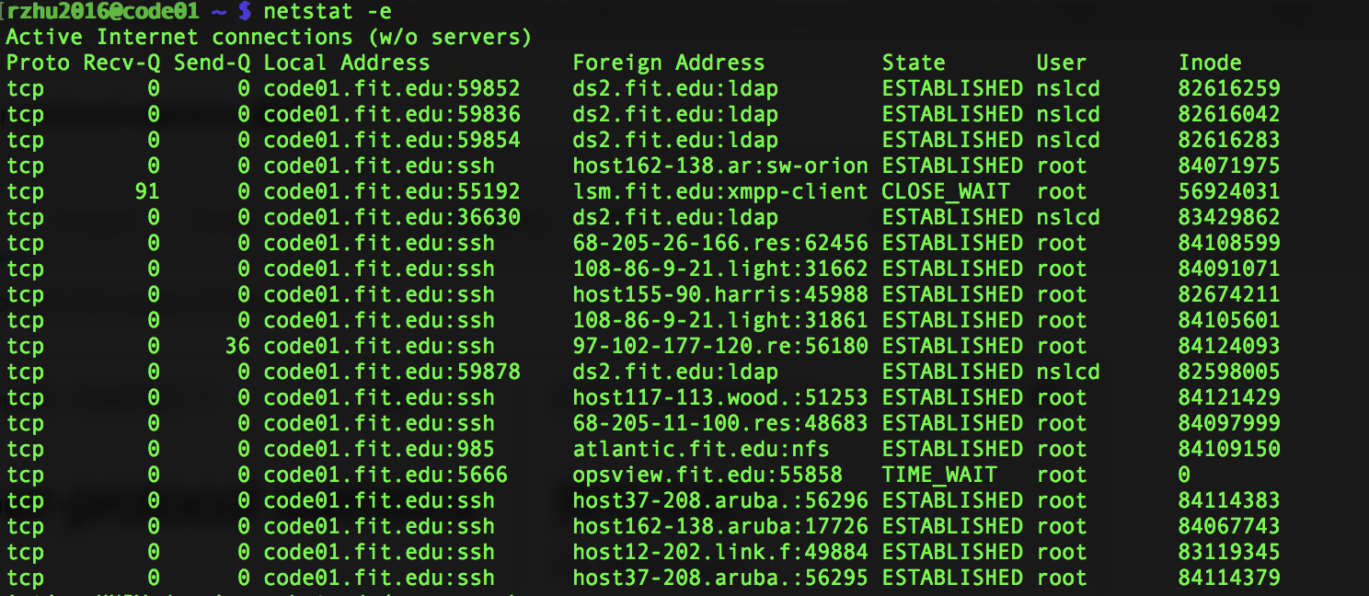

Here the state “LISTENING” shows a classic open port listening for inbound connections. “ESTABLISHED” means there’s an actual connection between your machine and the remote IP and port that is able to exchange traffic. Occasionally, you’ll see “CLOSE_WAIT” in this column, which is a state TCP goes into while ending an established connection. So we can use these states to figure out whether messages come from other computers.

If you want to send message, use *netsend addr <message>* to send.