**书籍:**

**React、React Native、你不知道的JavaScript、nodeJS、Linux、Vue、JavaScript设计模式**

**Vue脚手架**

**全局安装vue脚手架**

**$ npm install -g vue-cli**

**卸载方法**

**$ npm uninstall -g vue-cli**

**查看vue版本（注意：大写的V）**

**$ vue -V**

**创建项目**

**$ vue init webpack vue-app**

**? Project name vue-app**

**? Project description Vue 基础知识**

**? Author ProsperLee <lcsshengsss@outlook.com>**

**? Vue build (Use arrow keys)**

**> Runtime + Compiler: recommended for most users**

**Runtime-only: about 6KB lighter min+gzip, but templates (or any Vue-specific HTML) are ONLY allowed in .vue files - render functions are required elsewhere**

**? Install vue-router? No**

**? Use ESLint to lint your code? No? Set up unit tests No**

**? Setup e2e tests with Nightwatch? No**

**? Should we run `npm install` for you after the project has been created? (recommended)**

**(Use arrow keys)**

**> Yes, use NPM**

**Yes, use Yarn**

**No, I will handle that myself**

**项目根目录下执行：**

**$ npm run dev**

**Your application is running here:** [**http://localhost:8080**](http://localhost:8080)

**安装路由**

**$ npm install vue-router --save-dev**

**安装vue-resource**

**$ npm install vue-resource --save-dev**

**安装WangEditor**

**$ npm install wangeditor --save-dev**

**打包项目：$ npm run dev**

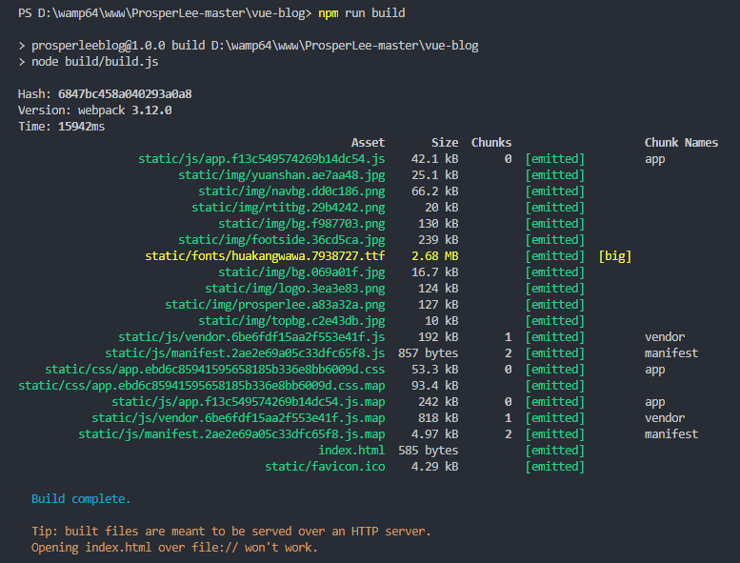

**创建项目**

**$ vue init webpack-simple vue-app**