Appendix S1

Buckley et al.

We provide an additional example using microclimate data measured along an elevation gradient in CO, USA to illustrate use of TrenchR. We first use a time series of air temperatures and wind speeds collected at multiple heights to examine profiles and surface roughness. We then use a time series of air and surface temperatures, wind speeds, and solar radiation collected at a single height to implement a biophysical model for grasshoppers and compare estimates to observations. We omit the code to read and process the environmental data here for brevity. R markdown files with the full code and the associated environmental data are available at <https://github.com/trenchproject/TrenchRmanuscript/>.

# Microclimate Models

We first examine how temperature and wind speed profiles can be used to scale conditions to the heights of organisms. We start by using wind speeds ($u_{r}$, m/s) at a vector of reference heights ($z_{r}$, m) to estimate surface roughness ($z_{0}$).

z0 <- apply(C1.hr[, c("Wind0.25m", "Wind0.5m", "Wind1m", "Wind1.5m")], FUN = surface_roughness, MARGIN = 1, zr = c(0.25, 0.5, 1.0, 1.5))

We then calculate the temperature and wind speed profiles for a given hour using multiple, alternative functions in TrenchR that assume both neutral and forced flows and treat the profile as a single or multiple segments. The functions require temperatures ($T_{r}$, $​^{∘}$ C) and wind speeds ($U_{r}$, $ms^{−1}$) at reference heights ($z_{r}$, $m$), $z_{0}$, surface temperature ($T_{s}$, $​^{∘}$ C), and the desired height for scaling ($z$, m).

# subset to day and hour  
C1.sub <- subset(C1.dayhr, C1.dayhr$day == 10)  
hr <- 10  
  
# vector of heights  
z.seq <- seq(0, 2, by = 0.1)  
  
# temperature profiles  
t.seq1 <- sapply(z.seq, FUN = air_temp_profile_neutral, T_r = C1.sub[hr, "Air0.5m"], z0 = z0[hr], zr = 0.5, T_s = C1.sub[hr, "Soil"])  
  
t.seq2 <- sapply(z.seq, FUN = air_temp_profile, T_r = C1.sub[hr, "Air0.5m"], u_r = C1.hr[hr, "Wind0.5m"], zr = 0.5, z0 = z0[hr], T_s = C1.sub[hr, "Soil"])  
  
t.seq3 <- sapply(z.seq, FUN = air_temp_profile_segment, T_r = C1.sub[hr, c("Air0.25m", "Air0.5m", "Air1.0m", "Air1.5m")], u_r = C1.sub[hr, c("Wind0.25m", "Wind0.5m", "Wind1m", "Wind1.5m")], zr=c(0.25, 0.5, 1, 1.5), z0 = rep(z0[hr], 4), T_s = C1.sub[hr, "Soil"])  
  
# wind speed profiles  
u.seq1 <- sapply(z.seq, FUN = wind_speed_profile_neutral, u_r = C1.sub[hr, "Wind0.5m"], zr = 0.5, z0 = z0[hr])  
  
u.seq2 <- sapply(z.seq, FUN = wind_speed_profile_segment, u_r = C1.sub[hr, c("Wind0.5m", "Wind1m", "Wind1.5m")], zr = c(0.5, 1, 1.5), z0 = rep(z0[hr], 3))

The temperature and wind speed profiles illustrate how temperatures generally decrease and wind speeds generally increase with height above the ground (Figure S1).

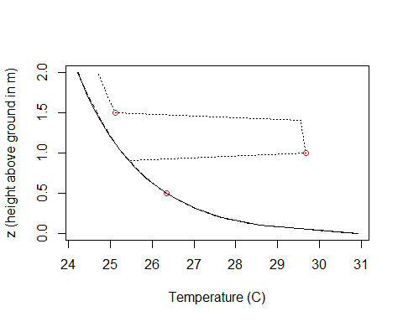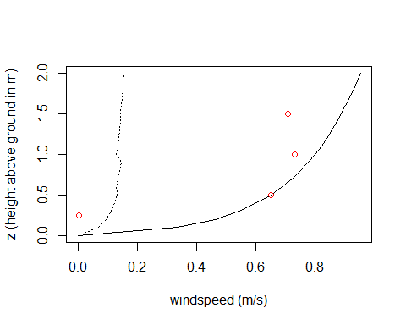

*Figure S1. Temperature (top) and wind speed (bottom) profiles using similar continuous [solid: air_temp_profile_neutral(); dashed: air_temp_profile()] and segmented estimation [dotted: air_temp_profile_segment()]. The points indicate empirical points used for parameterization.*

# Biophysical models

We next illustrate quantifying operative environmental temperatures, which are estimated body temperatures for grasshoppers in the specified environments. Assuming we have read and processed the time series of environmental data, we first estimate the zenith angle ($psi$, $​^{∘}$), the angle between the sun’s rays and the vertical, as a function of day of year ($doy$), latitude ($lat$, $​^{∘}$), longitude ($lon$, $​^{∘}$), and hour.

dat$psi <- zenith_angle(doy = dat$J, lat = dat$lat, lon = dat$lon, hour = dat$hour)

We scale the air temperature ($T_{r}$, $​^{∘}$ C) and wind speed ($u_{r}$, m/s) from a reference height of $z_{r}$ = 0.5m to grasshopper height ( $z$ = 0.001m). The functions also require surface temperature ($T_{s}$, $​^{∘}$ C), and surface roughness ($z0$, m).

z <- 0.001 #specify distance from ground   
  
# scale temperature   
dat$Tgrass <- air_temp_profile(T_r = dat$Temp, u_r = dat$Wind, zr = 0.5, z0 = 0.02, z = z, T_s = dat$SoilTemp)  
  
# scale wind speed  
dat$Ugrass <- wind_speed_profile_neutral(u_r = dat$Wind, zr = 0.5, z0 = 0.02, z = z)

We then use biophysical models to estimate body temperatures ($T_{b}$, $​^{∘}$ C) based on air ($T_{a}$, $​^{∘}$ C) and surface temperatures ($T_{g}$, $​^{∘}$ C), wind speed ($u$, m/s), and solar radiation ($H$, $Wm^{−2}$). We first use a biophysical model specifically configured for grasshoppers where $K_{t}$ is the clearness index (dimensionless), which is the ratio of the global solar radiation measured at the surface to the total solar radiation at the top of the atmosphere; $l$ is grasshopper length (m); $A_{condfact}$ is the proportion of the grasshopper surface area in contact with the ground; $abs$ is absorptivity of grasshopper to solar radiation (proportion, $abs$ =0.9 corresponds to dark colors); and $r_{g}$ is substrate solar reflectivity (proportion).

dat$Te <- Tb_grasshopper(T_a = dat$Tgrass, T_g = dat$SoilTemp, u = dat$Ugrass, H = dat$Rad, K_t = 1, psi = dat$psi, l = 0.0211, Acondfact = 0.0, abs = 0.9, r_g = 0.5)

We then implement a generic energy budget. We first illustrate the estimation of convective heat transfer coefficients ($H_{L}$, $WK^{−1}m^{−2}$) as a function of wind speed ($V$, $ms^{−1}$) based on empirical measurements, where $D$ is the characteristic dimension (m), $K$ is the thermal conductivity of air ($Wm^{−1}K^{−1}$), and $nu$ is the kinematic viscosity of air ($m^{2}s^{−1}$). We subsequently estimate $H_{L}$ using a spherical approximation and a simplified version of the approximation, respectively.

dat$H_L <- heat_transfer_coefficient(V = dat$Ugrass, D = 0.0211, K = 0.025, nu = 15.3 * 10^(-6) , taxon = "cylinder")  
  
H_L1 <- heat_transfer_coefficient_approximation(V = dat$Ugrass, D = 0.0211, K = 0.025, nu = 15.3 * 10^(-6), taxon = "flyinginsect")  
  
H_L2 <- heat_transfer_coefficient_simple(V = dat$Ugrass, D = 0.0211, type = "Gates")

We then implement the energy budget as follows, where $A$ is surface area ($m^{2}$), $Q_{abs}$ is the solar and thermal radiation absorbed (W), $epsilon$ is longwave infrared emissivity of skin (proportion), and $ef$ is the enhancement factor that is used to adjust $H_{L}$ to field conditions. The proportions $psa_{dir}$, $psa_{ref}$, $psa_{air}$, and $psa_{g}$ are the proportions surface area exposed to direct radiation from the sky (or enclosure), reflected radiation from the ground, and air, and in contact with the ground, respectively. We note that the energy budget can not be solved for some time periods and errors are generated.

TeGates <- rep(NA, nrow(dat))  
  
# surface area from length(m)  
A <- surface_area_from_length(l = 0.0211)   
  
for (ind in 1:nrow(dat)) {  
  
 out <- Tb_Gates(A = A, D = 0.0211/3, psa_dir = 0.5, psa_ref = 1-0.5, psa_air = 1, psa_g = 0.0, T_g = dat$SoilTemp[ind] + 273, T_a = dat$Tgrass[ind] + 273, Qabs = A * 0.66 * dat$Rad[ind], epsilon = 0.95, H_L = dat$H_L[ind], ef = 1.3, K = 0.15)  
  
 if (is.numeric(out)) {  
 TeGates[ind] <- out  
 }  
  
}

We aggregate the data and plot average conditions across sites (Figure S2). The simplifying assumptions in the biophysical model implementation reduce alignment with the observed temperatures of grasshoppers, but the divergence of grasshopper temperatures from air temperatures at 2m and, to a lesser extent, air temperatures at grasshopper height demonstrate the importance of implementing biophysical models.

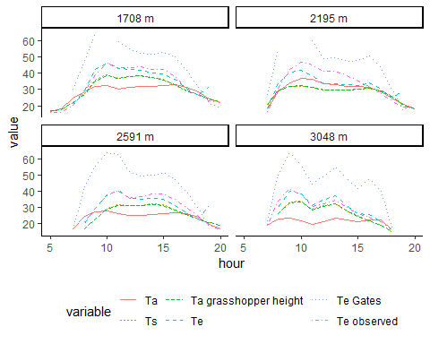

*Figure S2. Diurnal temperature variation averaged across days in August varies across the elevations of CO sites (panels) and the type of temperature ($​^{∘}$ C). Microclimate models indicate that the air temperatures experienced by grasshoppers near the ground (Ta grasshopper height) is generally above air temperatures (Ta) and close to surface temperatures (Ts). Body temperatures estimated by a grasshopper specific biophysical model (Te) are fairly similar to but sometimes less than the body temperatures of a physical grasshopper model implanted with a thermistor (Te observed). The general biophysical models that makes simplifying assumptions (Te Gates) tends to overestimate body temperatures.*