TrenchR: an R package for transparent microclimate and biophysical ecology

Lauren B. Buckley, Bryan A. Briones Ortiz, Isaac Caruso, Aji John, Ofir Levy,

Abigail V. Meyer, Eric A. Riddell, Yutaro Sakairi, and Juniper Simonis

* Within the word count (6000-7000 words for Standard Articles, 3000-4000 words for Applications and Practical Tools)
* Continuous line and page numbering throughout

Lauren B. Buckley1, Bryan A. Briones Ortiz1, Isaac Caruso1, Aji John1, Ofir Levy2, Abigail V. Meyer1, Eric A. Riddell3, Yutaro Sakairi1, and Juniper L. Simonis4

1. Department of Biology, University of Washington, Seattle, WA 98195-1800, USA
2. School of Zoology, Tel Aviv University, Tel Aviv, Israel
3. Department of Ecology, Evolution, and Organismal Biology, Iowa State University, Ames, IA 50011-4009, USA
4. DAPPER Stats, 3519 NE 15th Avenue, Suite 467, Portland, Oregon 97212, USA

Corresponding Author: Lauren Buckley, [lbuckley@uw.edu](mailto:lbuckley@uw.edu)

Running head: TrenchR microclimate and biophysical models

Type: applications

## Abstract

1. Much understanding of organismal responses to climate change and variability relies on the assumption that body temperatures are equal to temporally averaged air temperatures high above the ground. However, most organisms live near the ground and acute exposure to solar and thermal radiation and thermal extremes can substantially elevate their body temperatures.
2. We introduce the TrenchR package, which aids in Translating Environmental Change into organismal responses. The package includes microclimate models to vertically scale weather station data to organismal heights. The biophysical modeling tools include both general models for heat flows and specific models to predict body temperatures for a variety of ectothermic taxa. Additional functions model and temporally partition air and soil temperatures and solar radiation. We offer utility functions to aid in estimating the organismal and environmental parameters needed for biophysical ecology.
3. TrenchR focuses on simple and modular functions so users can create transparent and flexible models for biophysical applications.
4. The package aims to introduce and enable microclimate and biophysical modeling to improve ecological and evolutionary forecasting. We further this aim through a series of educational modules that introduce the field of biophysical ecology.

**Keywords**: biophysical, climate change, ecotherm, energy budget, mechanistic models, microclimate, scaling, temperature

## Introduction

Responses of organisms and ecosystems to climate change are heterogeneous and thus inconsistent with current predictive models (Maguire et al., 2015). Some of these predictive shortcomings stem from omitting spatial and temporal environmental variation and how it interacts with organismal phenotypes (e.g., size, coloration) (Nadeau et al., 2017; Potter et al., 2013). Many analyses assume that organismal body temperatures are equal to air temperatures at weather station height (usually 2 meters). However, air temperatures near the ground where most organisms reside are often considerably warmer, and absorption of solar and thermal radiation can raise body temperatures well above air temperatures, resulting in potential discrepancies of tens of degrees Celsius (Kearney et al., 2009; Sinclair et al., 2016; Sunday et al., 2014). Applications are increasingly demonstrating the importance of accounting for microclimate variation (Bramer et al., 2018; Bütikofer et al., 2020; Lembrechts et al., 2019). Acute thermal stress events are often more relevant to the physiology and energy balance of organisms than daily, monthly, or annually averaged environmental conditions. Yet, daily and seasonal environmental variation is often neglected (Dillon et al., 2016; Dillon & Woods, 2016). We aim to help remedy these shortcomings by introducing the TrenchR package (<https://github.com/trenchproject/TrenchR>) as a component of the TrEnCh project (<https:www.trenchproject.com>), which builds computational and visualization tools to Translate Environmental Change into organismal responses.

The mathematical tools for leveraging environmental data to predict organismal conditions have long lingered in books (Campbell & Norman, 2000; Gates, 1980) and articles (Porter & Gates, 1969; Porter & Tracy, 1983), but adoption of these tools has not kept pace with research on climate change responses. In recent decades, adoption of biophysical approaches is expanding with recognition of the importance of spatial and temporal environmental variation to determining climate change responses (Buckley et al., 2018; Kearney & Porter, 2017) and the increased dissemination of computational tools.

Estimating how organisms experience their thermal environment generally entails two classes of models (Campbell & Norman, 2000; Gates, 1980) (Figure 1). Microclimate models allow scaling conditions from sensors to organism height. They can characterize heat and air transport to estimate vertical air and soil temperature and wind profiles. They can also characterize direct and diffuse solar radiation and longwave radiation emanating from the sky, ground, and surrounding objects like vegetation. Biophysical models estimate body temperatures using an energy budget to balance heat exchanges between organisms and their environment.

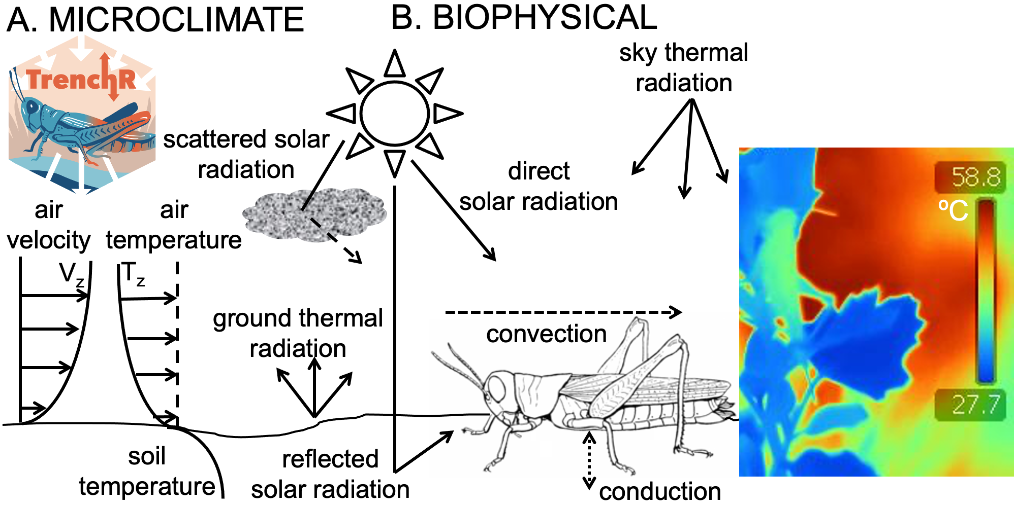

**Figure 1** A) Microclimate models scale air and soil temperatures and wind speeds from sensor to organismal heights. B) Biophysical models balance heat exchanges between organisms and their environment to estimate body temperatures (Porter et al., 1973). A thermal image depicts how grasshopper body temperatures vary substantially from vegetation, air, and ground temperatures due to heat exchange.

The TrenchR package is intended to complement the NicheMapR package, which includes sophisticated microclimate (Kearney & Porter, 2017) and biophysical (Kearney & Porter, 2020) models. Although the Fortran source code was recently released, the complexity of NicheMapR functions can make it difficult to understand and modify the source code. The function documentation including variable definitions and units can also be challenging to follow. Many of the approaches are similar between the packages, but TrenchR provides simple functions to aid the understanding and transparency of biophysical approaches. The TrenchR functions are modular and easily adapt to a variety of organisms and research questions. Although many of the TrenchR functions are general, some components of TrenchR are best suited for ectothermic animals. We omit plant specific biophysical models since they are the focus of several R packages [tealeaves: (Muir, 2019); plantecophys: (Duursma, 2015)]. Some energy budget calculation components of biophysical models are also available in the ThermImage package (Tattersall, 2017). Microclimate models, with an emphasis on describing spatial variation, are also available in the Microclima package (Maclean et al., 2019).

## Methods and Features

The TrenchR package (<http://trenchproject.github.io/TrenchR/>) aims to promote transparency and reproducibility. We welcome contributions and corrections from users. Our package was built using the devtools methodology (<https://github.com/r-lib/devtools>) with version control managed in Github. Issues and feature requests can be contributed in Github (<https://github.com/trenchproject/TrenchR>). The package is available via Github and has been submitted to CRAN.

We adapted functions from biophysical ecology textbooks (Campbell & Norman, 2000; Gates, 1980) and research articles. Source references are included in function headers and reference sections. We have incorporated default parameters (e.g., organism emissivity or heat conduction rates) when general values are available. Many functions additionally include comments that describe potential parameterizations. The biophysical ecology texts (Campbell & Norman, 2000; Gates, 1980) include many tables with parameter values and we provide several data tables in TrenchR.

### Components

TrenchR functions are organized into the following categories (Figure 2):

**Utility functions** calculate environmental metrics that form the basis of microclimate and biophysical models (e.g., zenith and declination angles, which describe the angles of incident sunlight), facilitate modeling diurnal temperature variation, and estimate biologically relevant aggregate metrics such as degree days available for oranismal development.

**Allometric functions** allow estimating the dimensions of organisms needed for energy balances and other analyses. Available functions can convert between organismal length, mass, surface area, and volume as well as estimate the silhoutte area, which describes the organismal area exposed to solar radiation.

**Microclimate functions** facilitate calculating the environmental conditions experienced by organisms. Temperature and wind profile functions scale environmental conditions from sensors to organismal height. Radiation functions allow estimating incoming solar radiation and partitioning the variation diurnally and across components (i.e., direct, diffuse, reflected).

**General biophysical functions** provide generalized models of heat exchanges between organisms and their environment so that users can build custom biophysical models. The functions allow implementing an energy balance including the following components of heat exchange between organisms and their environment:

* *radiative heat exchanges* of solar and thermal radiation;
* *convective heat exchanges* between organisms and their surrounding fluid (air or water) driven by fluid flow;
* *conductive heat exchanges* between organisms and solid surfaces (generally the ground) due to physical contact; and
* *evaporative heat exchanges* associated with organisms’ evaporative water loss.

Additional functions aggregate these forms of heat exchange into energy balances and to use the energy balances to predict body temperatures.

**Specific biophysical functions** provide biophysical models that have been built for particular organisms based on their physical properties, behavior, environment, and life history. We currently provide published biophysical models for lizards, salamanders, butterflies, grasshoppers, limpets, mussels, and snails. Most models predict operative environmental temperatures, which are the equilibrium body temperatures of organisms with specified physical properties in a specific microclimate and assume no heat exchange via metabolism or evaporation (Bakken, 1992). However, we also present an analytical function for humid operative temperature that incorporates the effects of evaporative cooling on operative temperatures for wet-skinned ectotherms, such as salamanders.

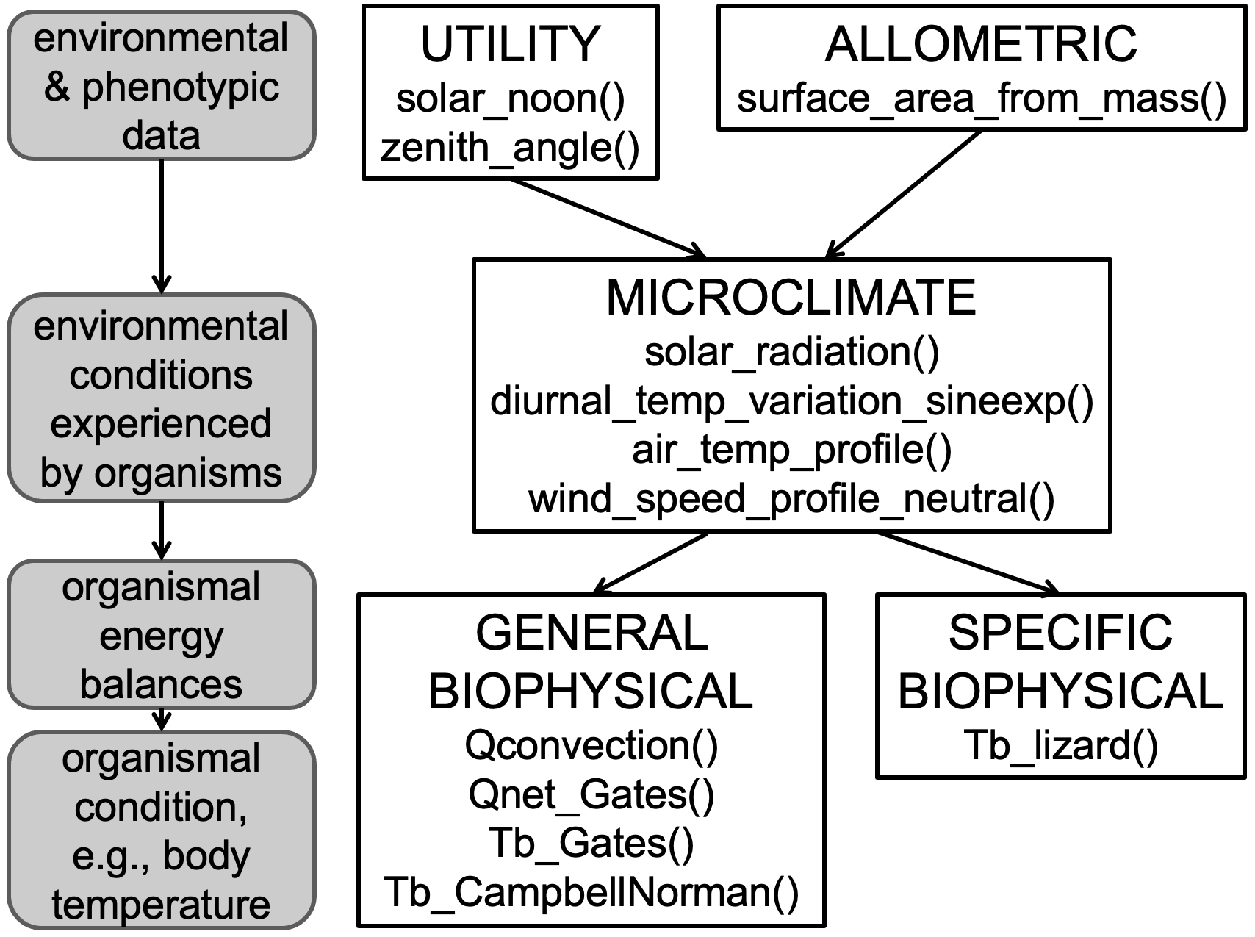

**Figure 2** An examplar aim of translating from environmental and phenotypic data to organismal conditions in a given environment (grey boxes) can be achieved in TrenchR via several categories of functions (white boxes). We list example functions for each category used in the example application below.

### Vignettes and introductory tutorials

We introduce the functions in several vignettes. A good place to start is the *Allometry and Conversions* vignette, which provides tools for preparing data, such as estimating additional dimensions of organisms from measured dimensions. The *Estimating Microclimates* vignette provides resources for estimating the environmental conditions experienced by organisms. This includes estimating solar radiation and its components, diurnal variation in temperature and radiation, temperature and wind speed profiles, and soil temperatures and profiles. Finally, the core biophysical modeling functions are described in a tutorial on *Using Energy Balances to Estimate Body Temperatures*. Components of an energy budget can be estimated using individual functions and then body temperatures can be solved for using either a generic energy balance or taxa specific biophysical models. We additionally offer a *List of Symbols* used in equations.

For additional background on microclimate and biophysical modeling, we have updated a series of tutorials entitled *Physical Processes in Ecosystems*. We intend the tutorials to provide a more contained and accessible introduction to microclimate and biophysical modeling than that included in classic textbooks (Campbell & Norman, 2000; Gates, 1980). The tutorials provide less detailed coverage of many of the topics contained in the books. The series of 14 tutorials starts with an overview of the calculus and physics principles underlying the modeling. Thermodynamics and energy budget modeling are then introduced with detailed examples. Tutorials address the climate space concept, operative temperatures, biophysical models for leaves and sheep, and heat flow in soils. We have revised the tutorials (which originated from an NSF training grant in 1979 and lacked broad distribution) to include R code and utilization of TrenchR functions. We expanded the original series to include tutorials contributed by M. Kearney introducing the Microclim environmental data (Kearney et al., 2014) and integrating the Microclim data with biophysical modeling to examine broad scale climatic limits. The tutorials are provided in html form and available for download as a pdf at the bookdown server (<https://bookdown.org/huckley/Physical_Processes_In_Ecosystems/>). R markdown files for the tutorials are available in Github (<https://github.com/trenchproject/TrenchRmodules>).

## Example Application

We illustrate the use of the TrenchR package by estimating an energy budget for a *Sceloporus* lizard on June 1, 2021 in Santa Fe, New Mexico, USA (35.69N, -105.944W, elevation: 2121 m). The example is also incorporated in the *Using energy balances to estimate body temperatures* vignette. We start by generating environmental inputs (Figure 2). Using these inputs, we estimate the energy budget with component functions. Finally, we use an integrated biophysical model to estimate operative environmental temperatures. See Appendix S1 for another example examining a time series of microclimate data and applying and testing the biophysical models.

We will use the energy budget to estimate body temperature, , which can depart dramatically from the air temperatures due to energy exchange with the environment. Heat is gained from absorbed solar and thermal radiation and from metabolic reactions. Heat is lost through the organism’s emission of radiation and the evaporation of water. The organism exchanges heat with the surrounding air or water via convection and with the ground via conduction. The balance of these heat exchanges (omitting metabolism and evaporation, which are often negligible for ectotherms) can be estimated and often referred to as operative environmental temperature, (Bakken, 1992). is an estimate of and the package functions refer to for simplicity. Our exemplar estimation of assumes thermal equilibrium.

Let us assume the lizard is in an unshaded location where a weather station at standard height (2 meters) reports that the daily air temperature varies from a minimum of 10 C to a maximum of 25 C and the wind speed averages 1 m/s. The soil surface temperature varies from a minimum of 15 C to a maximum of 30 C. We assume that atmospheric transmissivity and albedo .

### Environmental data

At the first stage, we prepare the environmental data for analysis. We will estimate hourly air and soil temperatures and radiation using a function describing diurnal temperature variation. We start by estimating the day of year and the timing of sunrise and sunset:

# Set up input data as variables  
  
lat <- 35.69 # Latitude (degrees)  
lon <- -105.944 # Longitude (degrees)  
elev <- 2121 # Elevation (meters)  
  
Tmin <- 10 # Minimum air temperature (C)  
Tmax <- 25 # Maximum air temperature (C)  
Tmin_s <- 15 # Minimum soil temperature (C)  
Tmax_s <- 30 # Maximum soil temperature (C)  
V <- 1 # Wind speed (m/s)  
  
# Assumptions  
  
tau <- 0.7 # Atmospheric transmissivity  
rho <- 0.6 # Albedo  
Tb0 <- 25 # Initial assumption of body temperature (C)  
  
doy <- day_of_year("2021-06-01", format = "%Y-%m-%d") # Day of year  
  
snoon <- solar_noon(lon = lon, doy = doy) # Estimate solar noon  
dayl <- daylength(lat = lat, doy = doy) # Estimate day length  
  
tr <- snoon - dayl / 2 # Time of sunrise  
ts <- snoon + dayl / 2 # Time of sunset

Although measured solar radiation is preferable if available, we can estimate hourly solar radiation by discounting incoming solar radiation as it moves through the atmosphere as follows. The function partitions radiation into direct, diffuse, and reflected components:

# Estimate zenith angle (degrees)  
  
psi_deg <- sapply(1:24, FUN = zenith_angle, doy = doy, lat = lat, lon = lon)   
  
# Convert to radians  
  
psi_rad <- degrees_to_radians(psi_deg)   
  
# Estimate radiation  
  
Srad <- sapply(psi_rad, FUN = solar_radiation, doy = doy, tau = tau, elev = elev, rho = rho)  
  
# Separate solar radiation into direct, diffuse, and reflected components  
  
Sdir <- Srad[1,] # Direct solar radiation (W/m2)  
Sdif <- Srad[2,] # Diffuse solar radiation (W/m2)  
Sref <- Srad[3,] # Reflected solar radiation (W/m2)

We then calculate hourly air and soil surface temperatures based on daily minimum and maximum temperatures. We select the sine-exponential model for air temperature and the sine model for surface temperature:

# Air temperature (C)  
  
Ta <- sapply(1:24, diurnal_temp_variation_sineexp, T_max = Tmax, T_min = Tmin, t_r = tr, t_s = ts, alpha = 2.59, beta = 1.55, gamma = 2.2)   
  
# Soil surface temperature (C)  
  
Ts <- sapply(1:24, diurnal_temp_variation_sine, T_max = Tmax_s, T_min = Tmin_s)

At the second stage, we use microclimate models to scale air temperature () and wind speed () from weather station height (reference height = 2 m) to lizard height (organism height = 0.02 m). We assume a surface roughness of m, which corresponds to bare sand and determines the turbulence of airflow. We implement neutral air temperature and wind speed profiles driven by density differences but profiles forced by wind speed are also available.

# Neutral air temperature profile  
  
Ta_liz <- air_temp_profile_neutral(T_r = Ta, zr = 2, z0 = 0.2, z = 0.02, T_s = Ts)   
  
# Neutral wind speed profile  
  
V_liz <- wind_speed_profile_neutral(u_r = V, zr = 2, z0 = 0.2 , z = 0.02)

### Energy balance

Finally, we will use our microclimates estimates to solve the following energy balance to estimate :

where is the net energy exchange with the environment (W), is the solar radiation absorbed (W), is the net thermal radiation emitted (W), is energy exchange due to convection (W), is energy exchange due to conduction (W), is the energy emitted due to metabolism (W), and is the energy emitted due to evaporative water loss (W). We will estimate each term on the right side of the equation in turn. Estimating requires the surface area exposed to radiation and the solar absorptivity of the animal surface ( proportion). We use zenith angle to estimate the projected (silhouette) area as a portion of the surface area of the organism, which allows estimating absorbed solar radiation. We model a 10 gram *Sceloporus* lizard with solar absorptivity (Gates, 1980). We will initially assume to illustrate the calculations before solving for given the environmental conditions.

mass <- 10 # Mass (g)  
a <- 0.9 # Solar absorptivity (proportion)  
  
# Estimate surface area (m^2) and the proportion sihouette area  
  
A <- surface_area_from_mass(mass, "lizard")   
psa <- sapply(psi_deg, proportion_silhouette_area, taxon = "lizard", posture = "prostrate")   
  
# Change negative values to zero  
psa[psa < 0] = 0

We calculate the hourly solar radiation absorbed (W) as follows:

Qabs <- rep(NA, 24)  
for (hour in 1:24) {  
   
 Qabs[hour] <- Qradiation_absorbed(a = a, A = A, psa_dir = psa[hour], psa_ref = 1 - psa[hour], S_dir = Sdir[hour], S_dif = Sdif[hour], a_s = rho)  
  
}

We estimate thermal radiation (W) for the lizard outdoors, where and are the proportions of surface area () exposed to direct and reflected solar radiation, respectively. We assume the surface emissivity of lizards, (Barlett & Gates, 1967).

epsilon_s <- 0.965 # Surface emissivity of lizards  
  
Qemit <- rep(NA, 24)  
for (hour in 1:24) {  
   
 Qemit[hour] <- Qemitted_thermal_radiation(epsilon = epsilon_s, A = A, psa_dir = psa[hour], psa_ref = 1-psa[hour], T_b = Ta_liz[hour] + 273.15, T_g = Ts[hour] + 273.15, T_a = Ta_liz[hour] + 273.15, enclosed = FALSE)  
   
}

We next estimate convection (W) and conduction (W). We will estimate the lizard’s heat transfer coefficient, () using an empirical relationship for lizards (heat_transfer_coefficient()). We average thermal conductivity and kinematic viscosity across the day for simplicity and since there is not substantial diurnal variation. We also illustrate a function estimating using a spherical approximation (heat_transfer_coefficient_approximation()) and a simplified approximation (heat_transfer_coefficient_simple()) for cases when taxon specific relationships for estimating heat transfer coefficients are not available.

# Use DRYAIR from NicheMapR to estimate the thermal conductivity of air and kinematic viscosity  
  
ap <- airpressure_from_elev(elev) * 1000 # Barometric pressure (pascal)  
  
DRYAIRout <- DRYAIR(db = Ta, bp = ap, alt = elev)  
  
K <- mean(DRYAIRout$thcond) # Thermal conductivity (Wm^-2K^-1)   
nu <- mean(DRYAIRout$viskin) # Kinematic viscosity (m2 s-1)  
  
svl <- 0.006 # Approximate snout vent length (meters) for Sceloporus, used as the characteristic dimension for heat transfer  
  
# Estimate the heat transfer coefficient using an empirical relationship for lizards  
  
H_L <- heat_transfer_coefficient(V = V_liz, D = svl, K = K, nu = nu, taxon = "lizard_surface")  
  
# Estimate the heat transfer coefficient using a spherical approximation  
  
H_L2 <- heat_transfer_coefficient_approximation(V = V_liz, D = svl, K = K, nu = nu, taxon = "lizard")  
  
# Estimate the heat transfer coefficient using a simplified version of the approximation  
  
H_L3 <- heat_transfer_coefficient_simple(V = V_liz, D = svl, type = "Gates")

We estimate convective heat exchange between the animal and surrounding air using the following relationship:

where an enhancement factor, , multiplier can be incorporated to account for increases in heat exchange resulting from air turbulence in field conditions. We implement the function in R assuming that 2/3 of the lizard’s surface area is exchanging heat through convection. We currently estimate no convection since we are assuming for illustration purposes:

Qconv <- rep(NA, 24)  
for (hour in 1:24) {  
   
 Qconv[hour] <- Qconvection(T_a = Ta_liz[hour] + 273.15, T_b = Ta_liz[hour] + 273.15, H = H_L, A = A, proportion = 0.67, ef = 1.3)  
   
}

We estimate conductive heat flow (W) from the lizard to the surface assuming conductance through the animal tissue is the rate limiting step as follows:

We implement the estimate in R assuming that 1/3 of the lizard surface is in contact with the ground and a skin thickness :

Qcond <- rep(NA, 24)  
for(hr in 1:24) {  
   
 Qcond[hr] <- Qconduction_animal(T_g = Ts[hr] + 273.15, T_b = Ta_liz[hr] + 273.15, d = 10^-6, K = K, A = A, proportion = 0.33)  
   
}

We assume, as is generally done for lizards, that heat exchange associated with metabolism and evaporation is negligible:

Qmet <- 0   
Qevap <- 0

The full heat budget can be calculated as follows (Gates, 1980):

Qnet <- Qnet_Gates(Qabs = Qabs, Qemit = Qemit, Qconv = Qconv, Qcond = Qcond, Qmet = Qmet, Qevap = Qevap)

We constructed the energy balance assuming for illustration. Thus, the energy balance is dominated by heat gain from contact with the warmer surface. We now use a function based on the energy balance above to estimate body temperature given the environmental conditions:

Te <- rep(NA, 24)  
for (hour in 1:24) {  
   
 Te[hour] <- Tb_Gates(A = A, D = svl, psa_dir = psa[hour], psa_ref = 1 - psa[hour], psa_air = 0.67, psa_g = 0.33, T_g = Ts[hour] + 273.15, T_a = Ta_liz[hour] + 273.15, Qabs = Qabs[hour], epsilon = epsilon_s, H_L = H_L, ef = 1.3, K = K)  
   
}

We also implement a similar but simplified energy balance (Campbell & Norman, 2000). The energy balance omits conduction with the ground:

Te2 <- rep(NA, 24)  
for (hr in 1:24) {  
   
 # S is solar radiation flux (W m^-2), so we divide by surface area, A  
  
 Te2[hr] <- Tb_CampbellNorman(T_a = Ta_liz[hr] + 273.15, T_g = Ts[hr] + 273.15, S = Qabs[hr] / A, alpha_L = 0.96, epsilon = epsilon_s, c_p = 29.3, D = svl, V = V_liz)  
   
}

We additionally estimate using a specialized function for lizards (Buckley, 2008), where , , , and are the view factors between the surface of the lizard and diffuse solar radiation, reflected solar radiation, atmospheric thermal radiation, and ground thermal radiation, respectively:

Te3 <- rep(NA, 24)  
for (hour in 1:24) {  
   
 Te3[hour] <- Tb_lizard(T_a = Ta_liz[hour], T_g = Ts[hour], u = V_liz, svl = svl * 1000, m = mass, psi = psi_deg[hour], rho_S = rho, elev = elev, doy = doy, sun = TRUE, surface = TRUE, alpha_S = a, alpha_L = 0.965, epsilon_s = epsilon_s, F_d = 0.8, F_r = 0.5, F_a = 0.5, F_g = 0.5)  
  
}

The microclimate models indicate that air temperatures at lizard height are similar to surface temperatures (Figure 3). The biophysical models indicate that solar radiation will elevate lizard body temperatures far above air temperatures and that the lizard will face thermal stress if it is unable to seek shade (Figure 3). The three biophysical models predict different body temperatures during peak period of solar radiation because they model interactions with the ground differently and users are encouraged to review the details of each biophysical model before selection. Differences in estimated body temperatures are accentuated by the high level of solar radiation.

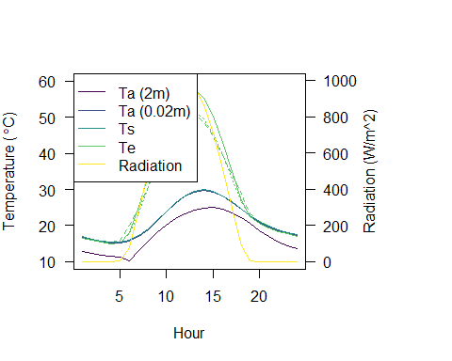

**Figure 3**. Body temperatures (Te) are predicted to drastically exceed air temperature when lizards are exposed to high levels of solar radiation. Air temperatures (Ta, C) at lizard height (0.02 m) are predicted to exceed air temperatures at 2 m and to be similar to surface temperatures (Ts). We estimate body temperatures using two general energy budgets [solid: Tb_Gates(); dotted: Tb_CampbellNorman()] and a lizard specific biophysical model [dashed: Tb_lizard()] that differ in how they model heat exchanges.

## Conclusions

TrenchR is intended to promote understanding of how organisms interact with their environment and consequences for physiology, energetics, behavior, and demography. Our example implementation highlights the importance of considering organismal body temperatures, rather than air temperatures, when examining thermal stress and other responses to environmental variability and change. TrenchR currently focuses on heat balances but may be expanded to include water balances. Simple functions can be combined as needed to produce comprehensive and transparent models for biophysical ecology and evolution. The resultant models are likely to be sufficiently detailed for many applications, but users are referred to NicheMapR for more detailed biophysical models (Kearney & Porter, 2017, 2020). We focus on models that predict equilibrium conditions for simplicity (that is, steady-state conditions). Such models generally do not present computational challenges so our models are not optimized for computational efficiency. Making classic biophysical ecology techniques more accessible will allow researchers to take advantage of rapidly accumulating data on environmental conditions and organismal traits to understand and predict ecological and evolutionary responses. Considering how organisms experience their environment is central to understanding responses to variable and changing environments (Suggitt et al., 2018).

## Acknowledgements

We thank A. Cannistra, R. Huey, J. Kingsolver, L. Miller, W. Porter, and H. A. Woods for assistance and input and B. Helmuth for providing functions. We particularly thank M. Kearney for extensive input on TrenchR and its alignment with NicheMapR and for contributing two tutorials.

## Authors’ Contributions

LB conceived and designed the package and lead all aspect of the packages creation and dissemination. All authors wrote and edited functions and associated package resources, contributed critically to manuscript drafts, and gave final approval for publication. AJ and JS configured the package. AM, BBO, YS, and LB converted and edited the educational modules.

## Data Availability

TrenchR is available at <https://github.com/trenchproject/TrenchR>. All text, code, and data for this manuscript are available at <https://github.com/trenchproject/TrenchRmanuscript/>.

## References

Bakken, G. S. (1992). Measurement and application of operative and standard operative temperatures in ecology. *American Zoologist*, *32*(2), 194–216.

Barlett, P. N., & Gates, D. M. (1967). The energy budget of a lizard on a tree trunk. *Ecology*, *48*(2), 315–322.

Bramer, I., Anderson, B. J., Bennie, J., Bladon, A. J., De Frenne, P., Hemming, D., Hill, R. A., Kearney, M. R., Körner, C., Korstjens, A. H., et al. (2018). Advances in monitoring and modelling climate at ecologically relevant scales. *Advances in Ecological Research*, *58*, 101–161.

Buckley, L. B. (2008). Linking traits to energetics and population dynamics to predict lizard ranges in changing environments. *The American Naturalist*, *171*(1), E1–E19.

Buckley, L. B., Cannistra, A. F., & John, A. (2018). Leveraging organismal biology to forecast the effects of climate change. *Integrative and Comparative Biology*, *58*(1), 38–51.

Bütikofer, L., Anderson, K., Bebber, D. P., Bennie, J. J., Early, R. I., & Maclean, I. M. (2020). The problem of scale in predicting biological responses to climate. *Global Change Biology*, *26*(12), 6657–6666.

Campbell, G. S., & Norman, J. (2000). *An introduction to environmental biophysics*. Springer Science & Business Media.

Dillon, M. E., & Woods, H. A. (2016). Introduction to the symposium: Beyond the mean: Biological impacts of changing patterns of temperature variation. *Integrative and Comparative Biology*, *56*(1), 11–13.

Dillon, M. E., Woods, H. A., Wang, G., Fey, S. B., Vasseur, D. A., Telemeco, R. S., Marshall, K., & Pincebourde, S. (2016). Life in the frequency domain: The biological impacts of changes in climate variability at multiple time scales. *Integrative and Comparative Biology*, *56*(1), 14–30.

Duursma, R. A. (2015). Plantecophys-an r package for analysing and modelling leaf gas exchange data. *PloS One*, *10*(11), e0143346.

Gates, D. M. (1980). *Biophysical ecology*. Courier Corporation.

Kearney, M. R., Isaac, A. P., & Porter, W. P. (2014). Microclim: Global estimates of hourly microclimate based on long-term monthly climate averages. *Scientific Data*, *1*(1), 1–9.

Kearney, M. R., & Porter, W. P. (2017). NicheMapR–an r package for biophysical modelling: The microclimate model. *Ecography*, *40*(5), 664–674.

Kearney, M. R., & Porter, W. P. (2020). NicheMapR–an r package for biophysical modelling: The ectotherm and dynamic energy budget models. *Ecography*, *43*(1), 85–96.

Kearney, M. R., Shine, R., & Porter, W. P. (2009). The potential for behavioral thermoregulation to buffer “cold-blooded” animals against climate warming. *Proceedings of the National Academy of Sciences*, *106*(10), 3835–3840.

Lembrechts, J. J., Lenoir, J., Roth, N., Hattab, T., Milbau, A., Haider, S., Pellissier, L., Pauchard, A., Ratier Backes, A., Dimarco, R. D., et al. (2019). Comparing temperature data sources for use in species distribution models: From in-situ logging to remote sensing. *Global Ecology and Biogeography*, *28*(11), 1578–1596.

Maclean, I. M., Mosedale, J. R., & Bennie, J. J. (2019). Microclima: An r package for modelling meso-and microclimate. *Methods in Ecology and Evolution*, *10*(2), 280–290.

Maguire, K. C., Nieto-Lugilde, D., Fitzpatrick, M. C., Williams, J. W., & Blois, J. L. (2015). Modeling species and community responses to past, present, and future episodes of climatic and ecological change. *Annual Review of Ecology, Evolution, and Systematics*, *46*.

Muir, C. D. (2019). Tealeaves: An r package for modelling leaf temperature using energy budgets. *AoB Plants*, *11*(6), plz054.

Nadeau, C. P., Urban, M. C., & Bridle, J. R. (2017). Coarse climate change projections for species living in a fine-scaled world. *Global Change Biology*, *23*(1), 12–24.

Porter, W. P., & Gates, D. M. (1969). Thermodynamic equilibria of animals with environment. *Ecological Monographs*, *39*(3), 227–244.

Porter, W. P., Mitchell, J. W., Beckman, W. A., & DeWitt, C. B. (1973). Behavioral implications of mechanistic ecology. *Oecologia*, *13*(1), 1–54.

Porter, W. P., & Tracy, C. R. (1983). Biophysical analyses of energetics, time-space utilization, and distributional limits. *Lizard Ecology: Studies of a Model Organism*, 55–83.

Potter, K. A., Arthur Woods, H., & Pincebourde, S. (2013). Microclimatic challenges in global change biology. *Global Change Biology*, *19*(10), 2932–2939.

Sinclair, B. J., Marshall, K. E., Sewell, M. A., Levesque, D. L., Willett, C. S., Slotsbo, S., Dong, Y., Harley, C. D., Marshall, D. J., Helmuth, B. S., & others. (2016). Can we predict ectotherm responses to climate change using thermal performance curves and body temperatures? *Ecology Letters*, *19*(11), 13721385. <http://onlinelibrary.wiley.com/doi/10.1111/ele.12686/full>

Suggitt, A. J., Wilson, R. J., Isaac, N. J., Beale, C. M., Auffret, A. G., August, T., Bennie, J. J., Crick, H. Q., Duffield, S., Fox, R., et al. (2018). Extinction risk from climate change is reduced by microclimatic buffering. *Nature Climate Change*, *8*(8), 713–717.

Sunday, J. M., Bates, A. E., Kearney, M. R., Colwell, R. K., Dulvy, N. K., Longino, J. T., & Huey, R. B. (2014). Thermal-safety margins and the necessity of thermoregulatory behavior across latitude and elevation. *Proceedings of the National Academy of Sciences*, *111*, 56105615. <http://www.pnas.org/content/early/2014/03/07/1316145111.short>

Tattersall, G. J. (2017). *Thermimage: Thermal image analysis*. Dec.