CSEE W4824 – Computer Architecture
Homework Assignment 1
Group members: Lucy He, Jiayi Wu
UNIs: lh3365, jw4782
Question 1
- Download PIN here.
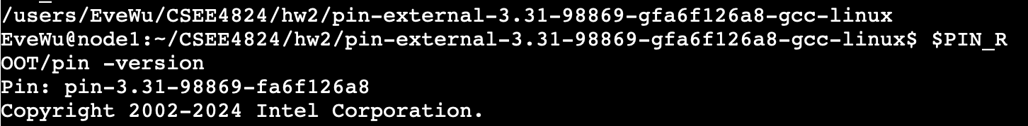
- Run and test PIN installation.
Commands:
cd ~/CSEE4824/hw2/pin-external-3.31-98869-gfa6f126a8-gcc-linux/source/tools/SimpleExamples
make
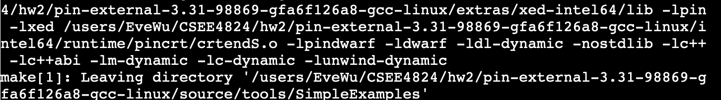
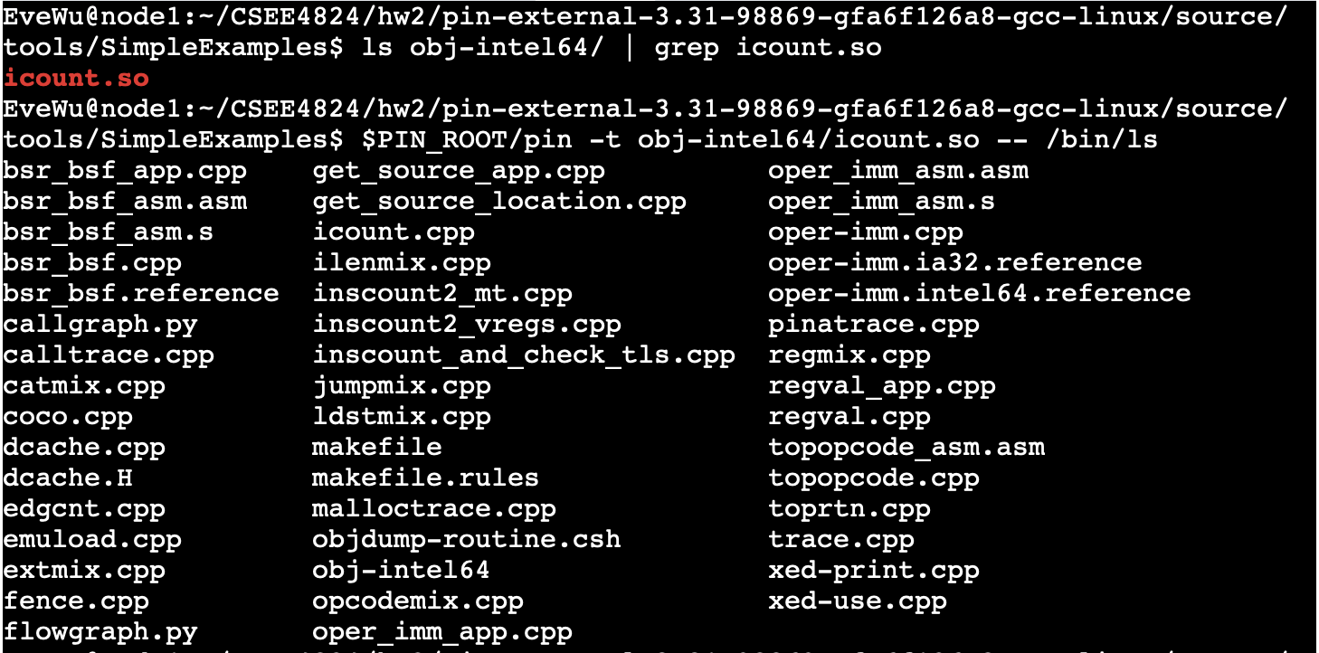
- Extract and make the cache simulator.
Commands:
Make
ls obj-intel64/ | grep cache
- Make and run some tests to ensure the cache simulator is generating outputs.
Commands:
$PIN_ROOT/pin -t ./obj-intel64/cache.so -- /bin/ls
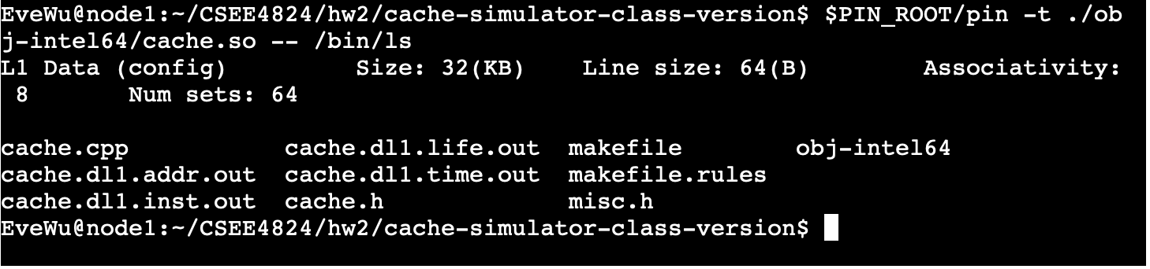
The simulator reported its configuration which is the same as the parameters mentioned in the homework instruction. Moreover, the simulator generated several output files such as cache.dl1.life.out and so on. These results confirm that the cache simulator runs correctly and collects cache performance data as expected.
- (a)
nl -ba cache.cpp | sed -n '990,1030p' // to locate the line number around 1000
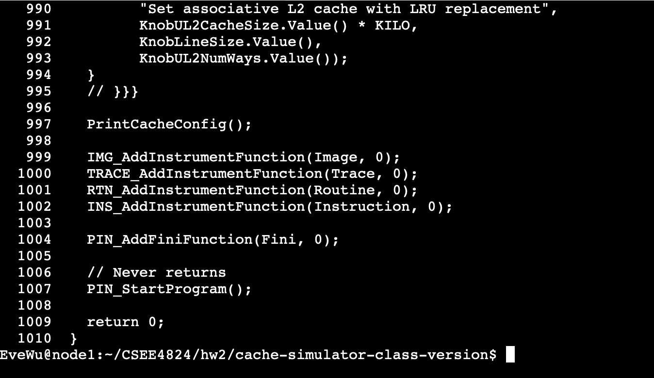
As the screenshot shows, Lines 999–1001 in cache.cpp register higher-level instrumentation callbacks at the image, trace, and routine levels. The actual handling of load/store instructions begins at line 1002 with INS_AddInstrumentFunction(Instruction, 0), which inspects each instruction, identifies memory operations, and inserts calls to RecordMemRead and RecordMemWrite for cache simulation.
So, we focus on the line 1002 next.
Firstly,
Secondly,
Using command,
nl -ba cache.cpp | sed -n '695,780p'
We got
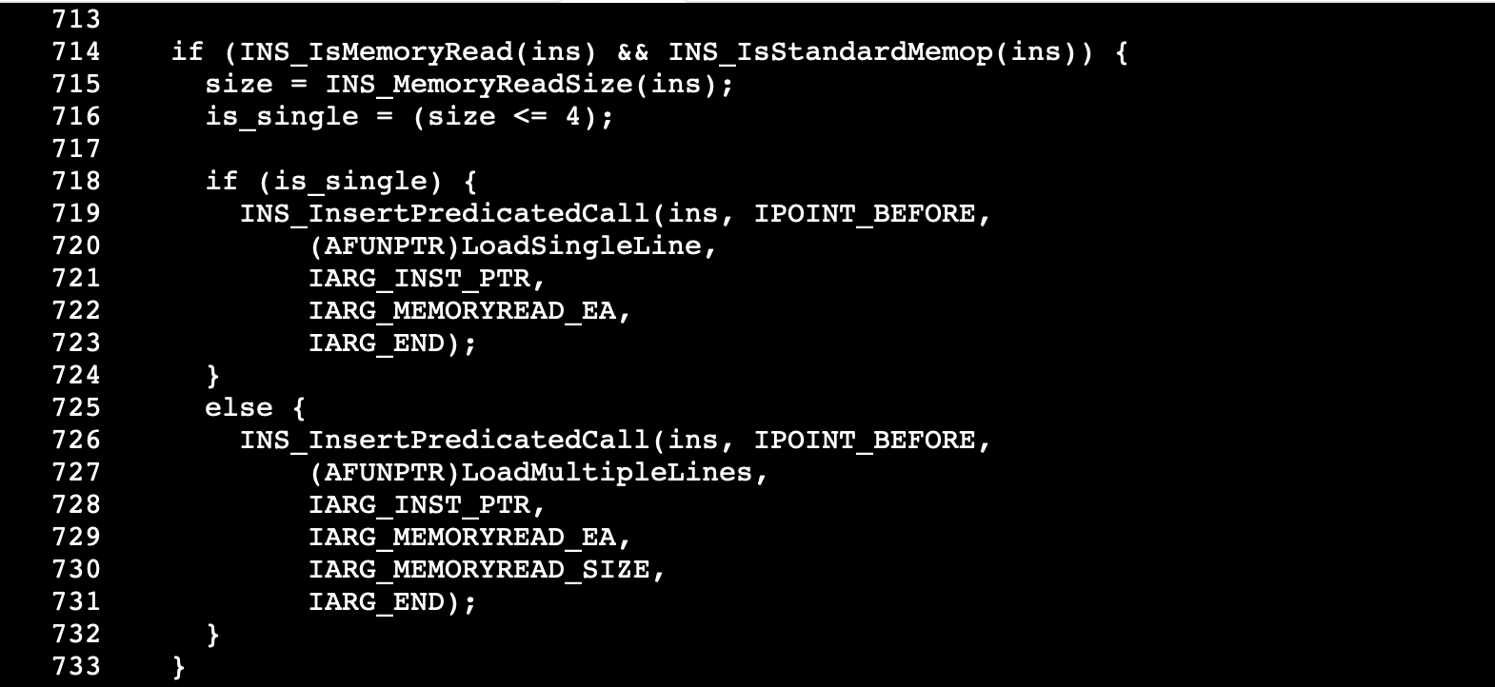
(b)
Also, we got the methods that are called for a store instruction.
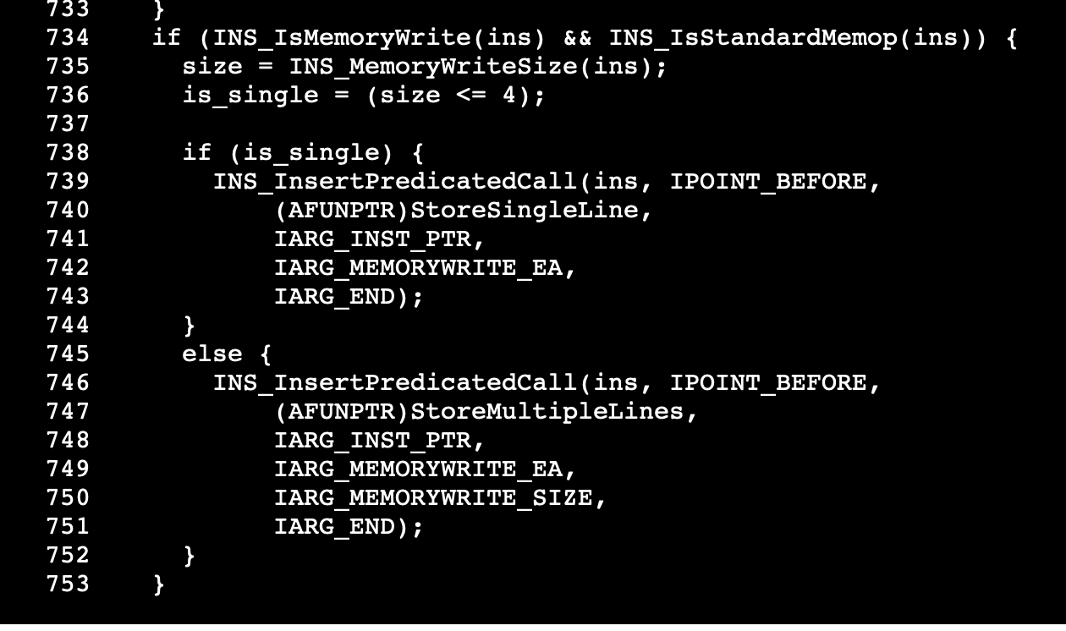
(c) According to the result we got in 5.(a), the line 701 in cache.cpp is shown as below.
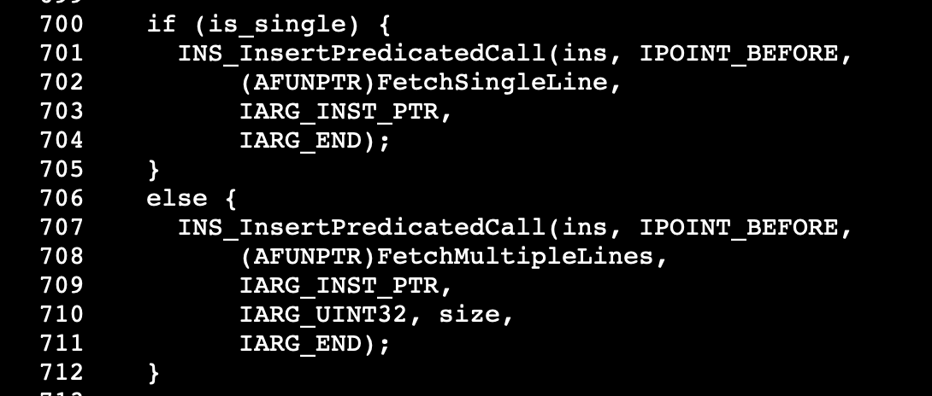
Line 701 means that before executing an instruction, PIN invokes the user-defined callback (FetchSingleline), which can record the instruction’s memory address and simulates instruction cache behavior.
(d)
Matrix n = 256;
For cache simulator, using command
/usr/bin/time -f "pin: %e sec" $PIN_ROOT/pin -t ./cache-simulator-class-version/obj-intel64/cache.so -- ./mm
The result is
