**[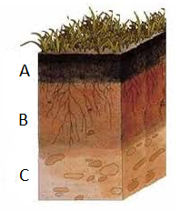](https://4.bp.blogspot.com/-LP6IQv-5noY/VGJgohw-d_I/AAAAAAAABXc/8HyH2ML3_Rc/s1600/Sem+t%C3%ADtulo.pngmop.png)**