# Exercise 5

## Create an experiment from scratch

You have been asked to create a “Rate this image” experiment, where the user is prompted with an image, and they have to rate the image via 3 distinctive questions from between 1 and 5. You have been asked to capture the gender of the user as part of the data capture.

Inside **ex5-image-ratings**, there is an images folder with 6 images that are ready to use already.

First of all, open up a new PsychoPy builder experiment, and save your experiment into the **ex5-image-ratings** folder with a suitable name.

Deliberately we have not given specific instructions of how to add the components, loops and routines required, but we have given you a design specification to complement the above description. Very often you will be given a specification like this, so it is good practice to try and construct from one. Everything set out here will have been covered in the training, so check previous experiment files and the slides if you need to refresh yourself.

**We will also come round and also periodically demo how to do particular segments until the end of the session.**

## Basic structure and sequence

### 1) Firstly add a gender question at the start

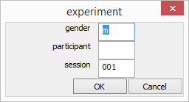

### 2) Title page + space to start



### 3) Main trial with the following sequence

**Fixation cross for 1 second before image shows**



**1 image flash for 3 seconds duration (suggest a separate routine for just this)**

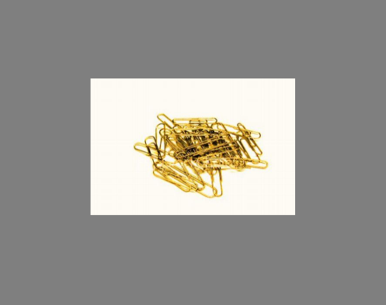

**Then followed by 3 questions for each image + rating scale (suggest a separate routine)**

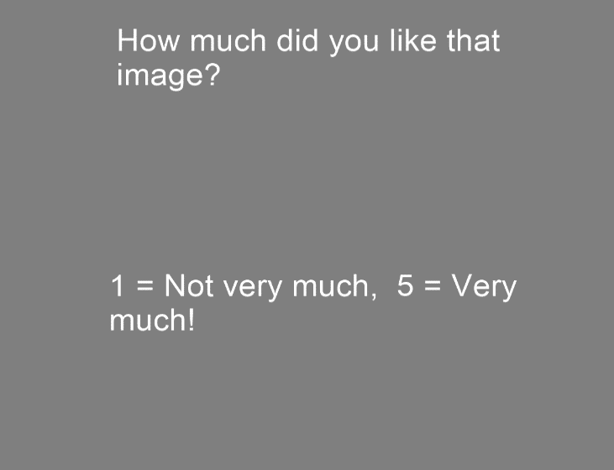

**Questions to ask / use in trial**

* How much did you like that image?
* How much did you recognize the content?
* How colourful was the image?

NOTE:

* Repeat for all images (a trial loop)
* Make the images repeat twice in total (i.e
* Set images to be randomly displayed, but the questions to always be in the same order

### 4) End / Thank you page (with a 3 second delay)

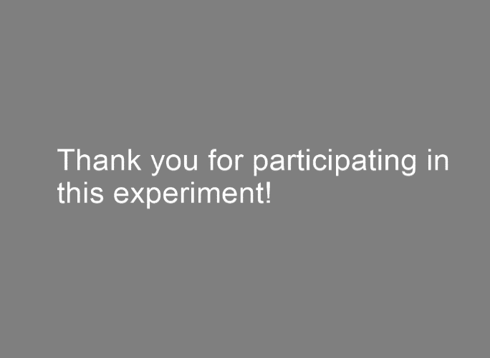

## Hints

* One loop around the question routine
* One loop around the image routine (just the image routine??)
* See “ex3-conditionals” for example of a fixation cross
* Make sure you set updates to the Question / Image items to NOT be constant!

## Advanced

Try to implement a break half way through after every 3rd image shown!