**Task-based investigations**

Decision making - choices13k

|  | t | p |
| --- | --- | --- |
| original |  |  |
| replicate | -9.69 | <0.001 |
| PE | -5.19 | <0.001 |

* replicate: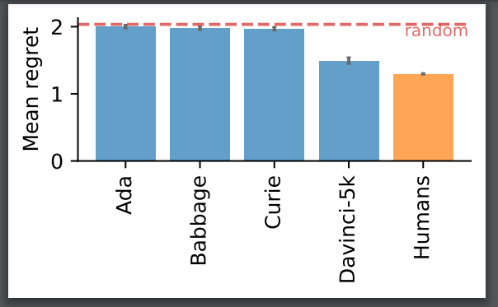
* PE: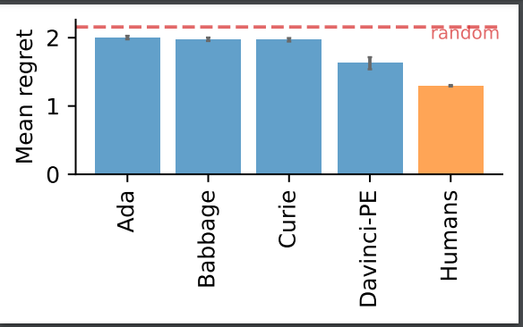

Information seeking - horizon/multi-arm bandit

|  | t | p |
| --- | --- | --- |
| original |  |  |
| replicate | -2.88 | 0.002 |
| PE | -2.34 | 0.0096 |

* Replicate: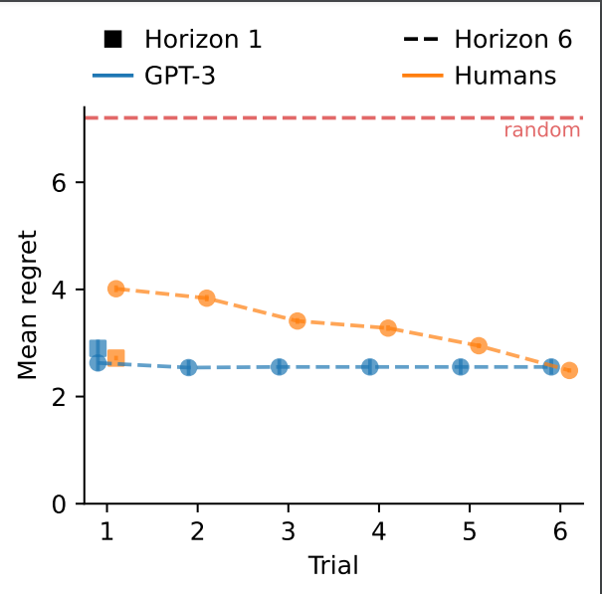
* PE: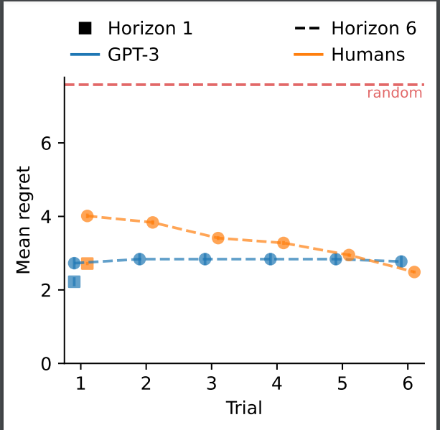

Deliberation - 2 stage decision tasks

Causal reasoning