DBS311 GROUP-3 PROJECT- MALL SYSTEM

STUDENT 1(Harsh Lodhi)- Employees TABLE

STUDENT 2(Jashanpreet)- Store TABLE

STUDENT 3(Rahul Kumar)-Inventory & Sales TABLE

OVERVIEW

This is a project of a sample of Mall Management system under a company that operates a number of malls. This project contains the complete data accessible through the C++ executable file that can be installed as a software for easy execution of the data by the user.

This Model contains a number of tables that makes this project a complete database on its own

User Guide-

Table of Contents

Employees Table 2

INSERT 2

UPDATE: 4

SELECT: 6

DELETE 7

Store Table 8

Insert: 8

Update: 10

SELECT: 12

DELETE: 13

Inventory and Sales Table: 15

INSERT 15

UPDATE: 16

SELECT: 16

DELETE: 17

SQL Procedures

Employees TABLE

## INSERT

PLSQL for insert INPUT:

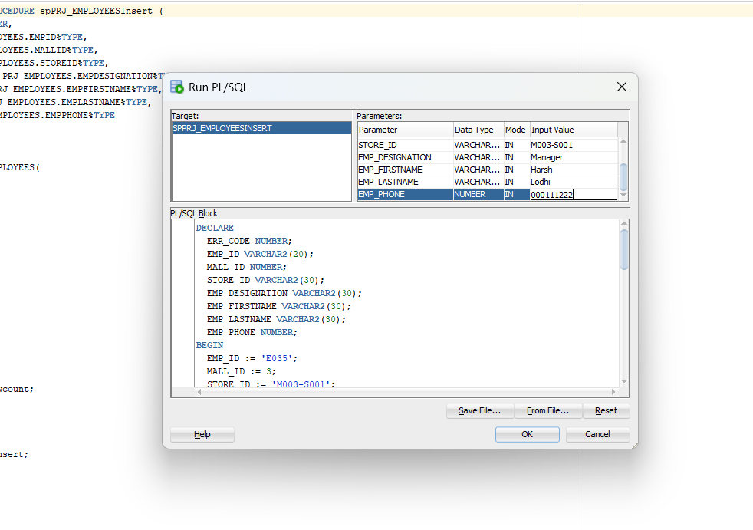

OUTPUT:

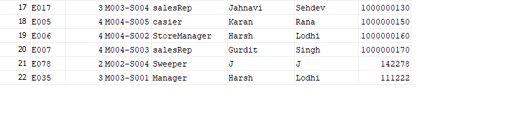

## UPDATE:

INPUT:

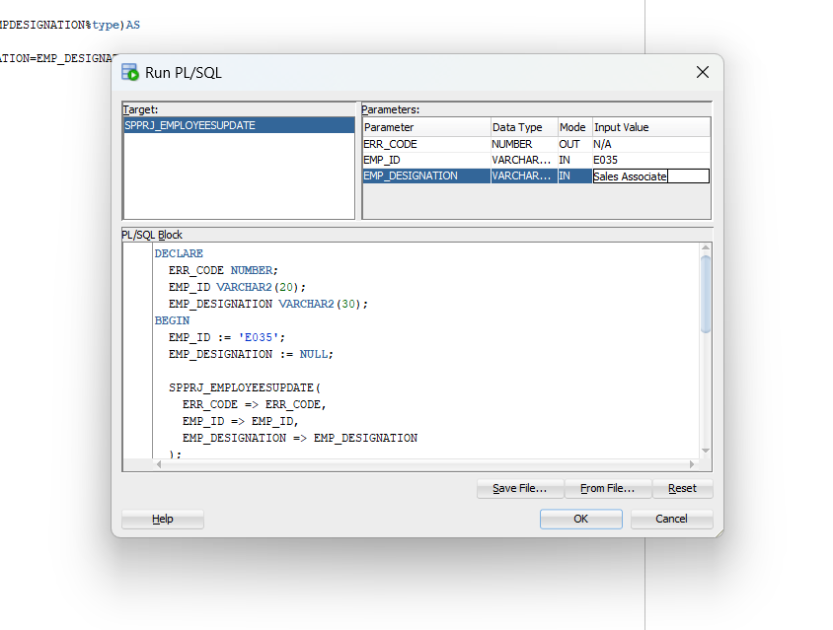

OUTPUT:

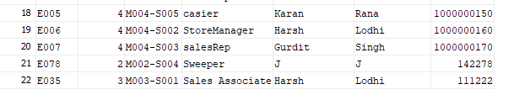

## SELECT:

Input:

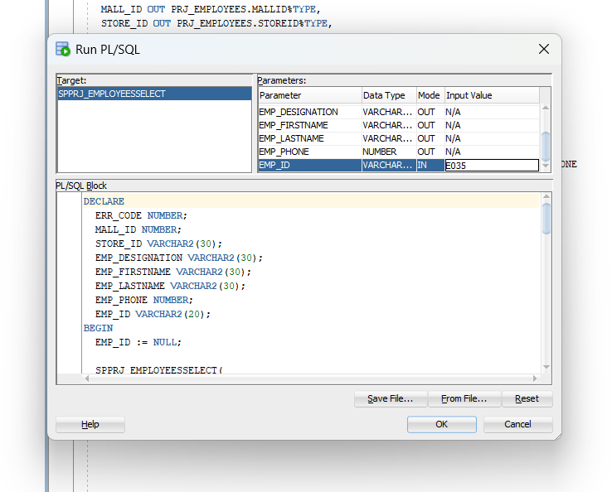

## DELETE

Input:

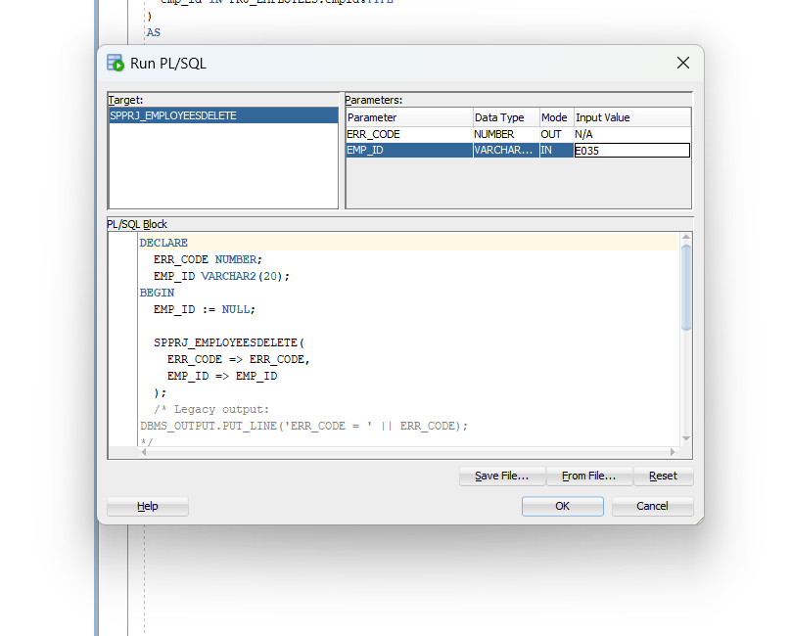

Output:

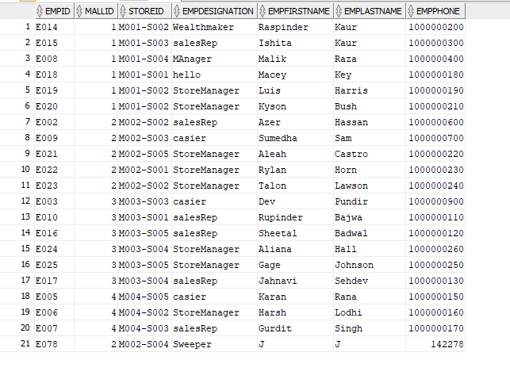

You cannot find E035 here.

# STORE

## Insert:

Input:

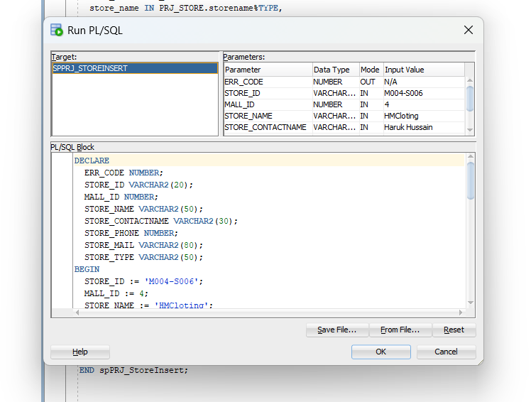

Output:

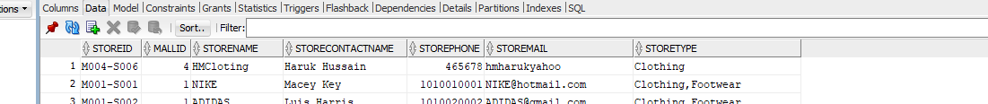

## Update:

Input:

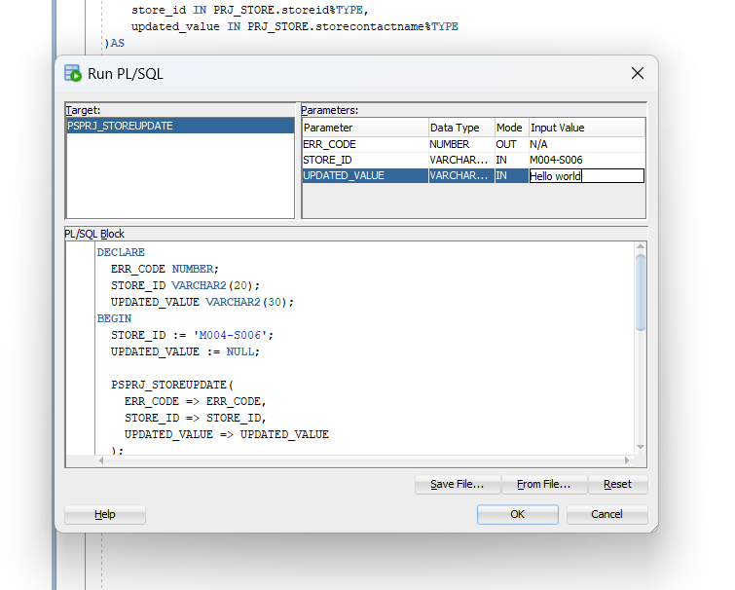

Output:

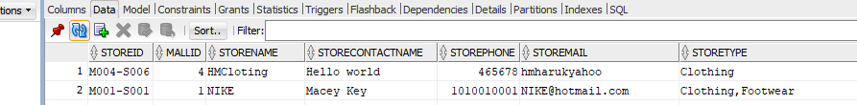

## SELECT:

Input:

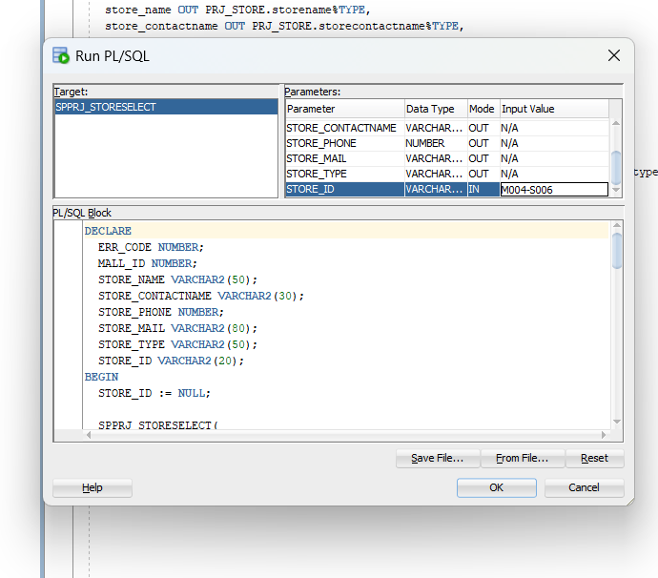

## 

## DELETE:

Input:

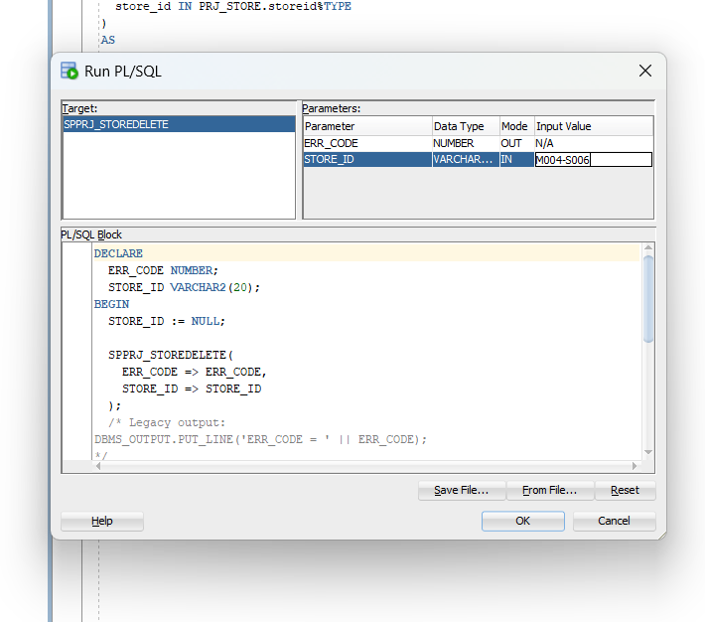

Output:

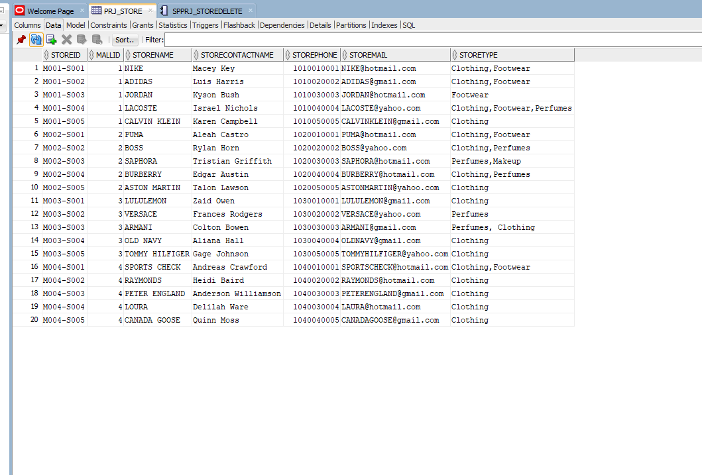

Store M004-S006 is deleted.

# Inventory and Sales:

## INSERT(inventory)

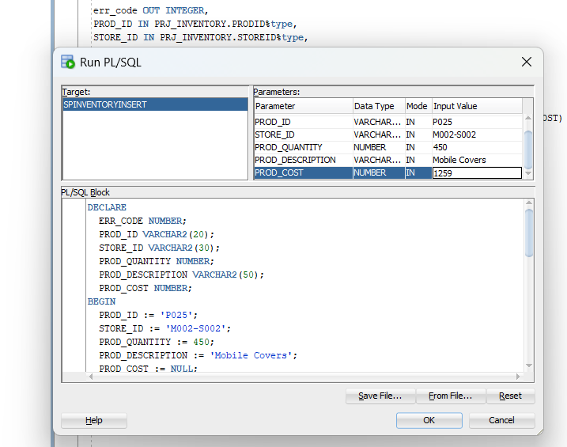

Output:

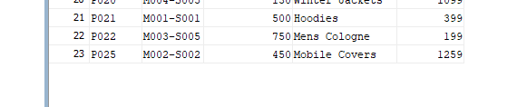

## UPDATE(Sales):

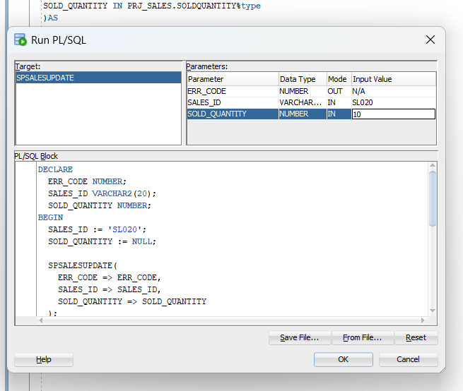

Output:

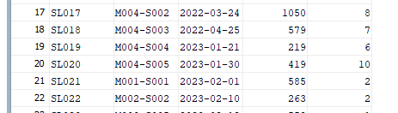

## SELECT(Inventory):

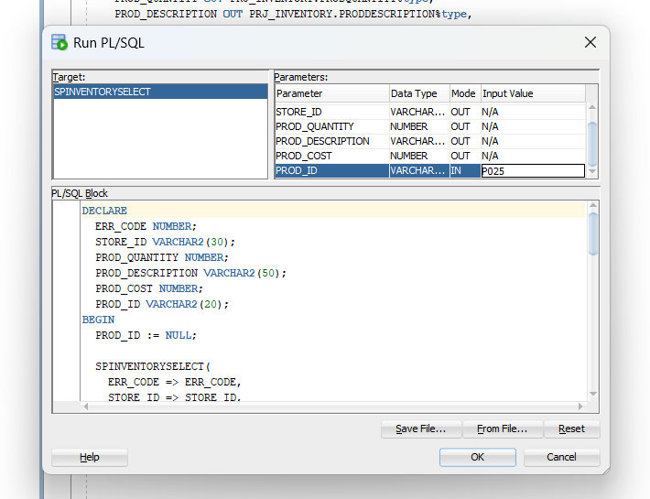

## DELETE(Sales):

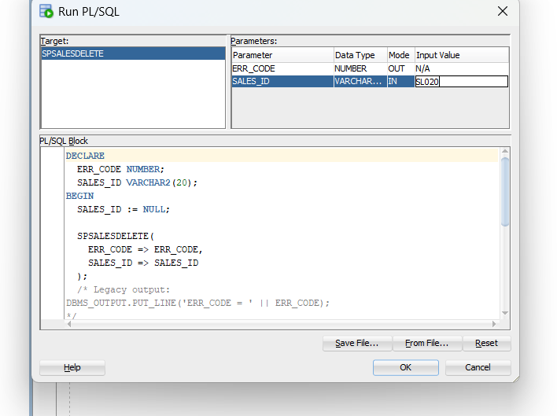

Output:

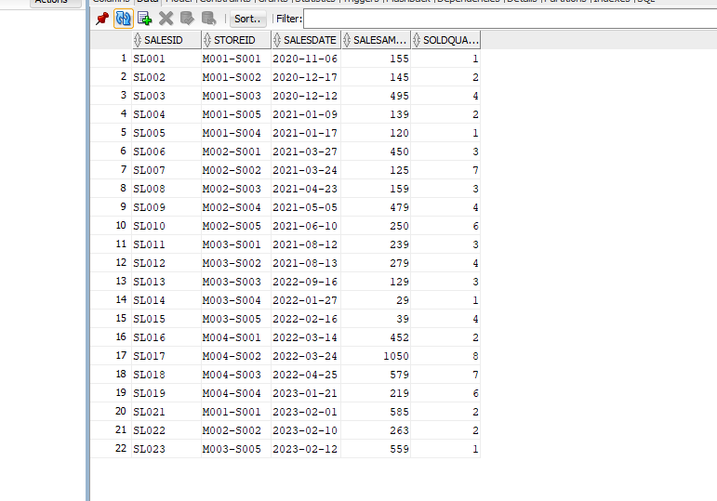

SL020 is deleted

**CPP Files Output:**

**Harsh’s Part:**

Insert Part:

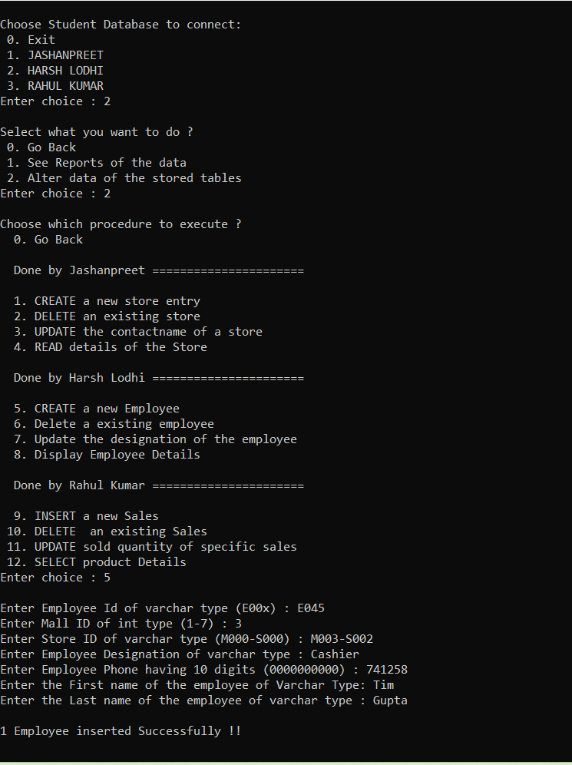

Update Part:

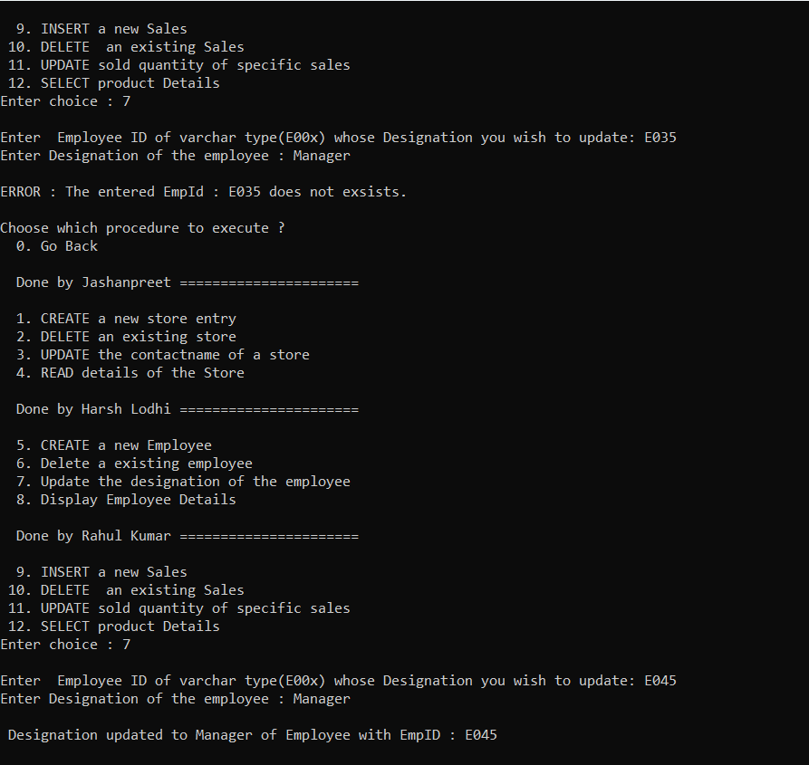

Select Part:

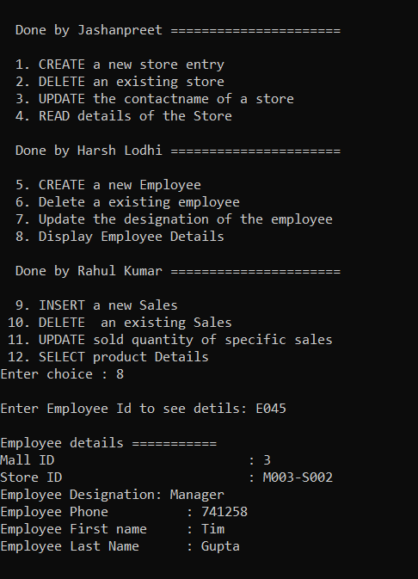

Delete Part:

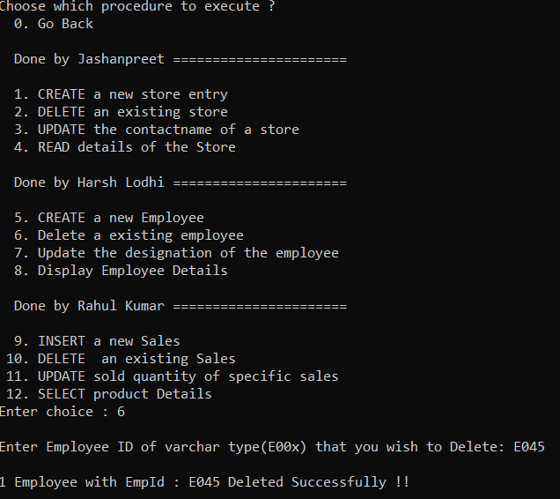

**Jashanpreet’s Part:**

Insert Part:

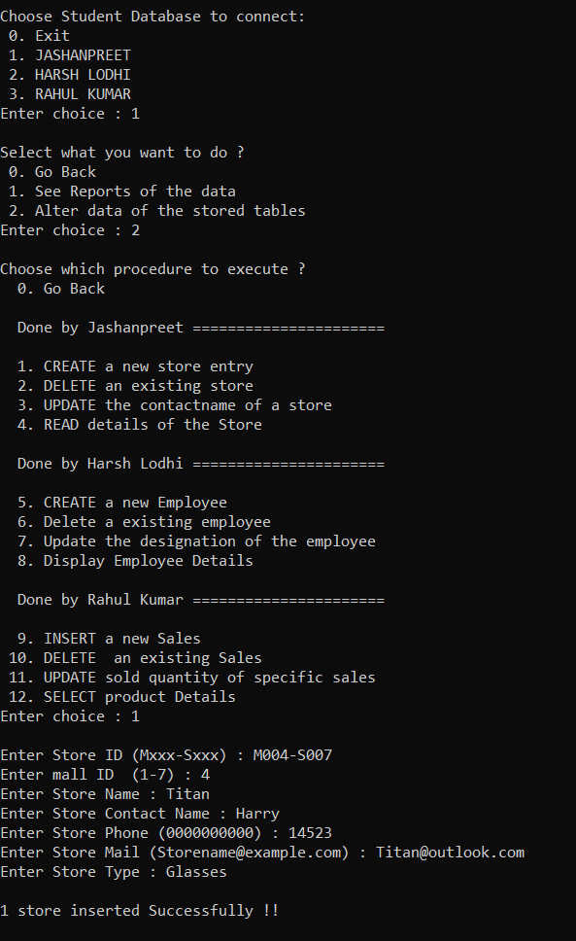

Update Part:

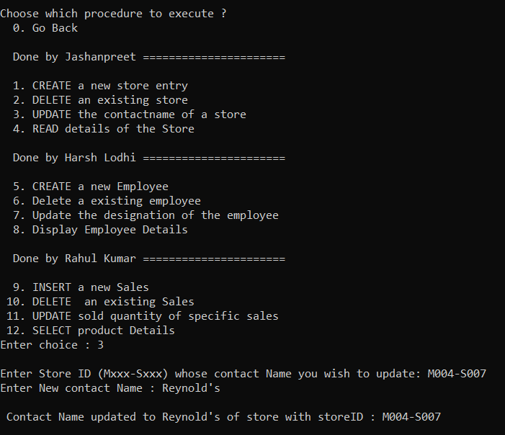

Select Part:

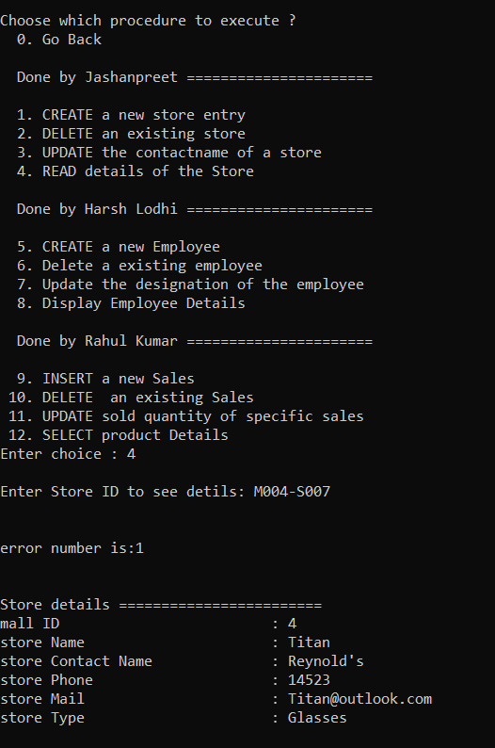

Delete Part:

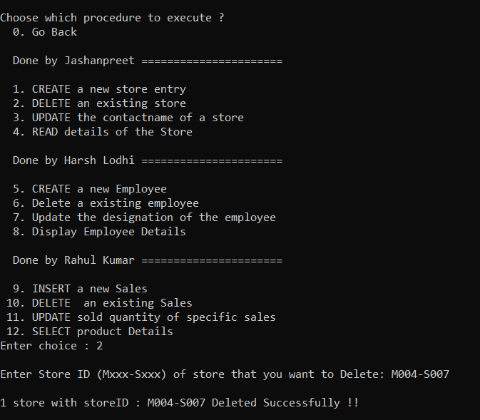

**Rahul’s Part:**

Insert Part:

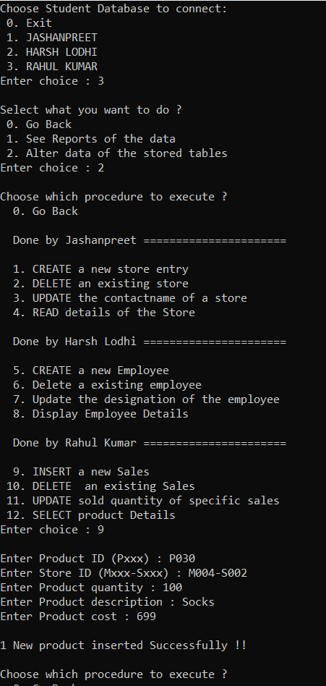

Update Part:

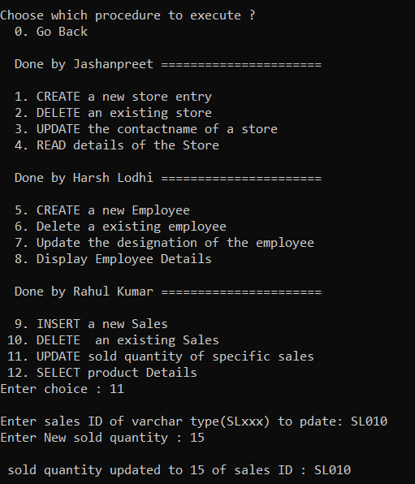

Select Part:

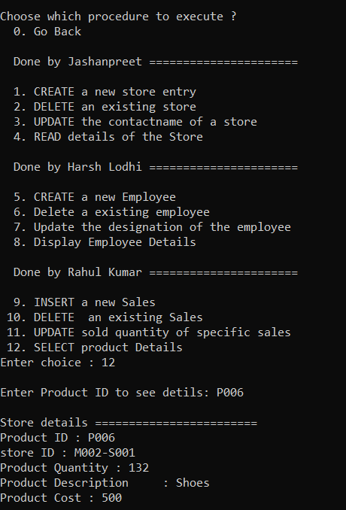

Delete Part:

