**Layouts**

Pages are route-specific UI components

A layout is UI that is shared between multiple pages in your app

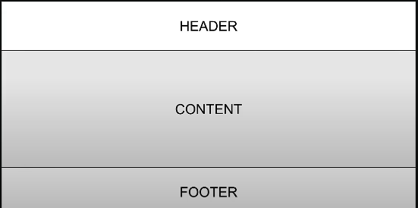

How to create layouts

Default export a React component form a layout.js or layout.tsx file

That component takes a children prop, which Next.js will populate with your page content

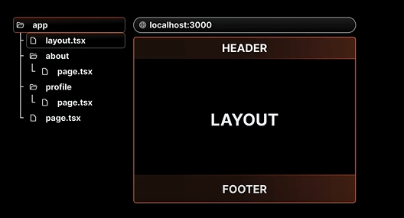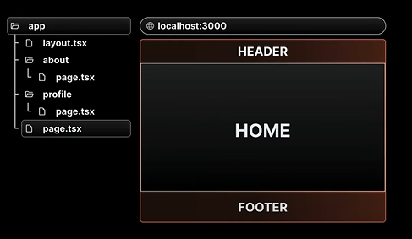

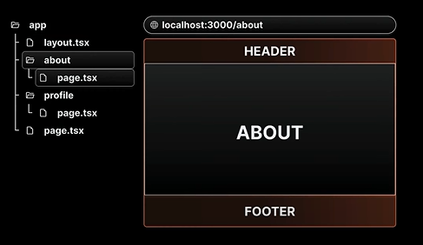

**Nested Layouts ( Bố cục lồng nhau )**

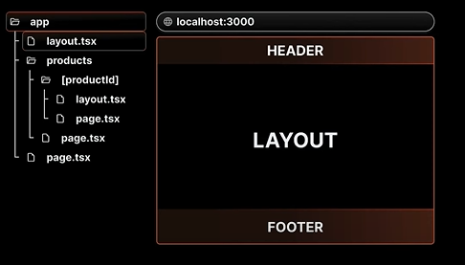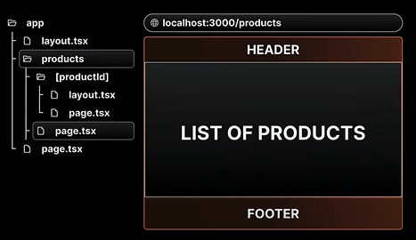

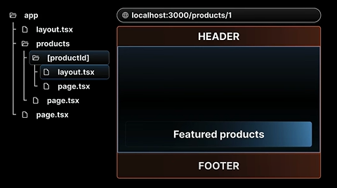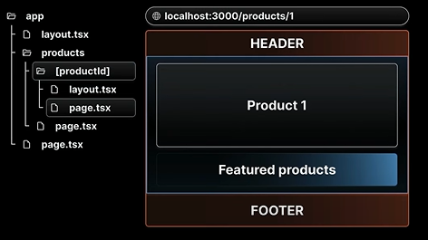

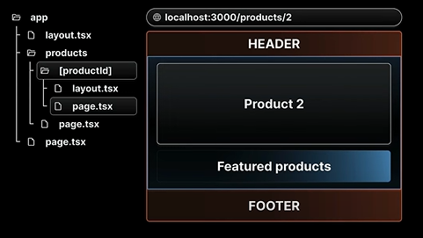

**Multiple Root Layouts ( Nhiều bố cục gốc )**

**Route Group uses:**   
Organize our project structure without affecting URLs  
Apply layouts selectively to specific parts of our app