**Link Component**

**Navigation**

Defining routes for our application’s root, nested routes, dynamic routes, and catch-all routes

We’ve been typing URLs directly in the browser to test these routes

Users

* Click on links
* Get directed after certain actions

**UI navigation**

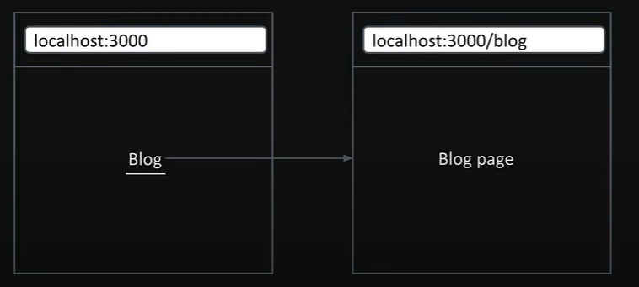

**Link component navigation**

For client-side navigation, Next.js gives us the <Link> component

The <Link> component is a React component that extend the HTML <a> element, and it’s the primary way to navigate between routes in Next.js

To use it, we’ll need to import it from “next/link”

**Các thuộc tính thường dùng**

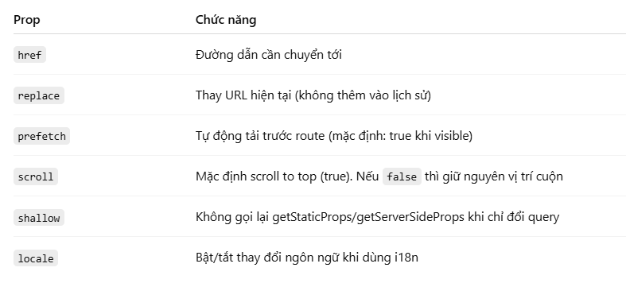

**Active Links**

**Params and searchParams**

For a given URL,

**params** is a promise that resolves to an object containing the dynamic route parameters (like id)

**searchParams** is a promise that resolves to an object containing the query parameters (like filters and sorting)

while page.tsx has access to both params and searchParams, layout.tsx only has access to param

**Navigating Programmatically**

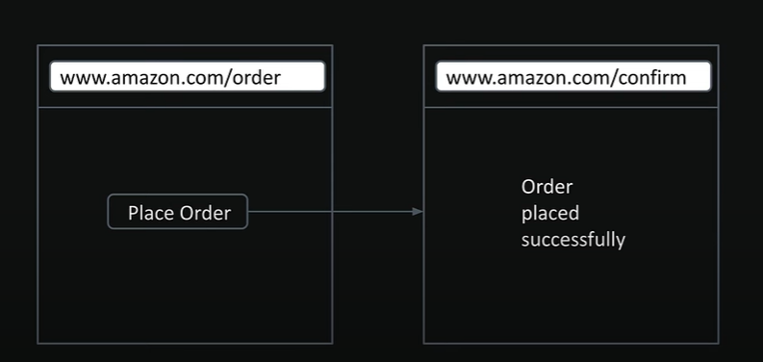

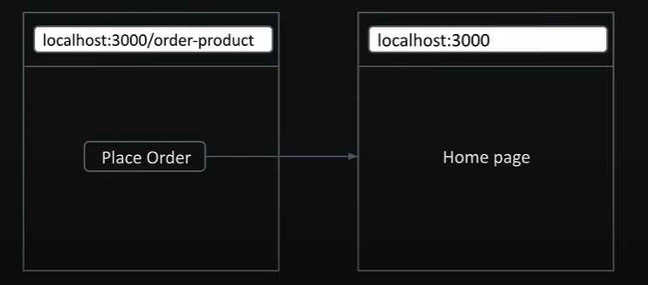

**const router = useRouter();**

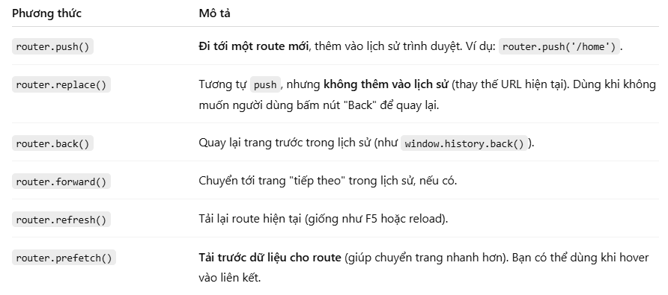

**Redirect**

**import { notFound, redirect } from "next/navigation";**

