Parallel routes ( Các tuyến đường song song )

What the are:

Parallel routing is an advanced routing mechanism that lets us render multiple pages simultaneously within the same layout

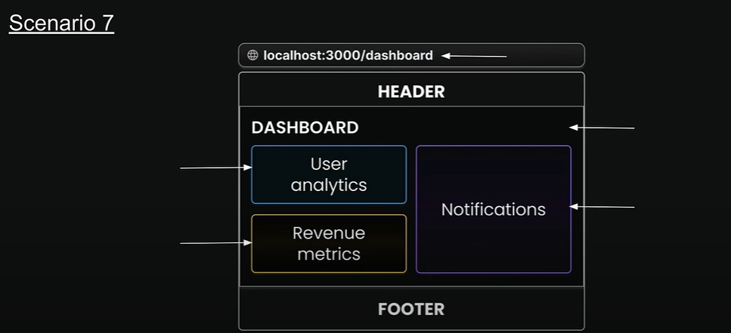

How to set them up:

Parallel routes in Next.js are defined using a feature known as “slots”  
Slots help organize content in a modular way  
To create a slot, we use the “@folder” naming convention  
Each defined slot automatically becomes a prop in its corresponding ‘layout.tsx’ file  
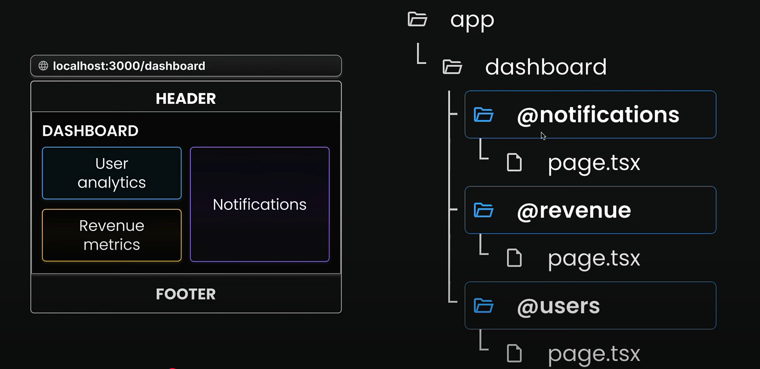

**Parallel routes use cases**

* Dashboards with multiple sections
* Split-view interfaces
* Multi-pane layouts
* Complex admin interfaces

**Parallel routes benefits**

1. Parallel routes are great for splitting a layout into manageable slots ( especially when different teams work on different parts)
2. Independent route handling
3. Sub-navigation

**Independent route handling**

Each slot in your layout, such as users, revenue, and notifications, can handle its own loading and error states  
This granular control is particilarly useful in scenarios where different sections of the page load at varying speeds or encounter unique errors.

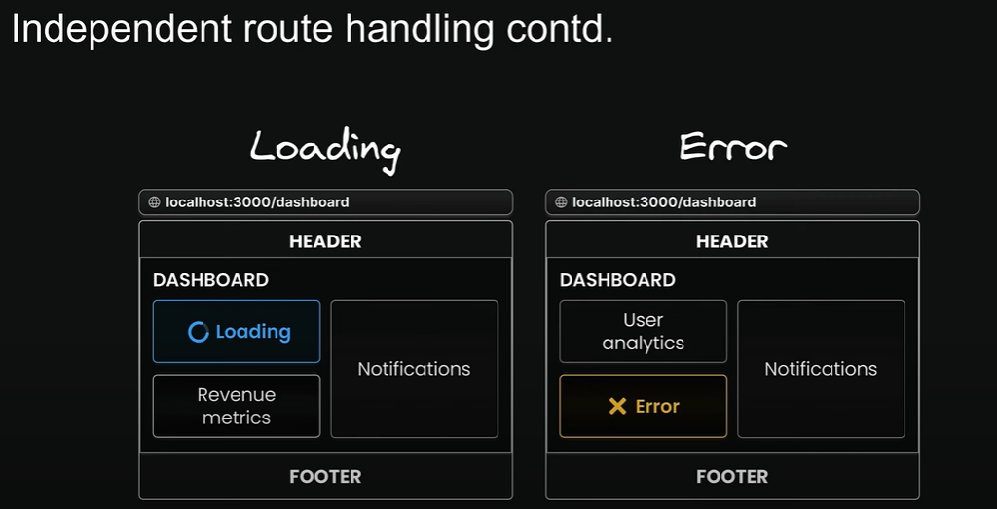

**Sub-navigation in routes**

Each slot can essentially function as a mini-application, complete with its own navigation and state management  
Users can interact with each section saparately, applying filters, sorting data, or navigating through page without affecting other parts.

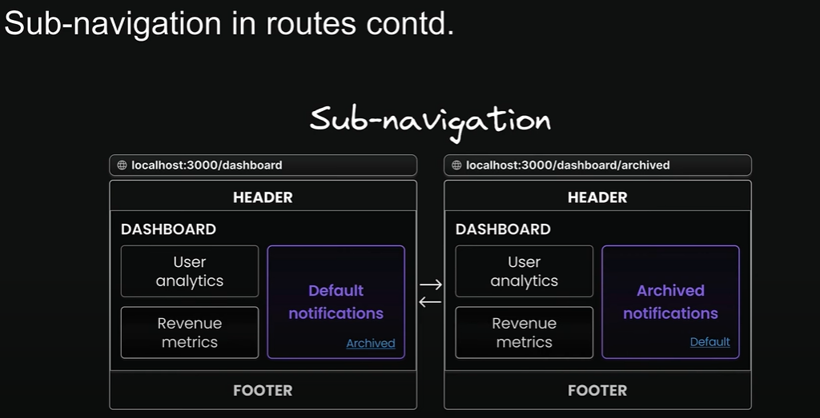

**Unmatched Routes**Navigation from the UI

When navigating through the UI ( like clicking links ), Next.js keeps showing whatever was in the unmatched slots before

Page reload  
Next.js looks for a ‘default.tsx’ file in each unmatched slot  
This file is critical as it serves as a fallback to render content when the framework cannot retieve a slot’s active state from the current URL

Without the file, you’ll get a 404 error

**Conditional Routes ( route có điều kiện )**

Imagine you want to show different content based on whether a user is logged in or not  
You might want to display a dashboard for authenticated users but show a login page for those who aren’t   
Conditional routes allow us to achieve this while maintaining completely separate code on the same URL

**Intercepting Routes**

Advanced routing patterns  
1. Parallel routes  
2. Intercepting routes   
 a. Understanding the core concepts and conventions  
 b. Practical implementation

Intercepting routes is an advanced routing mechanism that allows you to load a route from another part of your application within the current layout  
It’s particularly useful when you want to display new content while keeping your user in the same context