***Dynamic Detection of Different Battery Chemistry Using Neural Networks***

Hector K. Lopez

Computer Science and Electrical Engineering

Florida Atlantic University

Boca Raton, FL. United States

hlopez5@fau.edu

Zilouchian, Ali (*Author*)

line 1 (of *Affiliation*): dept. name of organization

line 2-name of organization, acronyms acceptable

line 3-City, Country

line 4-e-mail address if desired

*Abstract*—Lithium-iron-phosphate (LiFPO4), Nickel-metal-hydride (Ni-MH), and a Lead Acid battery are simulated without aging or temperature effects. A constant load is placed on the batteries and the discharge curves are used to train a neural net. The simulation is repeated for many discharge curves. Three feed-forward back-propagation neural net methods are analyzed: Single hidden layer, Double hidden layer and radial basis transfer function. The neural nets are trained at the various discharge curves to improve pattern recognition performance.

Keywords—Neural Networks; Lithium-Ion; NiMH; Lead-Acid; Battery Modeling; Pattern Recognition; Radial Basis

# Introduction

The popularity of battery storage systems has been on the rise in recent years. The similar rise in residential battery storage, and electric vehicle has led to interest in smart-grid applications where these potentially shared resources are managed in a dynamic way. For example, a fleet of various electric vehicles can be plugged into the same grid and then managed to provide energy storage services for homes in a neighborhood. One potential opportunity for a system like this is to detect the battery chemistry of any connected battery storage device and detect the battery chemistry. This paper is focused on the attempt to classify three different battery chemistries from each other using different neural network methods. The goal of this paper is to provide research on the accuracy of certain neural networks to detect the battery chemistry from just the voltage and state of charge of the battery. The experiment begins with basic battery models discharged at a constant load for one hour. A neural net is trained on the voltage response of each battery as the batteries discharge. The neural net is then validated for performance and a mean-squared-error (MSE) is established to grade the neural networks performance at that discharge rate. The discharge rate is increased by increasing the constant load. The simulation is repeated for increasing rates of discharge. In the end, a sweep of different load currents provides neural net MSE at each discharge rate. The paper then explores adjustments to the neural network to improve performance.

The battery models are analyzed to see the performance against similar commercial battery manufacturer published discharge curves.

# Battery Modeling

The battery is modelled using a simple controlled voltage source in series with a constant resistance. The model assumes the same characteristics for the charge and discharge cycles. The open voltage source is calculated with a non-linear equation based on the actual SOC of the battery. [1]

A generic dynamic battery model is represented in figure 1. The model shows the charge and discharge equations used.

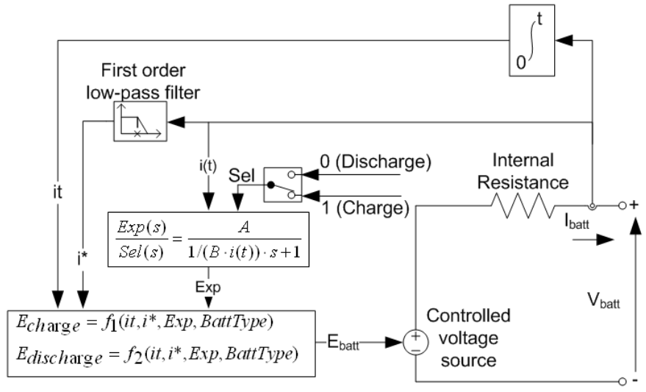

Figure 1

## The Generic Battery Model

The discharge equations for the Lead-Acid and Ni-MH battery models are shown in equation (1) . The Lithium Ion discharge curve can be modeled using equation (2). These equations model the exponential curve at the beginning of discharge.



${E_{discharge}=E}_{0}-K∙ \frac{Q}{Q-it} ∙i^{*}-K∙\frac{Q}{Q-it}∙it+L^{-1}\left(\frac{Exp(s)}{Sel(s)}*0\right)$

${E_{discharge}=E}_{0}-K∙ \frac{Q}{Q-it} ∙i^{*} -K∙\frac{Q}{Q-it}∙it+A∙exp\left(-B∙it\right)$

In the equations:

* $E_{Batt}$ is nonlinear voltage, in V.
* $E_{0}$ is constant voltage, in V.
* $Exp\left(s\right)$ is exponential zone dynamics, in V.
* $Sel(s)$ represents the battery mode. Sel(s) = 0 during battery discharge, Sel(s) = 1 during battery charging.
* $K$ is polarization constant, in Ah−1, or polarization resistance, in Ohms.
* $i^{*}$ is low frequency current dynamics, in A.
* $i$ is battery current, in A.
* $it$ is extracted capacity, in Ah.
* $Q$ is maximum battery capacity, in Ah.
* $A$ is exponential voltage, in V.
* $B$ is exponential capacity, in Ah−1.

Note that.”

## Shepards Battery Model

Shepards battery model uses the similar equation as in the Generic Battery Model. This circuit was designed using Matlab code. The parameters have been adjusted to verify the discharge curves of the Generic Battery Model. The intent is to verify the Generic Battery Model and see how closely it adheres to the Shepard’s equation approximation of the battery discharge curve.

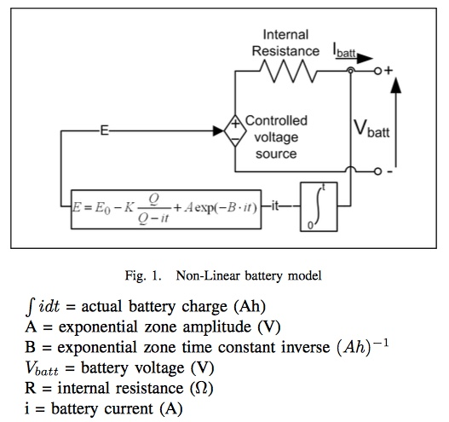

Figure 2

## Model Validation

The battery models where discharged at different rates by attaching them to a variable load current source. The circuit was simulated for 3600 seconds. Each circuit simulation provided an output of voltage and state of charge for each of the batteries at a given discharge rate. The output of each simulation was stored as an array.

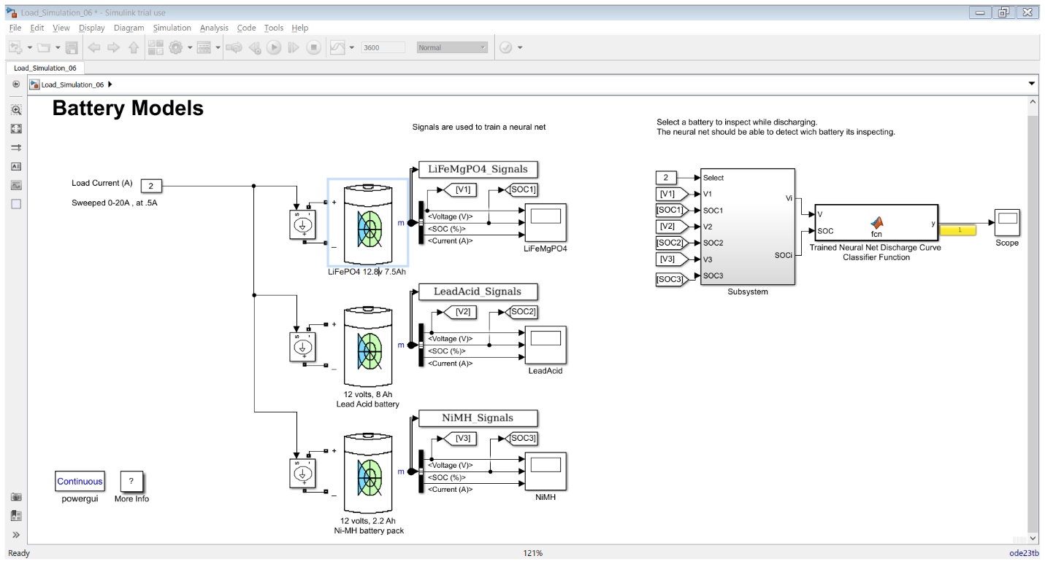

The discharge curves of each battery model at different discharge rates where compared to the manufacturer specs for similar parameters. The battery models where then adjusted to have the same nominal voltage, 12v and capacity rating, 2Ah. By normalizing the battery voltage and state of charge. It was then used to indicate any discrepancies between the battery chemistries.

Lead Acid:

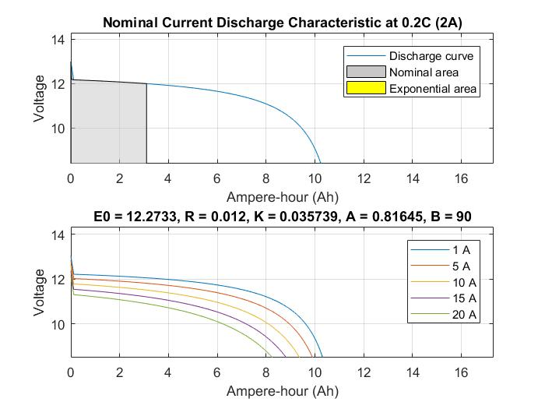

LFP:

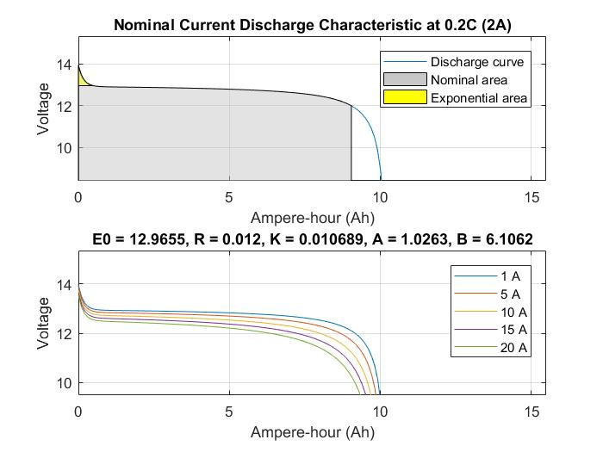

Ni-MH:

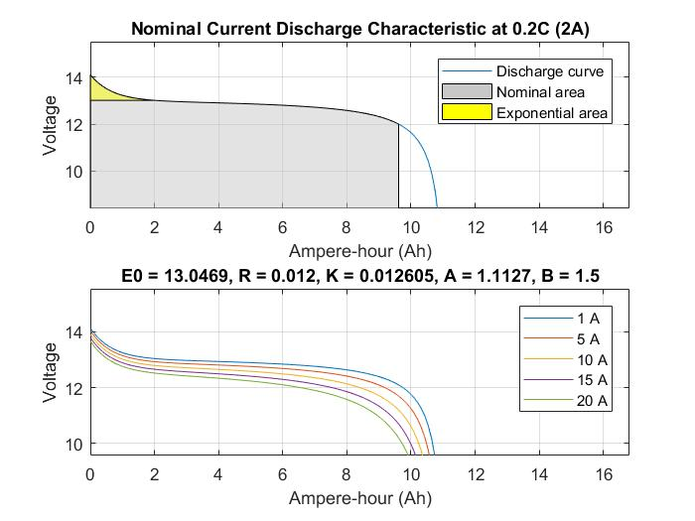

## Model Assumptions

* The internal resistance is assumed constant during the charge and discharge cycles and does not vary with the amplitude of the current.
* The capacity of the battery does not change with the amplitude of current (No Peukert effect).
* The self-discharge of the battery is not represented.
* The battery has no memory effect.

# Training Neural Networks

The battery discharge simulations provided data from each of the batteries that will be used to attempt to identify each battery and classify it to a distinct chemistry. A pattern recognition neural net can accomplish this by learning the relationship between variables and trying to predict the type given a new set of variables.

With a neural net sufficiently trained to detect patterns from variables such as state of charge and voltage as the neural net is applied to a circuit it can dynamically classify the battery type by its discharge. The rate of discharge is another variable that can be used to increase the performance of the neural net.

Three types of neural nets will be examined to find the best performing method for classification of this type of data set. The first neural net will be a single hidden layer, the second will be a double hidden layer and the third will be a radial basis neural net to decrease training time.

## Conditioning the Data

The data for each battery is an array of voltage over time and state of charge (soc) over time. The sample time is 1 sec. over the duration of 1 hour. The v-soc curve was generated from the dataset for each battery. The v-soc curve was then fitted to a polynomial. The polynomial was used to create an array of derivative values. This created a time independent variable representing the change in v-soc curve. Another variable that can be unique is the change in voltage over time.

Current sweep of 0.5A to 40A

NIMH 12v2AH

V vs. SOC

Lead-Acid 12v2AH

V vs. SOC

LFP 12v2AH

V vs. SOC

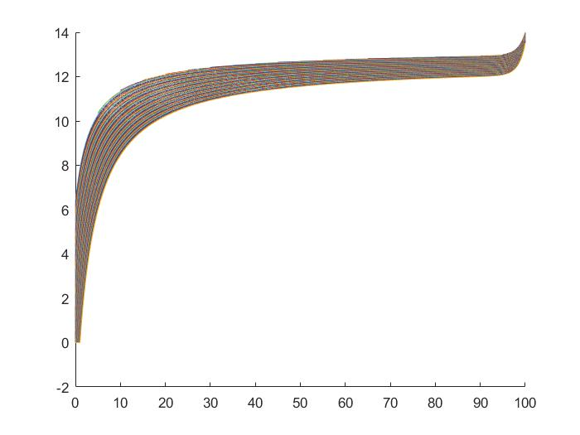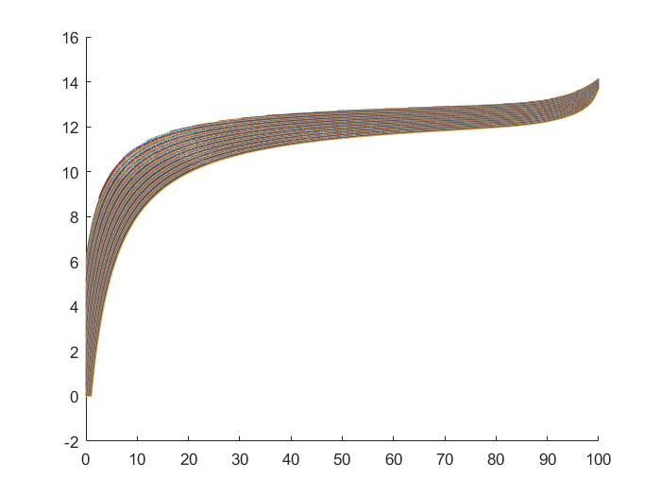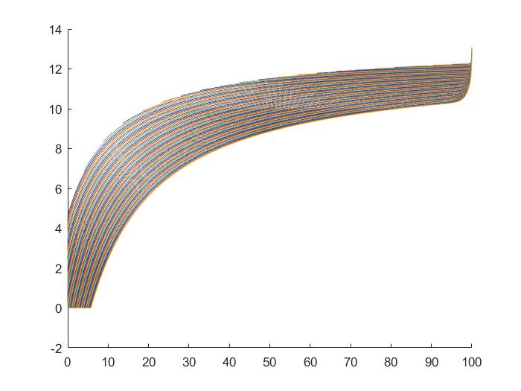

The voltage vs. soc curves shown in the figure are used to generate polynomial curves from. Each curve is shown for the entire sweep . A method is needed to flatten the dataset and also include the discharge rate alongside the v-soc curve point. Given a voltage and a discharge rate and a battery state of charge the system should be able to predict the battery out of the given set.

The classification will most likely work best in certain regions of the v-soc curve. The goal is to identify those regions and find a way to optimize or mitigate the regions it works poorly in.

|  | V-SOC | (V-SOC)Δ | Discharge Rate |
| --- | --- | --- | --- |
| Lead |  |  |  |
| LFP |  |  |  |
| NIMH |  |  |  |

## Training Neural Net

Define abbreviations and acronyms the first time they are used in the text, even after they have been defined in the abstract. Abbreviations such as IEEE, SI, MKS, CGS, sc, dc, and rms do not have to be defined. Do not use abbreviations in the title or heads unless they are unavoidable.

## Validating Neural Net

The original training data is split into 75% for training, then 15% for validation. The selection is random. The validation data is used to grade the neural net performance and adjust any parameters if necessary. The final 15% is verification data that is used to verify the neural networks given an unknown input the classification should predict accurately.

The figure below shows the Mean Average Percent Error for each neural net type that was trained. It is laid out by the discharge rate. Notice that the lower the discharge rate the lower the MAPE error. The greater the current the less information is available to use in order to distinguish each battery specific discharge curve.

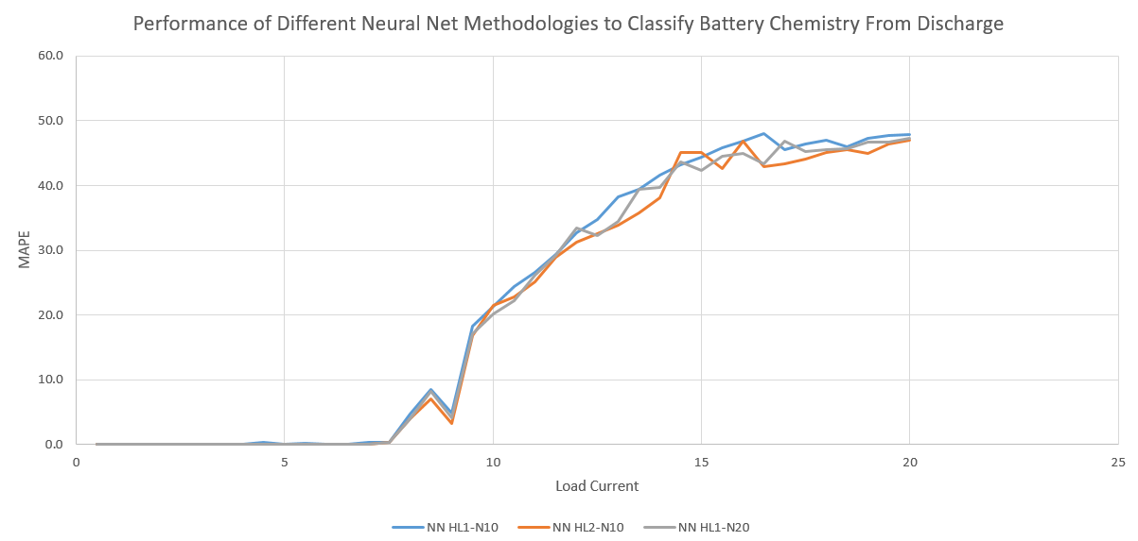

Figure 3

Performance of the neural net also needs to be analyzed by using the L-infinity and L2 norm values. This can give an indication of the fluctuations within the neural net validation. Since the mean error can mask any net neutral fluctuations.

|  | L-Inf | L-2 | MAPE |
| --- | --- | --- | --- |
| 1 HL |  |  |  |
| 2 HL |  |  |  |
| RBF |  |  |  |

## Performance Comparison

TBD

# Results and Implementation

The use of a neural net to dynamically predict the battery chemistry of a discharging battery was presented. A generic battery model was used to create the training data for three types of batteries, Lithium-Iron-Phosphate, Lead-Acid, and Nickel-Metal-Hydride. A current sweep was used to collect the discharge curves of each battery over a 1-hour period. Different neural nets where used for pattern recognition and the performance of each was analyzed.

The results show an obvious improvement in recognition when the battery discharge is slow enough to discern variations in exponential portions of the discharge curve. A method to step through each discharge rate and choose the classification was also discussed. This could lead to detection of battery chemistry during an irregular discharge curve. To verify that type of system a more accurate battery model should be used to account for chemistry effects.

##### References

1. “A Generic Battery Model for the Dynamic Simulation of Hybrid Electric Vehicles” Olivier Tremblay, Member IEEE, Louis-A. Dessaint, Senior Member IEEE, and Abdel-Illah Dekkiche Electrical Engineering Department, Ecole de Technologie Superieure (*references*)
2. “Calculation of Constant Power Lithium Battery Discharge Curves”, Aerospace and Mechanical Engineering Department, Embry Riddle Aeronautical University, Prescott, AZ 86314, USA; traubl@erau.edu; ; Published: 11 June 2016
3. “Development of High Energy and High Power Density Li-ion Batteries” Kensuke Nakura, Masahiro Kinoshita, Junichi Sugaya and Tetsuo Nanno Panasonic Corporation, Energy Company Technology Development Center 1-1 Matsushita-cho, Moriguchi City, Osaka 570-8511, Japan
4. “Modeling of Lead-Acid Battery Bank in the Energy Storage Systems” Ahmad Darabi1, Majid Hosseina2, Hamid Gholami3, Milad Khakzad4 1,2,3,4Electrical and Robotic Engineering Faculty of Shahrood University of Technology, Iran
5. “Application of Genetic Neural Network in Power Battery Charging State-of-Charge Estimation”. Yongqin Zhou College of Electrical & Electronic Engineering. Harbin University of Science & Technology Harbin, China zyqemail@163.com Chao Bai and Jinlei Sun College of Electrical & Electronic Engineering. Harbin University of Science & Technology Harbin, China baichaoabcd@163.com,sjl2001@163.com
6. “Electrochemical Modeling of Commercial LiFePO4 and Graphite Electrodes: Kinetic and Transport Properties and Their Temperature Dependence” Journal of The Electrochemical Society, 163 (13) A2803-A2816 (2016
7. Technoeconomic Modeling of Battery Energy Storage in SAM Nicholas DiOrio, Aron Dobos, Steven Janzou, Austin Nelson, and Blake Lundstrom National Renewable Energy Laborator