Modeling each battery

Equations are given that model the battery characteristics

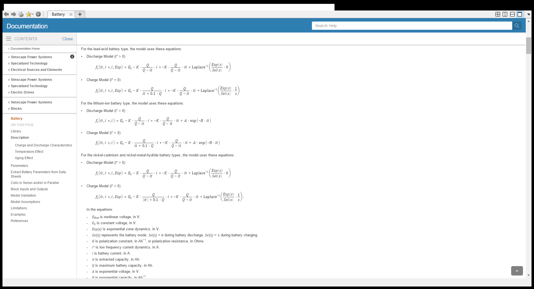

Lithium Iron Phosphate (LFP) – 12.8v 7.5AH 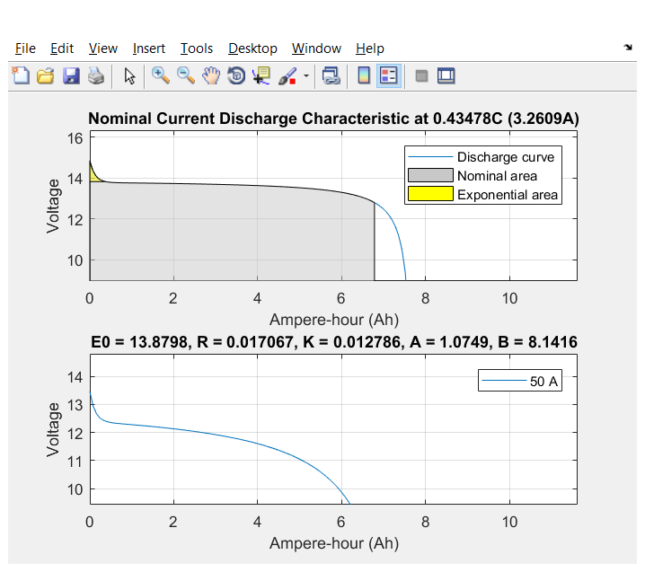

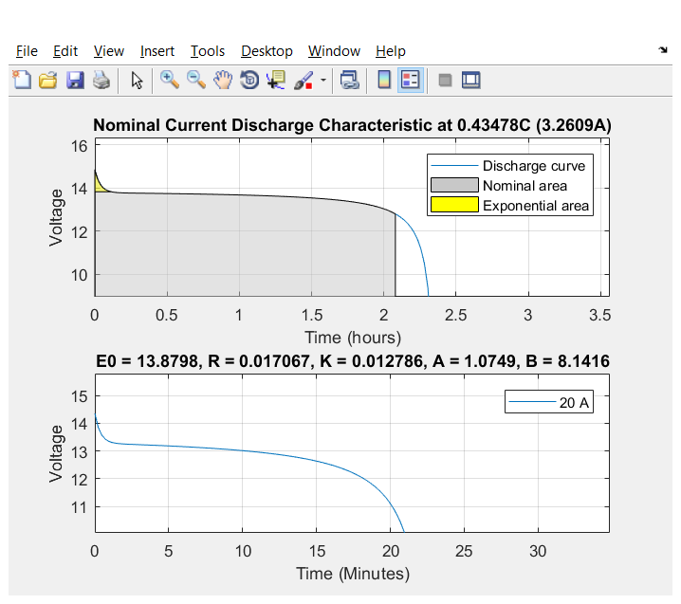

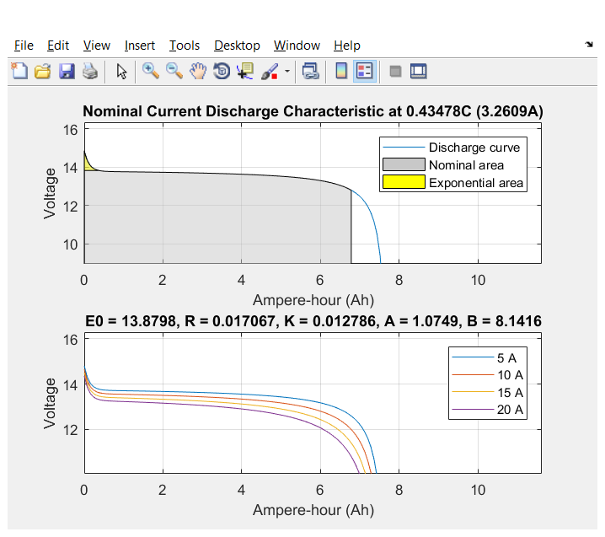

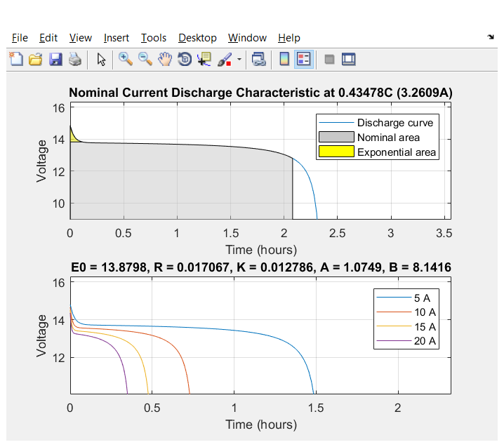

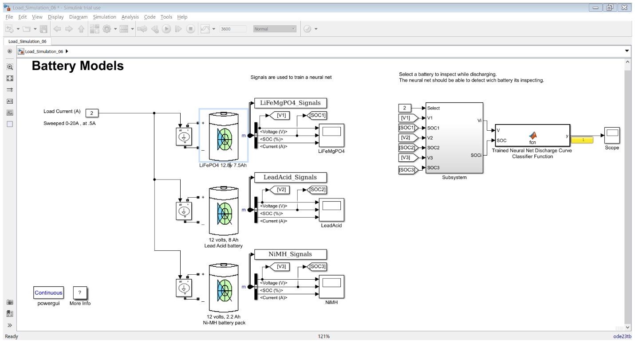

Neural Network training

RBF ?

Patternnet 2/3

Change the dataset to derivative ?

What is the neural net performance for each current?