A Game Theoretic Approach for Hybrid Configurations of Distributed Energy Resources and EV Charging Systems

Hector K. Lopez

To be completed later.

To be completed later.

# Introduction

To be completed later.

# Background Information

## Preliminary

Game theory is a mathematical tool and conceptual framework, according to . It is useful when studying complex, self-interested interactions among rational players. A simpler explanation, Game theory is the science of decision making. Game theory originated in the early 1940s. Economists like John Von Nuemann and Oskar Morgeston pioneered many of the original concepts; *Theory of Games and Economic Behavior*. Cournot, Bertrand and Von Stackelberg added perspectives around different types of games . It was in the 1950’s that John Nash published several ground-breaking works around special type of game involving compettition. John Nash introduced concepts like the Nash equilibrium and Nash bargaining, they where applied to competitive games and cooperative games. The latest developments came from John Maynard Smith (along with Ernst Mayr and G. Williams) “for developing the concept of evolutionary biology," . The adoption of Game theory grew because it was easy to form problems into the basic elements needed. Many optimization problems involve agents in some way, the decisions are oftengeneralized into mathematical constraints when applying traditional optimization techniques. The complexity of these optimization problems can be reduced when modeling the agents as rational agents with decisions to make instead of elaborate mathematical solution spaces with questionable edge cases to consider.

Game theory assumes that a rational agent, also known as a *player*, has its own cost function. The rational agent will try to optimize its own cost function, also known as *utility*,when presented with a set of options. Games in general are defined in as any situation involving more than one individual. Either individual can take more than one action. The individuals take actions influenced by the actions of others. Finally, the actions taken maximize the individuals utility, also known as a *pay-off*. Game theory defines a series of actions as a *strategy*. The strategy available to an agent/player is like a constraint. Depending on how the game is modeled the strategy available to a player may be different to each player. An illustration of what strategies look like is given by , as a game of chess played through another person; a proxy player. If the proxy player takes one move in any direction the opponent will respond in many different ways. As the actual player one must prepare a response for each of the opponents possible actions. The proxy player would need a set of actions to each possible response of the opponent. The set of actions that the proxy player would take is the strategy one has provied for the proxy player .

### Basic Elements in a Game

When modeling a market the players can be considered *firms*. The firms would consider the market demand and try to minimize payments or maximize incomes. These types of games are usually modeled with more than one firm. Lets consider a game where there are *n*-players .The elements of the game can be expressed as:

$$G=[N;S_{1},S_{2},...,S_{n};u_{1},u_{2},...,u_{n}]$$

(1)

Where the game is *G*, and *N* represents a set of players/firms in the *n*-player game. The *S* series represents the strategies of each *n*-player. Finally the *u* represents the payment for each *n*-player.

1. **Players/Firms**: The participants in the game who can decide their own strategies. An important assumption is that the players are rational, which means that they don’t leave things to chance and don’t take advantage of others’ mistakes. If the agent has perfect rationality and all relevant information. The agent can model the game as an optimization problem. Unfortunately according to people do not always choose the most rational choice in real life.
2. **Pay-offs**: After each player in the game chooses a strategy from their own strategies set, a relevant result (a group of data) is provided to show each player’s gain or loss. A good payoff is the fundamental goal of a player, and is the main basis of a player’s judgment and behavior. Pay-offs are also known as the players preferences described as ’utility’ and must be understood clearly for the model to be effective. The payoffs are very subjective. If there is a ranking to the payoff it is called *ordinal* , if it is just a subjective quantity value then it is a *cardinal* payoff.
3. **Strategy**: A set of available actions that can be taken by a player. In a *finite game* the number of actions the player can pic comes from a finite set. This is similar to a chess board or a tic-tac-toe game, so it is also known as a *matrix game*. Alternatively an *infinite game* set of actions means that the actions available to the player or on a *continuous-kernel* with respect to the action variables of all players. In either type of action set the strategy would be the available actions as a space of actions available to the player.

### Pay-Off Matrix

The normal-form representation for the standard game model is the pay-off matrix as described by . Each individual cell of the matrix typically contains comma seperated values. The first value corresponds to row and the second value corresponds to the column. Each row is an individual action one of the players can take. The second player’s actions are represented with each column. Since the matrix looks at the intersection of decisions between actions of each player the values represent each players pay-off for the actions corresponding with the row and column. In 2.1 the rows and columns are labled with actions $A$ and $B$ for Player 1 and Player 2. The assumption is that the players have the same actions available in the game, this may not always be the case. Another asumption is the pay-off for each player. In this example when both players choose $A$ or when both players choose $B$ they each have a pay-off of $0$. By analyzing this simple pay-off matrix it is plain to see that when the players implement opposing actions they both are awarded with $1$. This game may represent the interaction of two agents walking into each other. The actions can represent a simplified move to the left or right. The pay-offs would make sense in this example since the agents objective function would be to choose the actions that would allow them to avoid collision and continue on thier way.

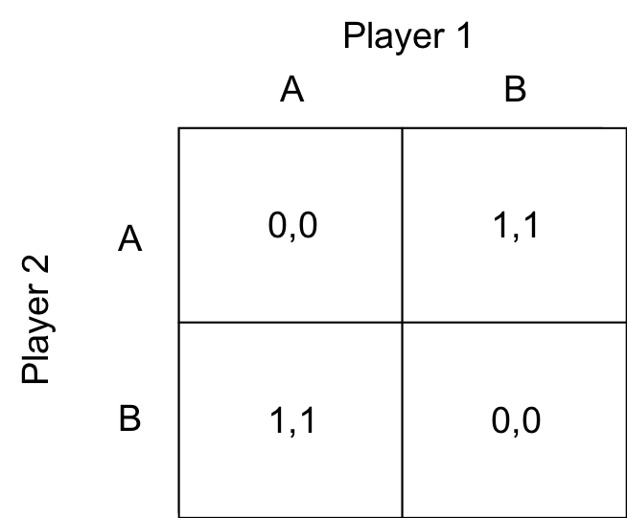

Example of a collision pay-off matrix for 2 players.

Let’s continue with another example to illustrate the pay-off matrix and demonstrate another non-cooperative game. A problem to consider is an automotive intersection with a stop light. Both drivers can be considered as players in this game and the decisions they can take , stop or go, can be expressed in with the pay-off matrix. The rewards for the game can be arbitrarily estimated given the desire of either players.

If both players decide to *go* at the same time then they will end up in a collision. This does not benefit either player so we place the reward for each accordingly (pay-off of -5). If either of the drivers have to stop to let the other go then the player who is stopped is inconvenience (pay-off of 0), while the driver who was able to go is now on its way and happy (pay-off of 1). Finally, if both players are stopped and niether move forward they are wasting time at the intersection. It is not as bad as a collision but it still can be considered a loss (pay-off of -1).

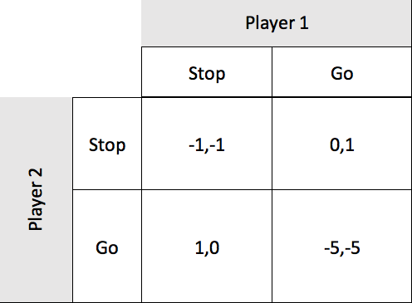

A traffic-light pay-off matrix for 2 players.

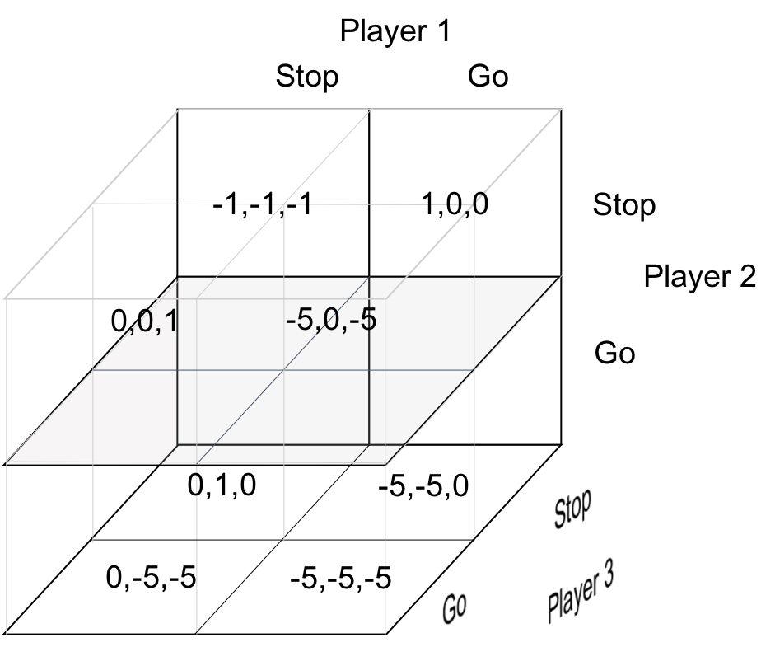

A traffic-light pay-off matrix for 3 players.

The possible decisions of the players in the game are mapped out in the game matrix. The strategy for each player can now be assesed. The goal would be to find the best strategies for player 1 and for player 2 respectively. For player 1, the strategy where he is able to go is when player 2 must stop (1,0). The best strategy for player 2 is the opposite (0,1). Since there are no better moves for each player to take these are both known as Nash Equilibriums. The equilibrium of a non-cooperative game is when either player has no other decisions available that would better thier individual positions. There can be more than one nash equilibrium in a game.

## Non-Cooperative Games

In a non-cooperative game each player has control over a set of variables and strives to optimize his individual objective function, regardless of its impact on other players. These games allow players to take necessary action to optimize without coordination or communication. Even though non-cooperative game may seem like there is no cooperation involved, the term actually refers to the lack of sharing strategic choices and communication during the game. If the players obtain an equilibrium solution, it is called the *Nash Equilibrium*, which is the most common concept of non-cooperative game. In some design problems there are closed form expressions of the Nash equilibrium. In general numerical techniques are required to find the solution. Some of the methods to find the Nash equilibrium provied by :

1. Nikaido-Isoda function :
2. Rational reaction set with DOE-RSM (Design of experiment- response servce method):
3. Monotonicity analysis:

Lets model a non-cooperative game as, $\{N;(S_{n})_{n∈N};(U_{n})_{n∈N}\}$. Then a Nash equilibrium can be thought of as a vector of actions ${\text{s}}^{*}$ such that the $U_{n}({\text{s}}^{*})≥U_{n}(s_{n},{\text{s}}_{−n}^{*}),∀n∈N$, where $s=[s_{n},{\text{s}}_{n}]$. So a Nash equilibrium can refer to the state where no player $n∈N$ can improve its utility by unilaterally altering its action $s_{n}$ from $s_{n}^{*}$ when the actions of the other participating players are fixed at ${\text{s}}_{−n}^{*}$. In a game where every action is deterministic (*pure strategy*) there may not be a Nash equilibrium solution available. Also there may be more than one Nash equilibrium in non-cooperative games. It is especially difficult to find the Nash equilibrium when there are more than two players. After obtaining it the best Nash equilibrium needs to be chosento optimize effecency if there are more than one. It is also important to note that a Nash equilibrium would always be present in a game where there is actions are probabilistic. (*mixed strategy*).

Modeling the non-competitive game to represent the problem yeilds different models. There are different types of models that can be created when dealing with non-cooperative games. By adjusting the elements of the game such as ’order’ , allowing one player to go before the others, the model of the game results in a different way to solve for the best response and resulting equilibrium states.

1. Ordinary Non-Cooperative game: Analyze the problem and abstract the players, strategies and the pay-offs for the model. The properties of the model should result in equilibrium solutions that could solve the problem.
2. Generalized Nash equilibrium game: Each player’s decision affects not only other players’ payoffs, but also their feasible strategies set.
3. Cournot game: Derived from prisoner’s dilemma model. Models the pay off capable in a game when both players will need to implement the strategy at the same time. Used in behavioral economics to determine pay-off of individual decisions.
4. Stackelberg game: Similar to the Cournot game, but assumes that there is a player that is a leader (goes first) and a player that goes after (follower). The model has the leader anticipate the followers response and include that in its own response. This technique helps the leader to optimize its utility in a market shared among two players.
5. Bounded rationality game: Models that attempt to remove the assumption that players are completely rational. Considering that players can take actions that do not immediately benefit them can possibly model the uncertainty of initial value assumptions of the utility modeled for each player.
6. Repeated game: A series of basic games one after the other. This type of model shows the varied results capable given the strategies implemented in each instance of a game.

## Cooperative Games

Cooperative games focuses on providing incentives to independent deision makers to act as a team to improve their position in the game. **Nash Bargaining** is the stufy of terms and conditions where players may agree to form a coalition. **Coalitional** gams deal with formation of coalitions. The coalitional game the set of players is called a coalition and they will all have the same value function. Coalitional games can be classified into :

1. Canonical coalitional game : Study the properties and stability of the coalition, the gains and the distribution of the gains in a fair manner. A solution is when all players do not have an incentive to regect the revenue allocation of the coalition.
2. Coalition formation game : The game incorporates a cost of cooperation that considers the gains to the members but also the cost of forming the coalition in the first place. Changes in number of players or variation of network topology can change the outcome of coalitional structures.
3. Coalitional graph game : The commnincation structures between players have an impact on the utility and other characteristics of the game. The main objectives is to create low-complexity distributed algorithms for players who wish to build a network graph and study properties such as stability and effeciency of the network.

## Stackelberg Oligopoly

A Stackelberg Game is a type of noncooperative game that deals with a multi-level decision making process of a number of independent decision makers or players(followers) in response to the decisiont taken by a leading player (the leader).

The game has the following components:

1. Followers in the game that respond to a price set by the leader
2. The strategy of each of the followers in terms of satisfying some constraint.
3. The utility function of each follower that captures the benefit of consuming the demand.
4. The utility function of the leader which captures the total profit.
5. The price per unit quantity

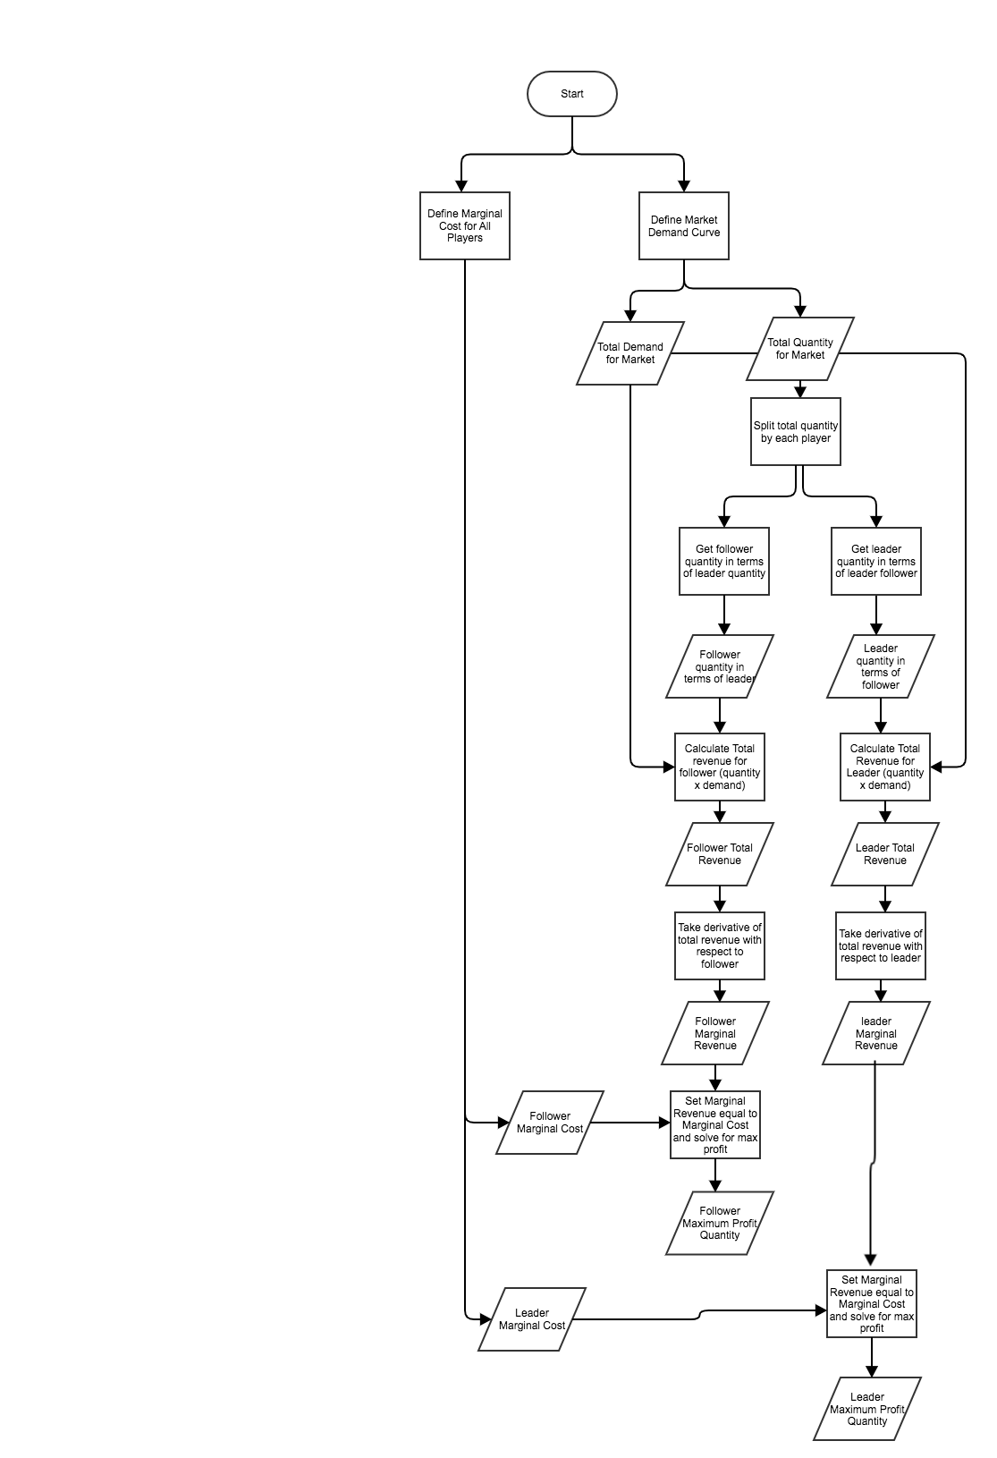

A flowchart showing how a backward induction 2-player Stackelberg Oligopoly game would play out.

The utility function of the follower represents the level of satisfaction of the follower. It is a function of the profit it recieves. The utility function is non-decreasing because each follower is interested in maximizing its profit. The marginal benefit of the follower is also considered a non-increasing function. The marginal benefit gets saturated the closer it gets to the maximum profit. The utility of a follower decreases as the price of a unit or cost of meeting a demand increases .

If the constraint is the same for all players then this gives rise to a noncooperative resource sharing game between the followers. A game like this represents a jointly convex generalized Nash equilibrium problem (GNDP) due to the same shared constraint. In game theory the coupling of the constraints has solution called the Gneralized Nash Equilibirum(GNE).

The stackleberg duoply is a non-cooperative game between two players where one is a leader and the other is a follower. They are the only two players able to supply the needs of the market by creating some quantity of goods. Each player has a utility function that will be satisfied if they can maximize the profit of supply a quantity of goods to the demand curve of the market considering the cost to provide a unit of goods. ,

Define a pricing demand as a linear function and call it a "Market Demand Curve"

$$P=a−b*Q$$

(1)

Where Q is the market quantity demanded and P is the market price in dollars The firms create the quantity.

The quantity created for the market comes from multiple firms. The firms in a Stackleberg game provide some quantity after the leader firm goes first. The leader firm assumes the moves of the other firms and tries to maximize its profit by incurring the costs to meet the demand that it deems appropriate given its own costs. The demand is met through a total quantity that can be represented by the combination of all of the players quantity.

$$Q=q_{1}+q_{2}+...q_{N}$$

(2)

The cost to meet a single unit of demand per unit qunatity created. This is a pre-defined metric or can be a dynamic value. Knowing the marginal costs is critical to determining the other players moves. The Leader needs to know what it would cost other players to take action.

Begin backward induction to determine what the reaction would be of the other firms. Lets assume two firms A, and B. The procedure to determine the Leaders (firm A) move would be as follows:

1. Calculate Firm B’s reaction 2. Calculate Firm A’s response to B’s reaction 3. Implement Firm A’s response 4. Calculate Firm B’s response given A’s response 5. End Game

### 2-Player Stackelberg Oligopoly Example

$$N_{firms}=2$$

(3)

$$MC_{a}=10$$

(4)

$$MC_{b}=12$$

(5)

$$P_{T}=−Q_{d}m+b$$

(6)

$$P_{T}=−Q_{d}*0.5+120$$

(7)

To avoid having to supply diminishing returns the leader can take into account the maximizing move for the second player and then include that in determining its stake in the market based on its own costs and break even point.

Total Market Quantity :

$$Q_{d}=q_{a}+q_{b}$$

(8)

Begin by substituting (6) for $Q_{d}$ into the two quantity terms for player $a$ and player $b$ as shown in (8).

$$P_{T}=−0.5*q_{a}+−0.5*q_{b}+120$$

(9)

Then replace $P_{T}$ in (8) with its definition in (7) to get the market demand in terms of total quantity and player quantity.

Total Market Quantity Demand :

$$−0.5*Q_{d}+120=−0.5*q_{a}+−0.5*q_{b}+120$$

(10)

The total revenue will be taken in terms of the player $b$ by just multiplying the market demand $P_{T}$ with just the quantity that will be made by $b$.

Total Revenue :

$$TR_{b}=−0.5*q_{a}*q_{b}−0.5*q_{b}^{2}+120*q_{b}$$

(11)

Marginal revenue can be derived from the derivative of the total revenue equation (10), with respect to the firm.

$$MR_{b}=\frac{∂d}{∂q_{b}}(−0.5*q_{a}*q_{b}−0.5*q_{b}^{2}+120*q_{b})$$

(12)

$$MR_{b}=−0.5*q_{a}−q_{b}+120$$

(13)

The reaction of the follower can be estimated by the leader by solving when the marginal cost of the follower will equal the marginal revenue of the follower. Setting them equal and solving for the quantity in terms of the quantity provided by the leader firm A we get the following reactionary quantity for firm B.

$$q_{b}^{*}=−0.5*q_{a}+108$$

(14)

The leader takes into account all the reactions and creates a leader response to the reactions. The approach is to use back induction to take the forecasted reaction of the follower when the marginal cost is equal to the marginal revenue (profit maximizing). That means that the follower will stop at some break even point that maximizes its profits. Given that information the leader can take that reaction and assume it is what the follower will do. The assumption is used in the price demand formula. By substituting equation (13) into equation (9) the demand for the leader is now shown below in (14). Knowing the demand the total revenue and marginal revenue can also be inferred.

$$P_{leader}=−0.25*q_{a}+66$$

(15)

$$TR_{a}=−0.25*q_{a}^{2}+66*q_{a}$$

(16)

$$MR_{a}=\frac{∂d}{∂q_{a}}(−0.25*q_{a}^{2}+66*q_{a})$$

(17)

$$MR_{a}=−0.5*q_{a}+66$$

(18)

The last step in the backwards induction for the leader is to try to maximize his profit by only providing a quantity where the followers quantity has been considered in the game. The final quantity to be implemented by the leader is done just as before by setting marginal revenue equal to marginal cost and finding quantity.

$$q_{a}^{F}inal=112$$

(19)

If we implement the leaders quantity output and then recalculate the resulting quantity for the follower, the follower will have a different output than what was orginally measured by the leader since the leader has now taken its maximum demand.

$$q_{b}^{F}inal=52$$

(20)

### 3-Player Stackelberg Oligopoly Example

$$N_{firms}=3$$

(21)

$$MC_{a}=10$$

(22)

$$MC_{b}=12$$

(23)

$$P_{T}=−Q_{d}m+b$$

(24)

$$P_{T}=−Q_{d}*0.5+120$$

(25)

Similar to a 2-play Oligopoly we can write the equation for the total market quantity with the additional player taking a share of the market.

$$Q_{d}=q_{a}+q_{b}+q_{c}$$

(26)

By using the definition for market demand $P_{T}$ and the expanded form of the toal quantity $Q_{d}$ re-write (25) in terms of total quantity and quantities for each player.

$$−0.5*Q_{d}+120=−0.5*q_{a}−0.5*q_{b}−0.5*q_{c}+120$$

(27)

Since backward induction forces us to begin with the last player in order to solve this sequential game we will start by dermining the total revenue of the last player $c$ by multiplying the market demand by $q_{c}$.

Total Revenue of C:

$$TR_{c}=−0.5*q_{a}*q_{c}−0.5*q_{b}*q_{c}−0.5*q_{c}^{2}+120*q_{c}$$

(28) Marginal Revenue of C:

$$MR_{c}=−0.5*q_{a}−0.5*q_{b}−q_{c}+120$$

(29)

Setting the marginal revenue equal to the marginal cost should provide the maximum quantity required to break even for player $c$. Therefore the best response for the last player will be in terms of what the first and second player is a able to provide in quantity.

Best Response for C:

$$q_{c}^{*}=−0.5*q_{a}−0.5*q_{b}+96$$

(30)

The best response for the last player is now used to calculate the best response for the second player. Remember that this is backwards induction and will be used to make a decision by the leader (first player) as how to how much it should generate in quantity.

The same tactic as was used before to determine the Total revenue and marginal revenue is used. Then the marginal revenue is set to the marginal cost (a constant in this case). The resulting maximizing value for the second player is in terms of the first and last. Since the last players best response has already been determined we use it in the best response equation for the second player.

Best Response for B:

$$q_{b}^{*}=−0.5*q_{a}−0.5*q_{c}+98$$

(31)

Substitute ’Best Response for C’ :

$$q_{b}^{*}=−0.5*q_{a}−0.5*(−0.5*q_{a}−0.5*q_{b}+96)+98$$

(32)

Simplify Response for B:

$$q_{b}^{*}=−0.375*q_{a}+0.125*q_{b}+50$$

(33)

Now this is the last step to determine the best response for the leader. The leader determines the total revenue amount by multiplying the market demand by $q_{a}$ just as it was done twice before. Then the total revenue is used to get the marginal revenue by looking at the total revenue’s derivative. The final step is to set it to marginal cost and determine the maximum quantity just as it was done twice before. The resulting equation will be in terms of the second player and the third player. so we substitute both players responses.

Best Response for A:

$$q_{a}^{*}=−0.5*q_{b}−0.5*q_{c}+100$$

(34)

Substitute ’Best Response for C’:

$$q_{a}^{*}=−0.375*q_{b}+0.125*q_{a}+52$$

(35)

Substitute ’Best Response for B’:

$$q_{a}^{*}=0.875*q_{a}+0.046*q_{b}+33.25$$

(36)

Simplify the Best Response for A:

$$q_{a}^{*}=(0.75*q_{a}+0.046*q_{b}+−18.75)+0.125*q_{a}+52$$

(37)

## Game Theory Application in Energy Management

TBD

# Appendix

## Stackelberg Example with Python

from sympy import *   
 init_printing(use_latex='mathjax')  
 from IPython.display import display  
 import string  
 alpha = list(map(chr, range(97, 123)))  
   
 firms = 2  
   
 N = symbols('N_{Firms}')  
 display(Eq(N,firms))  
   
 # Marginal Cost  
 MC = [symbols('MC_%s'% i) for i in alpha]  
 for i in range(firms):  
 cost = 10 + i*2  
 display(Eq(MC[i],cost))  
 MC[i]=cost  
   
 # General Market Demand Curve  
 b,m = symbols('b,m')  
 P_d = symbols('P_{T}')  
 Q_d = symbols('Q_{D}')  
 display(Eq(P_d,b-m*Q_d))  
 b = 120  
 m = 0.5  
 display(Eq(P_d,b-m*Q_d))  
 P_d=b-m*Q_d  
   
 # Total Market Quantity Demand  
 q = [symbols('q_%s'% i) for i in alpha]  
 Q = sum(q[i] for i in range(firms))  
 display(Eq(Q_d,Q))  
   
 # Market Demand Curve  
 P = b - m * Q  
 display(Eq(P_d,P))  
   
 # Total Revenue  
 TR = [symbols('TR_%s'% i) for i in alpha]  
 for i in range(firms-1):  
 display(Eq(TR[i+1],expand(P * q[i+1])))  
 TR[i+1]= expand(P * q[i+1])  
   
 # Marginal Revenue  
 MR = [symbols('MR_%s'% i) for i in alpha]  
 for i in range(firms-1):  
 display(Eq(MR[i+1],Derivative(TR[i+1],q[i+1])))  
 display(Eq(MR[i+1],Derivative(TR[i+1],q[i+1]).doit()))  
 MR[i+1]= Derivative(TR[i+1],q[i+1]).doit()  
   
 # Reaction Functions :  
 qq = [symbols('q^{*}_%s'% i) for i in alpha]  
 for i in range(firms-1):  
 display(Eq(qq[i+1],solve(MR[i+1] - MC[i+1],q[i+1])[0]))  
 qq[i+1]=solve(MR[i+1] - MC[i+1],q[i+1])[0]  
   
 # Leaders market demand in terms of leader quantity  
 P_0 = P   
 P_a = symbols('P_Leader')  
 for i in range(firms - 1) :  
 P_0 = P_0.subs(q[i+1],qq[i+1])  
   
 display(Eq(P_d,P))  
   
 display(Eq(P_a,P_0))  
   
 TR_0 = expand(P_0 * q[0])  
 TR_a = symbols('TR_a')  
 display(Eq(TR_a,TR_0))  
   
 MR_0 = Derivative(TR_0,q[0]).doit()  
 MR_a = symbols('MR_a')  
 display(Eq(MR_a,Derivative(TR_0,q[0])))  
 display(Eq(MR_a,MR_0))  
   
 # Most profit maximizing quantity for leader is q_0  
 q_0 = solve(MR_0-MC[0],q[0])[0]  
 q_a = symbols('q^Final_a')  
 display(Eq(q_a,q_0))  
   
 # Reactions Taken :  
 qqq = [symbols('q_%s__Final'% i) for i in alpha]  
 for i in range(firms-1):  
 display(Eq(qqq[i+1],qq[i+1].subs(q[0],q_0)))  
 qqq[i]=qq[i+1].subs(q[0],q_0)  
 P_d=b-m*Q_d  
 display(Eq(Q_d,Q))  
 q[0] = q_0  
 for i in range(firms-1):  
 q[i+1] = qqq[i]