Peer-to-Peer Energy Trading

Hector K. Lopez  
Florida Atlantic Univeristy

***Abstract—In this paper, the problem of … is studied using a …. In this game, on the one hand, the smart grid, which acts as a leader, needs to decide on its price so as to optimize its revenue while en- suring the …. On the other hand,…. Case Studies are proposed…***

# Introduction

State of the Art & Organization of the Paper; don’t put all the info in the intro, keep it in the background. Add an abstract that crystalizes what the paper is about (5-7 lines).

# Background

## P2P Energy Trading

### Overview

Renewable energy sources are usually intermittent and difficult to predict. When prosumers have surplus electricity, they can curtail it, store it with energy storage devices, export it back to the power grid, or sell it to other energy consumers. The direct energy trading among consumers and prosumers is called peer-to-peer energy trading, which was developed based on the “P2P economy” concept (also known as sharing economy) (Juho,2018) and is usually implemented within a local electricity distribution system.

With the prosumers in control of setting the terms of transactions and the delivering of goods and services (Morstyn,2018), prosumers can gain more through trading with each other and the grid. (Tushar, 2019) The challenge is that in a P2P network there isn’t a central authority that dictates the terms and settlement of transactions. A trustless system must be created that can simulate the needs and coordinate between competing agendas to reach a consensus for each participant while staying within the constraints of the physical systems.

### Elements of P2P

The P2P energy trading markets have a virtual, and physical layer. The virtual layer essentially provides a secured connection for participants to decide on their energy trading parameters. It ensures that all participants have equal access to a virtual platform. The virtual platform facilitates the transfer of buy and sell orders, and financial transactions. The physical layer is a physical network that facilitates the transfer of electricity from sellers to buyers once the financial settlements between both parties are completed over the virtual layer platform. It can be a traditional distributed-grid network maintained by the independent system operator or an additional separate physical microgrid distribution grid, in conjunction with the traditional grid. (Juho,2018)

#### Virtual Layer

### The virtual layer is a secure connection between the participants. It ensures that all participants have equal access to a virtual platform. The virtual platform facilitates the transfer of buy and sell orders, and financial transactions.

#### Physical Layer

The physical layer is a physical network that facilitates the transfer of electricity from sellers to buyers once the financial settlements between both parties are completed over the virtual layer platform. It can be a traditional distributed-grid network maintained by the independent system operator or an additional separate physical microgrid distribution grid, in conjunction with the traditional grid.

### Components

#### Prosumers: The end-user who acts as a buyer or a seller in P2P energy trading. Each prosumer chooses a role according to their current energy consumption and generation. The prosumer can be a consumer or a producer.

#### System Operator: The system operator is the central authority of the P2P energy trading system. The system operator is responsible for the entire energy trading service. The operator can log in via the web portal and manage the overall system.

#### Smart Controller: The component that allows for exchange of information in the market. Each prosumer has its own smart controller, so that it can exchange information with others in the P2P energy trading market.

### Type of Networks

Market operations of a P2P network consists of payment rules, and a clearly defined bidding format. The main objective is to enable an efficient energy trading process by matching the sell and buy orders in near real-time granularity. In market operations the generation of each producer influences the thresholds of maximum and minimum energy allocation. Different market-time horizons may exist in the market operation that should be able to produce enough allocation at every stage of operation. (Tushar, 2020)

#### Full P2P

Fully decentralized markets allow for prosumers to independently and directly negotiate with each other to decide on energy trading parameters without any centralized supervision by leveraging bilateral contracts between prosumers. In a fully decentralized market, the bilateral contracts capture both the upstream-downstream energy balance as well as forward market uncertainty. (Morstyn,2019)

#### Community-based

Community-based market can be applied to community microgrids and group of neighboring prosumers. The members of the community share common interests and goals even though they are not at the same location. (J. Ni ,2016) may work either in a collaborative or competitive manner. (Tushar, 2016) Participants generally trade energy through a community manager. The community manager manages exchanges outside of the community. Privacy is preserved by the community manager. (J. Ni ,2016)

#### Hybrid P2P

Composite market combines the fully decentralized and community-based market designs. An individual prosumer can engage in P2P trading between each other, while also interacting with existing markets like fully distributed markets. (N. Liu,2018) Community manager can also oversee trading inside the community. (Park, 2018)

| Market Structure | Advantages | Challenges |
| --- | --- | --- |
| *Full P2P* | 1) Freedom of choice and autonomy, 2) Energy use aligns with preferences, 3) Complete "democratization" | 1) Investment and maintenance with ICT infrastructure, 2) Potentially slow convergence, 3) Predicting system behavior, 4) Guarantee of safety |
| *Community-based* | 1) Enhancing community relationship, 2) Mobilizing social cooperation, 3) New services for grid operates | 1) Reaching the preferences for all member all the time, 2) Aggregating all members data 3) Unbiased sharing |
| *Hybrid P2P* | 1) ICT infrastructure and computation effort are scalable to all system, 2) Co-existent design, 3) More predictable to grid operators | 1) Coordinating internal trades in the communities with trades between high level agents. |

## Grid Operations

### Prosumers

With the increasing connection of renewable energy sources, traditional energy consumers are becoming *prosumers*, who can both consume and generate energy (Luo Y,2014). The trends consist of extensive growth in small-scale distributed energy resources, which encompass behind-the-meter generation, energy storage, inverters, electric vehicles, and control loads (Tushar,2020). The smart grid must grow to incorporate the bi-directional flow of electricity between supply and demand sources as penetration of Plug-in Electric Vehicles (PEVs) and distributed energy resources (DERs) like Photo-voltaic Solar Panels, (PV) increases in residential sectors. Peer-to-Peer (P2P) energy trading has emerged as a next-generation energy management mechanism for the smart grid that enables each prosumer of the network to participate in energy trading with other prosumers and the grid (Tushar,2018).

1. A prosumer is capable of producing energy, *P1* , by conditioning it and sending it to the grid , *M1* and consuming *C1* energy from the grid when production doesn’t fully cover the load of the home.

### Net-Metering

A prosumers solar energy system is typically comprised of photo-voltaic (PV) solar panels installed on the roof of a home. The excess flow of electricity from the PV solar panels into the Grid is seen as “Net Energy”. Florida Power and Light (FPL) is a utility in Florida, U.S. that provides users in its service territory with a net metering program that allows homeowners to install and connect solar energy systems to the grid. Homeowners receive credit for the energy produced by their systems. FPL allows customers to install systems meeting up to a certain amount. The systems cannot be sized to produce energy exceeding 115% of the annual consumption, as of December 2020 [1]. Customers’ credits will be applied to their energy bill. FPL would then provide monetary compensation for any extra credits not used over the course of the year in January of each year [2].

In 2018, a survey done by the U.S. Energy Information Administration showed that the average home in the United States used 10,972 kWh for the entire year, which is 914 kWh each month. In Florida, the survey showed that the average home used 1,110 kWh [2]. According to the U.S. Energy Information Administration the average price for FPL retail energy has been 12 cents/kWh for the last ten years.

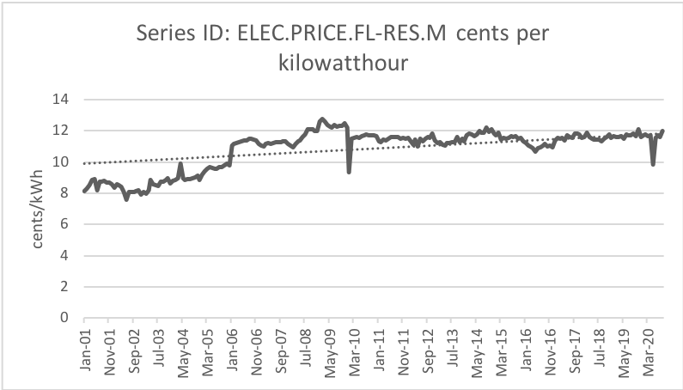

1. Retial pricing for Florida Power & Light utility collected by the United States Energy Information Administration.

The 1968 PURPA act was enacted after the energy crisis during the 1970s. The Act would ensure that net energy up to 2MW back to the grid would be compensated at retail prices. This provides a market for prosumers to offer energy and receive payments that do not include the cost of transmission. The deferred cost of transmission means that the prosumers can get paid for electricity at a premium compared to the pricing offered to power plants and co-generation facilities. [3].

Florida law requires net metering customers are compensated at the retail rate, so FPL customers are credited for the energy produced by their solar systems at their electricity rate. As of June 2017, this was 10.8 cents/kWh for residential customers using less than 1,000 kWh each month. FPL’s net metering program differs based on the size of the solar system installed. Home solar energy systems are required to fall in one of the three tiers. Each tier requires installation guidelines set by the utility. Most prosumer homes will fall within Tier 1 due to its low cost of installation and limited liability. The gross power rating or the alternating current (AC) rating for the system is the array direct current (DC) rating multiplied by 0.85. The AC rating determines the tier that the system falls under for agreement purposes. There are three tiers by system size; tier 1 is 10 kW and below, tier 2 is above 10 kW up to 100 kW, and tier 3 is above 100 kW up to 2,000 kW.

| Tiers | Florida Power and Light Utility Net-Metering Tiers | | |
| --- | --- | --- | --- |
| System Size | Application Fee | Insurance |
| 1 | <10kW AC | $0 | None |
| 2 | 10-100kW AC | $400 | $1M |
| 3 | 100-2,000 kW AC | $1000 | $2M |

### State of the Art

The advent of microgrid technology and the economic bilateral contracts has enabled the emergence of P2P markets in the energy sector. Bilateral contracts aim to increase competition in electricity markets. (Bower, 2000) It is an agreement between two parties to exchange electric energy. It is a credible alternative to the pool structure used in the wholesale electricity market. Microgrids are known as low voltage grids, which are used to supply electricity to communities that can be operated in an islanding and grid connected mode. Microgrids can have DERs and gain an advantage to continuing to operate in the islanding and grid connected mode. (Tushar, 2019). The DERs are managed by Prosumers in a microgrid and can sell energy back to the grid with a benefit from the Grid.

| P2P trading Platform | Country | Details |
| --- | --- | --- |
| Brooklyn Microgrid | United States | Brooklyn Microgrid is a community energy market on a microgrid. Members can buy and sell energy from each other with smart contracts based on blockchain. (Mengelkamp et al., 2018) An 'Exergy token' called 'XRG' has been developed as an additional project by LO3 to promote commercial investments in the community energy market. (Sakineh, 2020) |
| Centrica plc | United Kingdom | Centrica is a pilot project to develop a local energy market in Cornwall, UK by testing the use of flexible demand, generation, and storage, and rewarding consumers for being more flexible with their energy. Centrica is trialing the use of blockchain for this platform, using LO3's blockchain-powered energy trading platform (Centrica, 2018) |
| Lumenaza | Germany | Lumenaza's "utility-in-a-box" energy platform enables P2P energy sharing and communities on a local, regional, and national level. The software connects producers of electricity with consumers, controls demand and supply, and includes balance group management, aggregation, billing, and visualization of energy flows. It allows energy communities to participate in electricity market design (Lumenaza, 2020). |
| Piclo | United Kingdom | Piclo by open utility (a platform) and Good Energy ( a renewable energy power company) matches consumers and prosumers based on their preferences and locality every 30 minutes. Consumers are provided with consumption data visualizations, and generators are provided with control and visibility over who buys power from them. Good Energy balances the peaks and valleys in generation, provides contracts and meter data and does the billing (Piclo, 2019). |
| SOLshare | Bangladesh | SOLshare installs small-scale mini grids that connect local consumers and allow them to share electricity within the locality. Consumers who have solar panels installed on their homes can supply surplus power to others who do not have access to electricity. (UNFCC,2020) |
| sonnenCommunity | Germany | sonnenCommunity allows sharing of self-produced renewable power by individual consumers who are using sonnens batteries. This surplus energy is not fed into the grid, but into a virtual energy pool that supplies energy to other community members during times when they cannot produce. The price is fixed at USD 25 cents/kwh. The monthly usage fee for the platform is EUR 20 (sonnen, 2019). |
| Transactive Energy Initiative | Colombia | The pilot project activities include the development of a P2P trading app, the elaboration of policy recommendations for Colombian policymakers, and a roadmap for commercial scale-up (UCL, 2019). |
| Vendebron | Netherlands | Allows consumers to buy power directly from prosumers, at the price set by the prosumers. It behaves as an energy supplier that connects consumers. Provides suppliers with generation forecasting information for their assets. The monthly usage fee of the platform is USD 12 (Vanderbron, 2020) |
| P2P-SmartTest | Europe (Finland, United Kingdom, Spain, Belgium) | Advanced control and ICT for P2P energy market, local control and ICT market design |
| EMPOWER | United States | Architecture and ICT solutions for provider in local market, Local control and ICT. (EMPOWER, 2015) |
| Enerchain | Europe | P2P wholesale trading platform. (Enerchain, 2017) |
| Community First! Village | Unite States | Build Self-sustained community for homeless, local control and ICT. |
| PeerEnergy Cloud | Germany | Cloud-based energy trading for excessive production |
| Smart Watts | Germany | ICT to control consumption in a secure manner |
| NOBEL | Europe | ICT for energy brokerage system with consumers, local control and ICT. |
| Energy Collective | Denmark | Deployment of local P2P markets in Denmark |
| P2P3M | Europe (United Kingdom), Asia (South Korea) | Prototype P2P energy trading/sharing platform, market design |

* PV, ES
* EV
  + EVrequire bidirectional charging
  + Degradation of EV as ES
* Unit Commitment
* Economic Dispatch
* Scheduling of Ders
* Maintaining grids frequency
* Physics aware pricing mechanisms

### Blockchain on Energy Trading Systems

Blockchain originated from bitcoin, a virtual currency created in 2008, and is a new application mode of computer technologies (Crosby, M,2016). Much research has been conducted on power market transactions adopting blockchain technology. The main research areas are as follows:

#### Supervision of Power Institutions

Any node in a public blockchain can enter and leave at any time without any permission, this hinders supervision of power institutions.

#### Exposure of Private Data

A distributed data structure exposes the privacy of users and creates a risk of data leakage. This could hinder the adoption of the platform.

#### Anonymous Accounts

Even if blockchain implementations are private anonymous accounts can be created that re-join multiple times in a malicious manner to damage the network.

| Comparison of three types of blockchain | | |
| --- | --- | --- |
| Public Blockchain (Nakamoto, S. 2008), (Ethereum Community,2020) | Consortium Blockchain  (Armknecht,F.,2015),(Zhuo, N.,2019) | Private Blockchain (Novo, O. 2018) |
| Decentralized | Weak Centralized | Centralization |
| Need | Selective | Not |
| (1) Protect users from developers  (2) All data are exposed  (3) Low operating speed | (1) Low operating and maintenance costs  (2) Fast operating speed  (3) Flexible and expandable | (1) Fast operating speed  (2) Privacy is only visible to individual  (3) Inextensibility |
| Bitcoin, Ethereum | RIPPLE, LIP-Chain | Some central systems |

* Efficient Consensus mechanisms
  + Smart contracts
  + Permissions and Privacy

### Game Theory for Energy Management

Game theory is a mathematical and signal processing tool that analyzes (García-Triviño ,2016) A game theoretic approach strategies in competitive solutions where the outcome of a participant’s choice is based on the actions of other participants. There are two main branches: 1. non-cooperative and 2. cooperative game theory.

An energy management solution is needed that provides efficient and robust operation considering the conflicting nature of energy trading. Game theory should be a very effective tool for modeling the decision-making process of participants.

Game and auction-theoretic models have been used in P2P energy trading as an effective means of energy management approaches. The development of P2P energy trading has the potential to substantially benefit prosumers in terms of earning revenues, reducing electricity costs, and lowering their dependency on the grid. (Khalili,2017)

The application of game theory in energy trading and management is extensive. However, the discussion of its application in the field of P2P energy trading is limited, which could be because of the relatively recent emergence and exploration of P2P trading frameworks in energy domains (Juho ,2017).

These types of games allow players to take necessary action, to make optimal decisions, without any coordination or communication with each other. Noncooperative games can be further divided into 'static' or 'dynamic' games.

* ***Static game***: Players act only once, either simultaneously or at different times. An example could be two business owners deciding where to open a new store location.
* ***Dynamic game***: Players act more than once and have input regarding the choices of other players. Time can play a central role in these games. Dynamic games can be modeled as a series of static games, but time and information would need to be reflected in the utility functions. An example of a dynamic game would be Chess.

For both types of non-cooperative games, the players will make decisions based on "pure strategy" a deterministic way, or a probabilistic way "mixed strategy". (Juho, 2018)

The most popular concept in non-cooperative games is the solution concept called the Nash equilibrium. It refers to a stable state of a non-cooperative game where neither player can improve its utility by unilaterally altering its action when other players actions are fixed. An example in the game of Monopoly is when there are no more actions the player can make with the money on hand that could better the situation. A Nash equilibrium always exists in a game with mixed strategies (probabilistic decisions) but not always guaranteed in pure strategies (deterministic). Finally, the non-cooperative game may have multiple Nash equilibriums and the most desirable one should be chosen for the solution. (Xie, 2016)

Modeling the non-cooperative game to represent the problem yields different models. There are different types of models that can be created when dealing with non-cooperative games. By adjusting the elements of the game such as ’order’ , allowing one player to go before the others, the model of the game results in a different way to solve for the best response and resulting equilibrium states.

* ***Ordinary Non-Cooperative game***: Analyze the problem and abstract the players, strategies and the pay-offs for the model. The properties of the model should result in equilibrium solutions that could solve the problem.
* ***Generalized Nash equilibrium game***: Each player’s decision affects not only other players’ payoffs, but also their feasible strategies set.
* ***Cournot game***: Derived from prisoner’s dilemma model. Models the payoff capable in a game when both players will need to implement the strategy at the same time. Used in behavioral economics to determine pay-off of individual decisions.
* ***Stackelberg game***: Similar to the Cournot game, but assumes that there is a player that is a leader (goes first) and a player that goes after (follower). The model has the leader anticipate the followers response and include that in its own response. This technique helps the leader to optimize its utility in a market shared among two players.
* ***Bounded rationality game***: Models that attempt to remove the assumption that players are completely rational. Considering that players can take actions that do not immediately benefit them can possibly model the uncertainty of initial value assumptions of the utility modeled for each player.
* ***Repeated game***: A series of basic games one after the other. This type of model shows the varied results capable given the strategies implemented in each instance of a game.
* Used for market and prosumers

# Design of Peer-to-Peer Energy Markets

The traditional energy management technique is a centralized architecture where the intermediary manages all the power generators on a microgrid. The energy management is set in advance, so the flexibility and scalability of the system is poor. All the data is stored centrally so security risk of information is high. (Dimeas, A.L ,2005) A multi-agent method is applicable to microgrids but the operation costs for this method are high, and it is not suitable for underdeveloped areas (Prinsloo, G.,2017) A typical P2P energy management architecture is one where management is decentralized. Information is transmitted across the network in a democratized fashion so all nodes on the network can achieve a consensus on new information and create an autonomous management system. (Pei, W.,2010) P2P management has a plug-and-play advantage which is more suitable for renewable energy microgrids (Zhao, C.2018)

## Physical Layer

If small scale electricity suppliers and consumers are participants on the network and are connected on the physical layer through local distribution that can be islanded off, then there is potential for trading energy in an isolated fashion. The discrepancy between the wholesale price and retail price matters because the peer-to-peer trading price will be greater than the wholesale price but less than the retail price. The consumers will always want to trade with a peer because it would be cheaper than retail energy traveling over long transmission lines. The local prosumers would also benefit from the trading price being more than the wholesale price of creating the electricity and therefore gaining profit. (Lee, 2014)

### Communication

When communicating between many participants an encrypted form of communication can be used to secure transactions between the participants. They all work towards processing the message and providing a consensus on what the message between any two participants should be. This consensus across all participants is crucial for trustless systems.

The blockchain technology could realize P2P management with the assistance of asymmetric encryption, digital signature, and consensus mechanism. In P2P networks that are “Full P2P”, a blockchain messaging mechanism can be used to validate financial transactions on a distributed ledger, it can also be used to track energy usage without the fear of tampering with the metering information over the air. The attack would need to achieve 51% control of the network in order to approve the false transactions.

In an unsecure network the attack would only need to override a single node and create false readings for a meter or a financial transaction. In a federated system the operator would oversee securing the infrastructure and communications. But in an open P2P network design cryptographic methods such as blockchain provide unfederated security, privacy and protection against the network.

Secure communications when leveraging a centralized server can be achieved using certifications and current 2-factor authentication methods. Increasing the efficiency of transactions compared to the blockchain and increasing the privacy of each person while reducing the complexity of the platform. With a community-based market structure the communication technologies used can be housed in a central location and used as a service with agent connections from each of the prosumers.

### Infrastructure

A P2P network must contain prosumers to generate energy for consumers and other prosumers. The prosumers require the necessary hardware to support bi-directional energy flow from the grid and to the grid as needed. A switch to regulate the flow of energy on demand should be available with electronics to control the flow.

#### Smart Meter

A revenue grade meter can be used to measure the flow of energy from the prosumers on the network back to the grid and others. The metering can provide information for a virtual of energy exchange to keep load at a given point of interconnect with the grid to be stabilized as much as possible through the coordination of energy transactions on the market and the fulfillment of those bilateral contracts by the prosumers and consumers.

#### Prosumers using PV

The physical layer of P2P prosumers consists of distributed energy resources. A popular prosumer resource is solar power through Photo-voltaic (PV) panels that are installed on the roof of the homes. The reduction in costs for these systems has increased the adoption rate in recent years. In conjunction with PV the growth of energy storage the renewable energy generation available from the dynamic resource of the sun can be stabilized by injecting current from the previously stored energy inside a battery.

PV technology is simple in structure, stable in performance and does not produce any pollutants in the process of power generation; therefore, it is very suitable as a renewable power source in microgrids. It converts solar irradiation to electric, and the photoelectric effect electric current is:



Where *q* is the electron charge, *V* is the cell voltage, and *R_s* and *R_sh* are resistance connected in series and shunt resistance, respectively. *K, T* and *n* are Boltzmann constant, operation temperature, and ideality factor of diode, respectively. Equations (2) and (3) are light-generated electric current and saturation electric current, respectively.

2

3

Where *G,G_ref,* and *T_ref* are solar irradiation , solar irradiation at standard condition, and reference temperature, respectively. Equation (4) is the reverse saturation electric current and is expressed as:

4

Where *V_oc* and *K_i* are open circuit voltage and short circuit current coefficient, respectively. The power of the PV model is obtained by the multiplied model current and voltage, and expressed as:

5

* + Protocols / Methods
    - Blockchain vs Centralized?
    - OPC vs MQTT/IoT protocols
  + Infrastructure
    - Wireless, 5g, LTE
      * Blues.Io
    - MicroComputers
    - AMI metering
    - Inductive Meter

## Scheduling Layer

With a view toward reducing the cost of energy trading within the grid, a day-ahead optimization process regulated by an independent central unit has been proposed in (Atzeni, L, 2013). The existence of optimal strategies is proven, and, furthermore, the authors present a distributed algorithm to be run on the users’ smart meters, which provides optimal energy-production and storage strategies while preserving user privacy and minimizing required central unit communication

* Trading Strategy
  + Platform
    - Blind Auction
      * Coop. Game
    - Prosumers
      * Non-Coop. Game
  + Imbalance Management
    - What to do with excess energy

## Executive Layer

The coalition formed between prosumers is a canonical coalitional game with transferable utility, and the price for P2P energy trading is determined by an asymptomatic Shapley value (Han, 2009). The net surplus of the coalition is sold to the retail market at wholesale prices but bought at retail prices if there is a net deficiency. The coalition can then effectively ban together to optimize the return on energy generated and consumed by trading with each other before selling or purchasing from the grid.

There are only 10 states that still pay the wholesale price (avoided cost) when selling back to the grid. All other states pay retail price to sell to the grid. In these states the super additivity of the grand coalition is no longer viable and there is no reason to stay in the coalition. (Net Metering, 2021), and Local Communities An avoided cost (also known as net-metering) is the minimum amount an electric utility is required to pay an independent power producer, under the PURPA regulations of 1978, equal to the costs the utility calculates it avoids in not having to produce that power (usually substantially less than the retail price charged by the utility for power it sells to customers).

The system poses the challenge of modeling the decision-making process of each participant for the greater benefit of the entire energy network while considering human factors, e.g., rationality, motivation, and environmental friendliness. Particularly, in settings where there are many users with conflicting interests participating, it would be challenging either to integrate such conflicting interests when designing the decision-making process of each participant or, if necessary, to motivate the users to cooperate with reducing costs, maximizing revenues, and pursuing renewable energy objectives. (Farrel ,2018)

* Enrollment
  + Anonymity
  + Bad actors
  + Financial transaction using digital currency for settlements
* Settlements
* Incentives

# Design of Energy Trading Platform

In this section a design of a peer-to-peer platform for energy trading is proposed. Firs the physical requirements of the platform are defined along with the use of PV technology by the prosumers. A simulation of prosumers is generated by deriving the data from EIA.gov and synthesizing the load for the prosumers over a period of time.

## Software Design

* Software Implementation
  + Strategy of SW
  + Containers / AWS
  + How it works

Typical designs of peer to peer trading platforms focus on

decentralized communication protocols. These systems are created in fully decentralized networks. In a hybrid or community based prosumer network the requirements needed are not as exotic. The consensus to reach an equilibrium state can be performed by a central authority that is physically hosted and maintained by the community. The automated transactions can continue to be decentralized and not require constant oversight. We propose a novel approach to leveraging current IoT protocols and technologies that exist on the market. A microservice based architecture could provide resiliency and robustness to the design allowing everyone in the community to provide updates and oversights to the stability of the platform.

Software Architecture of Open-Elecbay: A proposal for an architecture that handles streaming IoT data sets from multiple clients requesting independent bids/offers on the market. The architecture utilizes MQTT and existing IOT protocol to facilitate a publish/subscribe style of communication. The transaction of the system is brokered and recorded through various microservices. The design can be scaled and distributed across agents.

1. Daily load demand of a typical consumer that draws an average of 1100kWh a month correlated to the normalized curve of overall demand between January 2020 and end of February 2020.

## Simulation

* Simulations
  + Gathering Prosumer Data for FPL
  + Community based Trading platform
    - Software design of system
      * Message bus
  + Logic to handle decentralized trading messages
    - Blind auction flowchart for prosumers
  + Prosumers modeled as Agents
    - Simulated loads
    - Non-Coop Prosumers bidding on market for optimizing “time” and “amount” and “cost” of energy
  + Simulation of “prosumers” buying and selling on a trading platform

The system to be modeled is a network of prosumers that will connect to a substation through a local distribution line. These substations usually provide power to a group of residential homes, and other commercial facilities in an area. For the purpose of this paper, the author considers a group of residential homes connected to a substation. The homes are equipped with PV solar installations of typical sizes. A meter at each home would determine the energy consumed by the prosumers home, C, and the production of the solar panels, P. The difference between the consumption of the home and the production of the PV panels installed on the home is the net energy X. The net energy is typically a positive load, indicating that the prosumer just pays a utility bill that is much less. When the net energy, X, becomes negative that means that the Grid is taking the supply from the prosumer and must be compensated for it at the utilities net-metering rate.

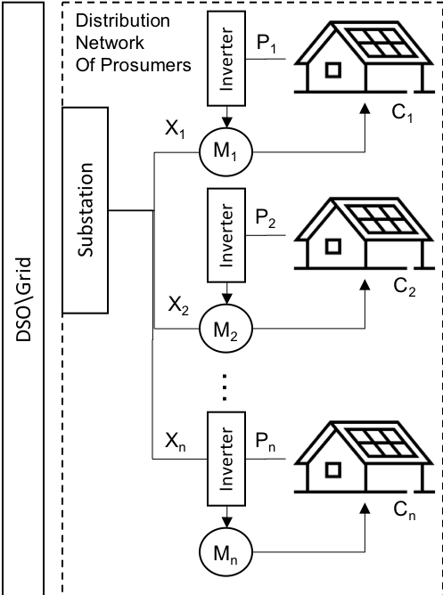

1. Network of Prosumers indicating a series of connected homes feeding directly to a substation managed by a Distribution Service Operators such as the FPL utility.

## Modeling Prosumer Data

The data used in the simulation is provided by the U.S. Energy Information Administration ([www.eia.gov](http://www.eia.gov)) [2] API (application programmable interface). The dataset is filtered for the Florida Power and Light service territory. The two datasets requested are for load demand and solar generation.

### Prosumer Load Data

The prosumers load demand must be derived statistically since an individual’s load is not made available through public datasets. The average use of a single prosumer can be inferred at a monthly time range but not on a daily or hourly time. So, we have an average monthly estimate for a prosumer in the FPL territory; 1,110 kWh/month [2]. The hourly and monthly load demand is publicly available data, but it is on an aggregate. To be able to use this data we will normalize the aggregate usage over a time window then multiply our estimated mean usage by each of the normalized samples over the time window. The result would be a load demand curve that estimates a typical prosumer load demand about the average load. The 1100kWh per month was divided by 730 hours in a month to arrive at a 1.5kW load at each hourly sample. The normalized curve was mapped against this load with 2 standard deviations as an error. Note that the figure below shows the values for 2 months, the start of January 2020 and end of February 2020.

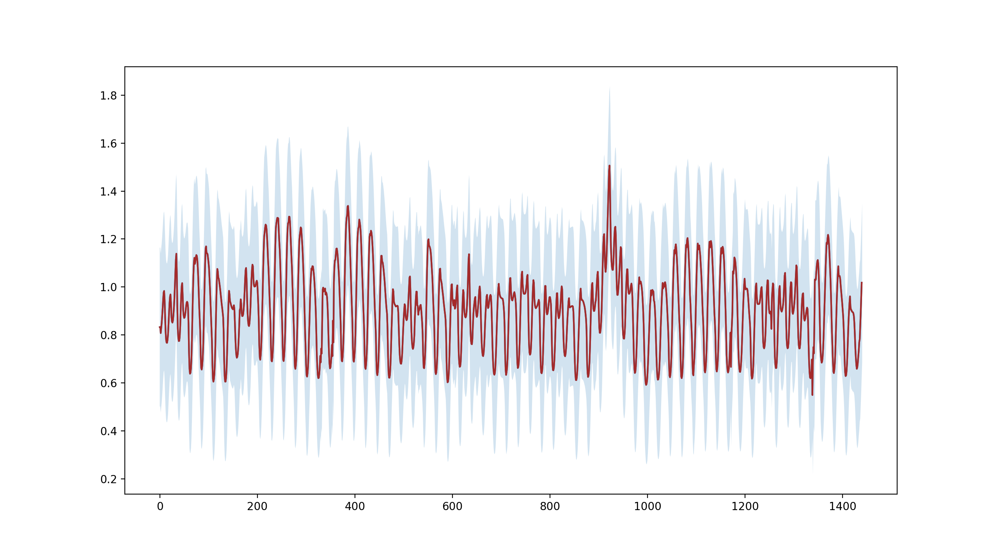

1. Hourly load demand (kWh) about an average prosumers load of (1100kWh/730h) between Jan. 2020 and Feb. 2020 with an error band of 2 standard deviations.



The time series is then segmented into periods so that they can be averaged into daily samples. The daily aggregate samples are then normalized so that it can create a curve that is used for the correlation with the typical load.





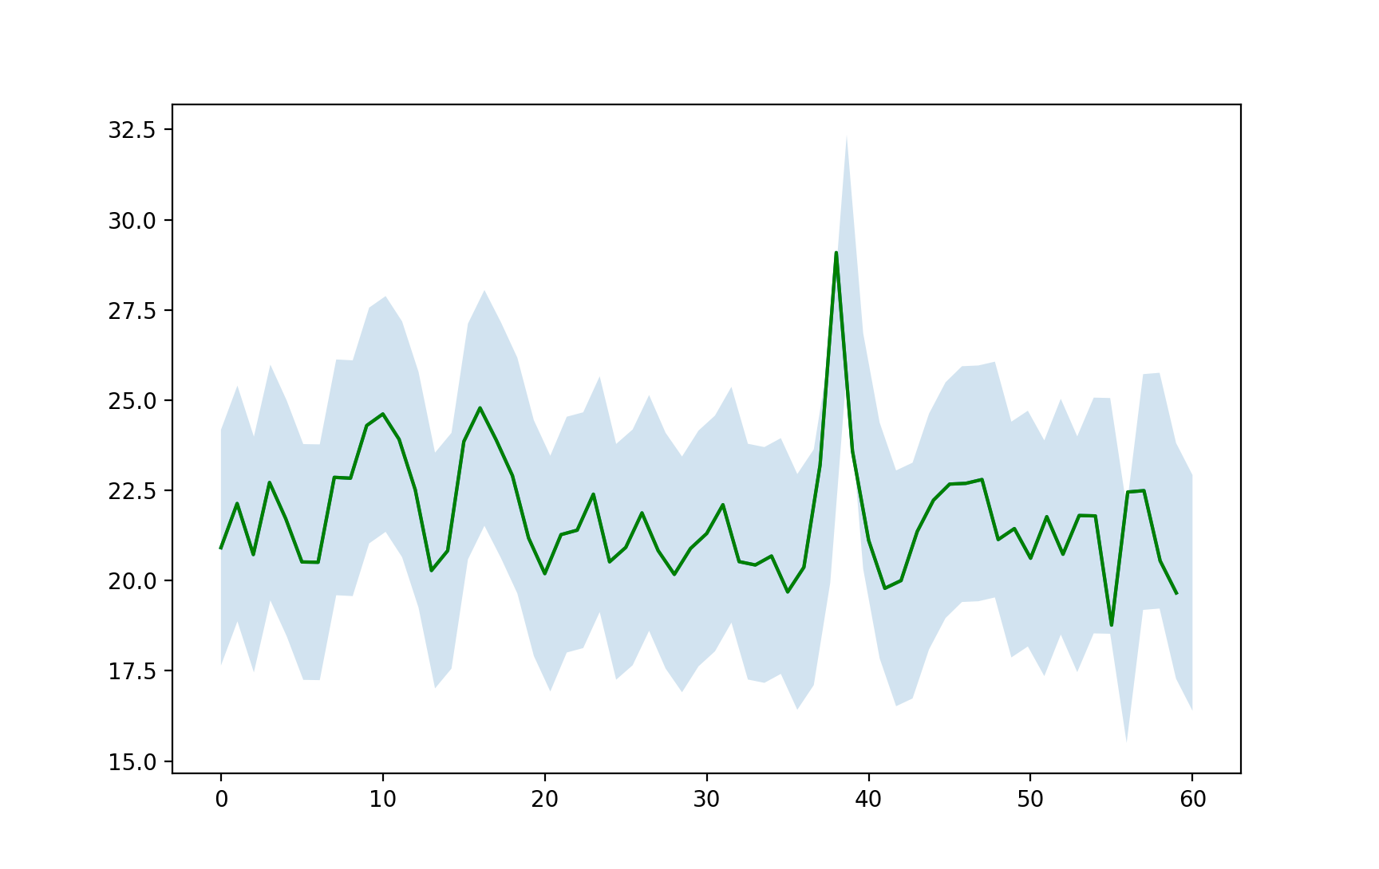

1. Daily load demand of a typical consumer that draws an average of 1100kWh a month correlated to the normalized curve of overall demand between January 2020 and end of February 2020.

The approximation provides a starting point to model a prosumers daily consumption. The prosumers variance of consumption is considered as 2 standard deviations from the mean but can be adjusted in future research. The actual load demand of individual users can be utilized instead of this approximation into the model for better results. By creating a method to instantiate prosumer generation we can build a model with any numbers of possible prosumers that will provide statistically significant results when looking management of net-metering payoffs. A prosumer can be considered to have a normal distribution within a given standard deviation over the mean defined in eq.4 as a prosumer, n belongs to a number of prosumers N, .



### Prosumer Generation Data

The prosumers must have some generation capability installed. In this research we will assume PV is utilized by the prosumers but this can be adjusted to be different types of generation with different driving renewable energy curves. The total solar generation of the FPL territory is an indicator of the potential capacity of a prosumers much smaller generation. The assumption is that the total correlation of solar generation on aggregate is proportional to the solar generation at the prosumer level. A Tier 1 system is going to have a limit of 10kW so the generation is multiplied by the proportional generation at each hour by the normalized curve derived from FPL’s total solar generation. An error of 2 standard deviations in the negative direction is considered here because we are limited by the 10kW constraint.







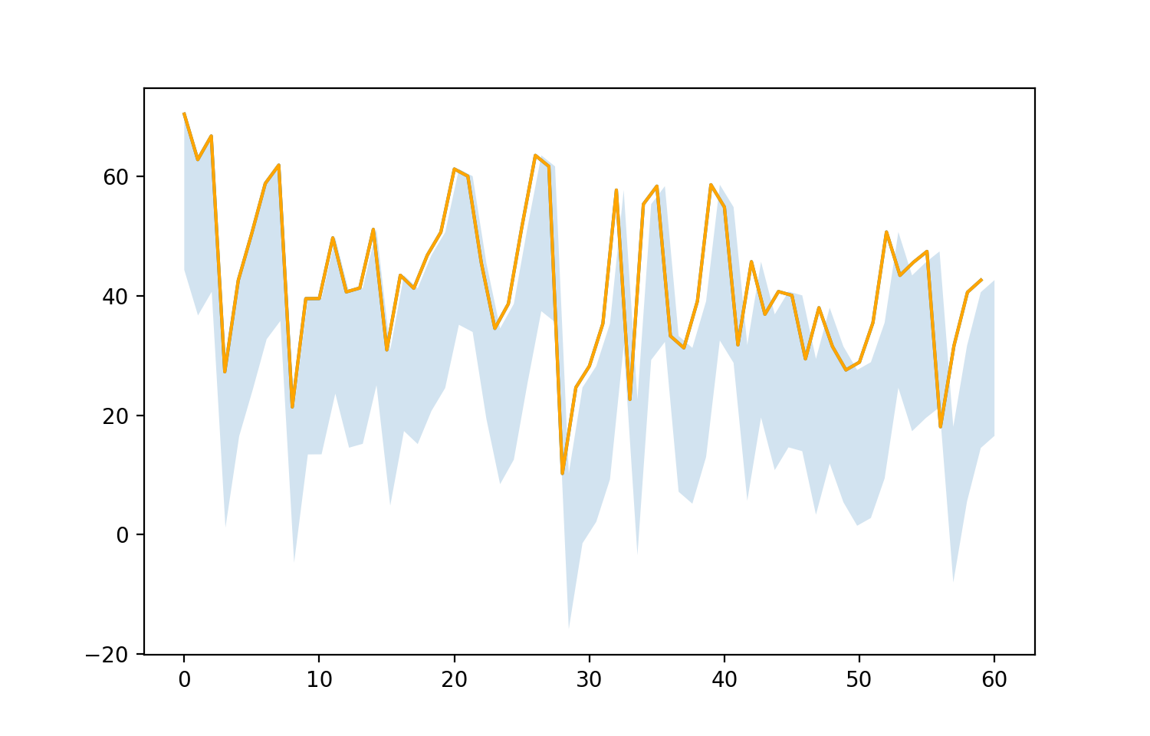

1. Daily generation of a Tier1 solar system installed on a a typical prosumer as a proportional correlation to the normalized curve of FPL’s overall generation from solar start of January to end of February, 2020.

The model for a prosumer’s generation will also be chosen from a normal distribution but will be constrained by the maximum allowed capacity . The maximum capacity chosen is 10kW.



## Modeling Prosumer Network

Prosumer data is used in creating a network of prosumers that can participate in a payment plan for the excess generation contributed to the grid. The prosumer network is represented by where N is the total number of prosumers in the network.



The prosumers net energy is used to pay off the prosumer. The net energy is the difference between prosumers load and prosumers generation. The excess generation of a prosumer is typically used to calculate the net metering price paid to the prosumer. The retail price is a retail price for the same time interval that the energy is generated.





The algorithm considers the total generation and total demand of the network.







The payment function can be a function of the prosumer’s net generation over the window of time and the total net generation. It tries to regulate the payment based on the group contribution of energy so that it is balanced with the demand. Since excess energy is actually not valuable when there is no one to consume it. So, to balance the supply and demand amongst a network of prosumers we want to compensate generation and load on the network at the correct times. (Vottem, 2019)





## Prosumers Simulation with Game Theory

As market participants prosumers seek to maximize the utility function so a non-cooperative game can simulate the interaction with each other over a distributed marketplace. The agents would model each of the incentives such as comfort, timing, and amount to benefit them at every transactional period. The sellers of energy would seek to maximize profits on the market. Finally, the DSO would seek to keep transactions as safe as possible by forecasting the risk profile of every commitment made and the risks to distribution.

* + Modeling prosumers as game agents
  + Provide the “agent” utility function
  + Non-cooperative game for each participant

## Manage Imbalances

There is often a disparity between the promised amount of energy in the placed orders and the actual energy consumption as recorded by smart meters. After the settlement process the broker needs to find ways to settle the imbalance. It does so by leveraging different mechanisms during the energy exchange period.

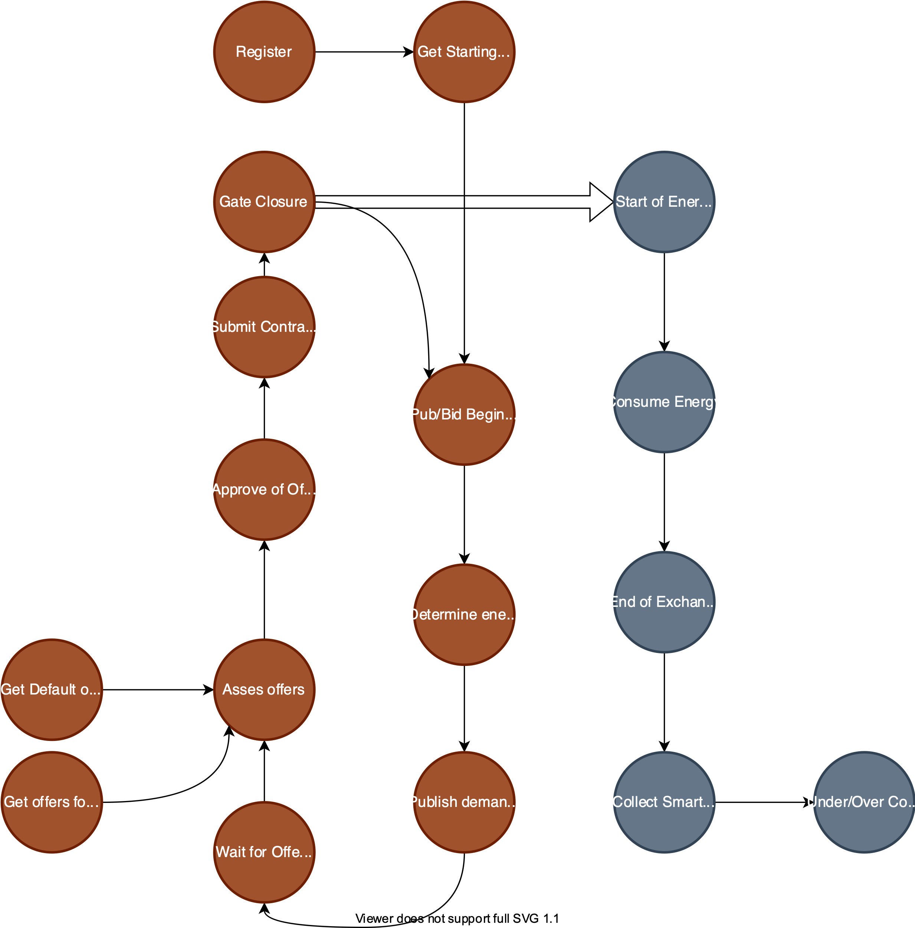

1. Market process to manage the onboarding and bidding of prosumers. The steps are done in succession on the virtual layer and impleented on the physical layer.

# Results

* Results of Prosumers
  + Financial Tranasctinos
  + Prosumer wealth
  + Effeciency of market
  + Benchmarking performances

## Prosumer Network Example

The prosumer network size will be adjusted to analyze the portfolio returns. The first simulation run is focused on providing an analysis of 3 prosumers. The prosumers each

| Num. of Prosumers | Prosumer Simulation (Jan. 2020 - Feb. 2020) | | | |
| --- | --- | --- | --- | --- |
| Avg. Generation | Avg. Consumption | Average Net Energy | NRG-X-Change Payment |
| 1 | 5028.6 | 2538.20 |  | 226.974 |
| 2 | 5044.12 | 2554.43 |  | 227.167 |
| 3 | 5047.033 | 2520.069 |  | 228.12 |

single home and average solar PV installation capacity of a typical prosumer.

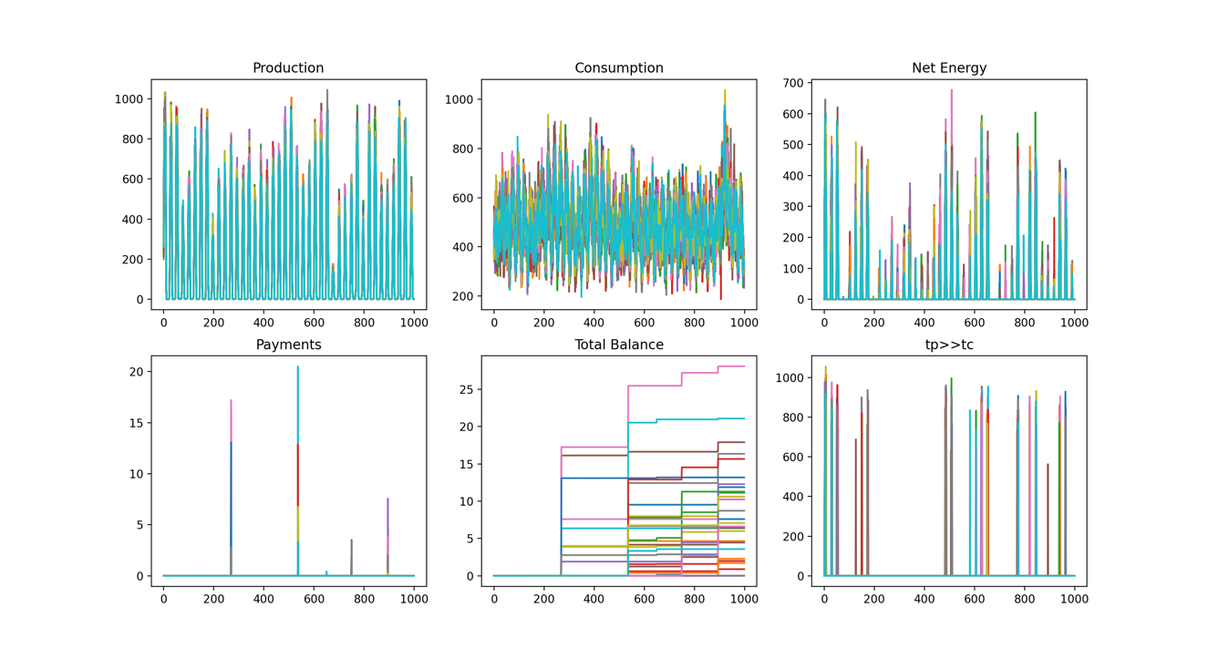

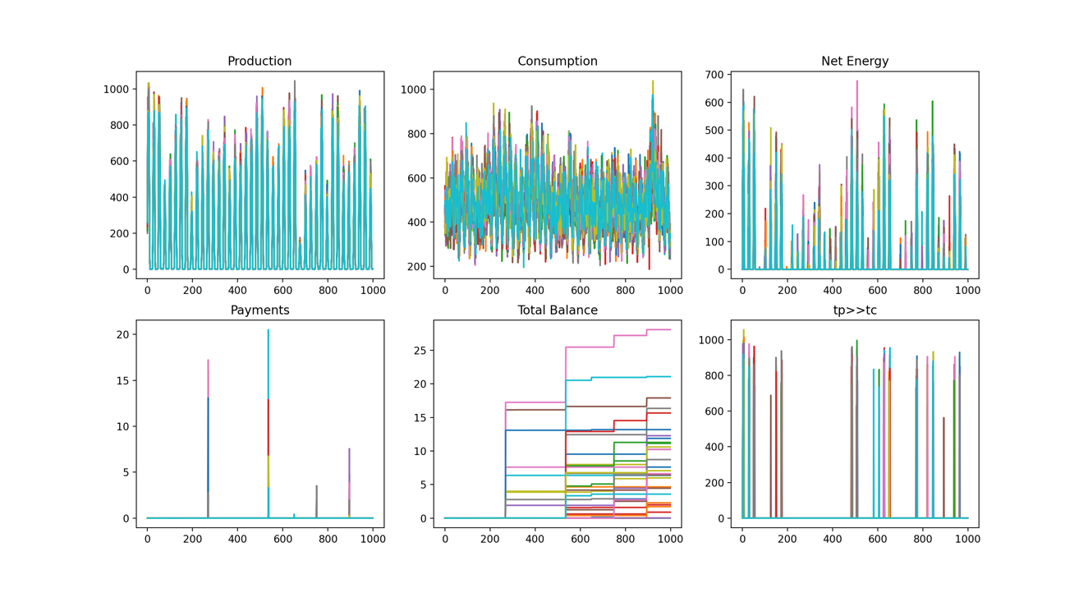





# Conclusion

* Future Works
  + What was not considered in this example
  + Whats possible
  + Things that are coming around the corner

##### References

1. https://www.fpl.com/clean-energy/net-metering/guidelines.html
2. Sage LLC. “Market Research on FPL” Sunshot U.S. Department of Energy https://www.energysage.com/local-data/net-metering/fpl
3. U.S. Energy Information Administration , “[www.eia.gov](http://www.eia.gov)” (Oct 2008).
4. The Public Utility Regulatory Policies Act of 1978; Sarah Czufin, Government Relations Director.
5. Spandana Vottem, “Application of Cooperative Game Theory in Smart Grids” B.S.A thesis submitted to the Graduate Council of Texas State University December 2019
6. Prosumption and the distribution and supply of electricity Sandra Bellekom1 , Maarten Arentsen1* and Kirsten van Gorkum2
7. NRG-X-ChangeA Novel Mechanism for Trading of Renewable Energy in Smart GridsMihail Mihaylov1,2, Sergio Jurado1,3, Kristof
8. Twan Burg (2020). Shapley Value for n-player Cooperative Games (https://www.mathworks.com/matlabcentral/fileexchange/35334-shapley-value-for-n-player-cooperative-games), MATLAB Central File Exchange. Retrieved October 22, 2020.
9. H. Yang, X. Xie, and A. V. Vasilakos, “Noncooperative and cooperative optimization of electric vehicle charging under demand uncertainty: A robust Stackelberg game,” IEEE Trans. Veh. Technol., vol. 65, no. 3, pp. 1043–1058, Mar. 2016.
10. W. Tushar, C. Yuen, H. Mohsenian-Rad, T. Saha, H. V. Poor, and K. L. Wood, “Transforming energy networks via peer-to-peer energy trading: The potential of game-theoretic approaches,” IEEE Signal Processing Magazine, vol. 35, no. 4, pp. 90–111, July 2018.
11. Luo Y, Davis P. Autonomous Cooperative Energy Trading Between Prosumers for Microgrid Systems. 3rd IEEE International Workshop on Global Trends in Smart Cities go SMART; 2014.
12. T. Morstyn, N. Farrell, S. J. Darby, and M. D. Mcculloch, “Using peer-to-peer energy-trading platforms to incentivize prosumers to form federated power plants,” Nature Energy, vol. 3, no. 2, pp. 94–101, 2018.
13. W. Tushar, T. K. Saha, C. Yuen, T. Morstyn, M. D. McCulloch, H. V. Poor, and K. L. Wood, “A motivational game-theoretic approach for peer-to-peer energy trading in the smart grid,” Applied Energy, vol. 243, pp. 10–20, June 2019.
14. J. Ni and Q. Ai, “Economic power transaction using coalitional game strategy in micro-grids,” IET Generation, Transmission Distribution, vol. 10, no. 1, pp. 10–18, Jan. 2016.
15. W. Lee, L. Xiang, R. Schober, and V. W. S. Wong, “Direct electricity trading in smart grid: A coalitional game analysis,” IEEE J. Sel. Areas Commun., vol. 32, no. 7, pp. 1398–1411, July 2014.
16. Atzeni, L. G. Ordòñez, G. Scutari, D. P. Palomar, and J. R. Fonollosa, “Demand-side management via distributed energy generation and storage optimization,” IEEE Trans. Smart Grid, vol. 4, no. 2, pp. 866–876, June 2013.
17. T. Morstyn, N. Farrell, S. J. Darby, and M. D. Mcculloch, “Using peer-to-peer energy-trading platforms to incentivize prosumers to form federated power plants,” Nature Energy, vol. 3, no. 2, pp. 94–101, 2018.
18. Sakineh Khalili, Vahid Disfani, Mo Ahmadi, "Impact of Blockchain Technology on Electric Power Grids - A case study in LO3 Energy", ConnectSmart Research Laboratory, University of Tennessee at Chattanooga.(2020)
19. Pablo García-Triviño, Decentralized Fuzzy Logic Control of Microgrid for Electric Vehicle Charging Station Pablo García-Triviño, Juan P. Torreglosa, Luis M. Fernández-Ramírez, Senior Member, IEEE, and Francisco Jurado,Senior Member, IEEE
20. Crosby, M.; Pattanayak, P.; Verma, S.; Kalyanaraman, V. Blockchain technology: Beyond bitcoin. *Appl. Innov.* 2016, *2*, 71.
21. Dimeas, A.L.; Hatziargyriou, N.D. Operation of a multiagent system for microgrid control. *IEEE Trans. Power Syst.* 2005, *20*, 1447–1455.
22. Prinsloo, G.; Mammoli, A.; Dobson, R. Customer domain supply and load coordination: A case for smart villages and transactive control in rural off-grid microgrids. *Energy* 2017, *135*, 430–441.
23. Pei, W.; Li, S.; Li, H.; Tang, X.; Cheng, J.; Zuo, W.X. Key technology and testbed for micro-grid operation control. *Au- tom. Electr. Power Syst.* 2010, *34*, 94–98.
24. Nakamoto, S. Bitcoin: A Peer-To-Peer Electronic Cash System. 2008. Available online: https://bitcoin.org/bitcoin.pdf.
25. Ethereum Community. A Next-Generation Smart Contract and Decentralized Application Platform, White Paper. Available online: https://github.com/ethereum/wiki/wiki/White-Paper.
26. Armknecht, F.; Karame, G.O.; Mandal, A.; Youssef, F.; Zenner, E. Ripple: Overview and Outlook. In Proceedings of the 8th International Conference on Trust and Trustworthy Computing, Heraklion, Greece, 14 August 2015; pp. 163–180.
27. Zhuo, N.; Muyang, L. LIP-Chain: A Logistics Information Platform Based on Permissioned Blockchain. *Comput. Technol. Dev.* **2019**, *29*,190–194.
28. Novo, O. Blockchain meets IoT: An architecture for scalable access management in IoT. *IEEE Internet Things J.* **2018**, *5*, 1184–1195.