**Starting point**

Installation instruction from <https://github.com/tpeng/python-crfsuite>

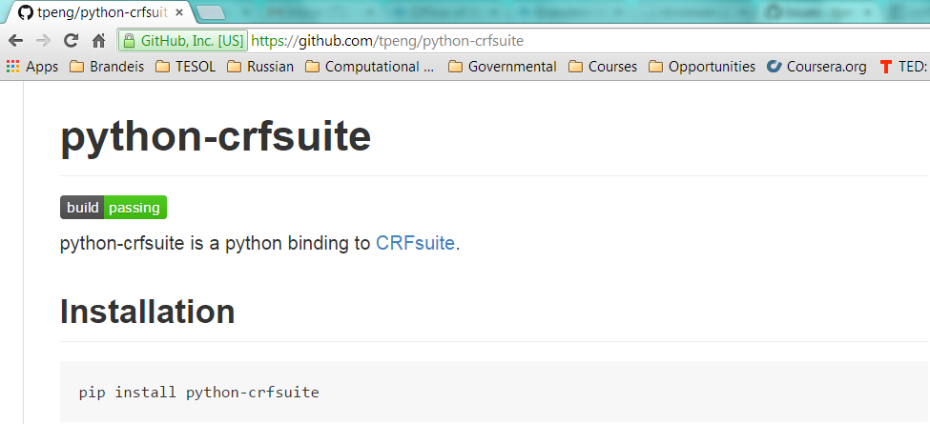

**My Windows**

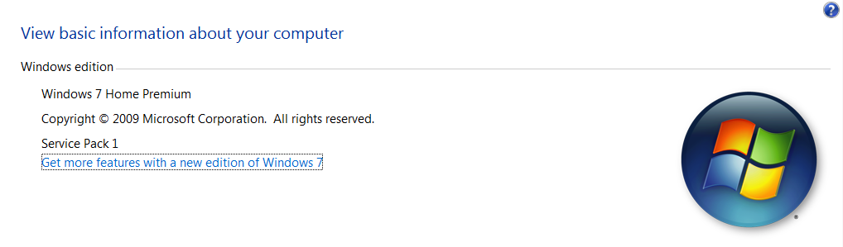

# Installation Troubleshooting

## Error 1 – *Unable to find vcvarsall.bat*

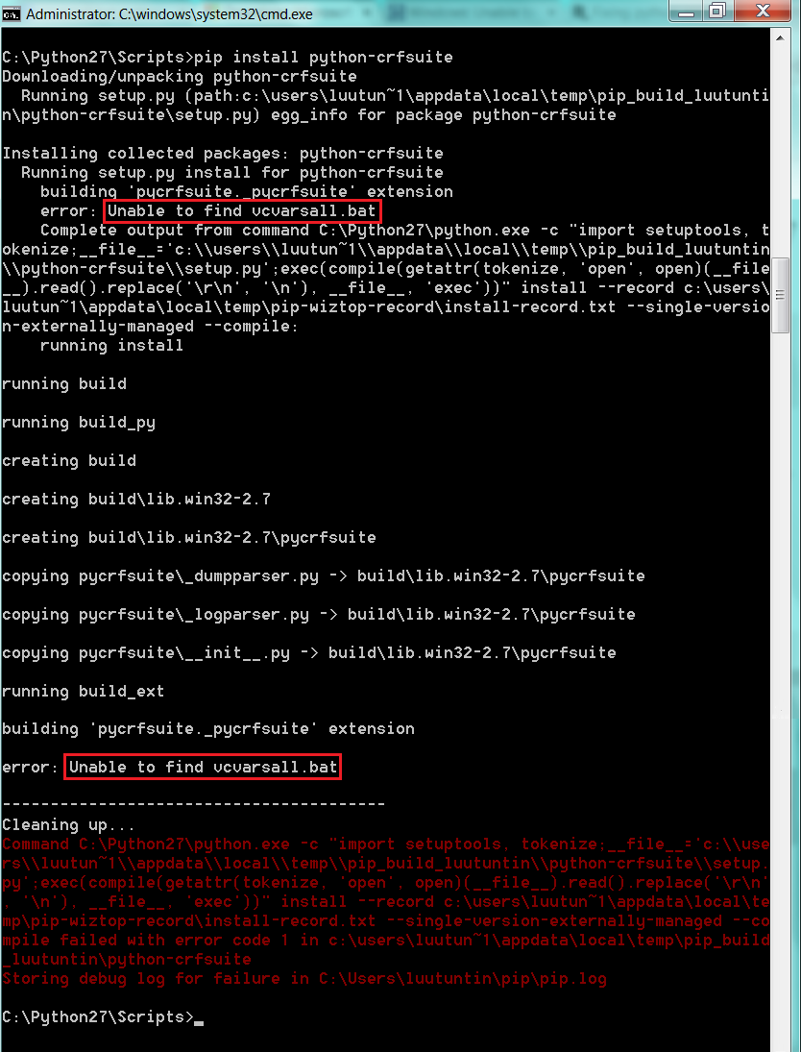

Solution:

1. Install C++ Compiler for Python (<http://www.microsoft.com/en-us/download/details.aspx?id=44266>)
2. Upgrade *setuptools* as below:

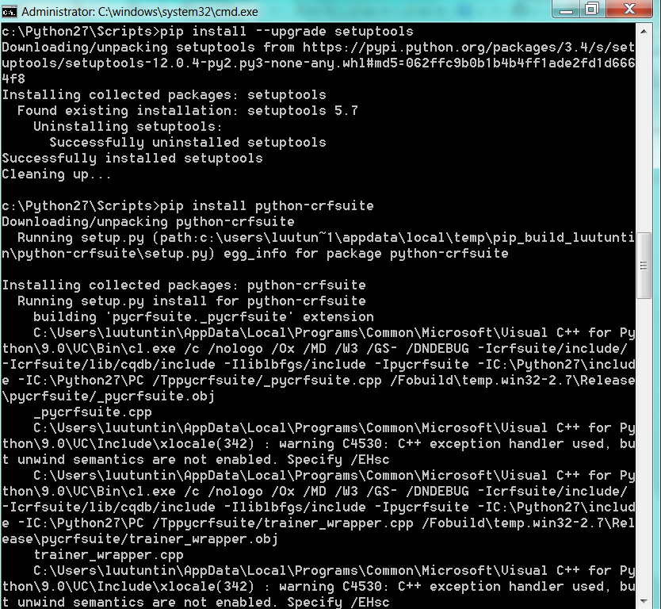

Reference: <http://stackoverflow.com/questions/2817869/error-unable-to-find-vcvarsall-bat>

## Error 2 – *Cannot open include file: ‘stdint.h’: no such file or directory*

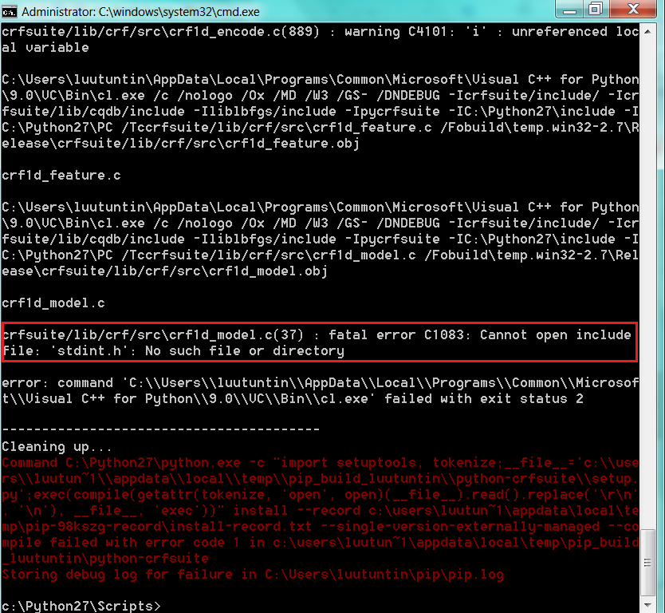

Solution:

1. Download *msinttypes-r26.zip* from <https://code.google.com/p/msinttypes/>
2. Add *stdin.h* from *msinttypes-r26* into *[current C++ Compiler for Python folder]\VC\include*
3. Rerun *pip install python-crfsuite*

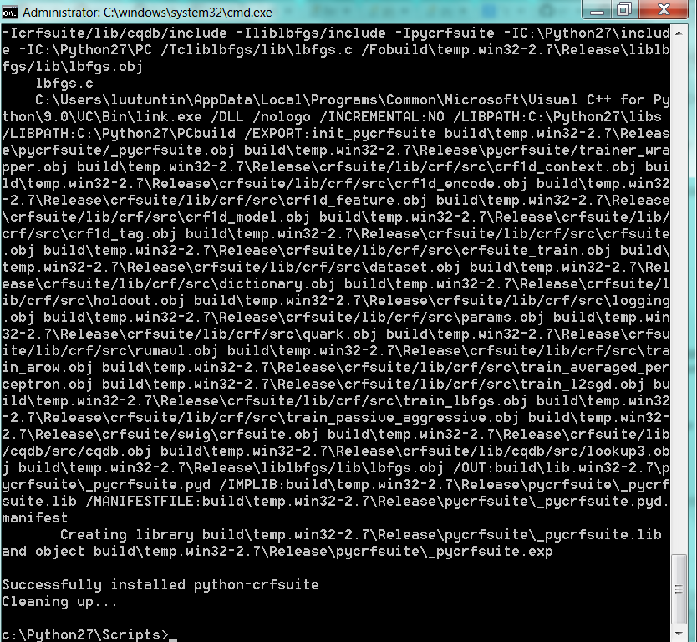

Reference: <http://tdistler.com/2011/11/13/adding-stdint-h-to-visual-studio>