

LAB 1 REPORT:
SPACE EXPLORER - 2D ARCADE GAME DEVELOPMENT

STUDENT NAME: PHẠM HỒNG PHÚC
STUDENT ID: QE190133
COURSE/CLASS: SE19B.NET_PRU213
Table of Contents
1. PROJECT OVERVIEW 3
1.1. Introduction 3
1.2. Game Objective 3
2. PRELAB SETUP AND ENVIRONMENT CONFIGURATION 3
2.1. Display and Camera Configuration 3
2.2. Tag System Initialization 3
2.3. Project Directory Organization 3
3. SCENE MANAGEMENT & USER INTERFACE (UI) 4
3.1. Build Settings and Scene Flow 4
3.2. Main Menu and "Mission Briefing" UI 4
4. CORE MECHANICS & PHYSICS SCRIPTING 5
4.1. Movement and Transform Logic 5
4.2. Physics and Collision Detection 5
4.3. Dynamic Memory Optimization (Garbage Collection) 6
5. CREATIVE IMPLEMENTATIONS (POLISH & GAME FEEL) 6
5.1. Audio Feedback System (SFX & BGM) 6
5.2. Kinesthetic Feedback (Camera Shake Effect) 7
5.3. Data Persistence 7
6. CONCLUSION 7

1. PROJECT OVERVIEW

1.1. Introduction
"Space Explorer" is a 2D endless-runner space shooting game developed using the Unity Engine (C#). The project demonstrates the application of fundamental game development principles, including object-oriented programming, physics-based collision detection, dynamic memory management, and user interface (UI) design.

1.2. Game Objective
The player controls a spaceship navigating through a hazardous asteroid field. The primary objectives are to survive by dodging or destroying falling asteroids using a laser cannon, and to accumulate points by collecting energy stars. The game tests the player's reflexes while providing a visually and auditorily engaging Sci-Fi experience.

2. PRELAB SETUP AND ENVIRONMENT CONFIGURATION

2.1. Display and Camera Configuration
To ensure a consistent gameplay experience across different monitors, the Main Camera was set to an Orthographic projection. The display aspect ratio was strictly locked to 16:9 (1920x1080 resolution), allowing for precise calculation of spawn points and screen boundaries.

2.2. Tag System Initialization
A customized Tag system was implemented to streamline the collision detection matrix. The following tags were declared and assigned to their respective Prefabs:
- Player: Assigned to the main spaceship.
- Asteroid: Assigned to the obstacle prefabs.
- Laser: Assigned to the projectile prefabs.
- Star: Assigned to the collectible prefabs.

2.3. Project Directory Organization
The Assets folder was structured logically to maintain a clean project architecture, which is crucial for scalable game development:
- Audio: Contains uncompressed .wav files for sound effects.
- Prefabs: Stores reusable GameObjects.
- Scenes: Contains the 3 main game states.
- Scripts: Houses all C# logic controllers.
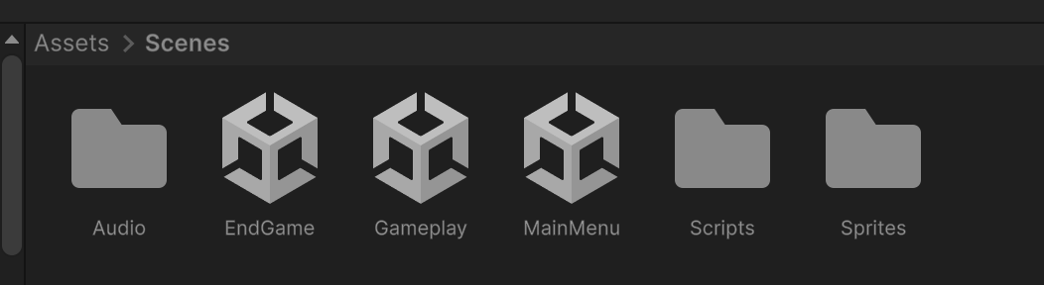
IMAGE 1: Screenshot of your organized 'Assets/Screens' folder in the Unity Editor

3. SCENE MANAGEMENT & USER INTERFACE (UI)

3.1. Build Settings and Scene Flow
The project relies on UnityEngine.SceneManagement to transition between game states. The scenes were registered in the Build Settings in the following index order to prevent loading errors:
- Index 0: MainMenu
- Index 1: Gameplay
- Index 2: EndGame
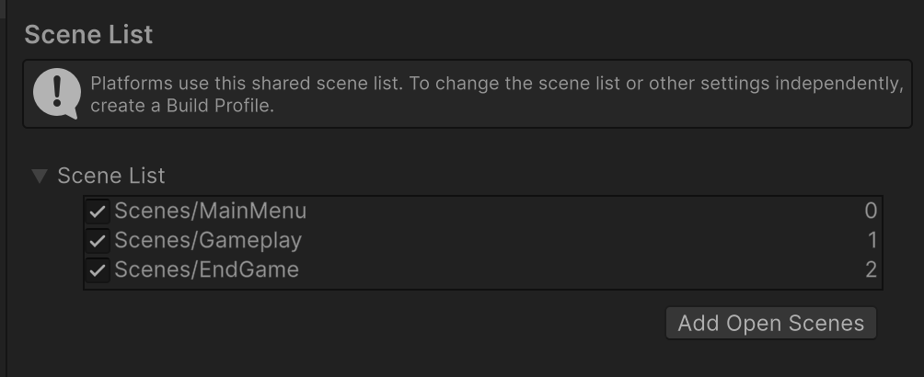
IMAGE 2: Screenshot of the Build Settings window showing the 3 indexed scenes

3.2. Main Menu and "Mission Briefing" UI
The front-end design was heavily polished to match a modern Sci-Fi aesthetic:
- Typography: Utilized TextMeshPro (TMP) for high-definition rendering. The main title features a custom Outer Glow property to simulate a neon light effect.
- Layout Automation: The main action buttons (Play, Instructions) were grouped using a Vertical Layout Group component, ensuring pixel-perfect spacing and alignment.
- Interactive Panels: An overlay UI Panel was designed as a "Mission Briefing" window. This provides gameplay instructions in English and is dynamically toggled via UI Button OnClick() events (SetActive(true/false)).

IMAGE 3: Screenshot of the Main Menu with the Instructions Panel actively displayed

4. CORE MECHANICS & PHYSICS SCRIPTING

4.1. Movement and Transform Logic
Game objects like Asteroids and Stars were scripted to simulate falling mechanics. The transform.Translate(Vector3.down * fallSpeed * Time.deltaTime, Space.World) method was used to enforce a strict downward trajectory relative to the world space, while transform.Rotate() was simultaneously applied to the asteroids to create a natural, zero-gravity spinning effect.

4.2. Physics and Collision Detection
The game relies on 2D colliders (set as Triggers) and rigidbodies. The OnTriggerEnter2D(Collider2D other) method handles core interactions:
- Combat: When a Laser tag intersects an Asteroid tag, both objects are immediately destroyed.
- Scoring : When the Player intersects a Star, it calls the AddScore() function in the GameManager to increase points. Conversely, if an Asteroid intersects the Player, the DeductScore() method is triggered to subtract points (acting as a health system).
- Game Over: The failure state is dynamically triggered by the GameManager only when the player's score drops to zero or below, seamlessly transitioning the game to the EndGame scene.

4.3. Dynamic Memory Optimization (Garbage Collection)
To prevent memory leaks caused by an infinite build-up of off-screen objects, the Destroy(gameObject, 10f) function was invoked in the Start() method of falling entities. This ensures that objects are automatically cleared from the computer's memory if they are not destroyed by the player.

5. CREATIVE IMPLEMENTATIONS (POLISH & GAME FEEL)
To elevate the project beyond basic requirements, several "Game Feel" enhancements were implemented (Creativity criteria):

5.1. Audio Feedback System (SFX & BGM)
- Background Music (BGM): An Audio Source component was added to the Main Camera in the Gameplay scene, configured to Play On Awake and Loop a dramatic Sci-Fi track. The script programmatically halts this BGM (AudioSource.Stop()) upon player death to prevent audio overlapping.
- Sound Effects (SFX): The static method AudioSource.PlayClipAtPoint() was utilized to trigger uncompressed .wav files upon specific events:
  - sfx_explosion: Played during asteroid destruction or player ship crash.
  - sfx_pickup_star: Played upon collecting points.
  - sfx_gameover: Played at the start of the EndGame scene to set a melancholic tone.
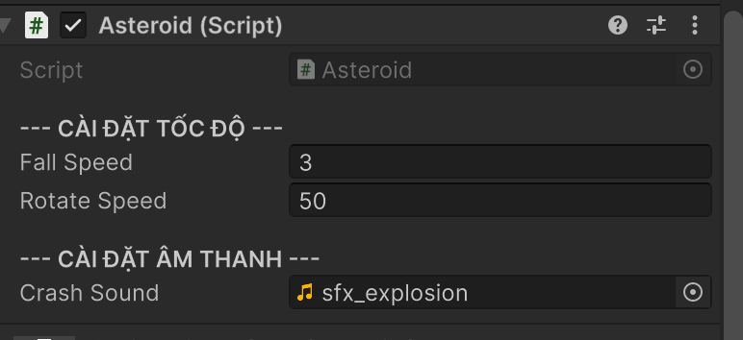
IMAGE 4: Screenshot of the Asteroid Inspector showing the Audio Clip fields populated with .wav files

5.2. Kinesthetic Feedback (Camera Shake Effect)
A custom Coroutine (IEnumerator) was engineered within a CameraShake.cs script. Upon a violent collision (asteroid destroyed or player crash), the script applies a randomized vector offset (Random.Range) to the Main Camera's local position for a fraction of a second. This screen shake effect significantly amplifies the impact of explosions.

5.3. Data Persistence
To seamlessly carry the player's final score from the Gameplay scene to the EndGame scene, the Unity PlayerPrefs class was utilized (PlayerPrefs.SetInt("FinalScore", score)). The EndGame manager retrieves this cached data to display the final result and calculate the player's ranking title (e.g., Space Admiral, Elite Pilot).

6. CONCLUSION
The "Space Explorer" project successfully fulfills all the requirements of the Lab assignment. It features a robust architecture, optimized script performance, a highly polished UI, and creative additions like dynamic audio and camera shake effects that provide a complete, professional arcade gaming experience.

