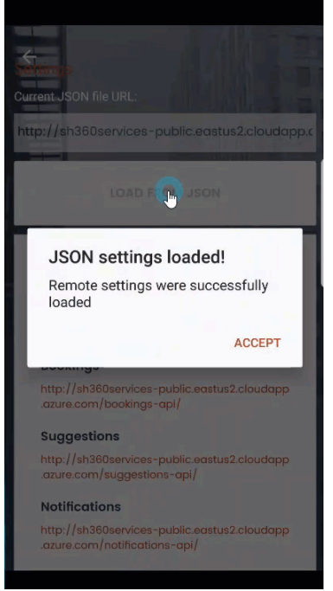

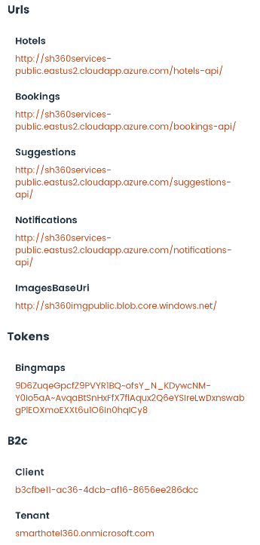

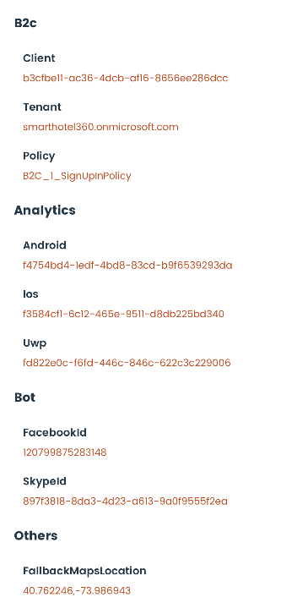

{

"urls": {

"hotels": "http://sh360services-public.eastus2.cloudapp.azure.com/hotels-api/",

"bookings": "http://sh360services-public.eastus2.cloudapp.azure.com/bookings-api/",

"suggestions": "http://sh360services-public.eastus2.cloudapp.azure.com/suggestions-api/",

"tasks": "http://sh360services-public.eastus2.cloudapp.azure.com/tasks-api/",

"notifications": "http://sh360services-public.eastus2.cloudapp.azure.com/notifications-api/",

"reviews": "http://sh360services-public.eastus2.cloudapp.azure.com/reviews-api/",

"discounts": "http://sh360services-public.eastus2.cloudapp.azure.com/discounts-api/",

"images_base": "http://sh360imgpublic.blob.core.windows.net/"

},

"pets_config": {

"blobName": "sh360imgpublic",

"blobKey": "iEgvetAFNG7Y3olF/yUj6+Ti2rYR+Go5+uwSxbcsqhrSpYILFeHpWZZ4eQ//2skAqMoTxI7zY/1TABRGwMVdkw==",

"cosmosUri": "https://sh360cosmosdbpublic.documents.azure.com:443/",

"cosmosKey": "07GT9U23QeY1acAQ0Lgy9QRuNoWbHuHdhtFAFI0xg1D0wZoLZdzjgkzTlVhLcXEeW0MTMlv5l9gfGYlGEVR0Nw=="

},

"tokens": {

"bingmaps": "9D6ZuqeGpcfZ9PVYR1BQ~ofsY_N_KDywcNM-Y0Io5aA~AvqaBtSnHxFfX7flAqux2Q6eYSIreLwDxnswabgPlEOXmoEXXt6u1O6In0hqICy8"

},

"b2c": {

"tenant": "smarthotel360.onmicrosoft.com",

"policy": "B2C_1_SignUpInPolicy",

"client": "b3cfbe11-ac36-4dcb-af16-8656ee286dcc"

},

"analytics": {

"android": "f4754bd4-1edf-4bd8-83cd-b9f6539293da",

"ios": "f3584cf1-6c12-465e-9511-d8db225bd340",

"uwp": "fd822e0c-f6fd-446c-846c-622c3c229006"

},

"others": {

"fallbackMapsLocation": "40.762246,-73.986943"

},

"bot": {

"id": "897f3818-8da3-4d23-a613-9a0f9555f2ea",

"FacebookBotId": "120799875283148"

}

}