PROG PART ONE POE ST10474357

Introduction

In this part of the assignment, I will be designing how the POE will work and be structured , this is a comprehensive guide on how the project will function and how data handling will be executed responsibly and thoroughly.

Section A
ERD 6 Entities listed below

Explanation

1.User Table : Has all the users’ details
2. Events Has all the event details.
3.Category Has all the categories in detail
4.Payment Has all the payment details
5.Enrollment Has all the details about the enrolments

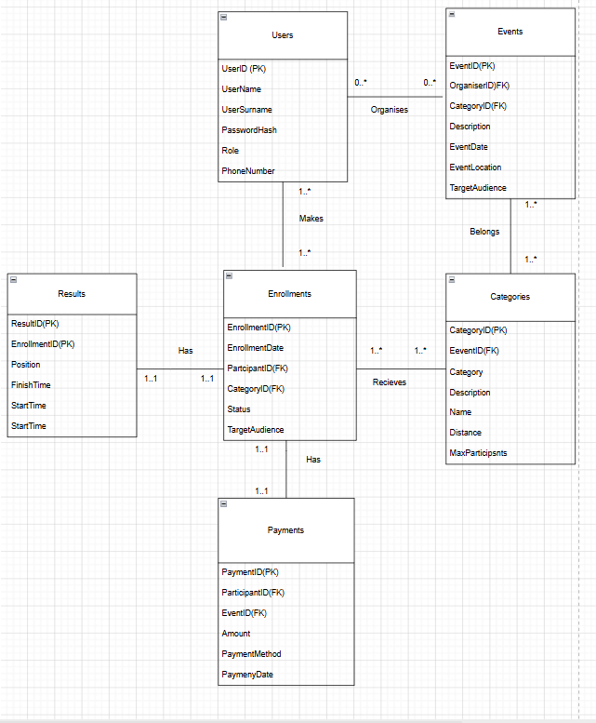

Section B

API Endpoint Plan

Method | Route | Description | Role Required | Request body | Expected response | Unexpected responses
Post | /api/auth/register | Registers a new user as a Participant or organiser | None | {UserName, UserSurname, Password, Role} | 201 Created: New User, 201 Email: Registration successful | 404: No registration page found  401: Access denied: Can’t register email
Post | /api/auth/register | Authenticates user and creates an access token | None | {email, Password

