Estimating the Income-Related Inequality Aversion

to Energy Limiting Behavior in the United States

Luling Huanga * and Destenie Nockb,c,d *

a Department of Communication, Missouri Western State University, USA

b Department of Engineering and Public Policy, Carnegie Mellon University, USA

c Department of Civil and Environmental Engineering, Carnegie Mellon University, USA

d Wilton E. Scott Institute for Energy Innovation, Carnegie Mellon University, USA

* Co-corresponding authors

Luling Huang: [lhuang@missouriwestern.edu](mailto:lhuang@missouriwestern.edu), 4525 Downs Dr., Missouri Western State University, Saint Joseph, MO 64507 USA

Destenie Nock: [dnock@andrew.cmu.edu](mailto:dnock@andrew.cmu.edu), 5000 Forbes Ave., Carnegie Mellon University, Pittsburgh, PA 15213 USA

**Funding:** The first author acknowledges support from the Council on Library and Information Resources, Alexandria, VA, USA. The second author acknowledges support from the National Science Foundation [grants: 2121730 and 2049333]. Both authors acknowledge support from the Alfred P. Sloan Foundation.

**Link to formal publication**: <https://doi.org/10.1016/j.eneco.2024.107716>

**Supplemental materials, data, and R code are available via this link**: https://doi.org/10.6084/m9.figshare.25854763

© 2024. This manuscript version is made available under the CC-BY-NC-ND 4.0 license <https://creativecommons.org/licenses/by-nc-nd/4.0/>

**Estimating the Income-Related Inequality Aversion**

**to Energy Limiting Behavior in the United States**

# 1. Introduction

Energy insecurity, a recognized global problem, arises when low-income, minority, and vulnerable households are at risk of not being able to satisfy their energy needs (Cheng et al., 2022; Jacobson et al., 2005; Nock et al., 2020; Schlör et al., 2013, 2012). In the U.S., where our study is based, it is estimated that 27% of households (approximately 34 million households) had difficulty meeting their energy needs or kept their homes at unhealthy temperatures in 2020 (U.S. Energy Information Administration, 2022). Due to income inequality, lower-income households reported more instances of energy insecurity than higher-income households (U.S. Energy Information Administration, 2022).

The dominant focus on energy insecurity research has been on energy spending habits in low-income households. The most widely identified energy insecurity indicators are energy burden, the percent of income spent on energy bills (Bednar and Reames, 2020; Scheier and Kittner, 2022), and energy disconnections, which result from forgone energy bill payments (Graff and Carley, 2020; Graff and Pirog, 2019). Yet, these economic-based indicators miss an important behavior-based factor: some low-income households have to limit energy usage to reduce financial strain (often in exchange of meeting other basic necessities like food and medicine), which may not be readily reflected in energy bills. This behavior-based factor is defined as *energy limiting behavior* (Cong et al., 2022; Huang et al., 2023).

One recent approach to quantify energy limiting behavior is to estimate the outdoor temperature at which households turn on cooling or heating units (i.e., inflection temperature or balance point) and compare such temperature across income groups. The empirical evidence from a hot climate region (Cong et al., 2022) and a cold climate region (Huang et al., 2023) shows an *energy equity gap*: Lower-income households limited energy consumption more (indicated by higher balance points in the summer) than their higher-income counterparts (Cong et al., 2022; Fig. 1).

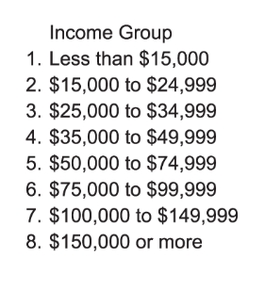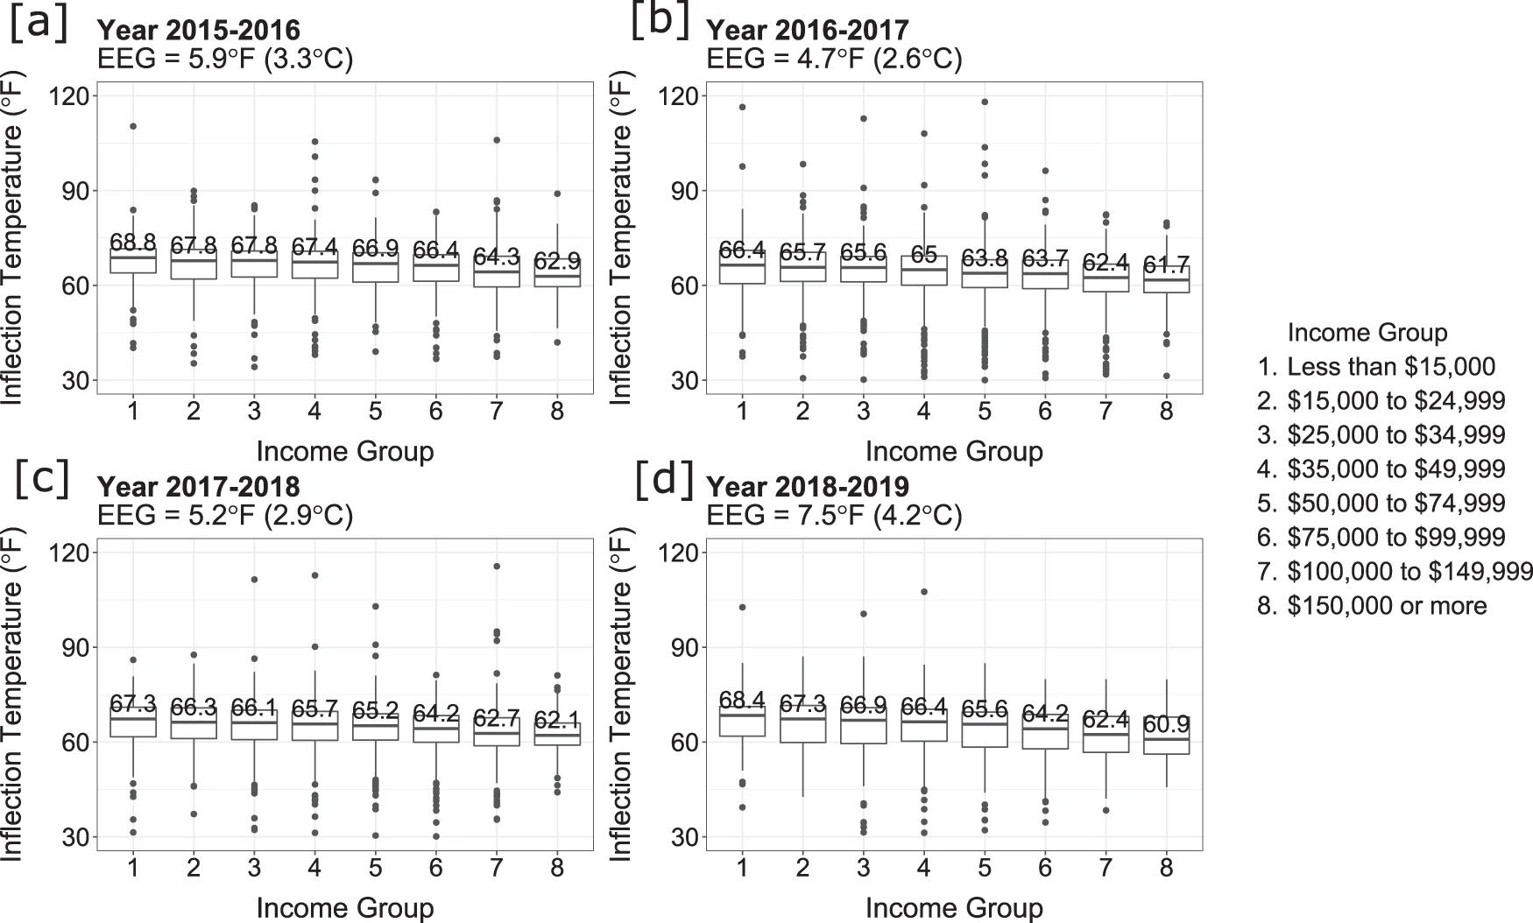

**Fig. 1.** **The distribution of inflection temperature across income groups.** Inflection temperature isthe outdoor temperature at which households turn on cooling units for space cooling. The energy equity gap (EEG) for each year is calculated as the difference between the highest and lowest median inflection temperature (indicated by the middle bar and number) among all income groups in all four panels, income group 1 had the highest, and income group 8 had the lowest median inflection temperature. The energy equity gap (EEG) is shown at the top of the figure. Data year: 2018–2019, *N* = 2,650 households. Each box and whiskers plot indicates the minima and maxima of inflection temperatures of one income group for one year (the lower and upper bound of the whiskers), the first and third quantiles (the lower and upper bound of the box), and the median (the middle line). The outliers are shown as dots on either side of the whiskers. *Adapted from “Unveiling hidden energy poverty using the energy equity gap,” by Cong et al., 2022, Nature Communications, 13, Article 2456, Figure 3. Adapted under Creative Commons Attribution 4.0 International License (*[*http://creativecommons.org/licenses/by/4.0/*](http://creativecommons.org/licenses/by/4.0/)*) with the following changes: keeping only one panel for Year 2018-2019 and some minor changes in the caption.*

In line with the tenets of distributional justice (Jenkins et al., 2016, 2020), all households, regardless of income level, should be relieved from the financial stress and provided with enough assistance to keep a comfortable and healthy indoor environment at home. Thus, the ideal policy goal is to reduce the energy limiting level among low-income households. Given the found energy equity gap (Fig. 1), one important unanswered question is to what extent citizens view such an inequality as a problem. That is, there are different policy agenda items to be addressed at the same time (e.g., health and environmental inequalities), and to what extent should energy equity gap be prioritized relative to other agenda items? Whereas decisionmakers who design and implement public policies may have *normative* assumptions regarding how the society *should value* the way energy limiting behavior is distributed across income groups, we ask the *empirical* question regarding how the society *values* the way energy limiting behavior is distributed.

Thus, the first research question of our work is: What is the public’s social preference regarding inequality in energy limiting behavior in the form of inequality aversion? This social preference could lean towards favoring lower-income households (pro-poor) or higher-income households (pro-rich). Based on the social welfare literature (Atkinson, 1970; Schlör et al., 2013, 2012), we consider the scenario when there is a trade-off between relieving the energy limiting behavior for a society as a whole (i.e., a preference for economic efficiency) and reducing the unequal distribution of the energy limiting behavior across income levels (i.e., a preference for social equality). This trade-off is captured in the form of a *bivariate income-related inequality aversion* parameter in social welfare functions, which is the social preference elicited through a survey in our study. Further, we used indoor temperature setpoints people can establish in their homes (i.e., the ability to set comfortable indoor environments) to quantify energy limiting behavior.

The first innovation point of our study is that it is perhaps the first attempt to elicit inequality aversion in the residential energy consumption sector. The second innovation point is that it builds on the recently developed literature on energy limiting behavior so that it avoids the pitfalls of the more traditional metrics of energy insecurity (see Cong et al., 2022; Huang et al., 2023). The result of our study can inform policymakers about: (1) the social preferences of their constituents regarding how high addressing the inequality in energy limiting behavior may rank in the policy agenda compared with other agenda items (e.g., income and health inequalities), and (2) an evidence-based strategy to redistribute energy limiting behavior across income groups.

Our second research question is: How would inequality aversion vary across different individual characteristics? Therefore, the third innovation point of our study is to help identify which social groups have greater inequality aversion, which has not been done in previous studies. It is our hope that answering our second research question can help decision makers raise awareness and take actions to address the inequality in energy limiting behavior.

The rest of the manuscript is structured as follows: Section 2 defines balance point and describes the social welfare framework that we use to measure inequality with an inequality aversion parameter; Section 3 reviews empirical evidence on the estimation of inequality aversion with a similar design; Sections 4 and 5 describes the methods and reports the results, respectively; Section 6 discusses the relation of our findings to the literature and the implications for policymakers and campaigners, as well as points out the limitations of our study and several specific directions for future research. Section 7 concludes our manuscript with a summary of major findings.

# 2. Definitions and theoretical framework

## 2.1 Balance point and assumptions

To elicit the inequality aversion in the distribution of energy limiting behavior across income groups, we first need to quantify energy limiting behavior. To achieve this, we define *cooling balance point* as the ideal temperature set point at which a household desires to keep its living space in summer. Similarly, *heating balance point* is defined as the temperature set point, at which a household desires to keep its living space at in winter (Huang et al., 2023). These set points are used to establish a baseline for temperature-related energy consumption (Dubin, 2008; Lovvorn et al., 2002; Perez et al., 2017; Woods and Fuller, 2014). The distribution of balance points across income groups is the focus of the current study.

In line with the definition of energy limiting behavior (i.e., energy usage reduced due to financial stress despite outdoor temperature changes), we assume negative relationships between cooling balance point and energy consumption (electricity used for cooling), and between cooling balance point and income based on the empirical evidence found in previous studies (Cong et al., 2022; Huang et al., 2023). Likewise, we assumed positive relationships between heating balance point and energy consumption (natural gas used for heating), and between heating balance point and income (Charlier and Legendre, 2016; Kelly et al., 2013). If cooling balance point is low, then it indicates that the household is able to use energy for space cooling earlier in the summer, and do not have to limit their cooling usage. However, the opposite is true of heating balance point. A higher heating balance point shows a reduction in energy limiting behavior (heating earlier in the winter), which is preferable in the winter months. In brief, we assume that the lower the cooling balance point, the better; the higher the heating balance point, the better.

## 2.2 The extended concentration index and inequality aversion

After we define what distribution is under focus, this section describes what the inequality measure is to be used, which provides the theoretical framework of the current study. In previous studies, measures of inequality in residential energy consumption were sourced from income inequality, including Lorenz curves and Gini coefficients (Jacobson et al., 2005), as well as the Atkinson index (Schlör et al., 2013, 2012). The Atkinson inequality index (Atkinson, 1970) provides a theoretical framework that links social preference (i.e., the inequality aversion parameter) with an inequality index using a social welfare function (see Schlör et al., 2012). The inequality aversion parameter embodies a stakeholder’s preference for fairness and is a factor of the distribution sensitivity that represents the value judgment in a society regarding how different positions in the income rank should be weighted.

However, the aforementioned indices only measure inequality along a single variable, limiting their ability to capture the complex nature of decision making. This is insufficient when one wants to examine how equally a resource is distributed across other variables (e.g., income). In our study we assume that a just distribution of energy limiting behavior (Variable 1: a resource variable, i.e. balance points) for keeping one’s home comfortable should be relatively equal across income groups (Variable 2: a ranking variable on socioeconomic status; in this case Variable 2 is income), rather than equal for every person. Therefore, the current study adopts the *extended* concentration index (Wagstaff, 2002) that: (1) quantifies how equally balance point is distributed across income; (2) and has a bivariate income-based inequality aversion parameter.

The extended concentration index, *C*(γ), is defined in Equation 1 (Wagstaff, 2002).

*C*(γ) = (1 – *Wj* /), (1)

where *C*(γ) ∈ [-1,1]. For cooling balance point, where cooling balance point is negatively correlated with income, a negative *C*(γ) indicates that high cooling balance points are disproportionately concentrated among the lower-income groups; for heating balance point, where heating balance point is positively correlated with income, a positive *C*(γ) indicates that low heating balance points are disproportionately concentrated among the lower-income groups. *Wj* is the social welfare regarding the cooling (*W*C, where *j* = C) or heating (*W*H, where *j* = H) balance point, which is a function of the inequality aversion parameter, γ (elaborated in Equations 2 and 3, below). is the mean cooling or heating balance point among the whole population in a society*.*

By assuming that individual utility is a negative function of cooling balance point in summer, a positive function of heating balance point in winter, and that social welfare is the weighted sum of individual utility, we define the social welfare functions for cooling balance point and heating balance point in Equation 2 and Equation 3, respectively.

*W*C = (Wagstaff, 2002), (2)

*W*H = (Hurley et al., 2020). (3)

In Equations 2 and 3, *Q* is the total number of income groups in a society, is the weight attached to the *q*th group’s average cooling balance point or average heating balance point , is the rank of income for the *q*th group (where refers to the lowest income group for cooling balance point, but refers to the highest income group for heating balance point). *W*C is the social welfare of a society regarding cooling balance point (the higher the value of *W*C, the worse a society is, because the social welfare is a bad-indicator of the sum of individual utilities; Equation 2); *W*H is the social welfare regarding heating balance point (the higher the value of social welfare the better a society is; Equation 3).

In Equations 2 and 3, the inequality aversion parameter, , describes whether a society is pro-poor (i.e., values equal distribution of balance points over a preferable mean balance point), or pro-rich (i.e., values a preferable mean balance point over equal distribution). The following is true for both cooling and heating balance point: For a society, if = 1, every group’s cooling or heating balance point-based utility is weighted equally; if < 1, this society is pro-rich, as the weight attached to a better-ranked income group becomes greater than the weight attached to a worse-ranked group; if > 1, and as increases, the weight attached to a worse-ranked income group becomes greater than the weight attached to a better-ranked group, so this society becomes more pro-poor. Fig. 2 shows how the weights vary as a function of inequality aversion values. For cooling balance point (Panel [a] in Fig. 2), the weights are pro-rich when < 1, as higher-income groups have greater weights than lower-income groups; the weights are pro-poor when > 1, as lower-income groups have greater weights than higher-income groups. For heating balance point (Panel [b] in Fig. 2), which shows a similar pattern. To simplify calculations, we use relative rank in Equation 2 and absolute rank in Equation 3. That is, when *Q* = 5, = 0.2, 0.4, 0.6, 0.8, or 1 in Equation 2 (Panel [a] in Fig. 2); = 1, 2, 3, 4, or 5 in Equation 3 (Panel [b] in Fig. 2).

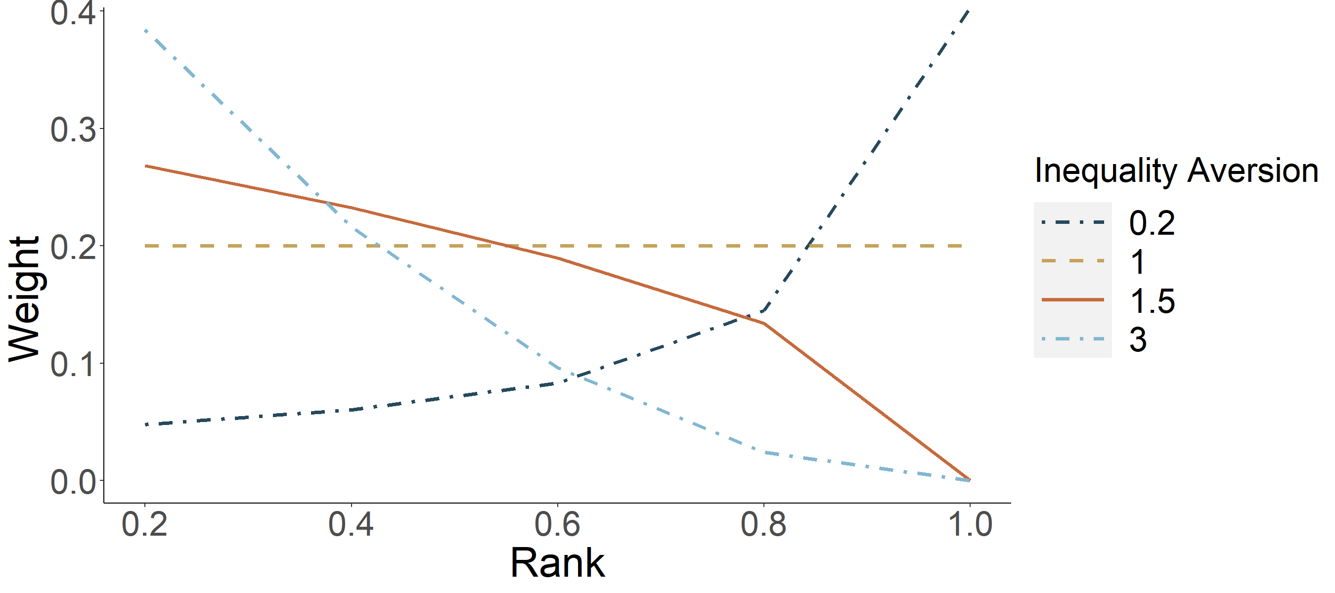

**(b)**

**(a)**

**Fig. 2.** Panel (a): Weights of ranked income groups by inequality aversion in the cooling balance point case; ranking uses relative ranks and starts with the lowest income group (i.e., Rank = 0.2). Panel (b): Weights of ranked income groups by inequality aversion in the heating balance point case; ranking uses absolute ranks and starts with the highest income group (i.e., Rank = 1).

# 3. Literature review and research questions

Once we have described what distribution is under focus and what type of inequality aversion is to be elicited, this section outlines the range of inequality aversion magnitudes found in previous studies with a similar design. Although the evidence is scarce in the energy field, previous studies in behavioral economics estimated the magnitude of inequality aversion for income distribution (Bérgolo et al., 2022; Carlsson et al., 2005; Johansson‐Stenman et al., 2002; Pirttilä and Uusitalo, 2010), for the distribution of health-related variables (Attema et al., 2015; Cropper et al., 2016; Dolan and Tsuchiya, 2011; Hardardottir et al., 2021; Hurley et al., 2020; Robson et al., 2017; Yang et al., 2022), and for the distribution of environmental commodities (Venmans and Groom, 2021). The estimated values found in these studies are shown in Table 1. The studies are presented in reverse chronological order.

In general, there are two approaches that elicit inequality aversion using survey. The first approach is the leaky-bucket method (Okun, 2015). In a leaky-bucket task, facing an efficiency-equality tradeoff, participants are asked to determine a tolerable amount of loss (leakage) when resources are transferred from the rich to the poor. The greater the tolerable leakage, the greater the elicited inequality aversion. In another efficiency-equality tradeoff, the second approach asks participants to choose between two resource distributions: one has a better average but is more unequal, and the other one has a worse average but is more equal.

In our review, to make the results more comparable to the design in the current work, we only included those studies with a similar elicitation method: Asking participants to choose a preferred distribution from two distributions. Our choice to use the distribution approach results from the fact that it is infeasible to directly transfer balance point among people (unlike income), which excludes the leaky-bucket approach as a viable option. We also excluded those studies that were not conducted in a social welfare framework (e.g., (Engelmann and Strobel, 2004; Fehr and Schmidt, 1999)).

As Table 1 shows, the estimated median income inequality aversion and environment inequality aversion were greater than 2; the median health inequality aversion ranged widely from one to 10.95. The design in Hurley et al. (2020) was the closest to the current work. This study elicited the inequality aversion values regarding income distribution, health distribution, and the income-related health distribution in one survey design (Hurley et al., 2020). The median bivariate income-related health inequality aversion was between 1.5 and 2, and it was found that the aversion values varied across issues (e.g., income vs. health vs. income-related health). If the estimated inequality aversion is issue-specific, the question becomes what the empirical value of inequality aversion would be in the energy field.

**Table 1**

Estimated values of inequality aversion in previous studies.

|  |  |  |  |
| --- | --- | --- | --- |
| Study | Country of study | Type of estimated inequality aversion | Median and/or mean inequality aversion estimate |
|  |  | Domain: Income |  |
| Bérgolo et al., 2022 (Bérgolo et al., 2022) | Uruguay | Univariate distribution of income | Median: [0.09, 0.15)  Mean: 0.21 |
| Pirttilä & Uusitalo, 2010 (Pirttilä and Uusitalo, 2010) | Finland | Univariate distribution of income | Median: Greater than 3 |
| Carlsson et al., 2005 (Carlsson et al., 2005) | Sweden | Univariate distribution of income | Median: (2, 3)a |
| Johansson-Stenman et al., 2002 (Johansson‐Stenman et al., 2002) | Sweden | Univariate distribution of income | Median: (2, 3) |
|  |  | Domain: Health |  |
| Yang et al., 2022 (Yang et al., 2022) | Uganda | Univariate distribution of healtha | Median: 14.70 |
| Hardardottir et al., 2021 (Hardardottir et al., 2021) | Sweden | Bivariate distribution of income-group-related incomeb; Bivariate distribution of income-related health | Income-group-related income:  Median: (3, 3.25)  Income-related health:  Median: (2, 3) |
| Hurley et al., 2020 (Hurley et al., 2020) | Canada | Univariate distribution of income; Univariate distribution of health; Bivariate distribution of income-related health | Income:  Median: Slightly greater than 3  Mean: 3.27  Health:  Median: (1, 1.5)  Mean: 1.17  Income-related health:  Median: (1.5, 2)  Mean: 1.66 |
| Robson et al., 2017 (Robson et al., 2017) | United Kingdom | Univariate distribution of health | Median: 10.95c |
| Cropper et al., 2016 (Cropper et al., 2016) | United States | Univariate distribution of health | Median: 2.8  Mean: 0.72 |
| Attema et al., 2015 (Attema et al., 2015) | Netherlands | Univariate distribution of health | Median: 3.65 |
| Dolan & Tsuchiya, 2011 (Dolan and Tsuchiya, 2011) | United Kingdom | Univariate distribution of healtha | Median: 27.9c |
|  | Domain: Environment | |  |
| Venmans & Groom, 2021 (Venmans and Groom, 2021) | Belgium | Univariate distribution of environmental commodities | Mean: 2.9 |

*Note. To make the comparison consistent with the design of the current study, the chosen studies listed above all used the same distributional approach, where participants were asked to make a choice between two distributions and with a magnitude of inequality aversion estimated. Studies are presented in reverse chronological order.*

*a Aimed; but it was in fact bivariate distribution of social-class-related and gender-related health*

*b The income groups are the poorest third, the middle third, and the richest third.*

*c This study uses different equations for individual utility, and the value shown here is the constant relative inequality aversion.*

Inequality aversion of decision makers has been applied in distribution analysis and social welfare analysis in various contexts related to energy economics, e.g., residential energy consumption (Nock et al., 2020; Schlör et al., 2013, 2012), electricity taxes and pricing (Feger and Radulescu, 2020; Hancevic et al., 2016), financing subsidies of renewable energy sources (Böhringer et al., 2022), and climate policy (Böhringer et al., 2012; Rezai and Van der Ploeg, 2016; Shiell, 2003), highlighting that stakeholder’s aversion to equality varies widely and can be context specific. In these studies, the inequality aversion values were predetermined by researchers. For example, in Nock et al. (Nock et al., 2020), the inequality aversion was assumed for representative decision makers on the problem of electricity planning in Liberia and was constrained to vary between zero and one, where a baseline value was chosen to be 0.86, a low value to be 0.10, and a high value preference to be 0.99; in Schlör et al. (Schlör et al., 2013, 2012), the inequality aversion was predetermined for the whole society in Germany (i.e., based on the researchers’ own judgment but trying to capture the German public’s sentiment on what a just distribution of residential energy consumption should be), and the values of inequality aversion included 0.1, 0.5, 1.0, 1.5, 2.0, and 2.5. Thus, there is a fundamental gap in our understanding of whether the predetermined inequality aversion values in the energy literature reflect the empirical inequality aversion values of the public.

Therefore, our study examines two research questions:

RQ1: What is the public’s social preference regarding inequality in energy limiting behavior in the form of inequality aversion?

RQ2: How would inequality aversion vary across different individual characteristics?

The contribution of our study to the literature is threefold. First, it would be the first study that elicits the empirical value of the bivariate income-related inequality aversion in the residential energy consumption sector. Second, our study focuses on the behavioral dimension of energy insecurity (i.e., energy limiting behavior), which has been understudied in the literature. Third, it would be the first study that examines how the estimated aversion varies across individual characteristics in the residential energy consumption sector. The contribution of our study to the practitioners, policymakers, and community advocates who want to tackle energy insecurity is also threefold. First, policymakers can be informed about to what extent the public values the inequality issue in energy limiting behavior, so that they can prioritize the problem of energy insecurity in their policy agenda accordingly. Second, the estimated aversion values can be used to design an evidence-based strategy to redistribute energy limiting behavior across income groups. Third, practitioners and community advocates can use our findings to identify which social groups may be more averse to inequality but at the same time more vulnerable to energy insecurity. Therefore, resources and attention in policymaking can be devoted more to such social groups accordingly.

# 4. Methods

## 4.1 Design of survey

We used a questionnaire-experimental method (Amiel and Cowell, 1999; Carlsson et al., 2005; Hurley et al., 2020) that infers a person’s inequality aversion based on this person’s choice between imagined societies having different distributions of balance points. The crux of the design is as follows. Based on Equations 1 and 2, given a certain value of the inequality aversion parameter (γ), it is possible to find two distributions that have different means and inequality levels, but with the same value of social welfare (*W*Cor *W*H). One of these two distributions has a more favorable mean (i.e., a lower mean in the cooling balance point case; a higher mean in the heating balance point case) but is less equal than the other distribution (based on the extended concentration index; see Tables 2 and 3, and Appendix A in [Supplemental Materials](https://figshare.com/s/5722f52b174768ee000e)). Then, let a study participant make a choice between these two distributions. If this person is indifferent between the distributions, this person’s inequality aversion value is equal to that given value of γ (the predetermined inequality aversion); if this person chooses the less equal distribution, his or her inequality aversion value is less than that given value of γ; if this person chooses the more equal distribution, his or her inequality aversion value is greater than that given value of γ.

**Table 2**

Temperatures used in the choice scenarios: the cooling balance point case.

|  |  |  |  |  |  |  |  |  |
| --- | --- | --- | --- | --- | --- | --- | --- | --- |
|  | Income Group 1 | Income Group 2 | Income Group 3 | Income Group 4 | Income Group 5 | Mean | Concentration Index (C(γ)) | |
| Policy A | 82 | 80 | 78 | 76 | 74 | 78 | Policy A | Policy B |
| Policy B1 | 91 | 86 | 78 | 70 | 65 | 78 | 0 | 0 |
| Policy B1.5 | 85.4 | 83.5 | 78 | 70 | 65 | 76.38 | -.02 | -.04 |
| Policy B2 | 83.4 | 82.1 | 78 | 70 | 65 | 75.7 | -.02 | -.05 |
| Policy B2.5 | 83 | 80.7 | 78 | 70 | 65 | 75.34 | -.02 | -.06 |
| Policy B3 | 82.6 | 80.3 | 78 | 70 | 65 | 75.18 | -.02 | -.06 |

*Note.* *Income Group 1 is the lowest income group, and Income Group 5 is the highest income group. The numbers represent cooling balance point (°F). The subscript for Policy B stands for the associated inequality aversion parameter value (γ). C(γ), the extended concentration index, is defined in Equation 1.*

**Table 3**

Temperatures used in the choice scenarios: the heating balance point case.

|  |  |  |  |  |  |  |  |  |
| --- | --- | --- | --- | --- | --- | --- | --- | --- |
|  | Income Group 1 | Income Group 2 | Income Group 3 | Income Group 4 | Income Group 5 | Mean | *C*(γ) | |
| Policy A | 64 | 68 | 70 | 72 | 74 | 69.6 | Policy A | Policy B |
| Policy B1 | 59 | 65 | 70 | 75 | 79 | 69.6 | 0 | 0 |
| Policy B1.5 | 62.1 | 66.4 | 70 | 75 | 79 | 70.5 | .02 | .03 |
| Policy B2 | 63.3 | 66.9 | 70 | 75 | 79 | 70.84 | .03 | .04 |
| Policy B2.5 | 63.5 | 67.6 | 70 | 75 | 79 | 71.02 | .04 | .06 |
| Policy B3 | 63.7 | 67.8 | 70 | 75 | 79 | 71.1 | .04 | .06 |

*Note.* *Income Group 1 is the lowest income group, and Income Group 5 is the highest income group. The numbers represent the heating balance point (°F). The subscript for Policy B stands for the associated inequality aversion parameter value (γ). C(γ), the extended concentration index, is defined in Equation 1.*

In our survey, participants made a series of choices between two distributions. In the choice task, participants were asked to imagine themselves to be policymakers in a hypothetical society. In this society, the citizens need to make a choice between two energy policies (Policy A and Policy B) that will lead to different distributions of energy limiting behavior in the form of cooling and heating balance points (see Appendix A in [Supplemental Materials](https://figshare.com/s/5722f52b174768ee000e) for the choice scenarios used in the questionnaire).Following Hurley et al. (2020), we created five pairs of distributions for both the cooling case and the heating case. Each pair was assigned one of five inequality aversion values: 1, 1.5, 2, 2.5, and 3. These numbers were chosen because they reflect the empirical elicited ranges of inequality aversion in previous studies (see Table 1). In all pairs, one distribution (Policy A) was treated as the reference distribution that remains constant, whereas the alternative distribution (Policy B) varied across the five pairs.

Each distribution was divided into five quantile groups ranked by income. Each of the quintile groups is assigned an average cooling balance point or heating balance point (Tables 2 and 3). The temperatures used for Policy A were roughly based on the thermostat-setting recommendations for homes from the U.S. Department of Energy (The U.S. Department of Energy, 2021), and a two-to-four-degree difference between two neighboring groups. Based on Equations 1 and 2, the numbers used in the Policy Bs were selected so that within a pair, the social welfare value (either *W*Cor *W*H) was the same for Policy A and Policy B.

All distributions had the same median value. For cooling balance point the Policy B mean values were all less than the Policy A mean values (except for γ = 1). This indicates that the society was in a more comfortable indoor living environment, and able to keep a living space cooler in the summer under Policy B than under Policy A. However, Policy B’s distributions were more unequal than Policy A’s distribution (see the first two columns from the right in Table 2 for the inequality levels based on Equation 1). When comparing the concentration index for Policy A and the concentration index for Policy B in the same row, the greater the absolute value of the index, the more unequal the distribution (i.e., Policy B is more unequal than Policy A).

For heating balance point, the Policy B mean values were all greater than the Policy A mean values (except for γ = 1). This indicates that the society as a whole was in a better situation, and able to keep their living spaces warmer in the winter under Policy B than under Policy A. As in the previous situation, Policy B’s distributions were more unequal than Policy A’s distribution (see the first two columns from the right in Table 3 for the inequality levels based on Equation 3). Each participant made five choices between Policy A and Policy B with the same choice order as shown in either Table 2 for the cooling case or Table 3 for the heating case. No randomization of choice order was involved in the design due to the inequality aversion recovery method. That is, the critical data that we aimed to record was the position (i.e., one of the five choices) at which a participant chose Policy B for the first time (see Section 3.5).

To ensure that factors like energy fuel and devices did not confound the choice results, in the questionnaire (see Supplemental Materials), we explicitly asked participants to imagine that all households in a hypothetical society need to use central air conditioning in the cooling case and natural gas central furnaces in the heating case. In addition, participants were told to assume that all households use a thermostat to control temperature. Additionally, the survey stated that this hypothetical society uses an advanced carbon capture technology to reduce the carbon footprint of energy consumption, so they should ignore the possible different environmental impacts between Policy A and Policy B.

From Policy B1 to Policy B3, the whole society by design becomes better off in terms of having lower mean cooling balance points (or higher mean heating balance points) and these balance points being more equally distributed across income groups (see how the balance points vary in the two low-income groups to make it a more equal distribution in Tables 2 & 3).[1] We define consistent choice as the situation when participants choose Policy B in one choice, they should also choose Policy B in the following choice(s). Based on our pilot study, we found that 16% of the participants made inconsistent choices. In the main study, to maintain a large sample size as much as possible and given the sensitivity analysis of including and excluding inconsistent choices provided in Robson et al. (Robson et al., 2017) showing robustness in the median estimates,[2] we dealt with the inconsistent choices by looking for the position of the choice where Policy B was first chosen. This position (one from six, where six denotes the situation when no Policy B was chosen) became the basis of data analysis (Section 3.5).

## 4.2 Participants

For the main study, we aimed to recruit 1,800 participants (900 for cooling balance point and 900 for heating balance point) from an online panel platform (Chandler et al., 2019) using quotas regarding age, gender, and race. These quotas were matched to a representative national sample. Data collection was conducted in December, 2021. For cooling balance point, 1,080 participants completed the survey; these participants were recruited from four U.S. southern states (Arizona, Louisiana, New Mexico, and Texas) that have a long summer and where cooling using air conditioning is essential. For heating balance point, 915 participants competed the survey; these participants were recruited from four U.S. Midwest states (Illinois, Indiana, Kansas, Missouri) that have a milder climate and mainly use natural gas for heating in winter (The U.S. Energy Information Administration, 2018).[3] A number of 14 participants in the cooling case and 9 participants in the heating case did not make a single choice, and therefore were excluded from analysis. The sample and population distributions regarding gender, age, and race were shown in Table B1 (Appendix B in [Supplemental Materials](https://figshare.com/s/5722f52b174768ee000e)). Sampling weights were created due to the significant differences in age, gender, and race between the sample distribution and the population distribution (see procedure in Appendix B in [Supplemental Materials](https://figshare.com/s/5722f52b174768ee000e)).

## 4.3 Measures

The measures of socio-demographic traits followed standard procedures. In this section, we describe the measures of other individual characteristics with descriptive statistics.

*4.3.1 Political party and ideological position*

For political party, participants were asked, “Which of the following best describes your political party affiliation?” The choices were “Strong Republican,” “Republican,” “Independent, leaning toward Republican,” “Independent,” “Independent, leaning toward Democrat,” “Democrat,” “Strong Democrat,” “No preference,” and “Other.” The choices were then recoded into three categories: Democrat (cooling: 36.3%; heating: 36.1%), Independent (cooling: 25.3%; heating: 23.9%), and Republican (cooling: 38.4%; heating: 40.0%). For ideological position, participants were asked to place themselves on a 0 (Liberal) to 100 (Conservative) scale. In the cooling case, *M* = 53.66, *SD* = 29.83; in the heating case, *M* = 52.95, *SD* = 28.84.

*4.3.2 Self-report balance points, housing condition, and energy burden*

We asked participants to report their thermostat set point in a typical summer or winter when they were at home and when they were not at home. We then took the average of the two temperatures to form a single balance point value for each participant. In the cooling case, *M* = 71.08°F, *SD* = 13.50°F; in the heating case, *M* = 66.76°F, *SD* = 10.32°F.

For housing condition and energy burden, we used the questions asked in the 2015 U.S. Residential Energy Consumption Survey (The U.S. Energy Information Administration, 2015). Participants were asked whether their homes were “Owned by you or someone in your household,” “Occupied without payment of rent,” or “Rented.” The responses were recoded by grouping the first two categories as Owned (cooling: 60.1%; heating: 63.3%) and Rented (cooling: 39.9%; heating: 36.7%).

For home insulation level, participants were asked to indicate where their homes were “Not insulated” (cooling: 2.5%; heating: 1.1%) “Poorly insulated” (cooling: 15.6%; heating: 18.8%), “Adequately insulated” (cooling: 48.2%; heating: 52.0%), or “Well insulated” (cooling: 33.6%; heating: 28.1%). The first two categories were grouped together in data analysis.

For energy burden, we asked how often participants forwent buying other necessities in order to pay energy bill: “Never” (cooling: 51.9%; heating: 54.7%), “1 or 2 months” (cooling: 9.4%; heating: 10.2%), “Some months” (cooling: 21.5%; heating: 18.9%), or “Almost every month” (cooling: 17.2%; heating: 16.2%). In data analysis, we grouped the first two categories as “Never or rarely,” and the last two categories as “Sometimes or often.”

*4.3.3 Open-ended response: rationale*

We also asked participants to provide a brief rationale for why they made their choices.

## 4.4 Data analytic approach

To answer the research questions, we applied techniques from survival analysis due to data type similarities (Clark et al., 2003). In survival analysis, one type of data was interval censored, meaning that a certain event was observed between two time points but without knowing the exact occurrence time. This type of data was conceptually the same as the type of data recorded in our study where participants chose at least one Policy B (e.g., if a participant chose Policy B in the first choice, then his or her inequality aversion was between zero and one). Another type of data was right censored, meaning that observation terminated at a certain time point after which a certain event may or may not occur. This type of data was consistent with the type of data recorded in our study where participants chose no Policy B (e.g., a participant’s inequality aversion was greater than three).

These censoring data are exactly what survival analysis deals with. Whereas survival analysis, by convention, examines the survival function with respect to time (i.e., the probability of being alive at a given time), we examined *the probability of Policy B not being chosen at a given value of inequality aversion*. To account for the censoring existing in our data, we used the non-parametric maximum likelihood estimator (NPMLE) to model the choice data (Anderson-Bergman, 2017; Turnbull, 1976). We first define a survival function for inequality aversion γ, treated as a nonnegative random variable: *S*(γ’), where it represents the probability that a participant has not chosen Policy B after a specific value of γ: γ’, as γ increases from zero (consistent with the presentation order of the five choices in our study).

Next, as γ was not observed, we defined the set of observed intervals, *D* = {(, ), *I* = 1, … , *n*}, where *n* is sample size, and are the left and the right interval for participant *i*, respectively, with < γ’ < . For the NPMLE, the log-likelihood is:

. (4)

The NPMLE is any *S*(γ’) that maximizes the log-likelihood in Equation 4. We used the estimated *S*(γ’) based on NPMLE to calculate the median γ’, defined as the value of γ’ when *S*(γ’) = 0.5. We note that this is one major advantage of using the survival analytic approach, because we were able to obtain a point estimate of the median inequality aversion.[4]

We then used the weighted logrank tests (Fay and Shaw, 2010) to compare the survival probability with regard to inequality aversion between groups (e.g., gender). Finally, we used the accelerated failure time (AFT) model, a parametric regression model used in survival analysis (Anderson-Bergman, 2017; Majeed, 2020; Zhang and Sun, 2010), to examine the possible effects of a group of variables on inequality aversion (modeling details presented in Appendix C in supplemental materials). Data analysis was conducted using the *interval* (Fay and Shaw, 2010) and *icenReg* (Anderson-Bergman, 2017) packages in R (R Core Team, 2021). The data and R code associated with this study are available in the supplemental materials.

# 5. Results

## 5.1 Estimated median inequality aversion

This section reports the results that answer the first research question: What is the public’s social preference regarding inequality in energy limiting behavior in the form of inequality aversion? We first report the estimated intervals of median inequality aversion to energy limiting behavior for the cooling case and the heating case in our study. The inequality aversion interval could be found by locating the choice category at which the cumulative proportion exceeded 0.5 (Table 4). Consistent with the literature on income distribution and health distribution, we found that the median inequality aversion (median of γ) was greater than one (i.e., pro-poor). The magnitude of the median inequality aversion was close to that of the income-related health inequality aversion (Hurley et al., 2020). Using the weighted data, in the cooling case, the median inequality aversion was between 1 and 1.5; in the heating case, the median was between 1.5 and 2 (Table 4). Then, based on the NPMLE, the median inequality aversion was 1.37, 95% CI of [1.35, 1.39] for the cooling case and 1.56, 95% CI of [1.56, 1.60] for the heating case.

**Table 4**

Descriptive results of survey.

|  |  |  |  |
| --- | --- | --- | --- |
|  |  | Cooling case | Heating case |
| The position of choice at which Policy B was first chosen | Implied interval of γ | Cumulative proportion with 95% confidence interval | Cumulative proportion with 95% confidence interval |
| 1 | 0 < γ < 1 | 0.23 [0.21, 0.26] | 0.22 [0.20, 0.25] |
| 2 | 1 < γ < 1.5 | 0.60 [0.57, 0.63] | 0.49 [0.45, 0.52] |
| 3 | 1.5 < γ < 2 | 0.73 [0.70, 0.75] | 0.61 [0.57, 0.64] |
| 4 | 2 < γ < 2.5 | 0.78 [0.76, 0.81] | 0.65 [0.62, 0.68] |
| 5 | 2.5 < γ < 3 | 0.82 [0.80, 0.84] | 0.69 [0.66, 0.72] |
| 6^ | γ > 3 | 1.00 | 1.00 |

*Note. For the cooling case, n = 1,066; for the heating case, n = 906. Weighted data were used.*

*^ No Policy B was chosen.*

## 5.2 Heterogeneity in median inequality aversion by individual characteristics

This section and the next section report the results that answer the second research question: How would inequality aversion vary across different individual characteristics? We examined the possible heterogeneity in median inequality aversion by individual characteristics. To do this, we first compared the choice proportions between two or three categories within a given variable for the cooling case (Fig. 3) and the heating case (Fig. 4); see Appendix D in [Supplemental Materials](https://figshare.com/s/5722f52b174768ee000e) for the group sample sizes, corresponding proportions, and the 95% confidence intervals. High education denotes bachelor’s degree or above; high income denotes annual income of $80,000 or above. The weighted percentages were used in this section, and the results of the weighted logrank tests were reported in each graph of Fig. 3 and Fig. 4. Under the context of survival analysis, the null hypothesis in a logrank test is that the survival functions were equal across groups. For our purpose, the null hypothesis was that the probabilities of not choosing Policy B as a function of inequality aversion were equal across groups. We reported Sun’s score for the logrank score *Z* (Sun, 1996) for a two-group comparison and χ2 for a three-group comparison (Fay and Shaw, 2010). The implied interval of median inequality aversion based on the position when Policy B was first chosen can be found in Table 4.

In the cooling case (Fig. 3), heterogeneity regarding the median inequality aversion existed across age groups and education groups, where the medians of inequality aversion for participants who were 60 years old or above (vs., age < 60) and with high education (vs. low) were greater. Except for gender, political party, and income, the distribution of choices was significantly different between the two groups in each of the remaining variables at the 0.05 level. There were less pro-rich (those who chose Policy B in the first choice) and more highly pro-poor participants (those who always chose Policy A) among older (vs. younger) participants, high-education (vs low-education), and among non-Hispanic whites (vs. non-whites).

*Z* = -0.11, *p* = 0.91

χ2 = 0.97, *p* = 0.61

*Z* = -1.06, *p* = 0.29

*Z* = 4.70, *p* < 0.001

*Z* = -2.79, *p* = 0.005

*Z* = -3.94, *p* < 0.001

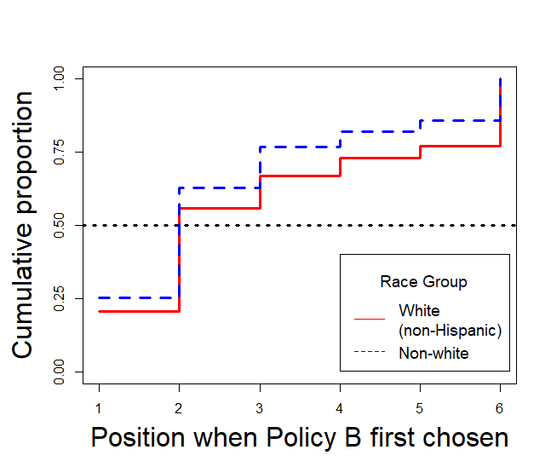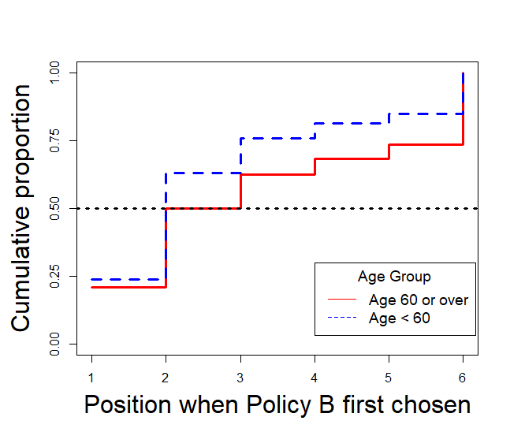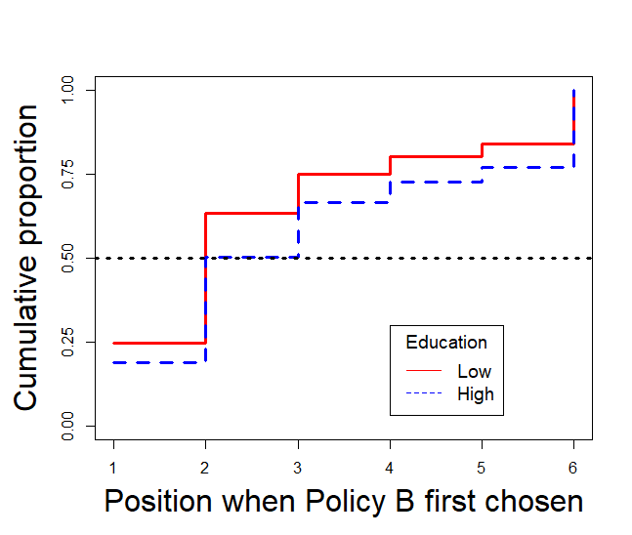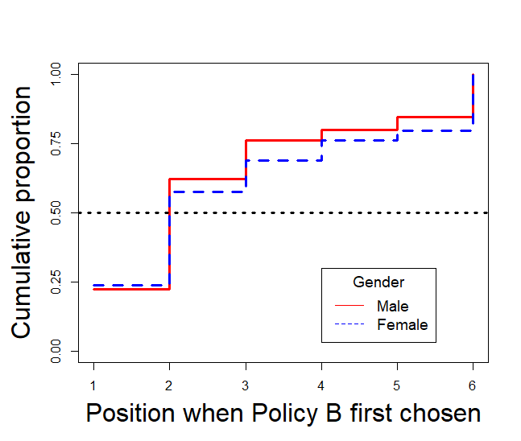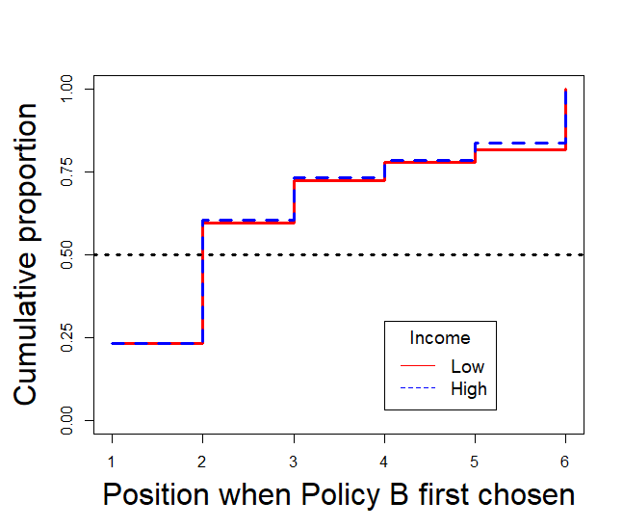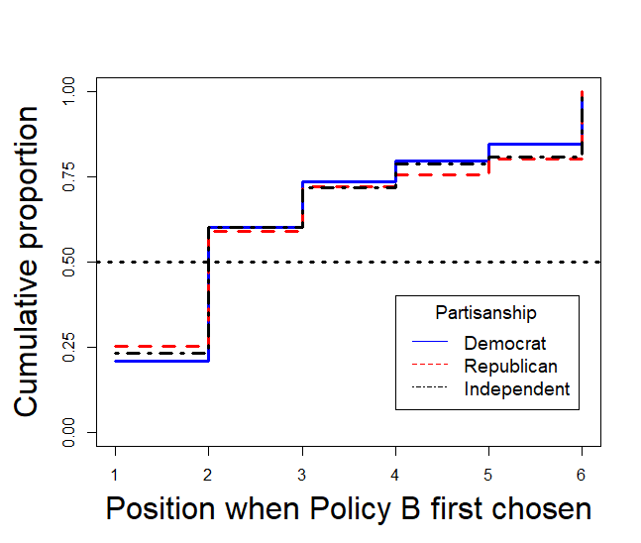

**Fig. 3.** Choice results by individual characteristics: cooling case (*n* = 1,066). Horizontal dash line denotes a proportion value of 0.5. Implied interval of median inequality aversion (γ) based on the position when Policy B was first chosen: 1: 0 < γ < 1, 2: 1 < γ < 1.5, 3: 1.5 < γ < 2, 4: 2 < γ < 2.5, 5: 2.5 < γ < 3, 6 (no Policy B was chosen): γ > 3.

In the heating case (Fig. 4), heterogeneity regarding the median inequality aversion existed across age, gender, education, race, and political party groups. The medians of inequality aversion for participants who were 60 years old or above (vs., age < 60), male (vs. female), with high education (vs. low), non-Hispanic whites (vs. non-whites), and Independents or Republicans (vs. Democrats) were greater. Among the above differences, the greatest one existed in age: Those who were 60 or above had a median inequality aversion between 2.5 and 3, whereas those younger had a median between 1 and 1.5. The weighted logrank tests told a slightly different story as in the cooling case: Except for gender and income, the test for the remaining variables were significant at the 0.05 level. Consistent with the cooling case, there were less pro-rich and more highly pro-poor participants among older, high-education, non-Hispanic white, and high-income participants. Lastly, for political party, against our expectation, there were less pro-rich and more highly pro-poor participants among the Republicans than the Independents and the Democrats.

χ2 = 8.06, *p* = 0.02

*Z* = 2.88, *p* = 0.004

*Z* = -5.71, *p* < 0.001

*Z* = -3.62, *p* < 0.001

*Z* = 0.81, *p* = 0.42

*Z* = 1.24, *p* = 0.22

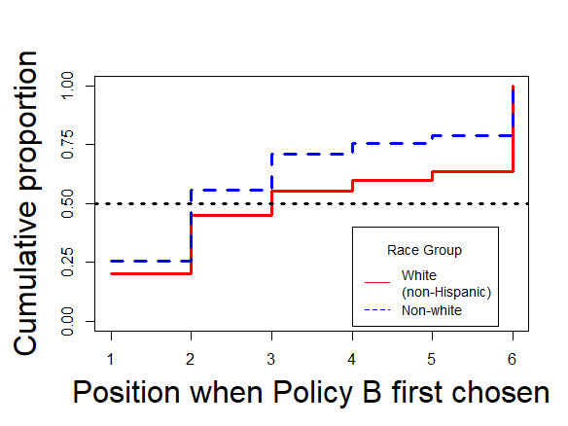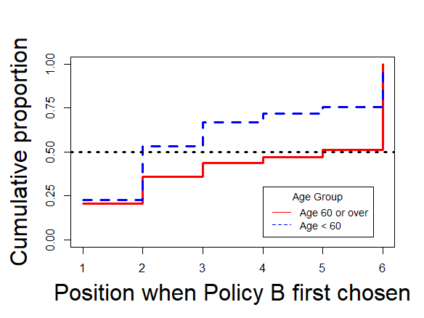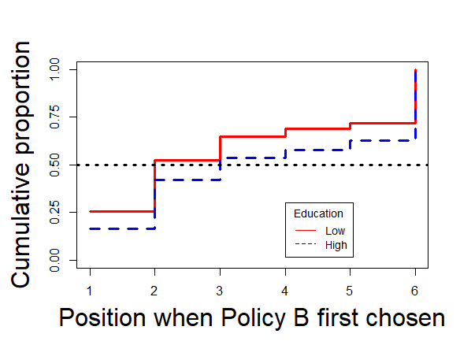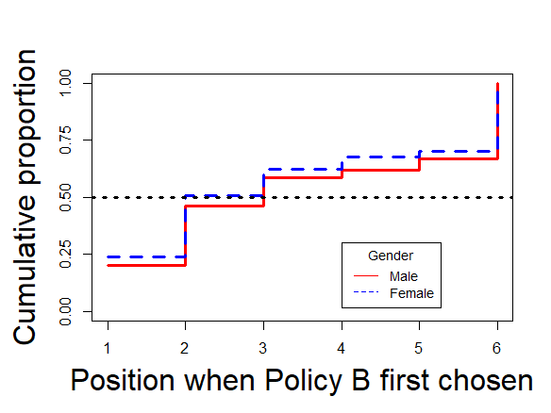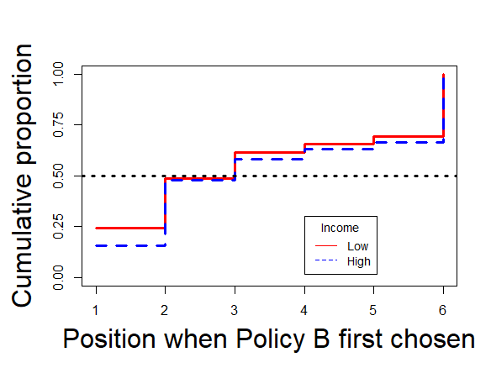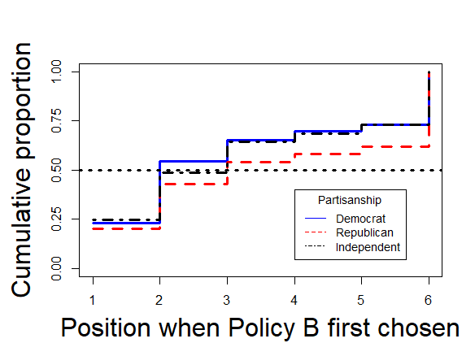

**Fig. 4.** Choice results by individual characteristics: heating case (*n* = 906). Horizontal dash line denotes a proportion value of 0.5. Implied interval of median inequality aversion (γ) based on the position when Policy B was first chosen: 1: 0 < γ < 1, 2: 1 < γ < 1.5, 3: 1.5 < γ < 2, 4: 2 < γ < 2.5, 5: 2.5 < γ < 3, 6 (no Policy B was chosen): γ > 3.

## 5.3 Covariates’ effects on inequality aversion

To examine the conditional effects of a group of variables while controlling for others on inequality aversion, we specified and fit the AFT model described in Appendix C (supplemental materials). Because using weights in a regression-type model would destabilize standard errors of the estimates (Gelman, 2007), we used the unweighted data and included those variables (age, gender, and race) used to create weights in the AFT model. The sample sizes used were reduced due to missing data in the predictors. Notwithstanding, we note that 90% and 92% of the participants in the cooling case and in the heating case were retained.

Regarding the results, first, the two parameters of the baseline loglogistic distribution of the survival function were highly significant for both the cooling and heating case. A greater-than-one shape parameter indicated that the hazard functions under a loglogistic-distributed survival function were nonmonotonic (Majeed, 2020), where the risk of a participant choosing Policy B increased then decrease. This was consistent with the observed proportions by choice outcome presented in Table 4, where a substantial number of participants (60% in the cooling case and 49%) had chosen Policy B at the second choice.

The results of the AFT model showed several significant effects at the 0.05 significance level (Table 5). We present the coefficients in the exponential form to aid interpretation. For example, in the cooling case, given the same probability of switching from preferring Policy A to preferring Policy B, the inequality aversion value of those participants who were 60 or older was 1.20 times (*p* = 0.002) as much as that of the younger participants. Similarly, in the heating case, the older participants had an inequality aversion 1.31 times (*p* = 0.001) as much as the younger participants.

We now present the significant predictors uniquely in the cooling case (the third column in Table 5) and uniquely in the heating case (the fourth column in Table 5). In the cooling case, blacks had less inequality aversion than whites (0.76 times as much as whites, *p* < 0.001); regarding ideology, conservatives had 0.89 times as much inequality aversion as moderates (*p* = 0.05 [.04992]). In the heating case, Hispanics had less inequality aversion than whites (0.79 times as much as whites, *p* = 0.04); high-education (with a bachelor’s degree or above) participants had 1.23 times greater inequality aversion than low-education participants (*p* = 0.005); against expectations, those who more often forwent buying other necessities to pay energy bill had less inequality aversion than those who never or rarely forwent doing so; in contrast, those whose home was just adequately insulated (vs. well insulated) and those whose home was poorly or not insulated (vs. well insulated) had greater inequality aversion. Lastly, the participants living in Missouri (vs. Kansas) and living in Indiana (vs. Kansas) had greater inequality aversion.

As a sensitivity analysis, we also fit the AFT model with weighted data (Table E1; see Appendix E in supplemental materials). The model fit (log-likelihood) improved slightly in the cooling case (by 0.99) but became worse in the heating case (by 6.91). The interpretation of most covariates’ effects stayed the same except the following: In the cooling case, female participants had greater inequality aversion than males (1.11 times as much as males, *p* = 0.03), those with high education had greater inequality aversion (1.11 times as much as those with low education, *p* = 0.006), but conservatives did not differ from moderates significantly (*p* = 0.29); in the heating case, the home insulation level did not have a significant effect on inequality aversion. However, we note that the difference in the interpretation of results is rather small. For example, the signs of the affected coefficients were the same between the unweighted and the weighted data. Also, using the unweighted data, the *p* values of adequately insulated (vs. well insulated) and poorly or not insulated (vs. well insulated) were 0.08 and 0.06, respectively (see Table E1). Based on this sensitivity analysis, and given that using weights in a regression-type model would destabilize standard errors of the estimates (Gelman, 2007) and that we have included those variables used to create weights in the AFT model as covariates, we have sufficient confidence in interpreting the results based on the unweighted data.

**Table 5**

Summary of AFT model results.

|  |  |  |  |
| --- | --- | --- | --- |
| Parameter | Coding scheme | Estimatea, Standard error (*p*) | |
|  |  | Cooling case (*n* = 958) | Heating case (*n* = 834) |
| Baseline loglogistic scale |  | 1.48, 0.02 (< 0.001) | 1.77, 0.03 (< 0.001) |
| Baseline loglogistic shape |  | 2.69, 0.04 (< 0.001) | 2.03, 0.04 (< 0.001) |
| Gender | Male [0] |  |  |
|  | Female | 1.07, 0.05 (0.12) | 0.94, 0.06 (0.35) |
| Age | < 60 [0] |  |  |
|  | ≥ 60 | 1.20, 0.06 (0.002) | 1.31, 0.08 (0.001) |
| Race | White [0] |  |  |
|  | Black | 0.76, 0.08 (< 0.001) | 0.95, 0.11 (0.63) |
|  | Asian | 1.12, 0.13 (0.38) | 0.94, 0.16 (0.69) |
|  | Hispanic | 0.92, 0.05 (0.12) | 0.79, 0.11 (0.04) |
|  | Other | 1.05, 0.22 (0.81) | 0.88, 0.23 (0.57) |
| Income | < $40,000 [0] |  |  |
|  | [$40,000, $60,000) | 1.01, 0.06 (0.84) | 1.03, 0.09 (0.72) |
|  | [$60,000, $80,000) | 0.90, 0.07 (0.15) | 1.02, 0.10 (0.82) |
|  | [$80,000, $100,000) | 0.88, 0.09 (0.17) | 1.05, 0.12 (0.69) |
|  | [$100,000, $120,000) | 0.94, 0.10 (0.58) | 1.08, 0.16 (0.61) |
|  | [$120,000, $140,000) | 1.18, 0.13 (0.22) | 1.24, 0.18 (0.23) |
|  | > $140,000 | 0.97, 0.11 (0.74) | 0.99, 0.13 (0.95) |
| Political party | Independent [0] |  |  |
|  | Democrat | 1.02, 0.06 (0.73) | 0.91, 0.09 (0.29) |
|  | Republican | 1.01, 0.06 (0.90) | 1.10, 0.09 (0.31) |
| Education | Low [0] |  |  |
|  | High | 1.10, 0.05 (0.08) | 1.23, 0.07 (0.005) |
| Home ownership | Owned [0] |  |  |
|  | Rent | 1.04, 0.05 (0.37) | 1.06, 0.07 (0.42) |
| Forgo buying other necessities to pay energy bill | Never or rarely [0] |  |  |
|  | Sometimes or often | 0.92, 0.05 (0.08) | 0.75, 0.07 (< 0.001) |
| Insulation | Well insulated [0] |  |  |
|  | Adequately insulated | 1.03, 0.07 (0.71) | 1.23, 0.09 (0.03) |
|  | Poorly or not insulated | 0.99, 0.05 (0.86) | 1.18, 0.07 (0.02) |
| Cooling (or heating) balance point | < 74°F (or 68°F) [0] |  |  |
|  | ≥ 74°F (or 68°F) | 1.06, 0.05 (0.17) | 0.93, 0.06 (0.24) |
| Ideology | Moderate [0] |  |  |
|  | Liberal | 0.95, 0.06 (0.35) | 1.01, 0.09 (0.87) |
|  | Conservative | 0.89, 0.06 (0.05) | 0.97, 0.08 (0.68) |
| State | Arizona (or Kansas) [0] |  |  |
|  | Texas (or Missouri) | 1.06, 0.05 (0.31) | 1.30, 0.10 (0.01) |
|  | New Mexico (or Illinois) | 1.19, 0.11 (0.12) | 1.14, 0.10 (0.16) |
|  | Louisiana (or Indiana) | 1.17, 0.09 (0.10) | 1.25, 0.10 (0.03) |
|  | Other | 1.10, 0.13 (0.45) | 0.93, 0.23 (0.75) |

*Note. High education denotes bachelor’s degree or above. Log-likelihood (cooling): -1,535.95; Log-likelihood (heating): -1,310.66*

*a Presented in exp(estimate).*

## 5.4 Examining open-ended responses

We used a mixed method to examine how participants reflected upon their choices. First, we used structural topic modeling (STM) (Roberts et al., 2016, 2014), a commonly used unsupervised text analysis technique for analyzing open-ended response in surveys, to identify prominent topics that emerged from the participants’ responses and to examine the relationship between the position where participants switch to Policy B and the identified topics. In a general case of topic modeling, each document is assumed to contain a set of latent topics, and each topic is assumed to be associated with a set of words. The goal is to discover which topics are prevalent in a document (topic prevalence) and which words are associated with a topic (topic content).

STM is an extension to the more traditional topic modeling methods like latent Dirichlet allocation (LDA; Blei, 2012) and leverages the metadata of documents (document covariates) to examine the covariates’ effects on topic prevalence and topic content. Our hypothesis was that the STM results would show that those who switched later should give their rationales focusing more on the equal distribution of Policy A and more concern for lower-income groups (maximin preference), whereas those preferred Policy Bs would focus more on Policy Bs’ lower average cooling balance points (or higher average heating balance points; preference for economic efficiency). The detailed procedure and results of STM are documented in Appendix F (supplemental materials). The results met our expectation in both the cooling and the heating case. The prominent topics on which the switching position had significant covariate effects reflected either a preference for equal distribution, an emphasized concern about the insufficient access for lower-income groups (maximin preference), or a preference for better average balance points (preference for economic efficiency).

During the second stage of the analysis on the open-ended responses, we read through the top responses associated with the prominent topics across the cooling and the heating case, and found representative responses under the prominent topics identified in the first stage (based on STM). In Table 6 we list the representative responses, which highlights that the participants’ responses correspond well with the logic of our study design.

**Table 6**

Representative responses associated with prominent topics (cooling and heating combined)

|  |
| --- |
| Preference for equal distribution |
| 1. Policy A’s distribution is the most equal and consistent in terms of decrease in temperature with higher income [for cooling]. In other words low income households didn’t have a huge gap in degrees separating them from higher income households. 2. Policy a always seemed to be more fair and equal than policy b. Policy b made it where people with less income have to be cold while the ones with the highest don’t [for heating]. 3. Purchases must remain fair to all. A cost is a cost no matter what. An apple isn't cheaper for different income levels |
| Emphasized concern for lower-income groups (maximin preference) |
| 1. I would not be in the lower income ranges, but I don’t feel it’s right for cooling temperature to be based on income!!! I felt bad for those lower level earners and was trying to be fair across the board. I was not being selfish. 2. I picked policy A because it gave the lower income bracket the highest temperature option [for heating]. 3. I chose mostly based on the minimum temperatures for lower incomes; there’s no reason lower income households should have to experience indoor temps over 80 [for cooling]. |
| Preference for better average balance point (preference for economic efficiency) |
| 1. Lower average temperature point [for cooling]. 2. Overall average Temps are in line with my comfort levels 3. Plan b seems to be the better option for everyone since it stays fair throughout the majority of the policy |

# 6. Discussion

This study aimed to elicit the social preferences towards inequality in energy consumption in the U.S. Whereas previous research in the energy field assumed a set of predetermined values of inequality aversion (Böhringer et al., 2012; Landis et al., 2021; Nock et al., 2020; Schlör et al., 2013, 2012), our study aimed to determine the empirical value of the inequality aversion parameter regarding energy consumption inequality among the U.S. public, and how inequality aversion varied across individual characteristics.

We focused on the income-related distributions of cooling and heating balance points, defined as the indoor temperature when homes turn on cooling and heating units (Cong et al., 2022; Dubin, 2008; Plagge et al., 2017). Our method to infer the empirical value of inequality aversion was to ask participants to make multiple choices between two income-related distributions of cooling balance points or heating balance points. Whereas similar efforts have been taken in income inequality (Carlsson et al., 2005; Johansson‐Stenman et al., 2002; Pirttilä and Uusitalo, 2010) and health inequality (Hurley et al., 2020; Robson et al., 2017), this study is among the first attempt to elicit inequality aversion from the public in the field of residential energy consumption. We discuss the implications of the findings below.

## 6.1 Implication of findings

The most important takeaway from our study was that the participants indeed showed a pro-poor propensity, indicated by a median income-related inequality aversion greater than one. We found that the median inequality in four southern states (Arizona, Louisiana, New Mexico, and Texas) was 1.37, 95% CI of [1.35, 1.39], whereas the median inequality aversion was 1.56 in four Midwest states (Illinois, Indiana, Kansas, and Missouri), 95% CI of [1.56, 1.60]. Thus, those for whom space heating in winter is a major concern were slightly more pro-poor than those for whom space cooling in summer is a major concern. In terms of the magnitude of the estimated inequality aversion, the only directly comparable evidence we were aware of was from a previous study on health inequality, where the median income-related inequality aversion was between 1.5 and 2 and the mean aversion was 1.66 (Hurley et al., 2020), which was close to those estimated in our study.

Regarding the results indicating that the median inequality aversion in the heating case was greater than that in the cooling case (with mutually exclusive 95% CIs), we surmised that this could be a product of the different effects of the self-report balance points. In the cooling case (*p* = 0.17), the higher the self-report cooling balance point, the greater the inequality aversion; in the heating case (*p* = 0.24), again, the higher the self-report heating balance point, the greater the inequality aversion. Given the evidence that the need for thermal comfort predicted energy consumption (Becker et al., 1981; Chen et al., 2017; Seligman et al., 1979), and that we controlled for home insulation level, our results indicated an opposing mechanism: As need for thermal comfort in the cooling case increased (with a lower balance point), inequality aversion decreased; however, as need for thermal comfort in the heating case increased (with a higher balance point), inequality aversion increased. This opposing mechanism is even more plausible if we consider the empirical evidence from Chen et al. (Chen et al., 2017), where the need for thermal comfort in summer was found to be greater than the need for thermal comfort in winter among low-income U.S. households. Still, we note that whether this opposing mechanism of the effect of need for thermal comfort can indeed explain the observed difference in median inequality aversion needs further investigation. Ideally, one should use the same sample to estimate inequality aversion in both the cooling and heating case, together with the measure of the need for thermal comfort in summer and winter.

To further unpack what the value of 1.37 and 1.56 imply for resource redistribution to reduce the inequality existing in the income-related distribution of energy consumption, we use the concept of *equally distributed equivalent* (EDE (Atkinson, 1970)). In the welfare-based inequality measures, given a value of inequality aversion, EDE is the amount of total resource or service (e.g., income, or balance point for our purpose) that is equally distributed and enables the society to reach the same level of social welfare as the actual distribution. In other words, EDE measures how much the society would give up the total amount of resource or service to have a greater level of equality.

To calculate the EDE based on the estimated inequality aversion values, we can directly use Equations 2 and 3 (Hurley et al., 2020). In the cooling case, *EDE*C = 79.34°F, and in the heating case, *EDE*H = 68.37°F. Under the context of our study, if we use the reference distributions (Policy A) in Tables 2 and 3 as the baseline distribution, where the mean in Policy A in the cooling case was 78°F, and the mean in Policy A in the heating case was 69.6°F, the temperature, *EDE*C = 79.34°F, implies that those in the four southern states are willing to have a higher (1.7%) mean cooling balance point by giving up a certain amount of energy consumption so that the cooling balance point (79.34°F) can be distributed equally across income groups; *EDE*H = 68.37°F means that those in the four Midwest states are willing to have a lower (1.8%) mean heating balance point by giving up a certain amount of energy consumption so that the heating balance point (68.37°F) can be distributed equally across income groups.

The estimated inequality aversion can also be applied in the real world using actual distributions. Take the empirical evidence regarding the distribution of cooling balance points in Arizona as an example (Fig. 1). Using the estimated balance points in Year 2018-2019 from their study, based on Equation 2 (with the same underlying assumptions) and the inequality aversion being 1.37, *EDE*C = 66.3°F (1.4% higher than the actual mean of 65.4°F). This indicates that whereas the public is pro-poor, there would be only a small amount of energy consumption that needs to be forgone to achieve a more equitable distribution.

With a specific target balance point available, policymakers and local governments can set realistic and workable pathways to tackle the issue of energy burden and energy limiting behaviors, as well as respond to the constituency’s pro-poor sentiment. For example, regarding the energy equity gap shown in Fig. 1 (Cong et al., 2022), to achieve energy equality the goal is to lower the cooling balance points of the five low-income groups to 66.3°F through weatherization or energy bill assistance programs. If the policy was focused on reducing energy consumption, then the goal is to bring the cooling balance points of the three high-income groups up to 66.3°F through behavior change campaigns.

One major takeaway from our examination of the second research question is that, younger people had lower aversion values than older people, which was the case in both the southern and Midwest states. This age effect was in the opposite direction against the one found in a study with a similar design in the health domain (Hurley et al., 2020). In southern states, blacks had lower aversion values than whites. In Midwest states, Hispanics had lower aversion values than whites. This pair of results regarding race is unexpected and needs further examination. However, we note that these results are consistent with one conclusion from the literature regarding the empirical evidence of the relationship between inequality aversion and sociodemographic variables: “… in general, few consistent patterns emerge, with the possible exception of that with political beliefs” (Hurley et al., p. 13). This exception regarding political belief indeed found some support in our results: In the southern states, those who had higher ideology scores (i.e., conservatives) were less averse to inequality than those who had moderate ideology scores, which is partly in line with an earlier piece of evidence in the health domain (Hardardottir et al., 2021). In contrast, our AFT model showed no significant effect of political partisanship. This is consistent with the evidence showing that ideological position do not always align with partisanship (Huddy et al., 2015), and that political ideology had stronger associations with the attitudes towards federal spending on welfare and concerns over inequality than political party identification in the U.S. (Baldassarri and Gelman, 2008). With regards to education, in the Midwest states, lower-education people had lower inequality aversion. Moreover, we did not find any significant gender effect on inequality aversion, which is in line with an earlier study based on a similar study in the health domain (Hurley et al., 2020), but contradicts another finding showing that women had greater health inequality aversion than men (Hardardottir et al., 2021). Before more evidence is obtained, for practitioners, policy designers, and community advocates, the takeaway message from the current study is that more resources and attention should be devoted to low-income senior citizens. The elderly group in the current study was more averse to inequality in both the cooling and heating case, and this group was more vulnerable to negative health impact due to unhealthy indoor environment.

Finally, within the cooling case or the heating case, we did not expect any difference across states. This turned out to be true in the cooling case. However, in the heating case, the results showed that the participants living in Missouri (vs. Kansas) and living in Indiana (vs. Kansas) had greater inequality aversion. Our results established the first of its kind empirical evidence of state differences. We hope that such evidence can guide future studies to investigate the state differences. For practical purposes, to increase inequality aversion in the Midwest states, campaigners may want to target the residents in Kansas, because two other states (Missouri and Indiana) had aversion values significantly higher than Kansas.

## 6.2 Methodological significance

Our study demonstrates how to model participant’s choice in studies that aim to elicit inequality aversion by using techniques from survival analysis, which had not been used in similar designs, e.g., (Carlsson et al., 2005; Hurley et al., 2020). On one hand, the nature of the interval data generated in our survey resembles those generated under interval censoring in survival analysis (Zhang and Sun, 2010). Survival analysis provides a useful way to model the uncertainty existing in the interval data. In addition, one major advantage of our method is that it allows a point estimate of median inequality aversion (with 95% CIs), whereas only intervals of median inequality aversion were estimated in previous studies.[5]

## 6.3 Limitations and future research

*6.3.1 Limitations*

There are several limitations in our study. First, due to the concerns over prolonged survey completion time and the cognitive load on participants (Brosnan et al., 2021), we did not measure participants’ social values orientation that would have enabled us to classify participants into altruistic, cooperative, individualistic, competitive, or aggressive (Hurley et al., 2020, p. 4). Social values orientation can be a significant predictor of inequality aversion. Due to the same concerns, we did not estimate the cooling inequality aversion and heating inequality aversion using the same sample. The primary goal of the current project was to elicit inequality aversion from participants for whom energy limiting behavior could have negative health consequences. This is why we focus on space cooling in the summer months when limiting energy consumption due to financial stress may lead to heat-related death (Iverson et al., 2020), and space heating in the winter months when limiting consumption may lead to cold-related death (Kinney et al., 2015; O’Neill, 2003). Our estimates represent an upper bound in the level of inequality aversion because they are elicited from places where the health risks of under-consuming energy are the most likely to be recognized. We hope that our studies can generate the most policy implications for the regions that need them the most. In future studies, using the same sample would help examine the opposing mechanism of the effect of the need for thermal comfort in summer and the need for thermal comfort in winter on inequality aversion (see Section 6.1). Second, our design in the heating case may lack in certain level of external validity, due to the mixed empirical evidence of heating balance point distribution across income groups (Charlier and Legendre, 2016; Huebner et al., 2019; Kelly et al., 2013; Oreszczyn et al., 2006). Nevertheless, our results are still meaningful because participants were asked to imagine themselves living in a hypothetical society, which did not depend on the actual balance point distribution. Third, we acknowledge that due to the lack of directly relevant previous studies in the energy field and based on our review of literature in other fields, our approach to examine the effects on inequality aversion was largely exploratory. Notwithstanding, our findings provide directions for rigorous hypothesis testing regarding effects on inequality aversion in future studies and provide some practical initial insights for energy justice campaigners.

*6.3.2 Future research*

As noted in Section 6.1, one area that needs to be examined further is the possible opposing mechanism of need for thermal comfort in summer and winter on inequality aversion. Whenever practical, one should estimate the cooling inequality aversion and the heating inequality aversion using the same sample, as well as measuring need for thermal comfort. To determine the priority of addressing various topics in inequality (e.g., energy inequality vs. health inequality), it would be useful to compare the bivariate income-related inequality aversions in two or more topics in a future study by either eliciting various inequality aversions using a common set of participants or randomizing topics. Another promising direction is to compare the relative strengths of the effects of political party identification, political ideology, and social value orientation on inequality aversion. Our results found that political ideology may be a stronger predictor than party identification, but we still need a more rigorous comparison with the measure of social value orientation (Section 5.3.1).

# 7. Conclusion

This research fills a gap in the understanding of how the public values the inequality in energy limiting behavior. We elicited the bivariate income-related inequality aversion to energy limiting behavior in the U.S. under a social welfare framework. We used balance points to quantify energy limiting behavior, which also indirectly reflects thermal comfort. In an online survey, 1,066 (from four southern states) and 906 (from four Midwest states) participants made choices between energy policies in a hypothetical society that would lead to different distributions of cooling balance points (southern) or heating balance points (Midwest) across five income groups. Participants showed a pro-poor propensity: the median inequality aversions were 1.37, 95% CI of [1.35, 1.39] (cooling) and 1.56, 95% CI of [1.56, 1.60] (heating). Regarding policy implications, the 1.37 inequality aversion in the cooling case sets a realistic redistribution goal about energy limiting behavior in Arizona: raising the average cooling balance point from 65.4°F (Year 2018-2019) to 66.3°F (by 1.4%) and making cooling balance points equal across income groups will generate the same level of social welfare as the existing distribution. The estimated aversion levels also indicate that designing policies to reduce inequality in balance points will generate social welfare gains. Moreover, the policy design tackling energy equity gaps should not separate energy consumption inequality from income inequality, as the public reacts to these two as intertwined issues.

One common significant effect existed in both cases: younger participants were less averse to inequality. For the cooling case, blacks (vs. whites) and conservatives (vs. centrist) were less averse to inequality; for the heating case, Hispanics (vs. whites), low (vs. high) education participants, and those whose homes were well insulated (vs. adequately and vs. poorly or not insulated) were less averse to inequality. The policy design should focus on the concerns of low-income senior citizens. Our findings provide significant insights for policymakers, activists in energy justice, and future research agenda.

**Funding**

The first author acknowledges support from the Council on Library and Information Resources, Alexandria, VA, USA. The second author acknowledges support from the National Science Foundation [grants: 2121730 and 2049333]. Both authors acknowledge support from the Alfred P. Sloan Foundation.

# References

Amiel, Y., Cowell, F., 1999. Thinking about Inequality: Personal Judgment and Income Distributions. Cambridge University Press, Cambridge, UNITED KINGDOM.

Anderson-Bergman, C., 2017. icenReg: Regression models for interval censored data in R. Journal of Statistical Software 81, 1–23. https://doi.org/10.18637/jss.v081.i12

Atkinson, A.B., 1970. On the measurement of inequality. Journal of Economic Theory 2, 244–263. https://doi.org/10.1016/0022-0531(70)90039-6

Attema, A.E., Brouwer, W.B.F., l’Haridon, O., Pinto, J.L., 2015. Estimating sign-dependent societal preferences for quality of life. Journal of Health Economics 43, 229–243. https://doi.org/10.1016/j.jhealeco.2015.07.006

Baldassarri, D., Gelman, A., 2008. Partisans without Constraint: Political Polarization and Trends in American Public Opinion. American Journal of Sociology 114, 408–446. https://doi.org/10.1086/590649

Becker, L.J., Seligman, C., Fazio, R.H., Darley, J.M., 1981. Relating Attitudes to Residential Energy Use. Environment and Behavior 13, 590–609. https://doi.org/10.1177/0013916581135004

Bednar, D.J., Reames, T.G., 2020. Recognition of and response to energy poverty in the United States. Nature Energy 5, 432–439. https://doi.org/10.1038/s41560-020-0582-0

Bérgolo, M., Burdin, G., Burone, S., De Rosa, M., Giaccobasso, M., Leites, M., 2022. Dissecting inequality-averse preferences. Journal of Economic Behavior & Organization 200, 782–802. https://doi.org/10.1016/j.jebo.2022.06.022

Blei, D.M., 2012. Probabilistic topic models. Commun. ACM 55, 77–84. https://doi.org/10.1145/2133806.2133826

Böhringer, C., Carbone, J.C., Rutherford, T.F., 2012. Unilateral climate policy design: Efficiency and equity implications of alternative instruments to reduce carbon leakage. Energy Economics, The Role of Border Carbon Adjustment in Unilateral Climate Policy: Results from EMF 29 34, S208–S217. https://doi.org/10.1016/j.eneco.2012.09.011

Böhringer, C., García-Muros, X., González-Eguino, M., 2022. Who bears the burden of greening electricity? Energy Economics 105, 105705. https://doi.org/10.1016/j.eneco.2021.105705

Brosnan, K., Grün, B., Dolnicar, S., 2021. Cognitive load reduction strategies in questionnaire design. International Journal of Market Research 63, 125–133. https://doi.org/10.1177/1470785320986797

Carlsson, F., Daruvala, D., Johansson-Stenman, O., 2005. Are People Inequality-Averse, or Just Risk-Averse? Economica 72, 375–396.

Chandler, J., Rosenzweig, C., Moss, A.J., Robinson, J., Litman, L., 2019. Online panels in social science research: Expanding sampling methods beyond Mechanical Turk. Behav Res 51, 2022–2038. https://doi.org/10.3758/s13428-019-01273-7

Charlier, D., Legendre, B., 2016. Fuel Poverty: A Composite Index Approach.

Chen, C., Xu, X., Day, J.K., 2017. Thermal comfort or money saving? Exploring intentions to conserve energy among low-income households in the United States. Energy Research & Social Science 26, 61–71. https://doi.org/10.1016/j.erss.2017.01.009

Cheng, Z., Guo, L., Smyth, R., Tani, M., 2022. Childhood adversity and energy poverty. Energy Economics 111, 106101. https://doi.org/10.1016/j.eneco.2022.106101

Clark, T.G., Bradburn, M.J., Love, S.B., Altman, D.G., 2003. Survival Analysis Part I: Basic concepts and first analyses. Br J Cancer 89, 232–238. https://doi.org/10.1038/sj.bjc.6601118

Cong, S., Nock, D., Qiu, Y.L., Xing, B., 2022. Unveiling hidden energy poverty using the energy equity gap. Nat Commun 13, 2456. https://doi.org/10.1038/s41467-022-30146-5

Cropper, M., Krupnick, A., Raich, W., 2016. Preferences for equality in environmental outcomes (Working Paper No. 22644), NBER WORKING PAPER SERIES. National Bureau of Economic Research.

Dolan, P., Tsuchiya, A., 2011. Determining the parameters in a social welfare function using stated preference data: an application to health. Applied Economics 43, 2241–2250. https://doi.org/10.1080/00036840903166244

Dubin, J.A., 2008. An integrated engineering–econometric analysis of residential balance point temperatures. Energy Economics 30, 2537–2551. https://doi.org/10.1016/j.eneco.2007.02.013

Engelmann, D., Strobel, M., 2004. Inequality Aversion, Efficiency, and Maximin Preferences in Simple Distribution Experiments. THE AMERICAN ECONOMIC REVIEW 94, 45.

Fay, M.P., Shaw, P.A., 2010. Exact and asymptotic weighted logrank tests for interval censored data: The interval R package. J Stat Softw 36, i02.

Feger, F., Radulescu, D., 2020. When environmental and redistribution concerns collide: The case of electricity pricing. Energy Economics 90, 104828. https://doi.org/10.1016/j.eneco.2020.104828

Fehr, E., Schmidt, K., 1999. A Theory of Fairness, Competition, and Cooperation. The Quarterly Journal of Economics 114, 817–868.

Gelman, A., 2007. Struggles with Survey Weighting and Regression Modeling. Statist. Sci. 22. https://doi.org/10.1214/088342306000000691

Graff, M., Carley, S., 2020. COVID-19 assistance needs to target energy insecurity. Nat Energy 5, 352–354. https://doi.org/10.1038/s41560-020-0620-y

Graff, M., Pirog, M., 2019. Red tape is not so hot: Asset tests impact participation in the Low-Income Home Energy Assistance Program. Energy Policy 129, 749–764. https://doi.org/10.1016/j.enpol.2019.02.042

Hancevic, P., Cont, W., Navajas, F., 2016. Energy populism and household welfare. Energy Economics 56, 464–474. https://doi.org/10.1016/j.eneco.2016.03.027

Hardardottir, H., Gerdtham, U.-G., Wengström, E., 2021. Parameterizing standard measures of income and health inequality using choice experiments. Health Economics 30, 2531–2546. https://doi.org/10.1002/hec.4395

Huang, L., Nock, D., Cong, S., Qiu, Y. (Lucy), 2023. Inequalities across cooling and heating in households: Energy equity gaps. Energy Policy 182, 113748. https://doi.org/10.1016/j.enpol.2023.113748

Huddy, L., Mason, L., Aarøe, L., 2015. Expressive Partisanship: Campaign Involvement, Political Emotion, and Partisan Identity. Am Polit Sci Rev 109, 1–17. https://doi.org/10.1017/S0003055414000604

Huebner, G.M., Chalabi, Z., Hamilton, I., Oreszczyn, T., 2019. Determinants of winter indoor temperatures below the threshold for healthy living in England. Energy and Buildings 202, 109399. https://doi.org/10.1016/j.enbuild.2019.109399

Hurley, J., Mentzakis, E., Walli-Attaei, M., 2020. Inequality aversion in income, health, and income-related health. Journal of Health Economics 70, 102276. https://doi.org/10.1016/j.jhealeco.2019.102276

International Code Council, 2012. 2012 IECC - International Energy Conservation Code Climate Zone Map.

Iverson, S.A., Gettel, A., Bezold, C.P., Goodin, K., McKinney, B., Sunenshine, R., Berisha, V., 2020. Heat-Associated Mortality in a Hot Climate: Maricopa County, Arizona, 2006-2016. Public Health Rep 135, 631–639. https://doi.org/10.1177/0033354920938006

Jacobson, A., Milman, A.D., Kammen, D.M., 2005. Letting the (energy) Gini out of the bottle: Lorenz curves of cumulative electricity consumption and Gini coefficients as metrics of energy distribution and equity. Energy Policy 33, 1825–1832. https://doi.org/10.1016/j.enpol.2004.02.017

Jenkins, K., McCauley, D., Heffron, R., Stephan, H., Rehner, R., 2016. Energy justice: A conceptual review. Energy Research & Social Science 11, 174–182. https://doi.org/10.1016/j.erss.2015.10.004

Jenkins, K.E.H., Stephens, J.C., Reames, T.G., Hernández, D., 2020. Towards impactful energy justice research: Transforming the power of academic engagement. Energy Research & Social Science 67, 101510. https://doi.org/10.1016/j.erss.2020.101510

Johansson‐Stenman, O., Carlsson, F., Daruvala, D., 2002. Measuring Future Grandparents’ Preferences for Equality and Relative Standing. The Economic Journal 112, 362–383. https://doi.org/10.1111/1468-0297.00040

Kelly, S., Shipworth, M., Shipworth, D., Gentry, M., Wright, A., Pollitt, M., Crawford-Brown, D., Lomas, K., 2013. Predicting the diversity of internal temperatures from the English residential sector using panel methods. Applied Energy, Special Issue on Advances in sustainable biofuel production and use - XIX International Symposium on Alcohol Fuels - ISAF 102, 601–621. https://doi.org/10.1016/j.apenergy.2012.08.015

Kinney, P.L., Schwartz, J., Pascal, M., Petkova, E., Tertre, A.L., Medina, S., Vautard, R., 2015. Winter season mortality: will climate warming bring benefits? Environ. Res. Lett. 10, 064016. https://doi.org/10.1088/1748-9326/10/6/064016

Landis, F., Fredriksson, G., Rausch, S., 2021. Between- and within-country distributional impacts from harmonizing carbon prices in the EU. Energy Economics 103, 105585. https://doi.org/10.1016/j.eneco.2021.105585

Lovvorn, N.C., Watson, T.E., Arnold, C.G., Baxter, V.D., Borges, D.S., Cabot, P.W., Clements, W.S., Coward, C.W., Crowder, H.L., Dougherty, B.P., Evans, R.A., Hallstrom, A.D., Hermans, R.D., Hogan, J.F., Kohloss, F.H., Landman, W.J., Lewis, R.H., Montgomery, R.D., Novosel, D., Stanke, D.A., Tavares, M., Taylor, S.T., Wright, J.R., Burgett, L.W., Holness, G.V.R., Ramspeck, C.B., 2002. ASHRAE guidelines: Measurement of energy and demand savings. American Society of Heating, Refrigerating and Air-Conditioning Engineers.

Majeed, A.-F., 2020. Accelerated failure time models: An application in insurance attrition. The Journal of Risk Management and Insurance 24, 12–35.

Nock, D., Levin, T., Baker, E., 2020. Changing the policy paradigm: A benefit maximization approach to electricity planning in developing countries. Applied Energy 264, 114583. https://doi.org/10.1016/j.apenergy.2020.114583

Okun, A.M., 2015. Equality and Efficiency: The Big Tradeoff. Brookings Institution Press.

O’Neill, M.S., 2003. Modifiers of the Temperature and Mortality Association in Seven US Cities. American Journal of Epidemiology 157, 1074–1082. https://doi.org/10.1093/aje/kwg096

Oreszczyn, T., Hong, S.H., Ridley, I., Wilkinson, P., 2006. Determinants of winter indoor temperatures in low income households in England. Energy and Buildings 38, 245–252. https://doi.org/10.1016/j.enbuild.2005.06.006

Perez, K.X., Cetin, K., Baldea, M., Edgar, T.F., 2017. Development and analysis of residential change-point models from smart meter data. Energy and Buildings 139, 351–359. https://doi.org/10.1016/j.enbuild.2016.12.084

Pirttilä, J., Uusitalo, R., 2010. A ‘Leaky Bucket’ in the Real World: Estimating Inequality Aversion using Survey Data. Economica 77, 60–76. https://doi.org/10.1111/j.1468-0335.2008.00729.x

Plagge, T., Ngo, P., Gee, M., 2017. Savings estimation using the OpenEEmeter.

R Core Team, 2021. R: A language and environment for statistical computing.

Rezai, A., Van der Ploeg, F., 2016. Intergenerational Inequality Aversion, Growth, and the Role of Damages: Occam’s Rule for the Global Carbon Tax. Journal of the Association of Environmental and Resource Economists 3, 493–522. https://doi.org/10.1086/686294

Roberts, M.E., Stewart, B.M., Airoldi, E.M., 2016. A Model of Text for Experimentation in the Social Sciences. Journal of the American Statistical Association 111, 988–1003. https://doi.org/10.1080/01621459.2016.1141684

Roberts, M.E., Stewart, B.M., Tingley, D., Lucas, C., Leder-Luis, J., Gadarian, S.K., Albertson, B., Rand, D.G., 2014. Structural Topic Models for Open-Ended Survey Responses. American Journal of Political Science 58, 1064–1082. https://doi.org/10.1111/ajps.12103

Robson, M., Asaria, M., Cookson, R., Tsuchiya, A., Ali, S., 2017. Eliciting the Level of Health Inequality Aversion in England. Health Economics 26, 1328–1334. https://doi.org/10.1002/hec.3430

Scheier, E., Kittner, N., 2022. A measurement strategy to address disparities across household energy burdens. Nat Commun 13, 288. https://doi.org/10.1038/s41467-021-27673-y

Schlör, H., Fischer, W., Hake, J.-F., 2013. Sustainable development, justice and the Atkinson index: Measuring the distributional effects of the German energy transition. Applied Energy 112, 1493–1499. https://doi.org/10.1016/j.apenergy.2013.04.020

Schlör, H., Fischer, W., Hake, J.-F., 2012. Measuring social welfare, energy and inequality in Germany. Applied Energy, Energy Solutions for a Sustainable World - Proceedings of the Third International Conference on Applied Energy, May 16-18, 2011 - Perugia, Italy 97, 135–142. https://doi.org/10.1016/j.apenergy.2012.01.036

Seligman, C., Kriss, M., Darley, J.M., Fazio, R.H., Becker, L.J., Pryor, J.B., 1979. Predicting Summer Energy Consumption from Homeowners’ Attitudes1. Journal of Applied Social Psychology 9, 70–90. https://doi.org/10.1111/j.1559-1816.1979.tb00795.x

Shiell, L., 2003. Descriptive, prescriptive and second-best approaches to the control of global greenhouse gas emissions. Journal of Public Economics 87, 1431–1452. https://doi.org/10.1016/S0047-2727(01)00218-3

Sun, J., 1996. A non-parametric test for interval-censored failure time data with application to AIDS studies. Stat Med 15, 1387–1395. https://doi.org/10.1002/(SICI)1097-0258(19960715)15:13<1387::AID-SIM268>3.0.CO;2-R

The U.S. Department of Energy, 2021. Thermostats [WWW Document]. URL https://web.archive.org/web/20210924130805/https://www.energy.gov/energysaver/thermostats (accessed 9.24.21).

The U.S. Energy Information Administration, 2022. Nearly 90% of U.S. households used air conditioning in 2020 [WWW Document]. URL https://www.eia.gov/todayinenergy/detail.php?id=52558 (accessed 10.21.22).

The U.S. Energy Information Administration, 2018. Table HC6.7 Space heating in homes in the Northeast and Midwest regions, 2015 [WWW Document]. URL https://www.eia.gov/consumption/residential/data/2015/hc/php/hc6.7.php (accessed 2.8.22).

The U.S. Energy Information Administration, 2015. 2015 Residential Energy Consumption Survey: Survey Form (457-A).

Turnbull, B., 1976. The empirical distribution function with arbitrarily grouped, censored, and truncated data (Technical Report No. 305). Cornell University, Ithaca, New York.

U.S. Energy Information Administration, 2022. In 2020, 27% of U.S. households had difficulty meeting their energy needs [WWW Document]. URL https://www.eia.gov/todayinenergy/detail.php?id=51979 (accessed 9.27.22).

Venmans, F., Groom, B., 2021. Social discounting, inequality aversion, and the environment. Journal of Environmental Economics and Management 109, 102479. https://doi.org/10.1016/j.jeem.2021.102479

Wagstaff, A., 2002. Inequality aversion, health inequalities and health achievement. Journal of Health Economics 15.

Woods, J., Fuller, C., 2014. Estimating base temperatures in econometric models that include degree days. Energy Economics 45, 166–171. https://doi.org/10.1016/j.eneco.2014.06.006

Yang, F., Katumba, K.R., Greco, G., Seeley, J., Ekirapa-Kiracho, E., Revill, P., Griffin, S., 2022. Incorporating Concern for Health Equity Into Resource Allocation Decisions: Development of a Tool and Population-Based Valuation for Uganda. Value in Health Regional Issues 31, 134–141. https://doi.org/10.1016/j.vhri.2022.04.006

Zhang, Z., Sun, J., 2010. Interval censoring. Stat Methods Med Res 19, 53–70. https://doi.org/10.1177/0962280209105023

1. When comparing the distributions from Policy B1 to Policy B3, the concentration index alone does not lead to a conclusion about which distribution is more unequal. There are multiple parameters varying from Policy B1 to Policy B3: the social welfare and the mean balance point. It is complicated to derive the exact direction of change in the concentration index, as the change direction in the social welfare is undetermined as a function of simultaneously changing balance points and inequality aversion.
2. Robson et al. (Robson et al., 2017) implemented a similar design and found that 32% of the participants reported inconsistent choices. These participants (along with additional participants under other criteria) were excluded in their main analysis. However, the sensitivity analysis, where the excluded participants were put back, revealed that the estimated medians were robust to exclusion.
3. In the southern states, about 90% of homes built between 2010-2020 use air conditioning (The U.S. Energy Information Administration, 2022); in the Midwest states, 73% of homes use natural gas for space heating (The U.S. Energy Information Administration, 2018). Our choice of the states is aimed at increasing comparability of studies on studying energy limiting behavior in Arizona (south; see Cong et al., 2022) and Illinois (mid-west; see Huang et al., 2023). In addition, to further improve the external validity of our study, we decided to include three more states based off Arizona (and three more states based off Illinois) that share a similar latitude and have a balanced mix of different levels of warmth and humidity according to the International Energy Conservation Code (IECC) climate zone map (International Code Council, 2012).
4. An alternative option is to use the midpoint of an interval and to apply bootstrapping to obtain a point estimate (Hardardottir et al., 2021). There are two limitations of this option. First, the midpoint assumption, although convenient and intuitive, may be inappropriate; second, this option does not apply to the right-censored data.
5. One exception is (Hardardottir et al., 2021) of which the limitations are discussed in Footnote 4.