**Quick Start User Guide**

Group 3

Han Lu 301104393

**1 Installation**

- Download the application from <https://github.com/hlutony/diabetes-prediction-react-flask.git>

- Open the client folder in your code editor.

- Install dependencies by entering npm i in the terminal.

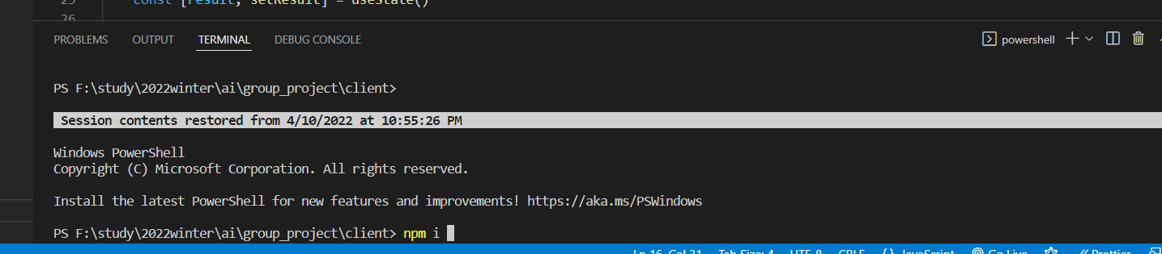

**2 Running Backend**

- Open terminal at the root folder

- Enter py diabetes_prediction_api.py in your terminal. You should see the following

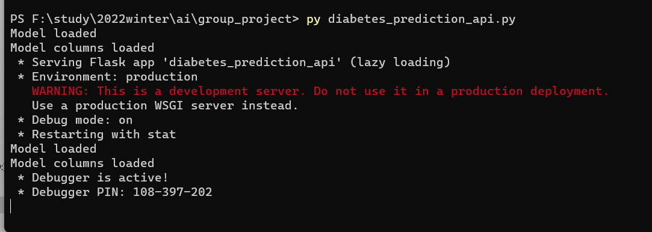

**3 Running Frontend**

- Open client folder in your code editor.

- Enter npm run start

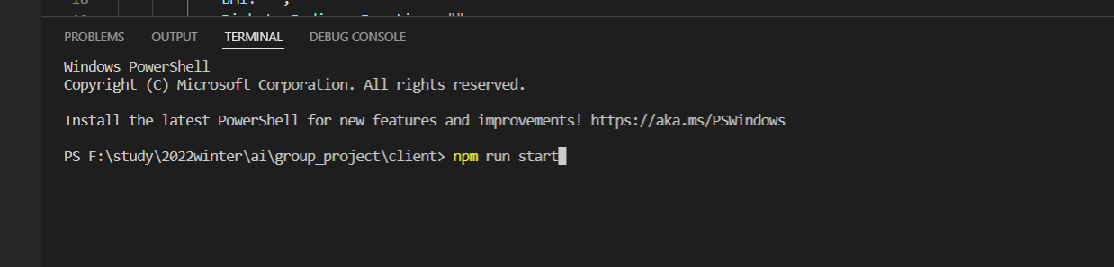

**4 Use the application**

- Open <http://localhost:3000.> You should see the following.

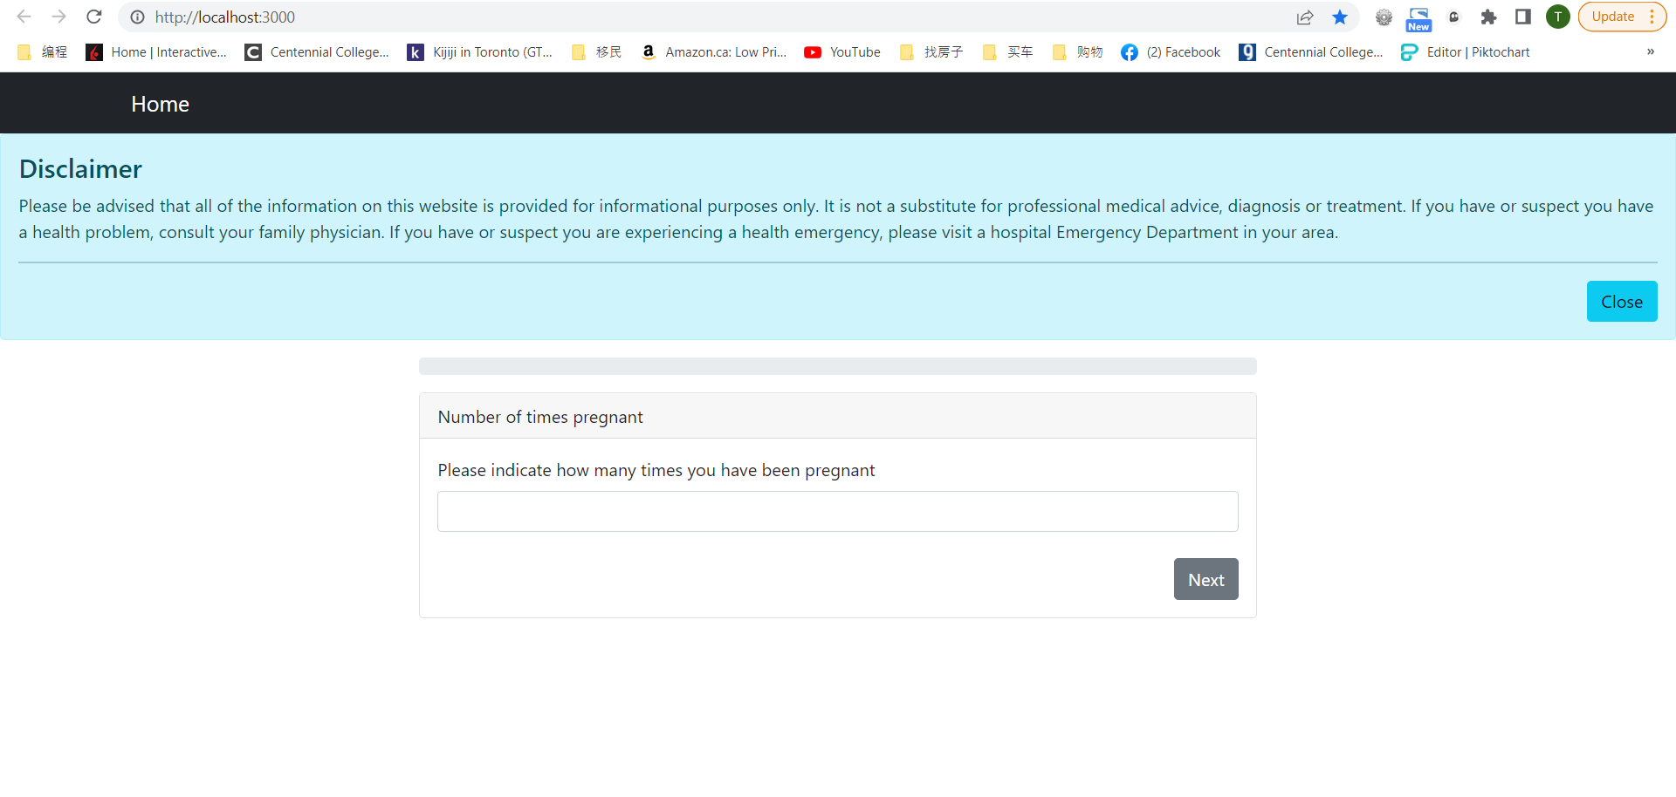

- You can close the disclaimer by clicking close button

- Answer questions on by one until you see the review of all questions and answers.

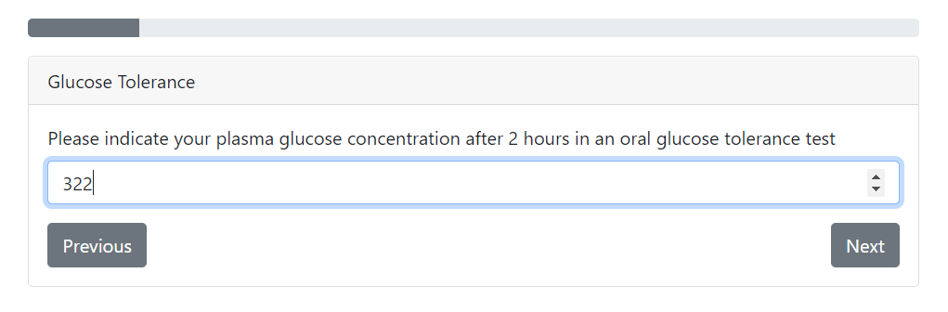

- Once you finish the question, click Next button.

- If you need to see and change the answer of previous question, click Previous button.

- Once you finish all questions, you should see the following.

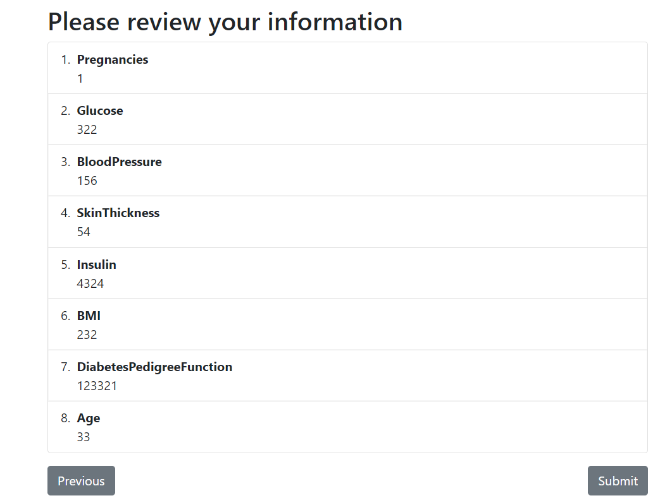

- Click Submit to See the result. You should see the following

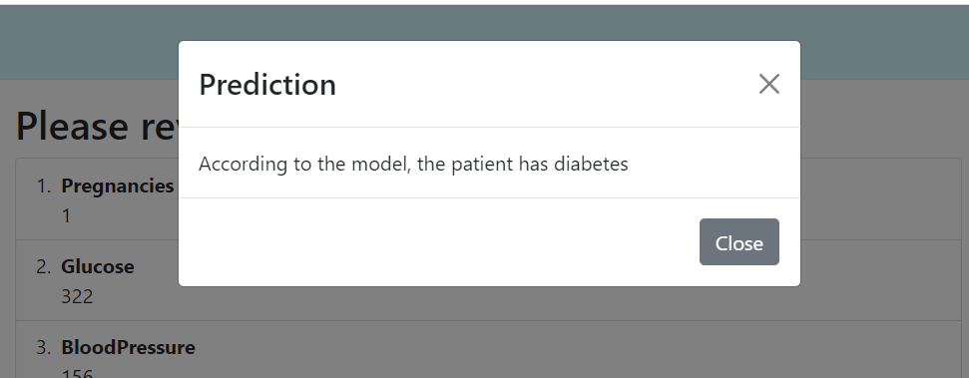

- Click Close button to close the pop. You should see the very first question.