# **AIRLESSCO FILTERS**

Airlessco filters protect your equipment and keep them operating at peak performance. Higher mesh counts are for thinner materials.

---

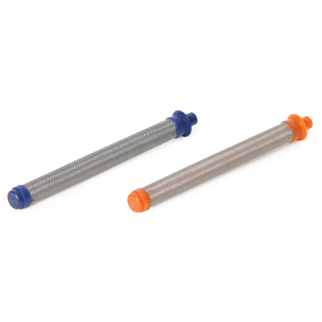

| Accessories Details | |
| --- | --- |
| **PROLIGHT 500 GUN FILTERS** | |
| PART NUMBER: | 17P312 - 50 mesh |
| AVAILABILITY: | North America, Central and South America, Europe, Middle East, Africa, Asia, Australia |

---

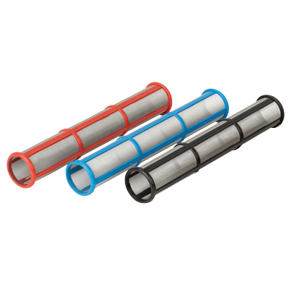

| Accessories Details | |
| --- | --- |
| **MANIFOLD FILTERS** | |
| PART NUMBER: | 244071 - 30 mesh, fits GS and TS models |
| AVAILABILITY: | North America, Central and South America, Europe, Middle East, Africa, Asia, Australia |

---

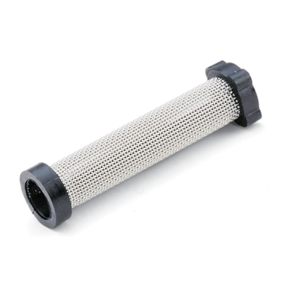

| Accessories Details | |
| --- | --- |
| **INSTACLEAN FILTERS** | |
| PART NUMBER: | 245571 - Fits SP380 and MP models |
| AVAILABILITY: | North America, Central and South America, Europe, Middle East, Africa, Asia, Australia |

---

| Accessories Details | |
| --- | --- |
| **PAINT STRAINERS 12 packs** | |
| PART NUMBER: | 867338 - To cover suction filter |
| AVAILABILITY: | Europe, Middle East, Africa |

---

| accessories-category | |
| --- | --- |
| title | **MORE ACCESSORIES** |
| types | sprayguns  \  spraytips  \  hoses  \  extensions  \  filters  \  fluids  \  striping  \  other |

| Metadata | |
| --- | --- |
| Title | Airlessco Filters | Airlessco.com |
| Description | Airlessco Professional Airless Spray Equipment Built to Perform. Built to Last. |
| Locale | /emea/en |