# **AIRLESSCO AIRLESS HOSES**

Airlessco airless hose provide superior flexibility and durability. They are designed to ensure you get the best results from your airless sprayer. They have swivel couplers and spring guards on both ends and can be coupled with other airless hoses. Whip hoses can be added to provide additional flexibility and reduce operator fatigue.

---

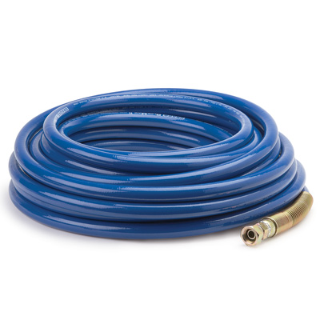

| Accessories Details | |
| --- | --- |
| **STANDARD HOSES** | |
| MAX PRESSURE: | 230 bar (3,300 psi) |
| PART NUMBER: | 865674 - 1/4 in x 15 m (50 ft) |
|  | 865675 - 3/8 in x 15 m (50 ft) |
|  | 278499 - 1/2 in x 15 m (50 ft) |
| AVAILABILITY: | Europe, Middle East, Africa |

---

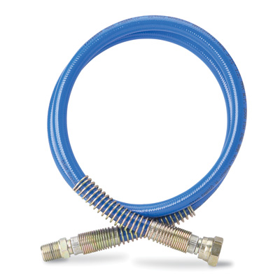

| Accessories Details | |
| --- | --- |
| **WHIP HOSES** | |
| MAX PRESSURE: | 230 bar (3,300 psi) |
| PART NUMBER: | 867741 - 3/16 in x 1.2 m (4 ft) |
|  | 867737 - 1/4 in x 0.9 m (3 ft) |
|  | 867739 - 1/4 in x 1.5 m (5 ft) |
|  | 867742 - 3/8 in x 1.8 m (6 ft) |
| AVAILABILITY: | Europe, Middle East, Africa |

---

| accessories-category | |
| --- | --- |
| title | **MORE ACCESSORIES** |
| types | sprayguns  \  spraytips  \  hoses  \  extensions  \  filters  \  fluids  \  striping  \  other |

| Metadata | |
| --- | --- |
| Title | Airlessco Airless Hoses | Airlessco.com |
| Description | Airlessco Professional Airless Spray Equipment Built to Perform. Built to Last. |
| Locale | /emea/en |