# **AIRLESSCO HVLP ACCESSORIES**

Airlessco offers a full range of HVLP accessories.

---

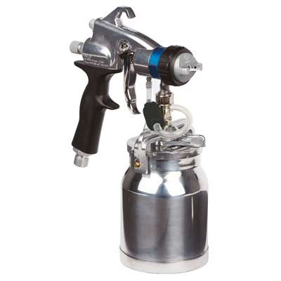

| Accessories Details | |
| --- | --- |
| **HV3000 Comfort HVLP Gun** | |
| INCLUDES: | Metal cup and needle stop |
| PART NUMBER: | 17R351 |
| AVAILABILITY: | Europe, Middle East, Africa |

---

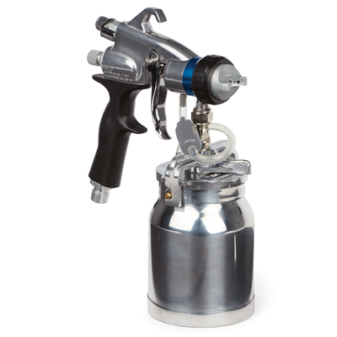

| Accessories Details | |
| --- | --- |
| **HV4000 Luxe HVLP Gun** | |
| INCLUDES: | Metal cup and all controls |
| PART NUMBER: | 17P655 |
| AVAILABILITY: | Europe, Middle East, Africa |

---

| Accessories Details | |
| --- | --- |
| **METAL CUP 1 LITRE** | |
| PART NUMBER: | 244132 |
| AVAILABILITY: | Europe, Middle East, Africa |

---

| Accessories Details | |
| --- | --- |
| **GRAVITY CUP 0.5 LITRE** | |
| PART NUMBER: | 244136 |
| AVAILABILITY: | Europe, Middle East, Africa |

---

| Accessories Details | |
| --- | --- |
| **FLUID SETS** | |
| PART NUMBER: | 17P485 - #2 (0.8 mm) |
| AVAILABILITY: | Europe, Middle East, Africa |

---

| Accessories Details | |
| --- | --- |
| **GUN AIR CAP** | |
| PART NUMBER: | 17P709 |
| AVAILABILITY: | Europe, Middle East, Africa |

---

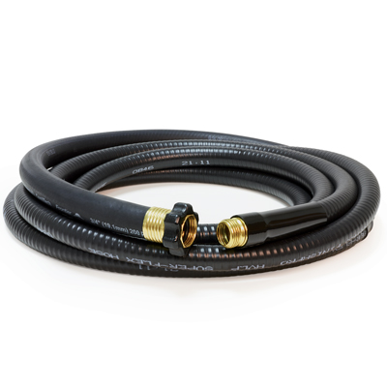

| Accessories Details | |
| --- | --- |
| **AIR HOSE** | |
| PART NUMBER: | 17R299 - 1.2 m (4 ft) |
| AVAILABILITY: | Europe, Middle East, Africa |

---

| accessories-category | |
| --- | --- |
| title | **MORE ACCESSORIES** |
| types | sprayguns  \  spraytips  \  hoses  \  extensions  \  filters  \  fluids  \  striping  \  other |

| Metadata | |
| --- | --- |
| Title | Airlessco HVLP Accessories | Airlessco.com |
| Description | Airlessco Professional Airless Spray Equipment Built to Perform. Built to Last. |
| Locale | /emea/en |