# **AIRLESSCO SPRAY TIPS**

This selection guide is given as an indication. You should always refer to the sprayer material data sheet to choose the correct tip.

---

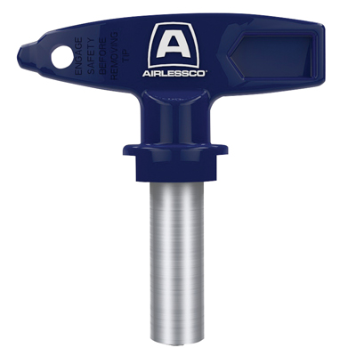

| Accessories Details | |
| --- | --- |
| **STANDARD TIPS** | |
| PART NUMBER: | ARVXXX |
| AVAILABILITY: | Europe, Middle East, Africa |
| TIP SIZE CHART: | |
| <https://main--airlessco--hlxsites.hlx.page/product-data/accessories/arvxxx.json?sheet=emea_en> | |
| PART NUMBER: | AFFXXX |
| AVAILABILITY: | Europe, Middle East, Africa |
| TIP SIZE CHART: | table |

---

| accessories-category | |
| --- | --- |
| title | **MORE ACCESSORIES** |
| types | sprayguns hoses spraytips extensions fluids filters hvlp striping other |

| Metadata | |
| --- | --- |
| Title | Airlessco Spray Tips | Airlessco.com |
| Description | Airlessco Professional Airless Spray Equipment Built to Perform. Built to Last. |
| Locale | /emea/en |

| Metadata | |
| --- | --- |
| Title | Airlessco Spray Tips | Airlessco.com |
| Description | Airlessco Professional Airless Spray Equipment Built to Perform. Built to Last. |
| Locale | /emea/en |