# **AIRLESSCO AIRLESS SPRAY GUNS**

Light trigger pull – trigger lock – hand tighten "no tools required" – easy-clean one-way filter with nylon reinforced core – extra large carbide ball and seat for long wear – durable stainless steel threads for tip attachments – long life needle seal.

---

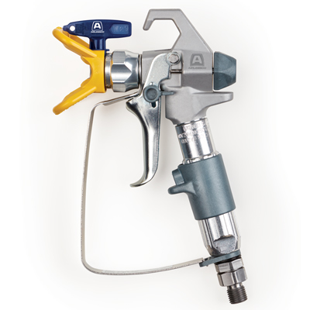

| Accessories Details | |
| --- | --- |
| **PROLIGHT 500 SERIES GUN** | |
| PART NUMBER: | 17N201 |
| INCLUDES: | 4-finger trigger (installed), 2-finger trigger, Rev-Tip 517 Tip & Guard |
| MAX WORKING PRESSURE: | 248 bar (3,600 psi) |
| REPAIR KIT: | 288817 |
| AVAILABILITY: | North America, Central and South America, Europe, Middle East, Africa, Asia, Australia |
| RESOURCES: | Operation/Repair Manual |

---

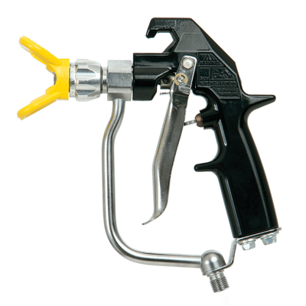

| Accessories Details | |
| --- | --- |
| **MASTIC TEXTURE GUN** | |
| PART NUMBER: | 24E470 |
| INCLUDES: | 4-finger trigger, Tip Guard |
| MAX WORKING PRESSURE: | 276 bar (4,000 psi) |
| REPAIR KIT: | 237260 |
| AVAILABILITY: | North America, Central and South America, Europe, Middle East, Africa, Asia, Australia |
| RESOURCES: | Operation/Repair/Parts Manual |

---

| Accessories Details | |
| --- | --- |
| **REVERSIBLE GUARDS** | |
| PART NUMBER: | 855051 - 11/16-16 |
| AVAILABILITY: | Europe, Middle East, Africa |

---

| Accessories Details | |
| --- | --- |
| **SEALS** | |
| PART NUMBER: | 858029 - Metal seal with O-ring |
| AVAILABILITY: | Europe, Middle East, Africa |

---

| Accessories Details | |
| --- | --- |
| **"F" TO "G" ADAPTER** | |
| Converts "F" thread to "G" thread. | |
| PART NUMBER: | 248248 |
| AVAILABILITY: | North America, Central and South America, Europe, Middle East, Africa, Asia, Australia |

---

| Accessories Details | |
| --- | --- |
| **SWIVEL "G" THREAD** | |
| PART NUMBER: | 7506AG |
| AVAILABILITY: | Europe, Middle East, Africa |

---

| Accessories Details | |
| --- | --- |
| **MASTIC GUN AIR ATOMIZER KIT WITHOUT AIR HOSE** | |
| Minimum air compressor rating of 15 cfm at 6 bar (90 psi) needed. | |
| PART NUMBER: | 244233 |
| AVAILABILITY: | North America, Central and South America, Europe, Middle East, Africa, Asia, Australia |

---

| accessories-category | |
| --- | --- |
| title | **MORE ACCESSORIES** |
| types | sprayguns  \  spraytips  \  hoses  \  extensions  \  filters  \  fluids  \  striping  \  other |

| Metadata | |
| --- | --- |
| Title | Airlessco Airless Spray Guns | Airlessco.com |
| Description | Airlessco Professional Airless Spray Equipment Built to Perform. Built to Last. |
| Locale | /emea/en |